**make omg app (omg is facebook game)**

* Create model with minimum 2 attributes
* Create List of model with dummy data
* User Random Class to view random result from your list
* Use stack widget

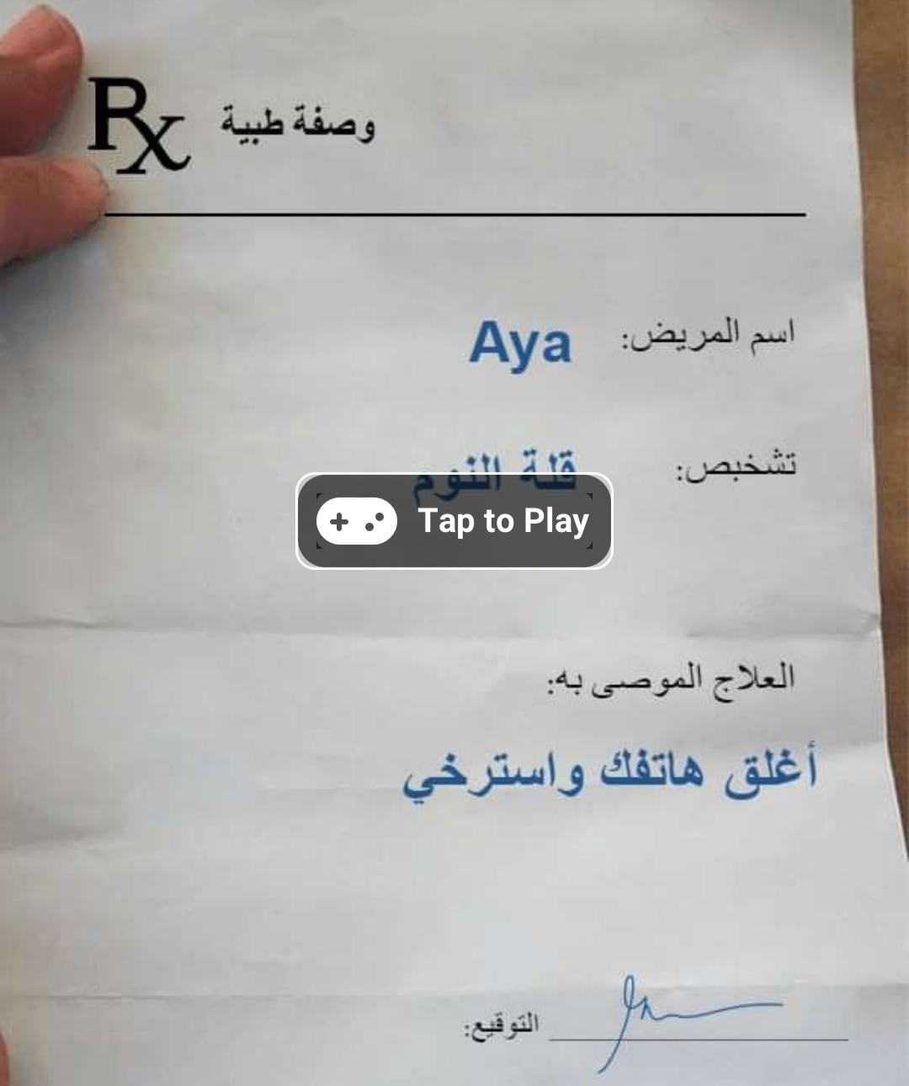

Background image:

