**Create TODO App**

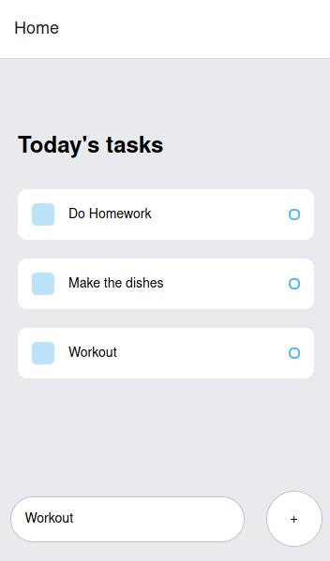

1-Create ui that take input from user ->validation

2-And add it to todo list

3-user can click checkbox to mark item as done

4-use model class

5- create custom widget for todo list item -> listtile