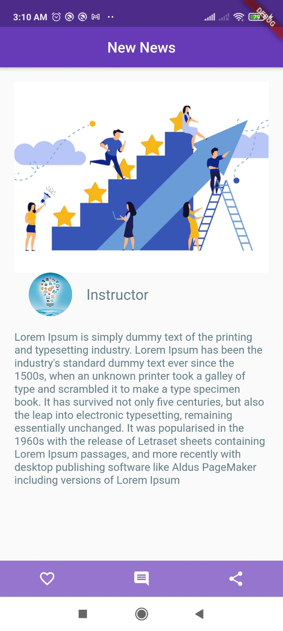

Create this page

Hint: upload source code and screenshot of running app on task folder under day2

Don't upload whole project