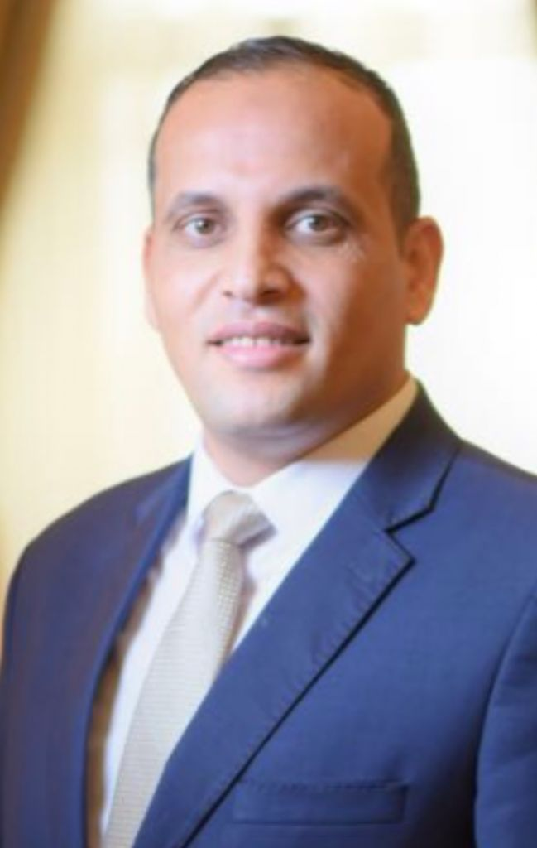
CURRICULUM VITAE:

Ahmed Helmy

Food & Beverage

PERSONAL DATA

Nationality : Egyptian.
Current Location : Cairo
Date of Birth : 14nd of August 1979
Military Status : Exempted.
Languages Spoken : Arabic, English
Height/Weight : 178 / 86 k.g
Mobile : 0096644681577
Email : ahmedhelmy7123@yahoo.com

CAREER HISTORY  POSITION | HOTEL | FROM | TO
Assistant Director of Banquet | The Ritz-Carlton, Jeddah. K.S.A | June 2021 | Present
Restaurant Manager  (All Day Dining) | The Ritz-Carlton, Jeddah. K.S.A | May 2018 | May 2021
Assistant Restaurant Manager | The Ritz-Carlton, Jeddah. K.S.A | February 2017 | April 2018
Assistant Restaurant Manager | Dusit Thani Lake View, Cairo. Egypt | April 2014 | January 2017
Pool & Garden Grill Supervisor | Dusit Thani Lake View, Cairo. Egypt | September 2010 | March 2014

JOB OBJECTIVE

The opportunity to develop my career and to expand my field of experience in a high standard hotel company that can offer personal and professional growth. To work in a different country in order to learn more about hotels and catering, and the needs / wishes of people in different cultures.

PERSONAL OBJECTIVE

To lead a successful, happy and productive team and eventually to achieve high management position.

PROFESSIONAL PROFILE

An enthusiastic and dedicated leader with excellent track record in Food & Beverage Management and Control. Passionate about delivering exceptional dining experiences, innovative menus, profitability and developing a strong and result driven team.

WORK EXPERIENCE:

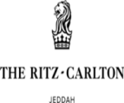
THE RITZ CARLTON JEDDAH AND KING ABDULLAH CONVENTION CENTER
PRE-OPENING TEAM

Assistant Director of Banquet (June 2021 - Present)
Leading a team of:
- 2 Managers, 2 Assistant managers & Supervisors.
- 15 permanent service team & around additional 15 part time employees.

Responsible for 25 meeting room and 2000 seating capacity Auditorium, two Grand ballrooms of 1850 M each
With Total indoor function space 63000 M.

Highlights:

- Prepare the BQT packages with the CCS managers
- Assist in hiring the F&B team including all the manger and the line staff

Restaurant Manager (May 2018 - May 2021)
In charge of the signature international restaurant, Reyhana trainings, floor plan, menu design in accordance with The Ritz-Carlton Brand Standards.

Highlights:

- 200 cover restaurant with Silhouette kitchen, Dining room, and lounge.
- Leading a multi-cultural team of 20 L & G – 2 Supervisors, 1 Bar Captain and 17 Waiters.
- Accountable for the restaurant’s annual operating budget.
- Acting Manager on Duty for the F & B Division on regular basis.
- Nominated as a Five Star Leader of the 3rd & 4th Quarter in 2020.
- driving the restaurant sales, 10% above the budget in 2019 and Above last year
- Achieved Employee Engagement Score: 97 % for 2 consecutive years (2018, 2019)
- Contributing and supporting all the major events in the hotel – Ramadan Pavilion, Weddings, Friday Brunch.
- Ensuring high level of Guest engagement, 80 % OSAT in Gallup Survey vs. goal of 75% for 2020.
- Scored 98.8 % in Brand Standard Audit conducted by Marriott International in August 2019
- Scored 100 % in the Accounting audits for 2019 (ISRA, Mystery Shopper).

Assistant Restaurant Manager (February 2017 - April 2018)
Led the pre-opening setup, hiring, trainings, floor plan, menu design in accordance with The Ritz-Carlton Brand Standards.

DUSIT THANI LAKE VIEW CAIRO

All Day Dining Assistant Manager (April 2014 - January 2017)
Assistant Manager for 24/7 All day dining Restaurant 200 seats, Lobby lounge & Shisha Terrace 140 seats managing a total staff of almost 45 people.


Leading and assist the Restaurant Manager to achieve and exceeded the budget and customer satisfaction and maintain the consistency of level of service, marketing plan, recap, on job training, maintaining budget line, inventory and cost controlling.

Pool & Garden Grill Supervisor (September 2010 - March 2014)
Pool Sala whilst relaxing surrounded by lush, landscaped greenery.
165 Chaise lounge, Leading 10 Associates.
Garden Grill outdoor venue set amongst landscaped gardens and fountains, Garden Grill serves a refreshing blend of North African, Arab and Mediterranean specialties. The menu presents a wide variety of mouthwatering mezzeh, orient-inspired spiced meats, kebabs and seafood, all served on individual grills at the table.
80 Seats, Leading 8 Associates.

Pool & Garden Grill Restaurant Captain (September 2009 - September 2010)
Leading and running the pool operation with side by side to the pool Manager to enhance my skills, interact with the guest to make sure they are happy and satisfied, train the team and make sure they implemented the standard and monitor the performance of each employee.

FOUR SEASONS SHARM EL SHIEKH

Pool Shift Leader (July 2006 - March 2008)

Food and Beverage Server / Waiter (June 2003 - June 2006)

Details of duties/experience:

Maintain the daily log book
- Attend daily operations meeting.
- Plan and organize festival bars promotions within the outlet
- Assume the function responsibilities of F&B duty manager as required
- Review and updating the outlet department operations manual on daily basis
- Control payroll through a flexible workforce maximizing utilization of part -time employees and close co-operation with other F&B outlets
- participate in the formulation of the annual operating budget, determining outlet projected revenues and expenses, operating, equipment & FF&E requirements in line with compilation of the annual business plan to strictly adhere to the established operating expenses
- Account for the correct settlement of all sales
- Identify and correct any errors to ensure that staff have the necessary skills
- Manage the outlet efficiently according to the established concept statement providing a courteous, professional, efficient and flexible service all the time following hotels standards of performance
- Assign responsibilities to subordinates, implementing a multi- tasking principle and check their performance periodically.
- Implement a flexible scheduling based on business levels.
- Ensure that the bar stocks for all operating equivalent are strictly adhered to and that the outlet is adequately equipped.
- Supervise and conduct monthly inventory checks on all operating equivalent.
- Control the requisition, storage and careful use of all operating equipment.
- Conduct daily pre- shift briefing to employees on preparation service menu.

TRAINING AND STAFF DEVELOPMENT:

TRAINING COURSES

- Service Excellence Part I , II , III, IIII
- Handling Complaints.
- Windows/Word/Excel
- F&B Basic Services
- Safety & Security / Personal Hygiene
- Four seasons Track Program (8 Month)
- Scala / Drive Club Car
- Coaching Skills
- Competencies Overview
- Communications
- P & L
- Train The Trainer
- Hygiene, Quality Control
- Div5ersy Training - Food Safety
- Performance Development
- HACCP Training
- Fire Fighting
- Time and Task Management
- COVID-19: Heightened Sanitation Practices
- Food & Beverage Leader | All-Inclusive
- The Ritz-Carlton Mystique
- Commitment to Talent (Certified Interviewer
- The Three Steps of Service
- Food Safety Certification
- Marriott TOPPS (Train the Trainer) Food Safety Certification
- Menu Development
- Beverage Certification
- Event Certification

REFERENCE REQUESTS

Name | Company | Position | Email / Tel
Amr El Kott | Triumph luxury hotel | Hotel manager | amr.elkott@triumph.com
Mohamed Adel | Anjum Hotel Mekah | Director of Food and Beverage | mohamed.adel@anjum.com
Fatih Massa | The Ritz-Carlton | EAM of Food and Beverage | fatih.massa@ritzcarlton.com

