AMIT’s Graduation Project
2020
Smart home by Bluetooth and two ECUs by SPI protocol

Ahmed hosny

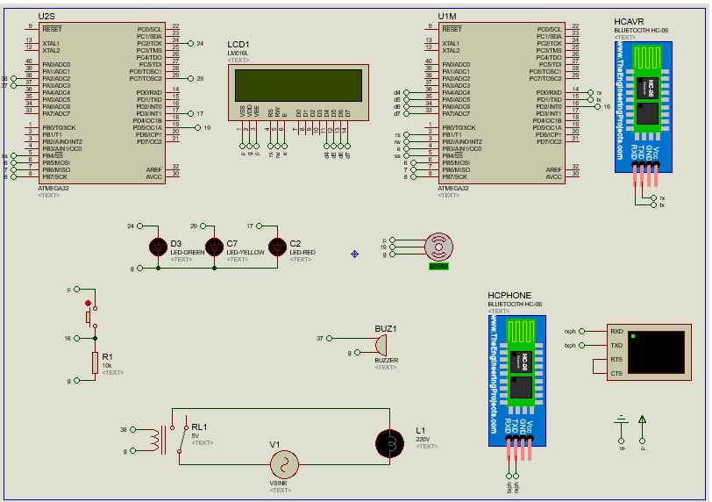
Schematic:

Machine of the System:
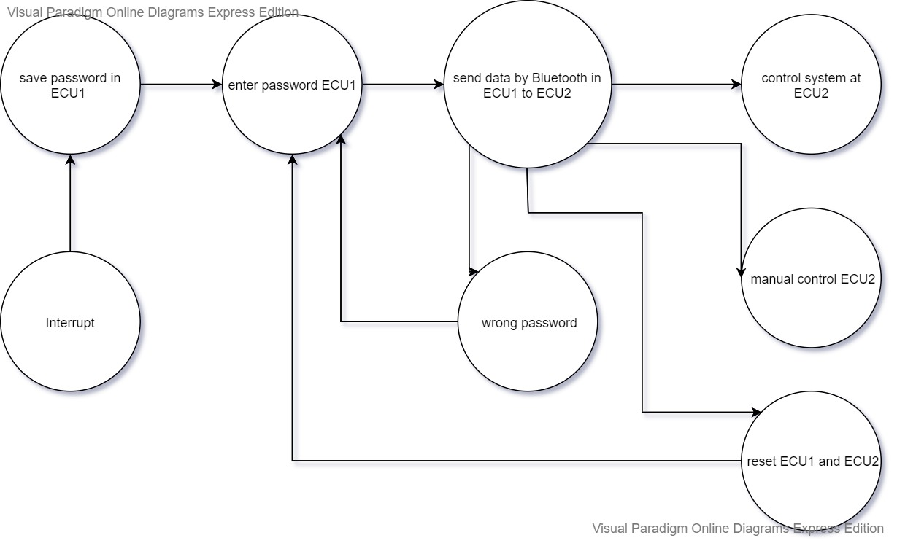

layer Architecture:
