**Visual Programming Languages – Theory**

**Final Group Project – Fall 2021**

**VPL-Final- (Hospital-Management-System)**

|  |  |  |
| --- | --- | --- |
| **S.No.** | **Roll Number** | **Name** |
| 1. | 12224 | M. Ahmed Raza Hussain. |

Project Title:

Hospital Management System

Project Description:

I will create a Hospital Management System application for a multi-specialty hospital to manage hospital data such as doctors' information, rooms' information, patients' information, bill information, and patient payment information, among other things. For every multi-specialty hospital, the Hospital Management System project is utilized to keep and track patient records.

Project Special Feature:

* Add Doctors
* Admit Patients
* OPD Checkup management
* Room management
* Generate Bill
* Payment Bill
* Discharge Patient

(I May change or add some features)

Project Security:

There is no way to use this software without admin id password, if anyone try to operate this software and he/she enters wrong password, the system will generate an error “INVALID INPUT”. Only hospital staff or admin staff can operate this software to maintain all details regarding hospital.

Project Flow:

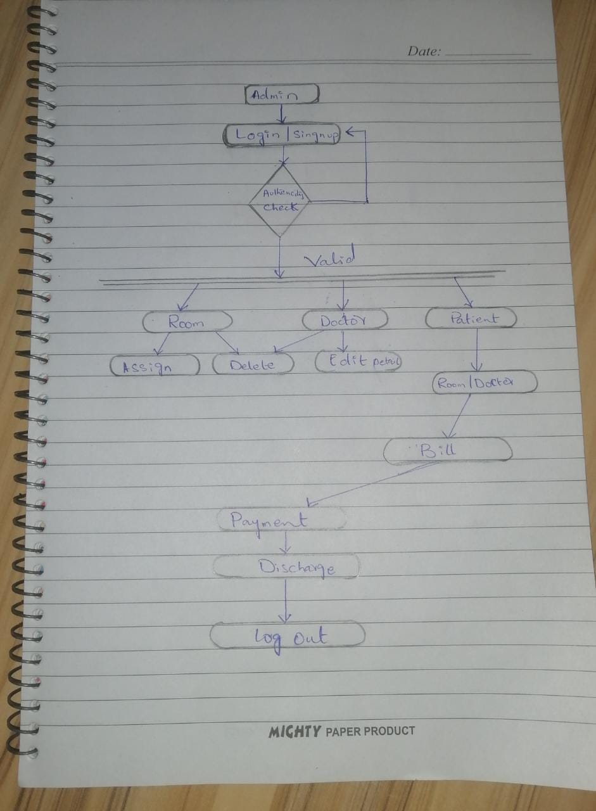

Project Database Schema:

Categories:

Doctor:

* Name, Doc_Charges, Doc_id

Room:

* RoomNum, Room_Charges

Patient:

* Name, CNIC, Number, Address, treatment_Charges

Users:

* Id, email, password, username, address, First_Name, Second_Name, Number