SimDrive: EV Transmission Design
Designing the Gearbox of an Electric Car | Project Brief
Third- and fourth-year design project | Methods from Shigley's Mechanical Engineering Design, 11th edition
Runs alongside a Shigley-based Machine Design course

Start here
You are going to design the transmission that takes up to 350 N·m (in the default car) from an electric motor, multiplies it about nine times and delivers it to the rear wheels, and you will check its conceptual design against a 150,000 kilometer target. The life is a classroom estimate, not a service-life prediction.
The loads come from a simulation of the car being driven, not from a problem statement.

What the project adds
Every stress problem in your design course began the same way. The load was in the question. Somebody had already decided that the shaft carries 4.2 kN, and your work started after that decision had been made.
This project adds the step before that. The load is not given: you have to find out what it is, and finding out means reading the results of a model of the system the component lives in, then arguing about which number out of that model belongs in which equation.
So the work runs in three stages, and only the middle one looks like the problems you have solved before.

1. System-level simulation
A Simulink model of the whole vehicle is driven through three situations: a city driving cycle, a long climb, and a full-throttle run. The model accounts for vehicle mass, aerodynamic drag, rolling resistance, the motor torque and power limits, and a controller that tracks the target speed. It reports what the transmission actually experiences, second by second.
Your instructor runs this and gives you the results. You do not have to build the vehicle model, but you do have to understand what it is telling you, because the next stage depends entirely on reading it correctly.

2. Analysis
Now the Shigley work begins, and it is the mechanics you already know: AGMA bending and contact stress on the gear teeth, endurance limits and Marin factors, stress concentration at every shoulder, the modified Goodman criterion, rolling-contact bearing life. Chapters 3, 5, 6, 7, 11, 13 and 14.
What has changed is where the numbers come from. The torque in your Goodman calculation is not given to you. It came out of a city cycle you can look at and plot. Nor are the rating factors given. Every AGMA factor, every Marin factor, the material and its grade: you choose each one, name the figure or table it came from, and defend it. The 150,000 km service target is fixed; the cycle count of each member over that target is yours to derive. An unsourced number costs more points than an arithmetic slip.

3. Optimization
A design that merely passes is not finished. A shaft thick enough to pass is easy to find; your task is to find the lightest shaft that still meets every safety factor at every critical section, which means searching the feasible geometry rather than picking one and checking it.
Here you find out which constraint controls the design. It is often not the one you expected, and the components are coupled, so relieving one constraint usually tightens another.

The machine
A rear-wheel-drive passenger electric vehicle. One motor on the rear axle, feeding a single-speed, two-stage reduction gearbox, a differential, and a half-shaft to each wheel.
Vehicle mass | 1610 kg
Motor peak torque | 350 N·m
Motor peak power | 210 kW
Gear reduction | 9:1 single speed, in two stages
Stage 1 (primary) | 20-tooth pinion, 60-tooth gear, helical
Stage 2 (final drive) | 20-tooth pinion, 60-tooth gear, helical
Modules and helix angles | As prescribed in Design_Summary.mat
Wheel radius | 0.334 m
Target life (gears and bearings) | 150,000 km
Safety-factor targets | Gear bending 1.5, gear contact 1.2; shaft fatigue and yield 1.5
These are the default values. If your instructor has changed the car or the gear train, the values you design with are the ones in Design_Summary.mat.
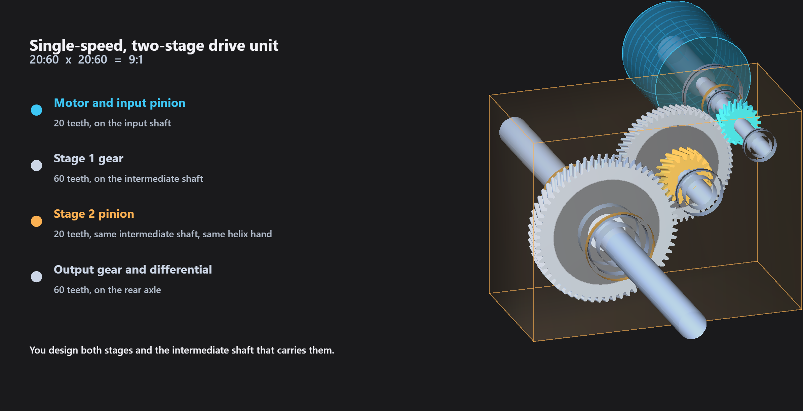
The rear drive unit. The motor drives the input pinion; stage 1 turns the intermediate shaft; the stage-2 pinion on that shaft drives the output gear, which carries the differential. You design both gear stages and the intermediate shaft that carries them.
Why two stages. Reaching 9:1 in a single mesh would need a driven gear larger than the road wheel. Splitting it into two meshes of about 3:1 keeps every gear small enough to fit beneath the car, and it is how production EV drive units are built. It also puts one shaft in the middle that is loaded by both meshes at once, and that shaft is the one you design.

The three load cases
A gearbox does not see one load. It sees a large torque a few times and a much smaller one several million times, and those two situations destroy a component by different mechanisms.
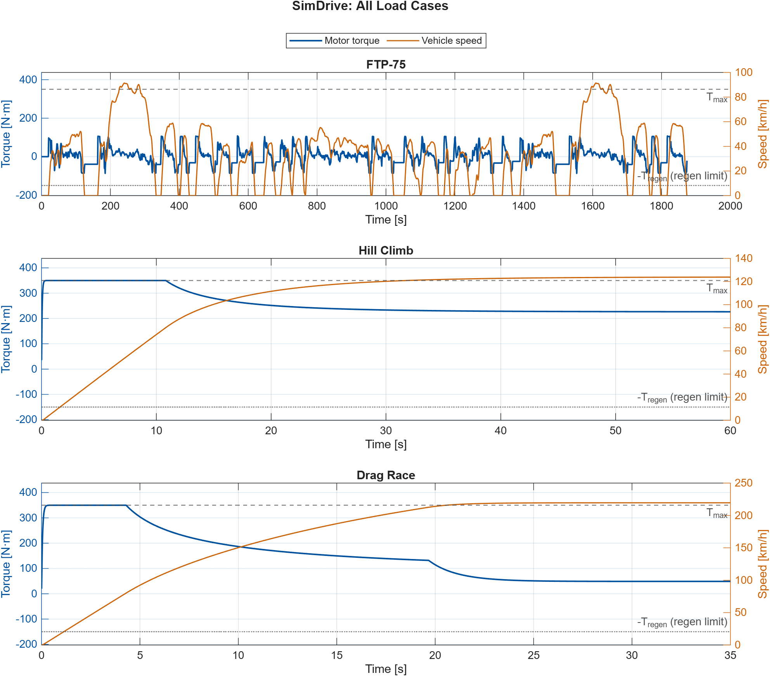
Overview of the three load cases: simulated motor torque and vehicle speed. For fatigue design use T_mean_eq and T_alt_eq from FTP75_Outputs.mat, not the raw FTP-75 trace shown here. The data files are in exports_design_ready.

FTP-75 city cycle
An 1874-second certification cycle of city driving: about two dozen stops and restarts and hundreds of smaller speed changes. No single load here is dangerous. Added together over the life of the car they are what can break a shaft by fatigue, at a stress well below the yield strength. Whether they do on this car, or whether the single full-throttle peak governs instead, is for you to show. This cycle also gives the bearings their design load: T_cubic_mean, the constant torque that Shigley Eq. (11-17) makes equivalent to this varying duty, from which you compute the L10 life.

Sustained hill climb
Full throttle on a steep grade (20 degrees by default) until the car settles at the fastest speed it can hold, with the motor on its power limit. That steady state has a closed form, so this is the case you use to check the simulation by hand before you trust any torque from it. As an extension, it also asks how long your shaft would survive a sustained full-power climb.

Full-throttle acceleration
Full motor torque from rest. This produces the largest torque the transmission will ever see. A gear tooth either survives the worst single load or it fractures, so this is the case for tooth stress and for the static yield check on the shafts.

What you design
Three components, in this order, each one constraining the next.
- Both helical gear stages. Face width, material and hardness, and every AGMA rating factor, checked against both bending and pitting for all four gears.
- The intermediate shaft. Stepped, with bearing journals and one seat carrying both gears, checked for fatigue and static yield at every critical section. Two meshes load it at once; work out how their forces and thrust couples combine before you calculate.
- Its two bearings, selected from a real manufacturer's catalog against rating life, with the thrust factors taken from Shigley Table 11-1 rather than copied off a catalog page.
The input shaft and its bearings are an optional extension.
These are not three separate problems. The bearing's nominal bore must match its journal. The journal sets the shoulder geometry. The shoulder sets the stress concentration that decides the shaft diameter. Choosing a bigger bearing to feel safe makes your shaft heavier. You will go around that loop more than once, and the report asks you to say which constraint ran out first.
The gear-seat shoulders are not automatically bearing abutments. Check the catalog abutment diameter and corner radius of each bearing against its shoulder, and describe the locating spacer or shoulder separately. Fits and axial retention are outside this project; state in your report what would have to be detailed before manufacture.

What you hand in
- The four completed MATLAB templates.
- A design report, following the supplied template.
- Result tables for the gears, shafts and bearings, with units.
- A scaled drawing of the intermediate shaft, showing diameters, lengths and fillet radii.
- At least one documented design iteration: what you changed, why, and what moved.
- The catalog page you took your bearing data from.

How it is graded
Load cases and torque handoff (15) | The right torque for each failure mode, and the hill-climb hand check of the simulation
Gear design (25) | Both stages rated in bending and contact, every factor with its Shigley source, the governing mode compared on a like basis
Shaft design (25) | Reactions in two planes with both thrust couples, DE-Goodman and yield at every critical section
Bearing selection (15) | Equivalent load, Table 11-1 factors, L10 life, a rejected candidate, the catalog cited
Integration and iteration (15) | Compatible bores and seats, every target met, a practical mass, changes justified
Engineering communication (5) | Units, figures, references, limitations stated, MATLAB work another student can rerun

Getting started
Put the supplied folder somewhere sensible and open MATLAB R2025a or newer. Read README.md in that folder for a file-by-file description, then work through the templates in order, filling the cells marked TODO. Each template tells you the method, gives the governing equations, and names the Shigley chapter it comes from.
Alongside the four templates your folder holds three supporting documents (ASSIGNMENT_BRIEF.md, DATA_DICTIONARY.md and DESIGN_REPORT_TEMPLATE.md), the two license files, and computeShoulderNotchFactors.m, which returns the shoulder stress concentration factors so you do not have to read five charts by hand for every candidate geometry. Read one shoulder off the charts yourself and check the function against it before you trust it for the rest.
The simulation results are in exports_design_ready, which sits beside the templates in the same folder. Keep it there and the relative paths in the templates will resolve. Design_Summary.mat holds the vehicle and gear data. Each of the three case files holds the design values for that case in ds_single, one torque-against-time curve you can plot, and a note saying what that curve is. For the city cycle that curve is the equivalent sinusoid your Goodman calculation uses, not the raw tracked torque; README.md explains why and what to watch for.

What a good submission looks like
The templates contain no starter values. Every value in your design is one you chose and have to defend. If it passes every check on the first attempt, you have probably not yet found the check that governs it.
A strong report states which section, which check and which parameter decided the design, and what you would change first if the car had more torque.

