**Assignment 1**

**Cloud Computing**

**Name: Ishraq Ahmed Esha**

**ID: 19301261**

**Course: CSE484**

**Sec: 01**

**Date: October 9, 2022**

**Answer to the Question No 1**

Delivering hosted services through the internet is referred to as "cloud computing" in general. There are three primary forms of cloud computing for these services. Various applications in the fields of art, business, data storage, backup, education, entertainment, management, social networking, etc., are offered by cloud service providers. There are various types of cloud computing applications these are:

1. **Github**

Github provides cloud storage to its user. User can save their works on the github platform and can work remotely by accessing the content from anywhere.

1. **Discord**

In terms of business application, it offers a user-friendly interface that enables us to establish public and private communication channels on the cloud they operate their operations from the cloud platform.

1. **LinkedIn**

In terms of social applications like Facebook, Twitter, etc., LinkedIn is a platform for professional work. It also works on the cloud computing platform.

1. **Netflix**

Regarding entertainment applications, streaming platforms like Netflix also host movies and series on the cloud platform. They hosted their service on the cloud through the internet, and users also get access from cloud computing platforms.

These are some different kinds of cloud computing applications.

**Answer to the Question No 2**

I have installed Ubuntu 20.04.1 LTS in Oracle VirtualBox. My username is ishraq, and pc name is ahmedesha-19301261

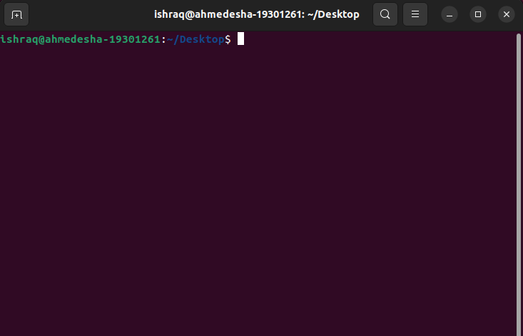

Some basic commands for Ubuntu.

1. **sudo**

Sudo (SuperUser Do) is similar to Launch as an administrator in Windows Linux commands lets you run applications or other commands with administrative tights. When you need to alter files in a directory that your user wouldn’t typically have access to, for instance, this is helpful.

**i) sudo apt-get update**

The first program you must perform in each Linux system after a new install is apt-get update with super user privileges. This command updates the database and notifies your system whether or not updated packages are available.

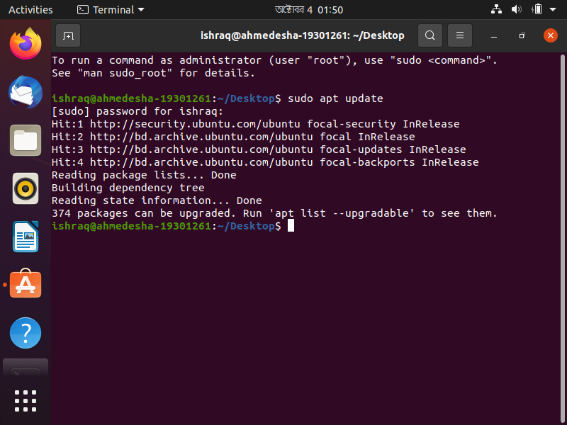

1. **sudo apt-get install**

To install any specific package, we can use this command. The command will then use as sudo apt-get install <package-name>

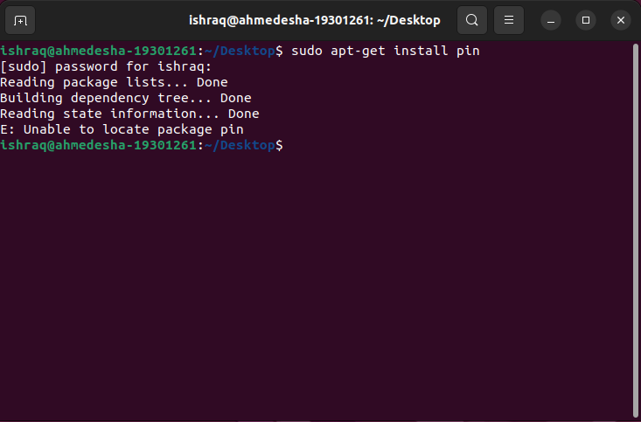

1. **dpkg - -list**

To show the list of packages installed on the system.

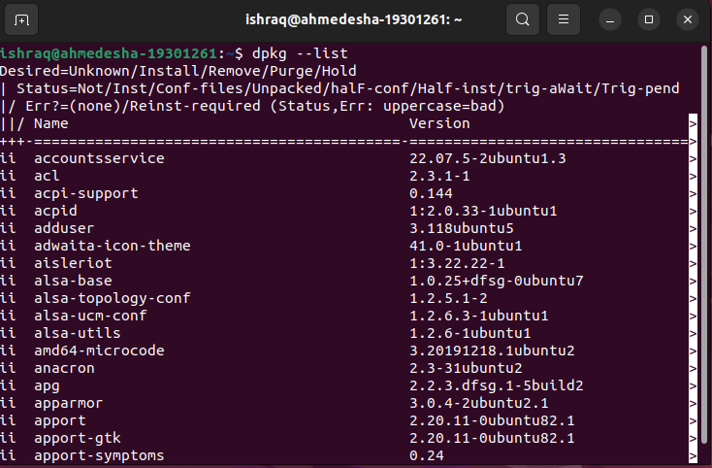

1. **cd**

cd refers to the change directory. As such, it is one of the most fundamental Ubuntu commands. Just type cd followed by the folder's name to use this command. Both relative and absolute paths to folders are supported, as is the usage of a folder’s name inside the current working directory. Such as cd / → refers to going to the root directory. Cd <folder name> → to go to the specific folder.

1. **ls**

The ls (list) command displays a directory tree with all the files and directories currently in use. If you wish to see the contents of a different directory, you may give its path.

1. **mkdir <folder name>**

To make a new folder, we can use mkdir command. With cd command, we have to go first to the desired directory, and then we can create a new folder by typing mkdir <folder name>

1. **pwd**

pwd refers to → print working directory. The current working directory’s whole pathname is shown by this Ubuntu command.

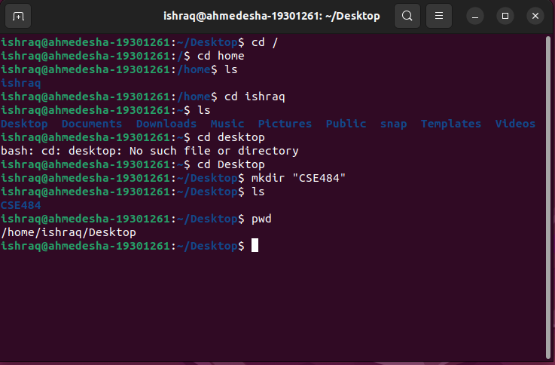

1. **history**

This command brings up a list of your past commands up to the limit of history.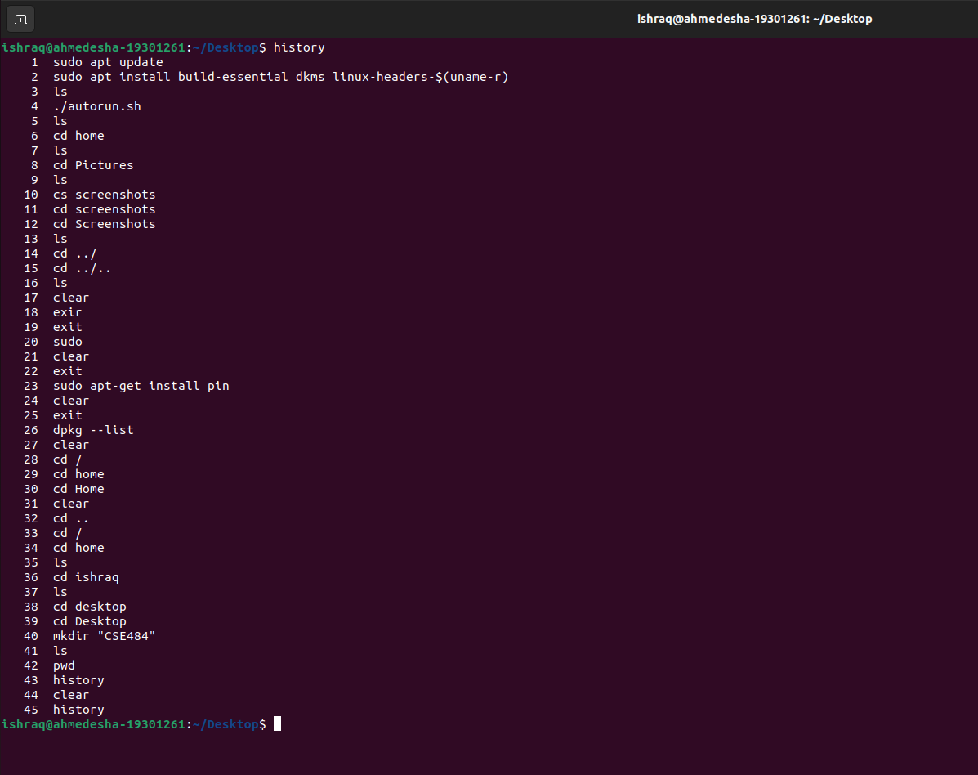

1. **cat > <filename>**

This command creates an empty file and can edit the file from the terminal. After adding the contents to the file, press crtl+d to save the content to the file. Such as cat > README.txt. After creating this empty file, I wrote Welcome to CSE484 Cloud Computing and pressed crtl+d to save this sentence to the file.

1. **touch <filename>**

This command creates an empty file like the previous command. It can’t edit the contents of the file from the terminal. To create an empty text file, we can just use touch cloud.txt this command.

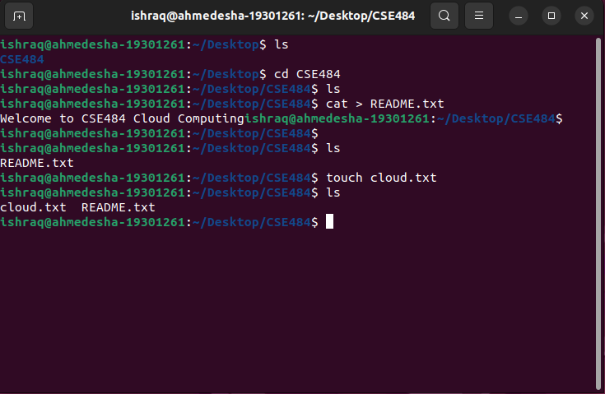

1. **rm**

This command is used to remove the file or directory. rm README.txt after typing this command, the README.txt file will be deleted. rm -r, this command removes the directory with its content.

1. **more <filename>**

There are lots of commands to display the contents of a file. We can use more README.txt this command. After typing this command, we can see the file's content in our terminal.

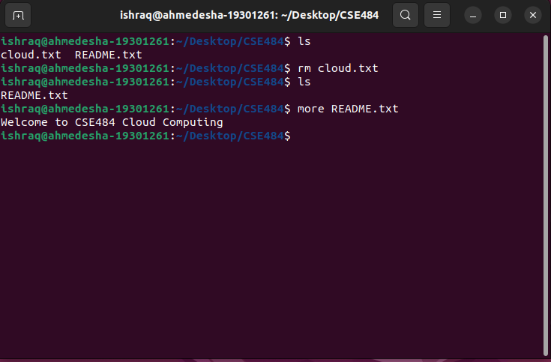

1. **df**

This command shows the information on disk space usage by all mounted filesystems.

1. **free**

This command shows the amount of unused storage space currently available on the system.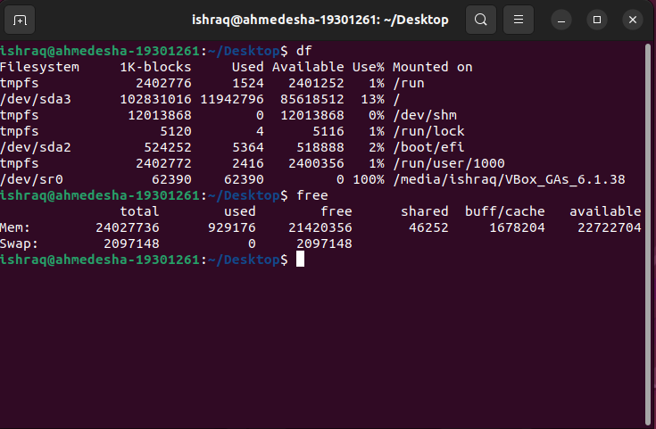

1. **rmdir**

This command removes the empty directory.

1. **ls -all**

This command is used to print the detailed information of the files/directories.

1. **cp**

This command is used to copy any file or directory to any directory.

cp <copy file name> <Folder name to copy> The command will be like

cp README.txt Folder.

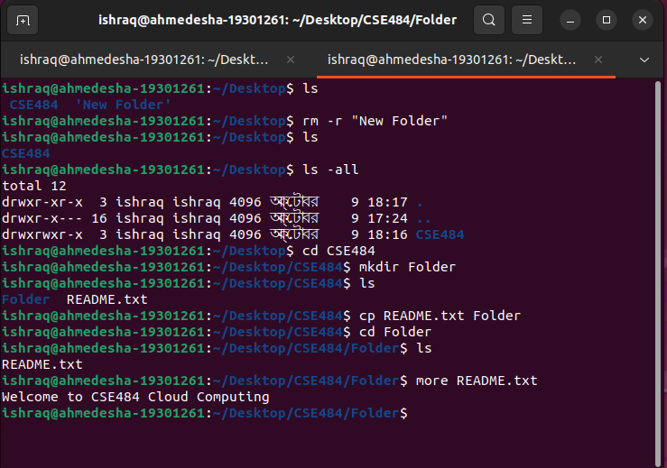

1. **mv**

This command moves any file or directory to another location. mv <file to move> <location name> Such as mv cloud.txt Folder.

1. **uname -a**

This command is used to show detailed information about the operation system (os), such as release number, version of Linux, and much more.

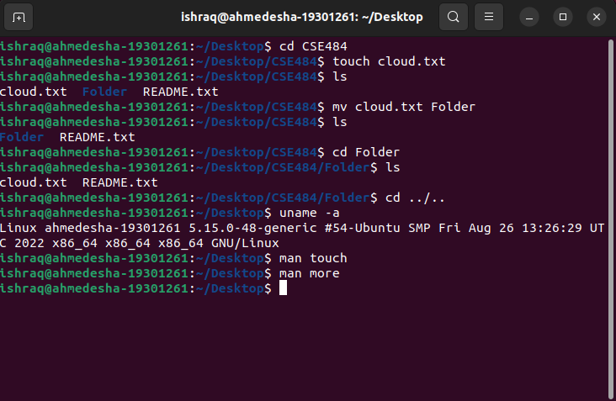

1. **Man**

The man command can assist you in obtaining the comprehensive instruction manual for any particular command. The command format is man <commmand name>. Such as man touch.

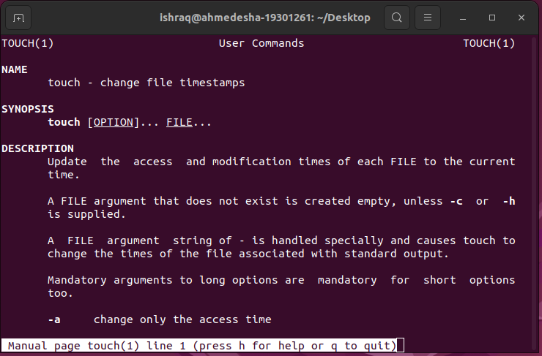

1. **gzip**

This command is used to zip any file or directory. gzip <file name>. Such as gzip README.txt

1. **gunzip**

This command is used to unzip any file or directory. gunzip <file name>. Such as gunzip README.txt

1. **hostname**

This command will print the hostname in the terminal. For me, it is ahmedesha-19301261

1. **w**

This command will display the user details currently logged into the system.

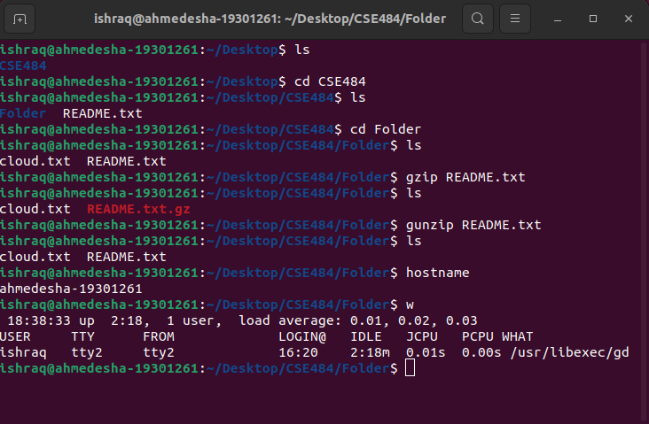

These are some basic commands for Ubuntu.