**Everything is Virtual?**

**by**

**Ishraq Ahmed Esha**

**19301261**

**A Lab Assignment 2 submitted to the CSE484 Cloud Computing**

**Course of Sec: 1**

**Brac University**

**October 30, 2022**

**Answer to the Question No 1**

First of all, I checked whether my “virtualization” option is enabled or not from BIOS settings. After enabling the virtualization as I run my Ubuntu 22.04 os through the virtual box, I also enabled the virtualization option. Then, by updating and upgrading the Ubuntu packages, I proceeded further. I used the “***sudo apt update***” and “***sudo apt upgrade***” commands to update and upgrade the packages, respectively. I checked the KVM compatibility in my system to do this; I used “***egrep -c ‘(vmx|svm)’ /proc/cpuinfo***” this command. If the output shows a value greater than 0, our system is compatible with KVM.

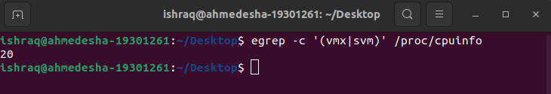

After that, I used the command “***kvm-ok***” to verify whether KVM virtualization was enabled. As it wasn’t enabled, I installed the cpu checker package using “***sudo apt install cpu-checker***”.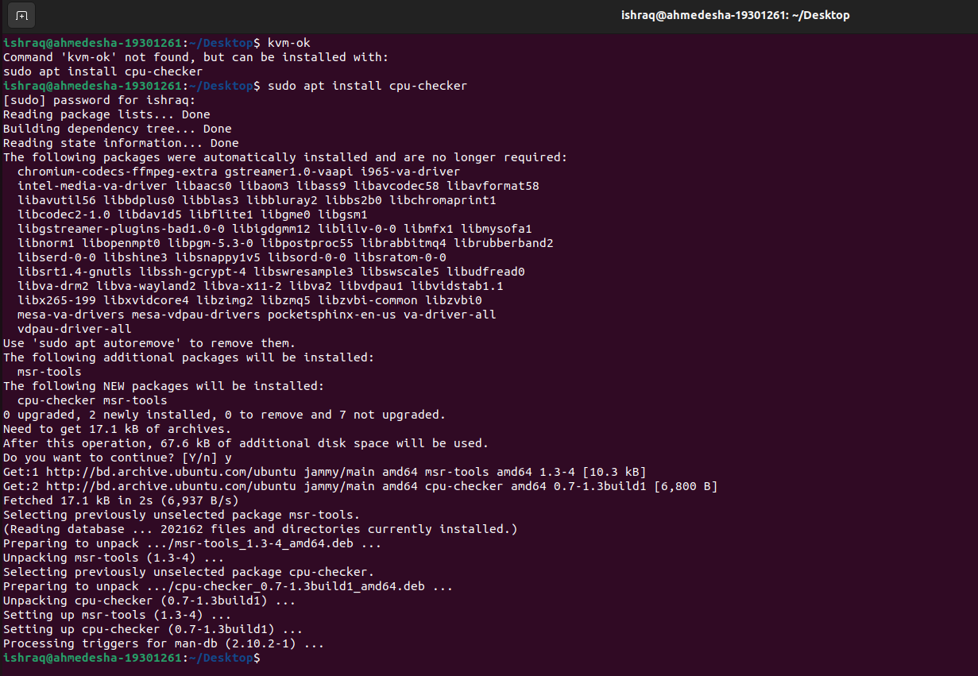

Now we get KVM acceleration can be used as output after running “***kvm-ok***” command.

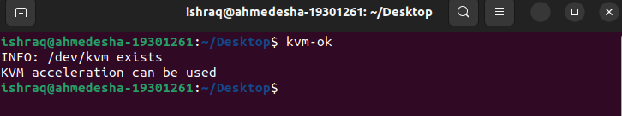

It’s time to install KVM, virt manager, and bridge utilities to this; I ran “***sudo apt install qemu-kvm virt-manager libvirt-daemon-system virtinst libvirt-clients bridge-utils***” this command.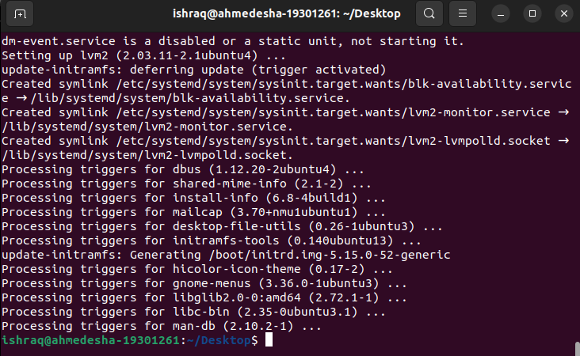

Now, we have to start and verify libvirtd to this; I used the following commands to start libvirtd “***sudo systemctl enable --now libvirtd***” and “***sudo systemctl start libvirtd***”. This command is to verify the libvirtd “***sudo systemctl libvirtd***”. 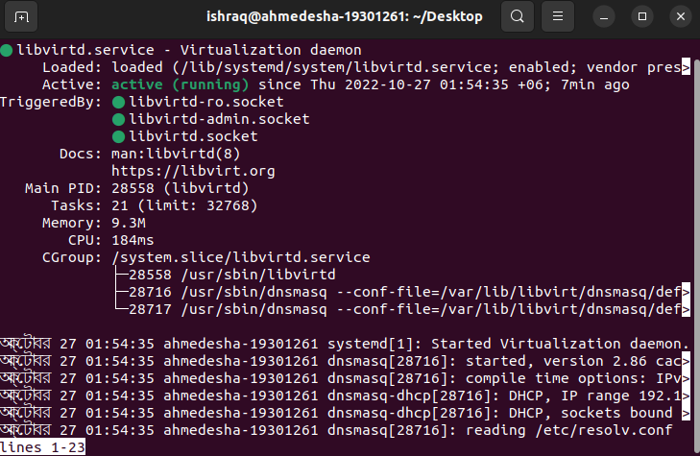

To add the user to the KVM and libvirt group, I used the following commands respectively, “***sudo usermod -aG kvm $USER***” and “***sudo usermod -aG libvirt $USER***”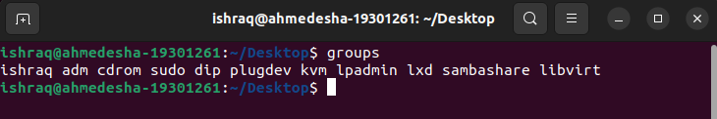

So we have successfully installed KVM on our machine.

**Answer to the Question No 2**

I have successfully installed KVM and virt manager to Ubuntu 22.04. Now using the virtual machine manager’s (vmm) GUI, installed an os of Ubuntu 22.04 on the system.

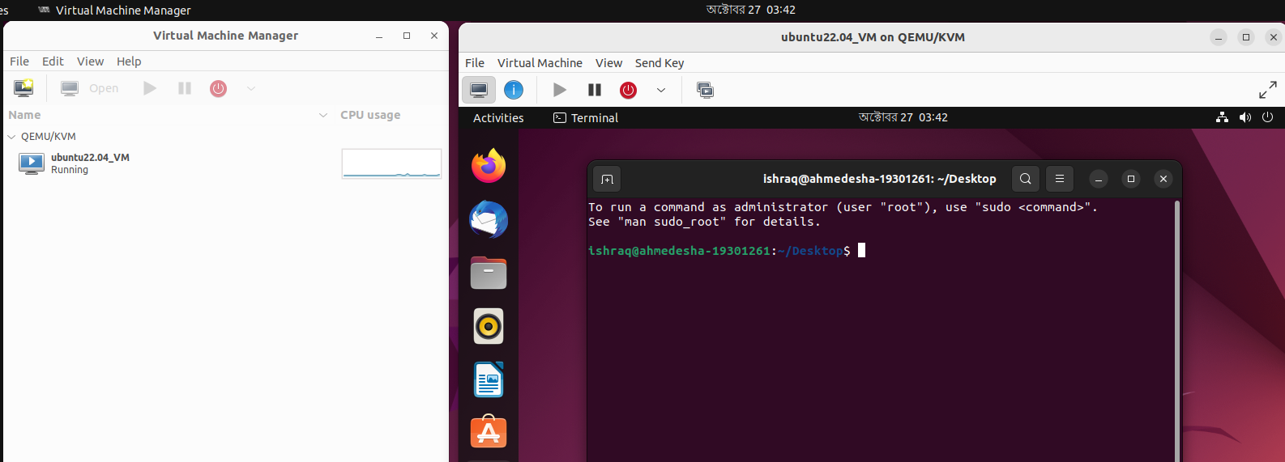

**Answer to the Question No 3**

Creating a KVM based VM using “***virt-install***” cli. To do this, I used the following command

“***sudo virt-install --name=debian-vm \***

***--os-type=Linux \***

***--os-variant=debian9 \***

***--vcpu=2 \***

***--ram=2048 \***

***--disk path=/var/lib/libvirt/images/Debian.img,size=15 \***

***--graphics spice \***

***--location=/home/james/Downloads/debian-11.1.0-amd64-DVD-1.iso \***

***--network bridge:virbr0***”

* **--name:** This attribute denotes the name of the virtual machine.
* **--os-type:** This attribute specifies the type of the operating system.
* **--os-variant:** This attribute specifies the operating system releases.
* **-vcpu:** This parameter specifies the number of CPU cores to be allocated to the virtual machine.
* **ram:** This parameter specifies the amount of RAM in Megabytes to be allocated.
* **-disk path:** This attribute defines the path of the virtual machine image.
* **-graphics:** This option specifies the graphical tool for the interactive installation.
* **-location:** This parameter specifies points to the location of the ISO image.
* **-network bridge:** This directive specifies the interface to be used the virtual machine.

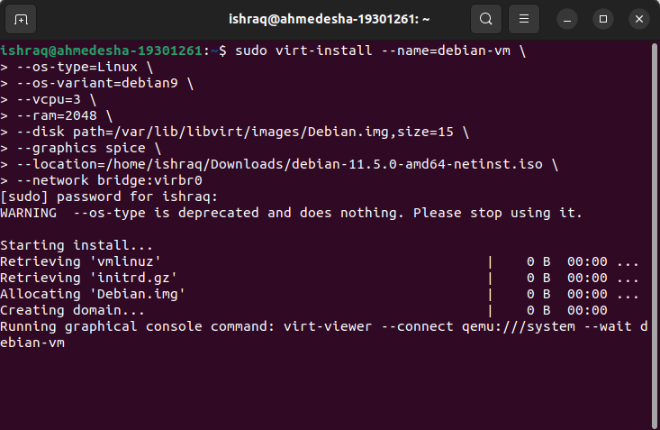

So, now in my host operating system, I have two other nested operating systems: Ubuntu 20.04, and Debian 11.5 have been installed successfully.

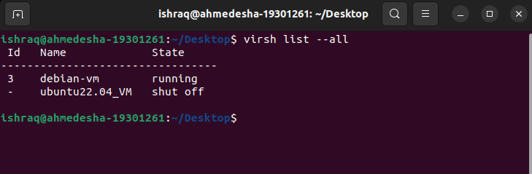

**Answer to the Question No 5**

I have made a shared folder between my host operating system windows and guest operating system ubuntu. After installing Guest Additions have to run “***sudo ./VBoxLinuxAdditions.run***” this command as a root user. Then, create a folder in the host operating system named Ubuntushare and add this file path to the shared folder option. After, that in guest operating system have to create a folder with following command “***sudo mkdir ~/Desktop/Windowsshare***”. Now we have to mount this folder with mountpoint to do this run following command “***sudo mount -t vboxsf Ubuntushare ~/Desktop/Windowsshare***”. In addition, we have to change the permission of Windowsshare folder in guest operating system, to do this run the following command “***sudo chmod a+rwx /home/ishraq/Desktop/Windowshare***”. Now we can share any files through these two folders among the host to the guest operating system and vice versa. This procedure is completed to make a shared folder between host and guest operating system.

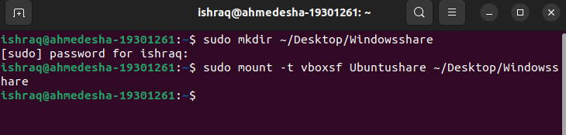

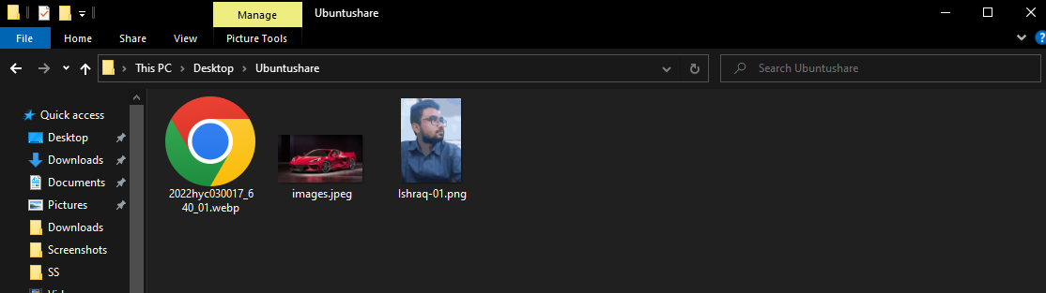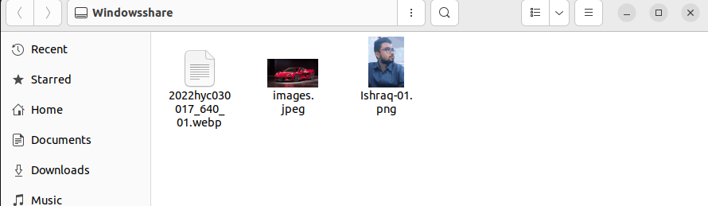

**Answer to the Question No 6**

There are several methods to connect a phone to a guest operating system (in this case Ubuntu). Mounting MTP is one of them. By using GNOME Virtual File System (GVFS) we can access the phone file system, but the major drawback of this method is it’s required a wired connection to perform this method we have to connect our phone with the pc with help of a usb connection. On the other hand, to perform this task wirelessly we can use KDE Connect, which facilitates wireless communications and data transfer between devices over local networks through guest operating system and phone.

**Answer to the Question No 7**

We can clone a vm using virtual machine manager (vmm) using it’s graphical user interface (GUI). To do this, simply just right click on the vm from virtual machine manager gui and select clone then have to select a name of the clone vm and we are done.

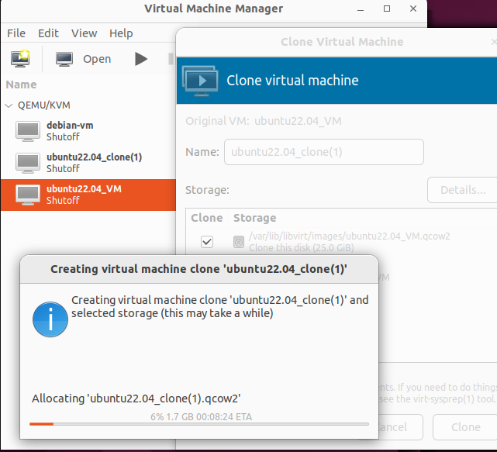

To clone a vm using kvm based command, we have to run the following command “***virt-clone --original ubuntu22.04_VM --name ubuntu22.04_clone -f /var/lib/libvirt/images/ubuntu22.04_clone.qcow2***” here after the keyword “*original”* we have to give the main server name then after the keyword of “*--name*” we have to provide the new name of the clone vm then “*-f*” this denotes the file path of the new vm which we provided the default path of kvm. After successfully running this command if we run “***virsh list --all***” we will see all the installed vm in our host machine. By following these steps we can clone a vm using kvm based command.

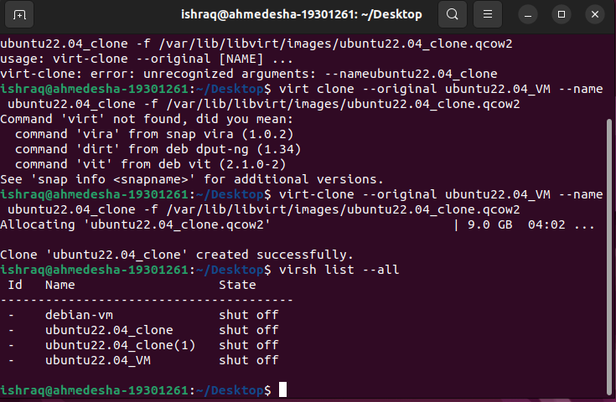

**Answer to the Question No 8**

We can add two hard disks to the new cloned vm using virtual machine manager gui easily. To do this, first of all have to double click the new cloned vm and then select the virtual hardware details option here we can see all the specifications of the vm. If we select the add hardware option from bottom then from storage option we can add hard disk with our desire storage size. To add another hard disk we have to follow the same procedure again. If we observe following two figures then we can notice that before add hard disk in our clone vm we have only one hard disk and after adding two extra hard disk we get three hard disk as our storage.

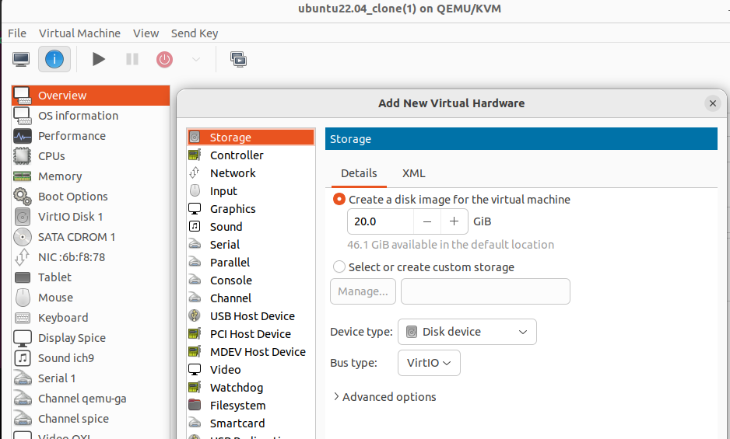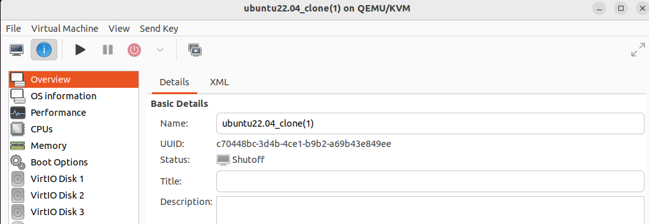

**Answer to the Question No 9**

To add hard disks to the new cloned virtual machine we have to use some kvm based command. First of all, we have to create a new disk image. For that we have to go to the kvm default directory by using this command “***cd /var/lib/libvirt/images/***”. Then to create a new disk image of qcow2 format have to write the following command “***sudo qemu-img create -f qcow2 disk3-6G 6G***”. Here we are creating a 6GB storage size with the name of disk3. Now, we have to attach the disk to the virtual machine for this run the following command “***sudo virsh attach-disk ubuntu20.04_clone /var/lib/libvirt/images/disk3-6G vdc --cache none***”. Here our virtual clone machine name is ubuntu20.04_clone and we added the path that we created and define the dev type as vdc, because we have two another disk which are vda and vdb. After running these command we can add hard disk to our new clone virtual machine. To add two hard disks just have to follow the procedure two times that’s it hard disk added.

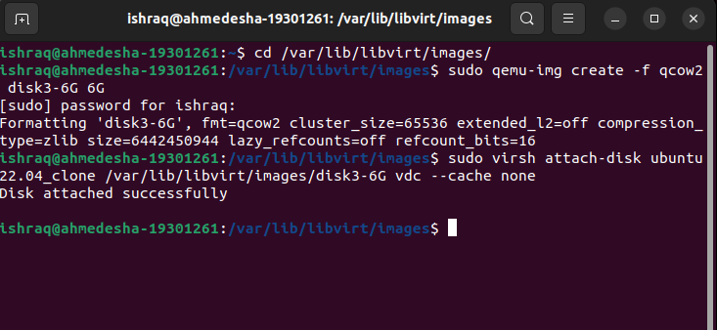

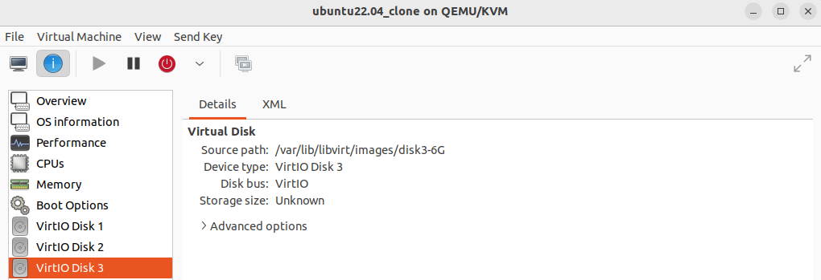

**Answer to the Question No 10**

Now it’s time to migrate a vm which I have installed via virt manager to another host. First of all, I need to copy the vm image into another directory. I will be needed this image file in another host to install the migrated vm. Have to make a directory in my vm with the following command “***mkdir ~/Desktop/Migrate_VM***”. Then have to copy the ubuntu22.04_VM qcow2 file from default kvm libvirt image directory with the following command “***suno cp /var/lib/libvirt/images/ubuntu22.04_VM.qcow2 .***”. Now need to change the permission of that directory for run the following command “***sudo -R chmod a+rwx***”.

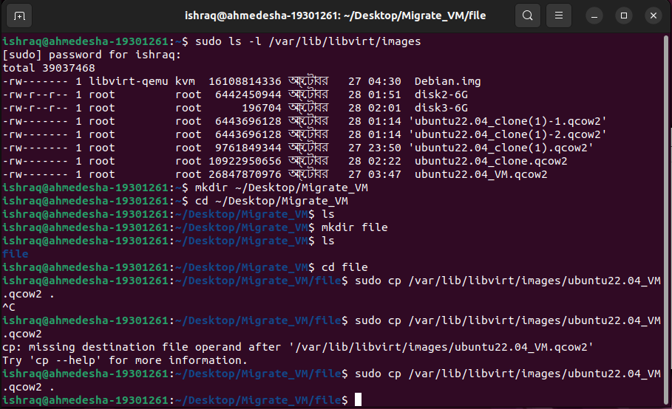

After completing these steps now have to save the qcow2 file into another host. Then we can use virt manger or virtual box to install the migrated vm. To do this we have to select the new vm from the gui then have to import the existing disk image from the local directory, this is the ubuntu22.04_VM.qcow2 file which we have copied form our main system then have to provide the memory size and cpu number and select finish. That’s it we are done we don’t need to do any other configuration as because we just migrated our main vm to another host, all the configurations will be same as our main vm. Now if we start the vm from host machine then we can operate the migrated vm.

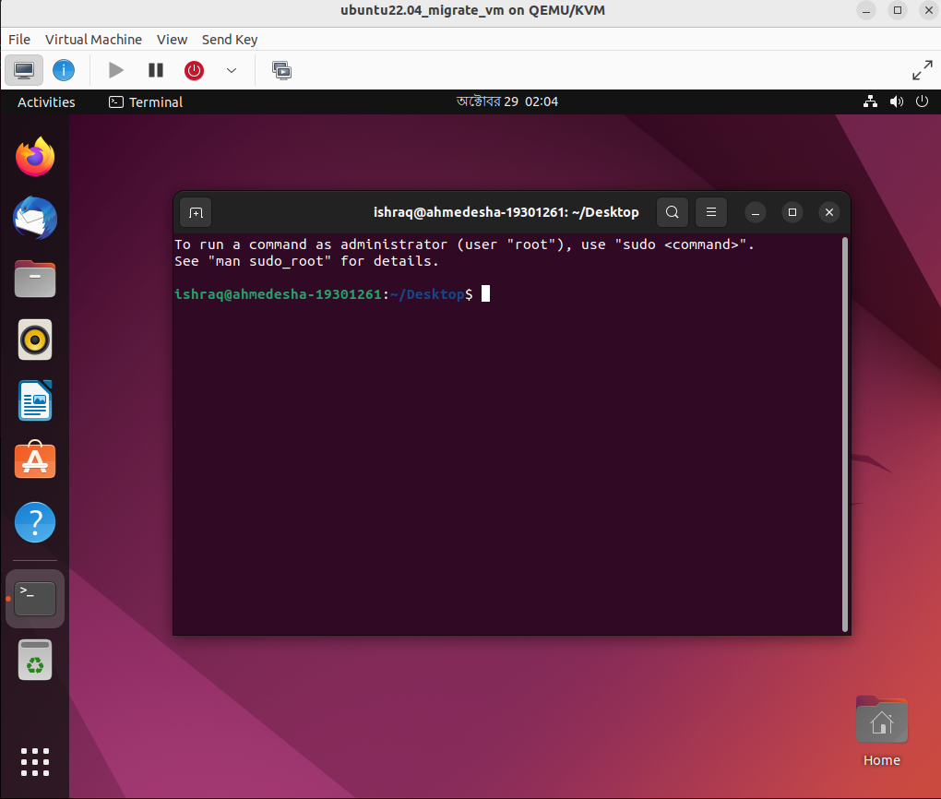

The same process can be done if we want vice versa. That’s it we have successfully migrate a vm to another host.