**Final Year Project Report**

PORTABLE SPRAY PAINTING UNIT

FOR AUTOMOBILE PARTS

**Names: Roll numbers: Supervisor:**

Ahmed Jalil Qureshi D-15-ES-08 Dr. Rashid Baig

M. Awais D-15-ES-48 **Co-supervisor:**

Jawad Jillani D-15-ES-32 Sir Mustafa Mohiuddin

Masooma Ali D-15-ES-38

Sajjad Haider D-15-ES-114

**ABSTRACT:**

We commonly see that when we go to buy specific paint tone, the worker tries to match the color and sometimes fails in doing it. Mixers that perform this task are too costly which cannot be afforded by every paint shop.

This project is about automatic toner, a system is created which will automatically detect tone, and then make the desired color. An interface to select specific tone is provided. Arduino is used as microcontroller, pumps to control the flow of paint, color sensor to detect colors. The three basic colors red, green and blue are used to achieve the desired color and a white color paint for their alpha. The paint is sprayed upon the object using an electric sprayer.

The system is economical and beneficial to the shops. This system can be bought by a shop or a mini industry/factory or by single individual. It is an easy-to-use product with portability and is less expensive than the other mixers.

The system can be installed and operated easily which makes this system applicable to even low cost as well as high cost industries.

**Contents**

**1. Overview of the project……………………………………………………………………….3**

**2. Motivation………………………………………….………………………………………….3**

**3. Application and features of the project.………………………………………….………….3**

**3.1. Features of the project………………………………………………………………3**

**3.2. Application of the project…………………………………………………………...3**

**4. Literature review………………………………………….………………………………......4**

**5. Description of project (Problem statement and objectives) .……………………………….4**

**6. Methodology for project implementation………………………………………….………...4**

**7. Hardware and Software requirements for project………………………………………….5**

**7.1. Hardware…………………………………………………………………………….5**

**7.2. Software……………………………………………………………………………...5**

**8. Block diagram representation of the project.………………………………………….…….6**

**9. Budget of the project………………………………………….………………………………7**

**10. Time Analysis (Gantt Chart) ……………………………………….……………………....8**

**11. References……………………………………..………………………………………….….8**

**Introduction:**

This project will implement a system through which we can monitor and control the mixing process of two pigments to get the desired color. Paint pigments will be mixed with solvent in proportionate quantity to get the desired paint. [1] After the mixing process, the testing of color will be done. For which, we will use a sprayer and a blank sheet. The system will consist of several actuators and sensors for monitoring and controlling the various parameters of the process. It is of low cost which will make it suitable for low budget factories (home cottages). It is targeted towards the painting of automobile parts.

The project idea is to implement something different in the industry, as it is our main interest to work on. Due to the rise of automation, we are considering implementing it in an industrial process. An industrial plant being supervised will be done in the project. The mixing process and testing will be done automatically. The idea can be implemented on any industrial plant with modifications.

**Literature review:**

In line of color mixing technology, few works have been done related to the inkjet printer technology. The work related to an inkjet printer, an ink billing system and to control method for an inkjet printer has been approached by researchers (Koike et al [2007]). Research related to the formulation of color ink composition for use in ink jet printing applications was published by Causley and Petersen [1989]. Researches on color sensor for recognizing the hue of articles by sensing rays of light passed through or reflected from the articles was done by Kanazawa et al [1987]. Works related to the types of color sensors i.e. contact types and non-contact types were done by DiCarlo et al [2010].

Conventional color mixers have a wide range of industrial applications and is used where there is a requirement of variety of colors with diversified applications. However, with the advancement in technology, more and more industries are leaning towards the use of these machines such as dyeing industries, painting industries etc. Conventional color mixing and determination process is a gruesome one and time taking. It requires a lot of effort and consumes a great amount of time. Currently there are large mixers which are used in industries and can only be used in an industrial level. Our aim here is to design and develop such a system which can be used on the individual user level. It must be a portable one and easy to be operated on. Similarly, the function should be simplified and should be made more user specific. The handling and operation must be such that a layman would find no difficulty in using it.

**Methodology for project implementation:**

The mixing of pigments and testing of the color is done automatically. A controller is used for automation of sensors, actuators and motors. The project contains simple containers for the unmixed pigments and a separate container where the mixing is done. A color sensor is used for the detection of color and then the system generates the required color. The testing of the final color is done on a blank sheet using an electric sprayer.

Pumps will be used to control the flow of paint. Blenders in container will run constantly to avoid the clotting and drying of paints. After mixing of paint, an automated air sprayer will be used to test the required color. Status of the process will be checked on display panel.

**Hardware and Software:**

* Paints
* Arduino Mega
* large containers
* Mixing dc long shaft motor
* Actuators
* Pumps
* 20*4 LED with I2C
* Press buttons
* Electric sprayer kit
* Color sensor
* Mixing container with motor and actuator
* Wooden framework
* Gel battery 12V
* Relays
* ARDUINO IDE (Software)

**Block diagram representation of the project:**

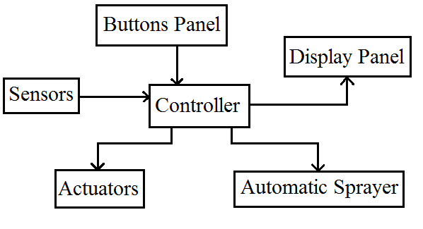

Figure 1: Block Diagram

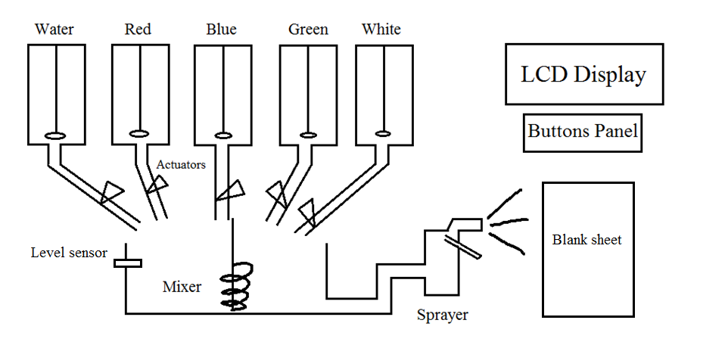

Figure 2: Plant Diagram

**Completed and incomplete tasks:**

* The project frame has been made.
* Containers and pipes have been
* Individually interfaced LCD using i2c.
* Created interfacing and controlling panel.
* Interfaced color sensor on LCD

While further work will be done in next phase, which includes:

* Assembling of all parts.
* Complete coding for the microcontroller.
* Connecting pumps with container.
* Setting up sensors and actuators into frame.
* Installation of the automatic sprayer.

**Time Analysis (Gantt Chart):**

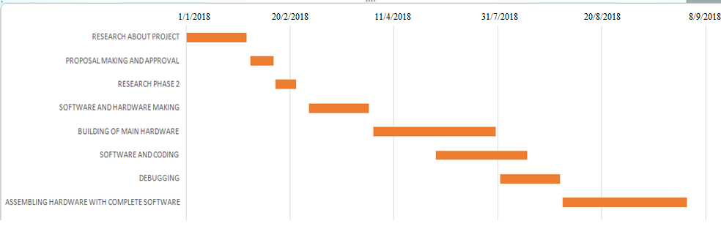

**References:**

[1] Thompson, Daniel V. The Materials and Techniques of Medieval Painting. Dover Publications, Inc., New York, 1956, ISBN 0-486-20327-1, p. 86.

[2] Darshini B. and E. Esakki Vigneswaran, *Industrial process monitoring and control using Raspberry Pi* ©2006-2016 Asian Research Publishing Network (ARPN). All rights reserved. VOL. 11, NO. 2, JANUARY 2016 ISSN 1819-6608