Description of Data Set:
This dataset is of predicting diabetes based on their age(continuous), gender(categorical), hypertension(categorical), heart disease(categorical), previous smoking history(categorical), BMI (continuous), HbA1c level(continuous), and blood glucose level(continuous). This is for binary classification to predict diabetes (0/1 or yes/no). It contains 59% female and 41% male. For this project we need to prepare the dataset and deal with missing value, outliers, and invalid data. Balancing datasets and splitting it into train test.
Dataset link: Diabetes prediction dataset
Use data set in RStudio :
- setwd("C:\\Users\\DELL\\OneDrive - American International University-Bangladesh\\Documents\\10th semester\\Mid\\Data Science")
- df <- read.csv("cleaned_dataset.csv", header = TRUE)
- df <- read.csv("cleaned_dataset.csv")
- View(df)

- If there are any missing values in the dataset, we should apply an applicable method from the available options to handle the missing values.
=> unique(df$gender)
unique(df$smoking_history)

=> df$gender[df$gender == "NA" | df$gender == ""] <- NA
df$smoking_history[df$smoking_history == "NA" | df$smoking_history == "No Info" | df$smoking_history == ""] <- NA
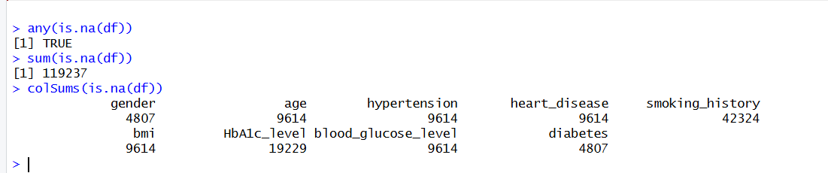
- any(is.na(df))
- sum(is.na(df))
- colSums(is.na(df))

- We can see missing values on a graph.
colors <- colorRampPalette(c("lightblue","darkblue"))(10)
par(mar = c(10, 4, 4, 2))
barplot(colSums(is.na(df)),
main = "Missing Values per Column",
xlab = "",
ylab = "Count",
col = colors,
las = 2, cex.names = 0.8)
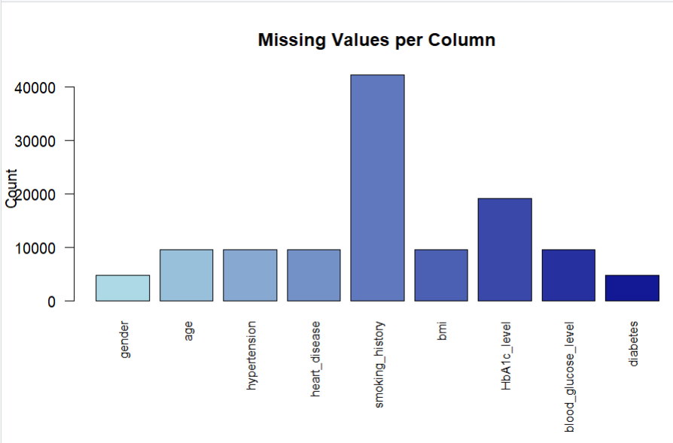
=> Handle missing values:
- Numeric Columns → Use Median
numeric_cols <- sapply(df, is.numeric)
for (col in names(df)[numeric_cols])
{
df[[col]][is.na(df[[col]])] <- median(df[[col]], na.rm = TRUE)
}

- Categorical Columns → Use Mode:
cat_cols <- sapply(df, is.factor) | sapply(df, is.character)
for (col in names(df)[cat_cols])
{
mode_value <- names(sort(table(df[[col]]), decreasing = TRUE))[1]
df[[col]][is.na(df[[col]])] <- mode_value
}

- Confirm to handle missing value:

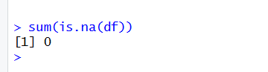

- Detect outliers in the data set and use the appropriate approach to handle those values.
- Numeric column findout :

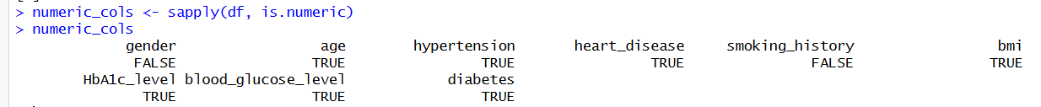

- Check outliers:
Q1 <- quantile(df$age, 0.25, na.rm = TRUE)
Q3 <- quantile(df$age, 0.75, na.rm = TRUE)
IQR <- Q3 - Q1
lower_bound <- Q1 - 1.5 * IQR
upper_bound <- Q3 + 1.5 * IQR
df[df$age < lower_bound | df$age > upper_bound, ]

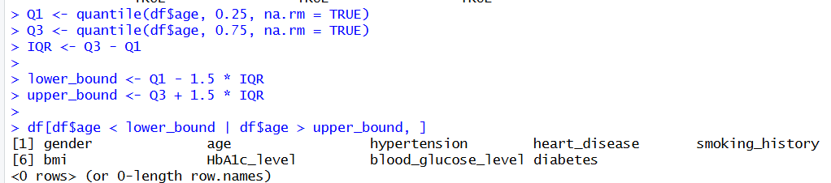

- Age Outliers using Boxplot:
boxplot(df$age, main = "Age Outliers Boxplot", col = "lightblue")

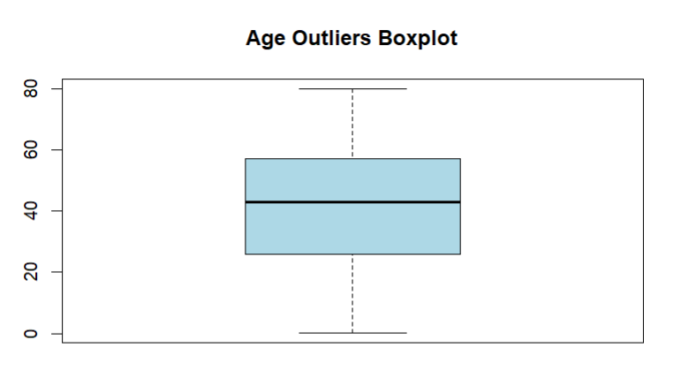

- All Outliers:
boxplot(df[, numeric_cols], main = "Outliers in Numeric Columns", col = "lightblue")
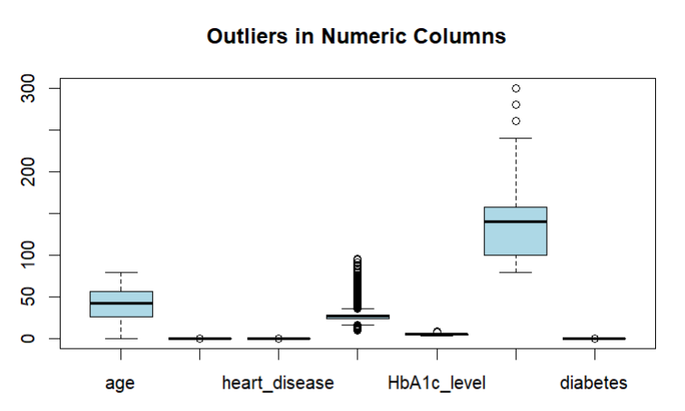
=> Remove Outliers:
df <- df[!(df$age < lower_bound | df$age > upper_bound), ]
=> Replace Outliers with Median:
median_age <- median(df$age, na.rm = TRUE)
df$age[df$age < lower_bound | df$age > upper_bound] <- median_age

- We can convert attributes from numeric to categorical or categorical to numeric.
- Age into categories like Child, Adult, Senio:
df$ageGroup <- cut(df$age,
breaks = c(0, 18, 60, 120),
labels = c("Child", "Adult", "Senior"),
right = FALSE)
- BMI into categories like Underweight, Normal, Overweight, Obese
df$BMI_Category <- cut(df$bmi,
breaks = c(0, 18.5, 25, 30, 100),
labels = c("Underweight", "Normal", "Overweight", "Obese"),
right = FALSE)

Convert Categorical to Numeric
=> df$Gender_numeric <- as.numeric(as.factor(df$Gender))

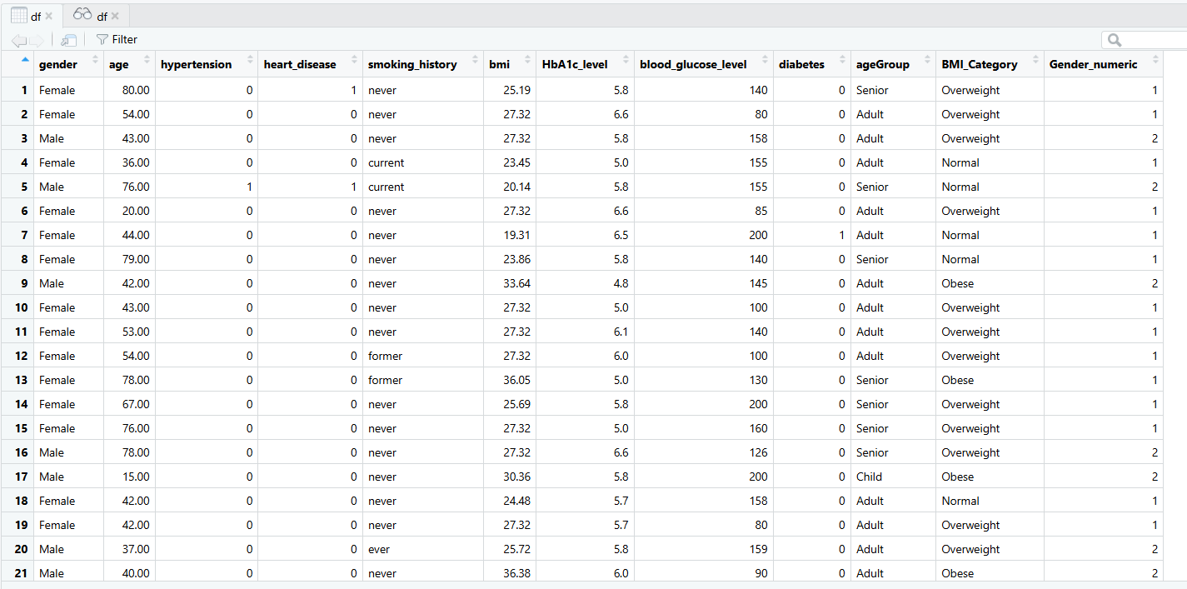

- We can apply the normalization method for any continuous attribute.
normalize <- function(x) {
return ((x - min(x)) / (max(x) - min(x)))
}
- We can find duplicate rows.
duplicated(df)
df[duplicated(df), ]

- Remove duplicate rows:
=> df <- df[!duplicated(df), ]
- Check duplicate rows:

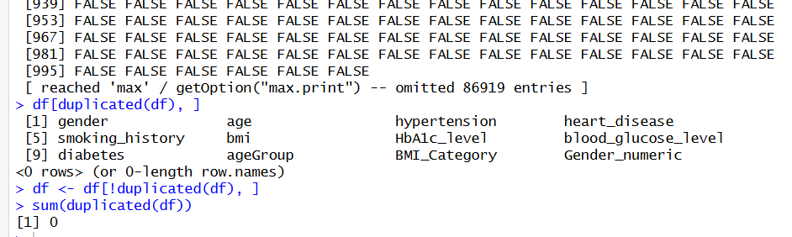
- We can apply some filtering methods to filter the data.
=> df_filtered <- df[df$gender == "Female" & df$bmi> 25, ]
8. Detect invalid data in the data set and use the appropriate approach to handle those values.
=> df[df$Age < 0 | df$Age > 120, ]
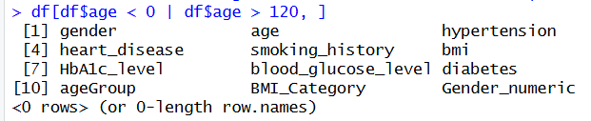
9.We can convert the imbalanced data set into the balanced data set.
- table(df$diabetes)
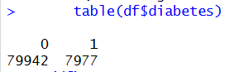
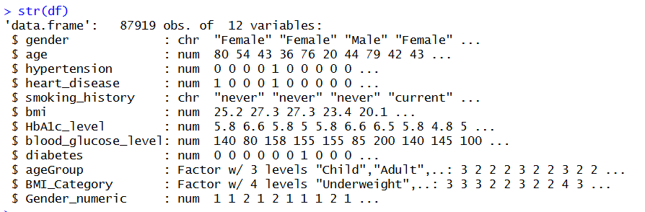
- Convert characters to factors
- df$gender <- as.factor(df$gender)
df$smoking_history <- as.factor(df$smoking_history)
df$diabetes <- as.factor(df$diabetes)
library(ROSE)
set.seed(123)
df_balanced <- ROSE(diabetes ~ ., data = df)$data
table(df_balanced$diabetes)

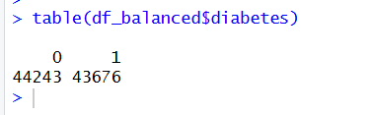

10.Split the dataset for Training(70%) and Testing(30%).
- set.seed(123)
split_index <- sample(1:nrow(df_balanced), 0.7 * nrow(df_balanced))
train_data <- df_balanced[split_index, ]
test_data <- df_balanced[-split_index, ]

- dim(train_data)
dim(test_data)

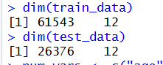

11.Since no specific dataset is provided, perform all necessary analyses using your chosen dataset. For example, you may:
- Calculate and interpret descriptive statistics of key numerical variables across two target classes.

- library(dplyr)
num_vars <- c("age", "bmi", "HbA1c_level", "blood_glucose_level")
descriptive_stats <- df_balanced %>%
group_by(diabetes) %>%
summarise(
count = n(),
mean_age = mean(age, na.rm = TRUE),
sd_age = sd(age, na.rm = TRUE),
mean_bmi = mean(bmi, na.rm = TRUE),
sd_bmi = sd(bmi, na.rm = TRUE),
mean_HbA1c = mean(HbA1c_level, na.rm = TRUE),
sd_HbA1c = sd(HbA1c_level, na.rm = TRUE),
mean_glucose = mean(blood_glucose_level, na.rm = TRUE),
sd_glucose = sd(blood_glucose_level, na.rm = TRUE)
)

- descriptive_stats
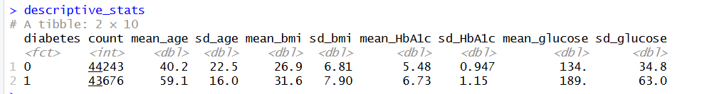

- Compare the average of one variable between two groups.
- tapply(df_balanced$bmi, df_balanced$diabetes, mean)
- t.test(bmi ~ diabetes, data = df_balanced)
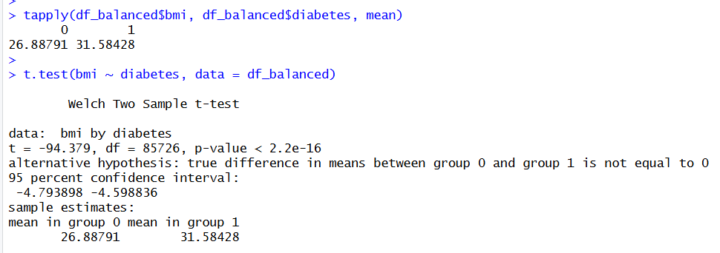
- Compare the variation or spread of a numerical variable across different categories of another variable. Use variables from your dataset that appropriately represent these types of analyses.

=> library(dplyr)
df_balanced %>%
group_by(gender) %>%
summarise(
count = n(),
mean_BMI = mean(bmi, na.rm = TRUE),
sd_BMI = sd(bmi, na.rm = TRUE),
var_BMI = var(bmi, na.rm = TRUE),
IQR_BMI = IQR(bmi, na.rm = TRUE)
)
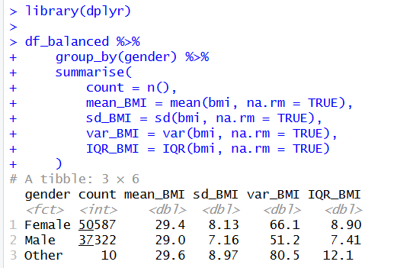

- par(mar = c(5, 4, 4, 2)) # bottom, left, top, right
boxplot(bmi ~ gender, data = df_balanced,
col = c("lightblue", "pink"),
main = "Variation of BMI Across Gender",
xlab = "Gender",
ylab = "BMI"
)
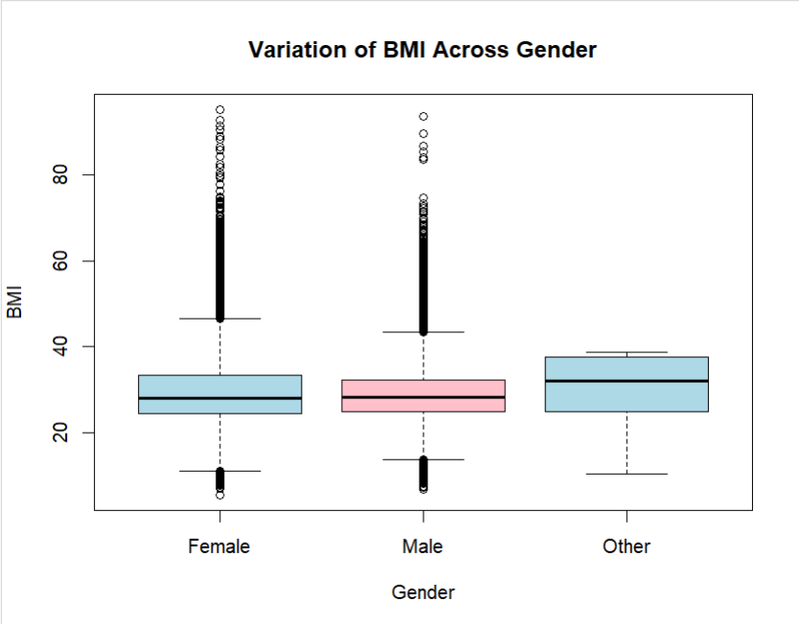
Clean data set:
