Project Assignment 17

GRASP Pattern

Name: Ahmed Kasteer

Roll Number: 20F-0336

Section: 5C

Creator Pattern:

Game Class created by Task Manager Class.

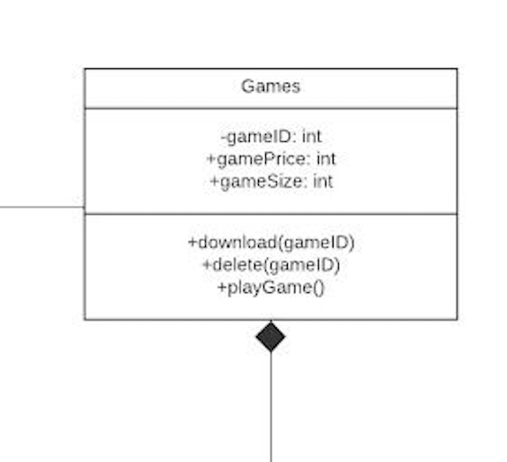

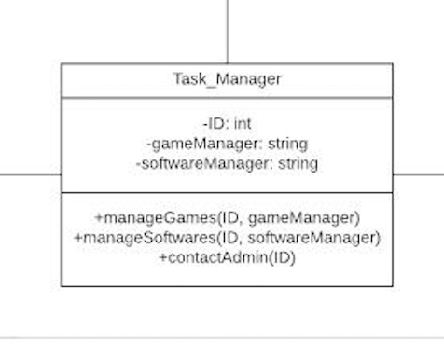

Information Expert Pattern:

Feedback Class Provided by Admin Class.

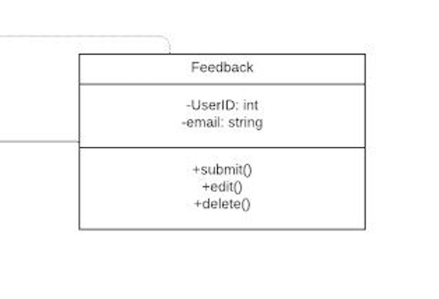

Polymorphism Pattern:

Admin and Tech Support:

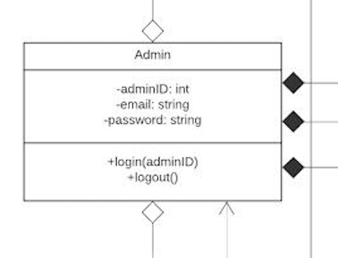

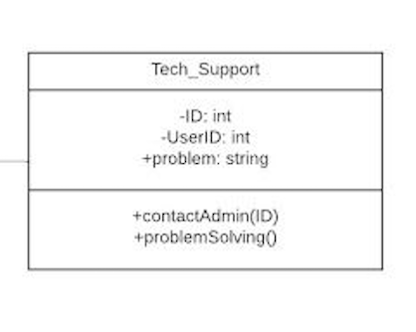

Polymorphism Pattern: Sequence Diagram

Information Expert on Sequence:

Creator Pattern on Sequence:

