**Project Assignment No. 10**

**Sequence Diagram**

**Software Design and Analysis**

Names: Ahmed Kasteer, Ahmed Bilal, Shamikh Sameer

Roll Numbers: 20F-0336, 20F-1026, 20F-1056

User Account Change Diagram:

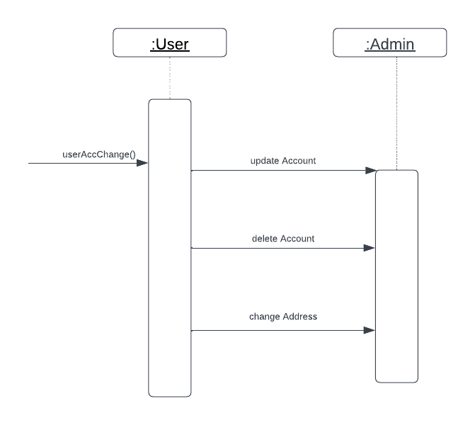

User Payment Method:

Admin Status:

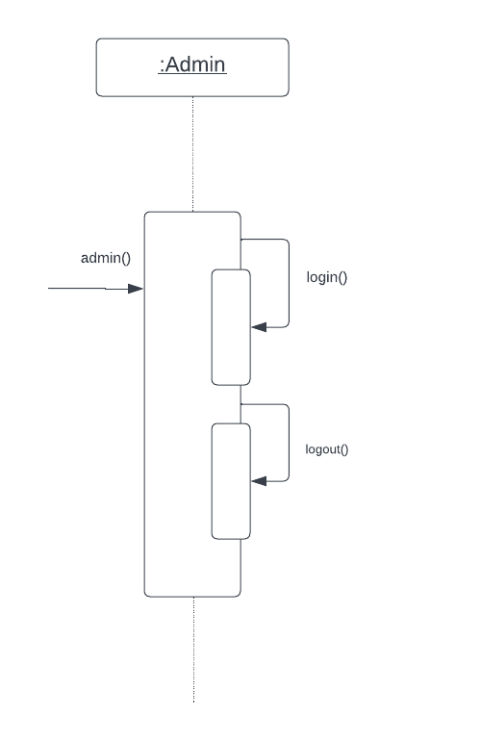

User Security:

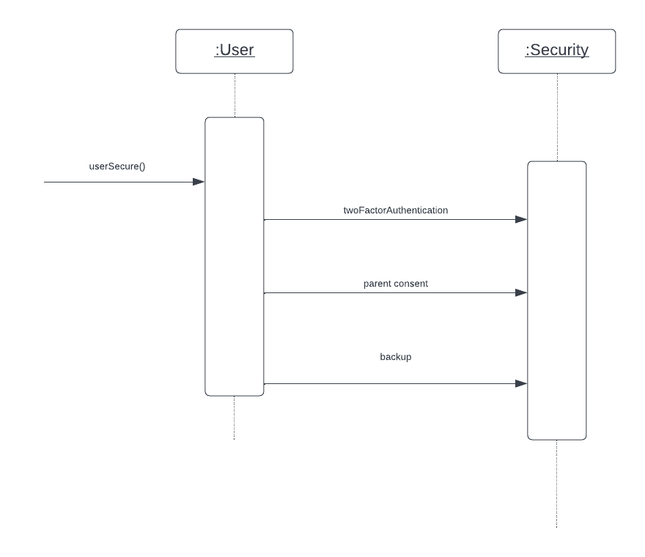

Task Manager:

User Activity:

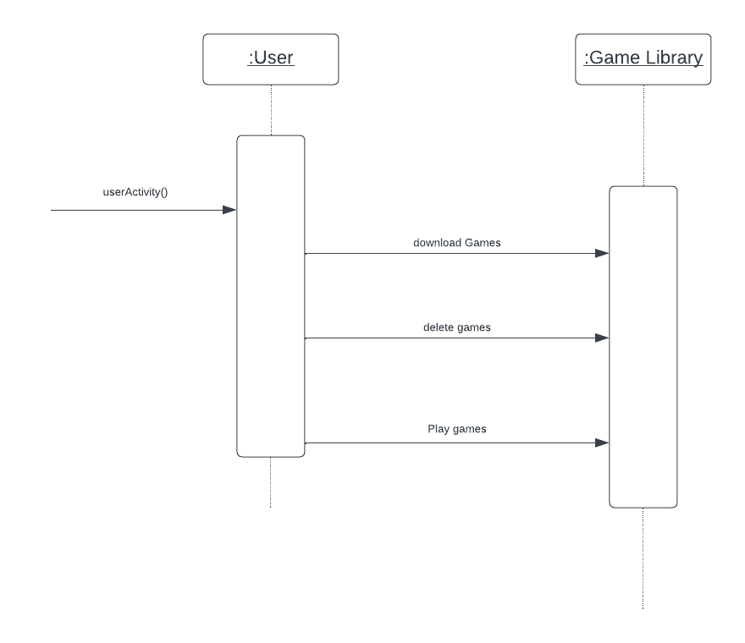

User Software Activity:

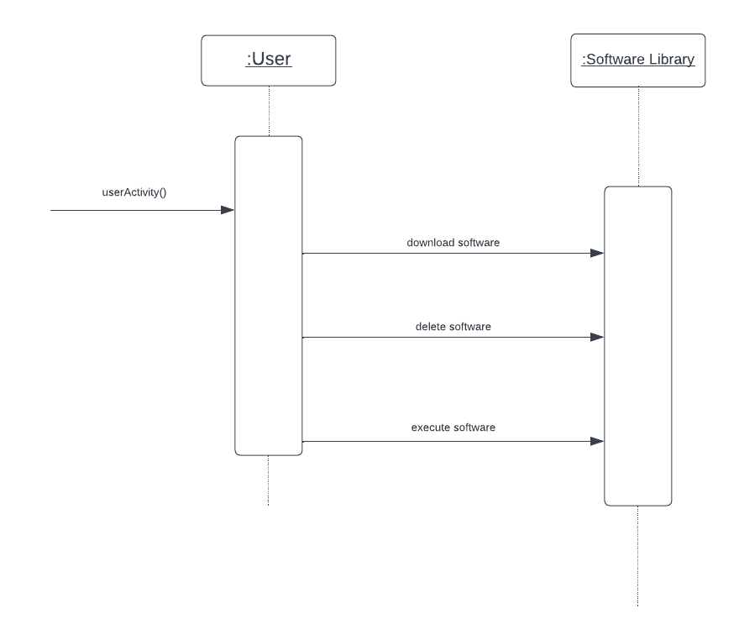

User Tech Support:

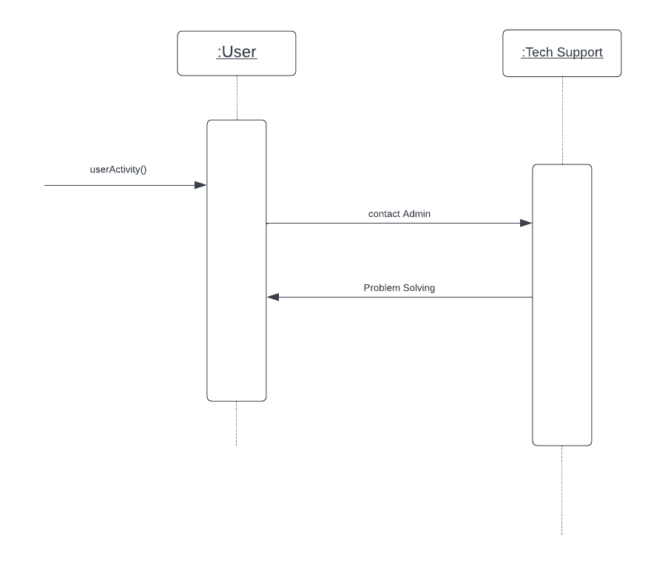

User Feedback:

