**MYSQL TABLES:**

**Employee**

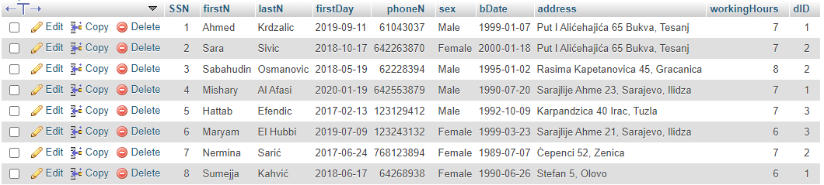

**Cleaner**

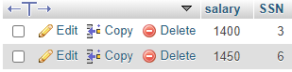

**Nurse**

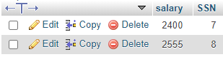

**Doctor**

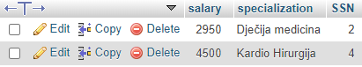

**EMR**

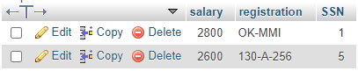

**Vehicle**

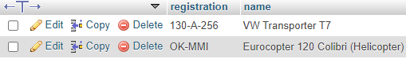

**Appointment**

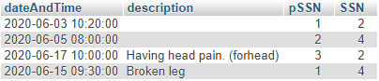

**Patient**

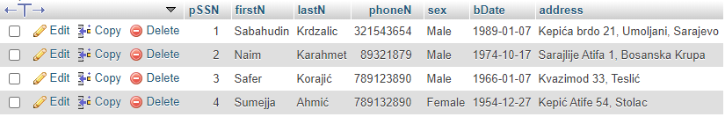

**Department**

