Date: ___________________ Name: ___________________________________

LABORATORY EXERCISE 0
GETTING FAMILIAR
Process Control Lab - Simulation software: PC-ControLAB 3.1
OBJECTIVE: To become familiar with the simulation software.

1. Running the Program
- Run PC-ControLAB.
- In the installation folder, locate and read the file "QuickStartGuide.pdf".
- Slow down the simulation speed via View | Scroll Rate and select a mid-value, to have a more practical experience.

2. The Feedback Loop
Retrieve the strategy via Control | Retrieve Strategy, Model and Tuning and select "Feedbck1" (in C:\Users\Public\PC-ControLAB 3.1).
The simulation starts with an initial controller output (OUT) of 35%. You can press PAUSE at any time and use the cursor to read the values. To rerun the simulation, press RUN.

2.1 Initial Values
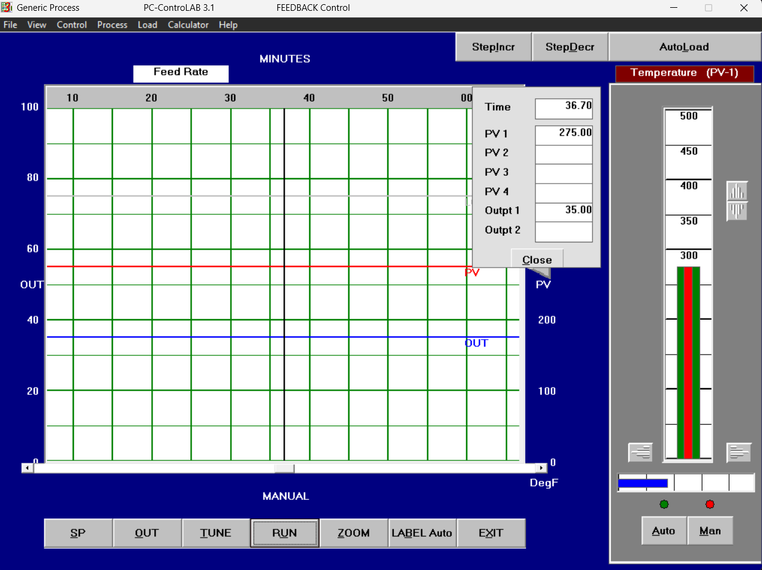
Figure 1: PC-ControLAB main window at start-up (MAN): Feed Rate trend with PV and OUT, and the readout panel showing Time = 36.70 min, PV1 = 275.00, Output1 = 35.00.
Q. What is the process variable (PV) current value?
A. 275
Q. What is its range?
A. From 0 to 500 DegF
Q. What is the controller output range?
A. From 0 to 100 %
Q. What is the setpoint (SP)?
A. 275 DegF
Quantity | Value
Process variable PV (current value) | 275
PV range | From 0 to 500 DegF
Controller output range | From 0 to 100 %
Setpoint SP | 275 DegF
Table 1: Initial loop values (see Figure 1).

2.2 Manual Mode: Step Change in OUT
With the controller in MAN, set the controller output to 20% and observe the process behavior. The continuously scrolling display records the previous 60 (simulated) minutes of the response; the trend that scrolls past the left display border cannot be retrieved.
Q. Can the process be described as static or dynamic?
A. Dynamic
Q. At which value does PV settle to?
A. 162.50
Q. After how long does PV appear to settle at this value?
A. 24.7 minutes = 22.95 +1.75
Q. Calculate the time elapsed since the controller OUT was changed to the time the PV becomes reasonably close to its final value (the usual definition of "reasonably close" is when 98% of the change has occurred).
A. 0.98 * (275 - 162.5) = 110.25 , measure till (275 - 110.25 = 164.75)
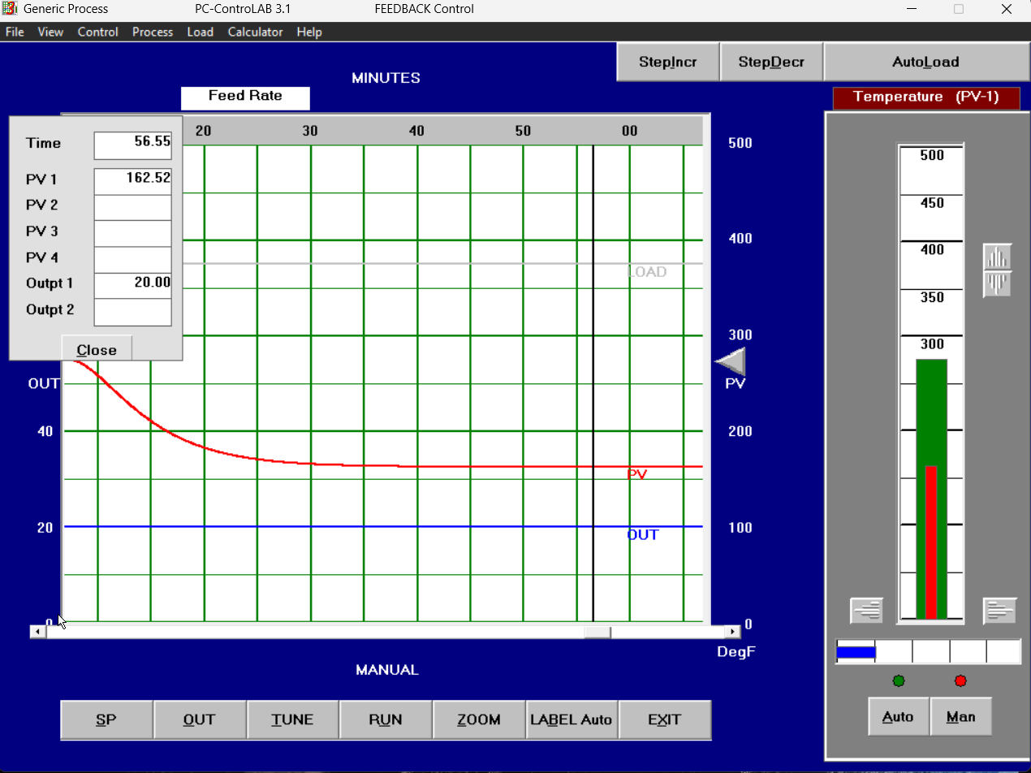
Figure 2: Manual mode (OUT = 20%): PV decays from 275 DegF and settles near 162 DegF (readout: Time = 56.55 min, PV1 = 162.52, Output1 = 20.00).
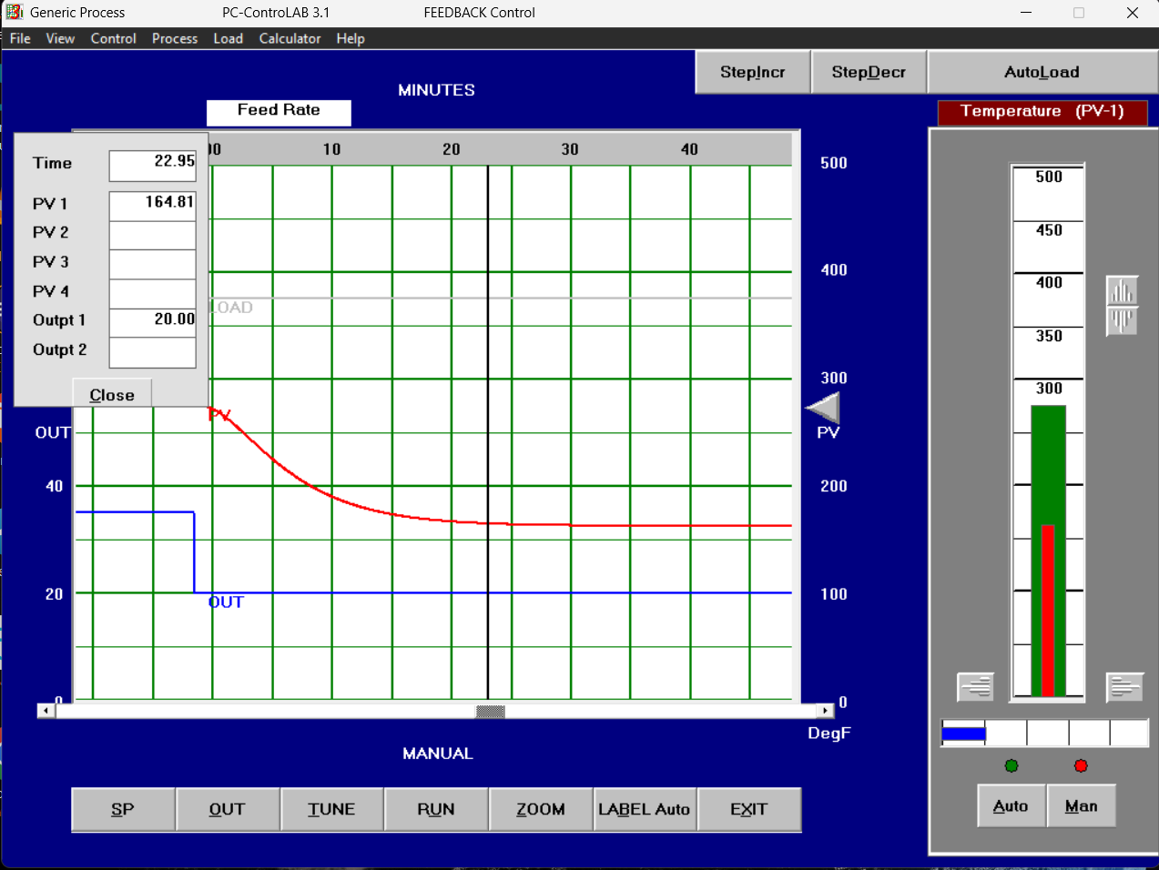
Figure 3: Manual mode, zoomed view used to time the 98% settling point (readout: Time = 22.95 min, PV1 = 164.81, Output1 = 20.00).

2.3 Load Disturbance in Manual Mode
Change the LOAD by pressing StepIncr or StepDecr twice in rapid succession.
Q. What do you observe?
A. The PV decreases when decreasing the load and increases when increasing the load; since we are in manual mode the OUT does not change.
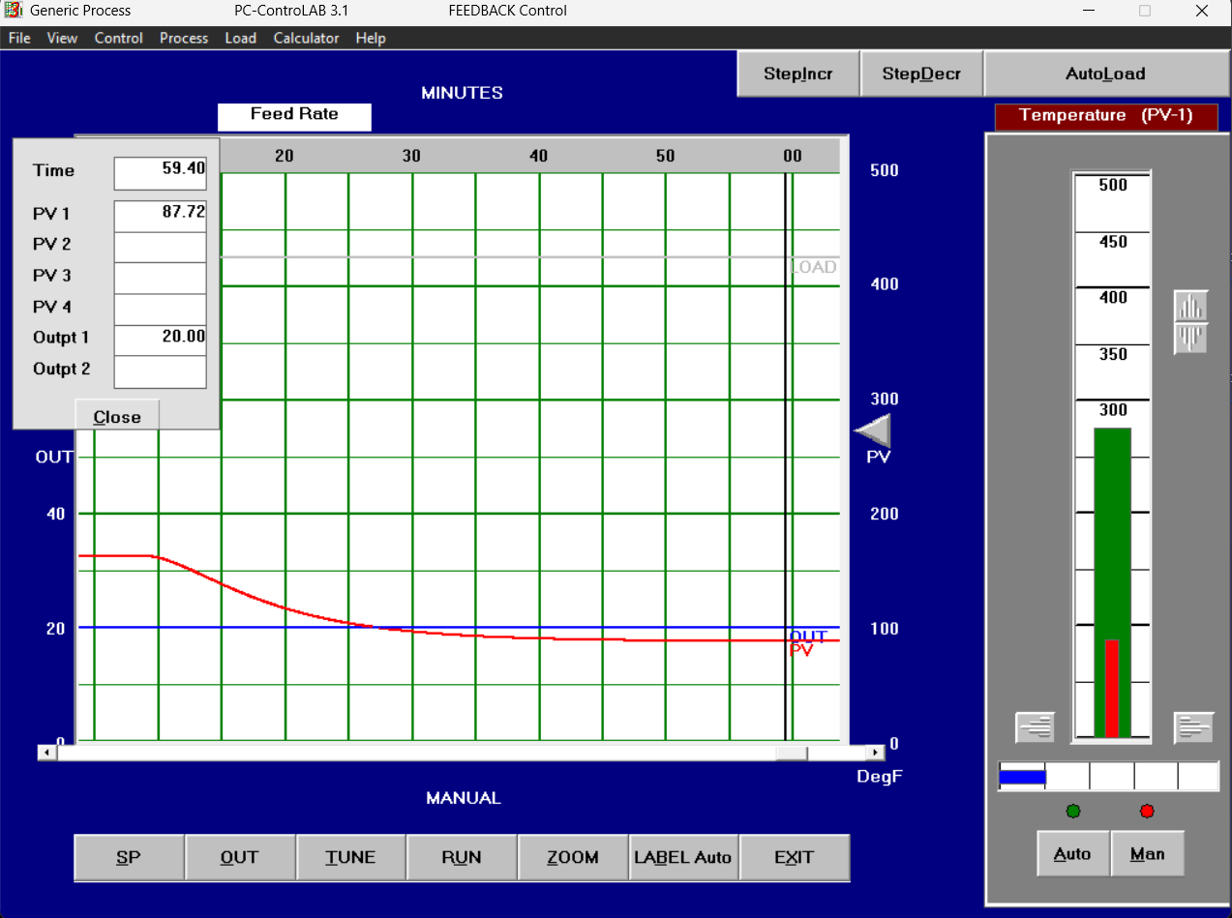
Figure 4: Manual mode (OUT = 20%), response to a load change: PV falls further, to about 88 DegF (readout: Time = 59.40 min, PV1 = 87.72, Output1 = 20.00).

2.4 Automatic Mode
Switch the controller to AUTO.
Q. Does the controller bring the PV back to the setpoint?
A. Yes, but after a lot of time and there was hunting in more than 2 clock cycles.
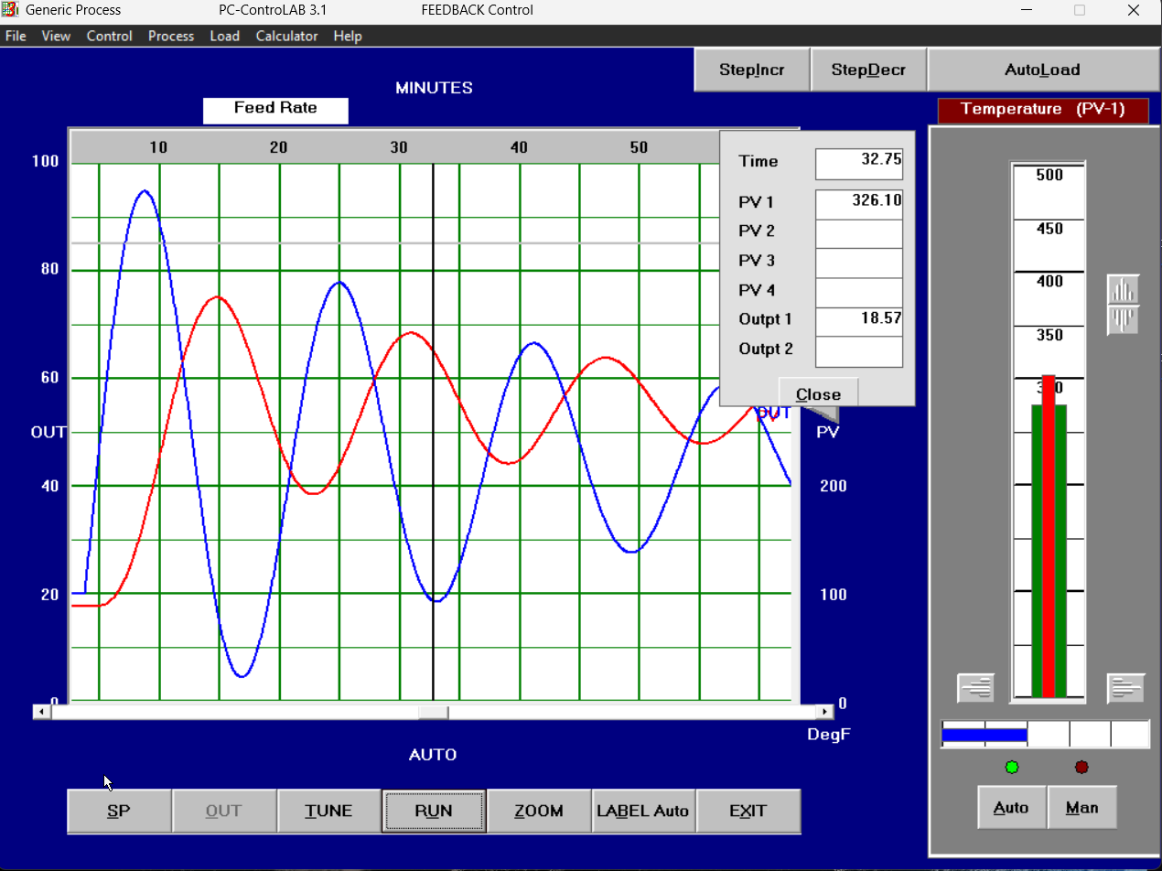
Figure 5: AUTO mode: PV hunting around SP after the controller takes over from MAN (readout: Time = 32.75 min, PV1 = 326.10, Output1 = 18.57).
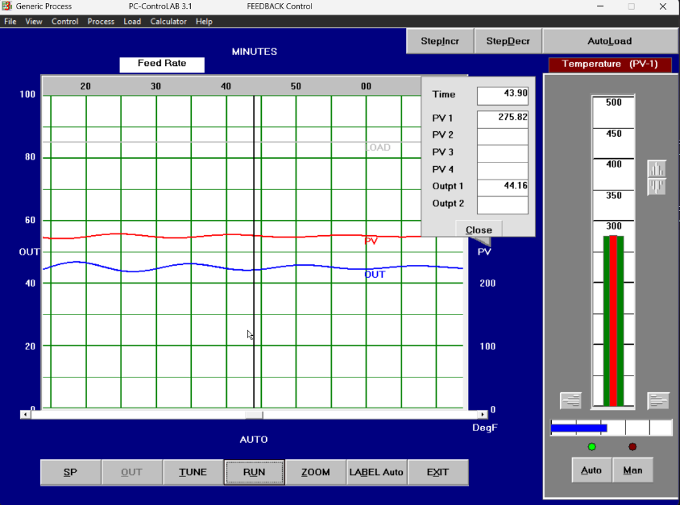
Figure 6: AUTO mode: PV brought back to the setpoint with only small residual oscillation (readout: Time = 43.90 min, PV1 = 275.82, Output1 = 44.16).

2.5 Setpoint Change to 350 °F
Increase SP to 350 degF and observe the response.
Q. Does it exhibit more time variability or less compared to the process response with no feedback (i.e., when the controller was in MAN)?
A. It exhibits more variability. In MAN, the PV smoothly decayed to a new value without oscillating. In AUTO, the controller fights the error, causing the PV to swing up and down repeatedly till it settles.
Q. Do the oscillations die out? (If so, they are called DAMPED oscillations.)
A. Yes
Q. Does the PV reach the new SP?
A. Yes , PV = 350.
Q. In how many cycles?
A. 7 cycles we measured till 1% above and down 162.5
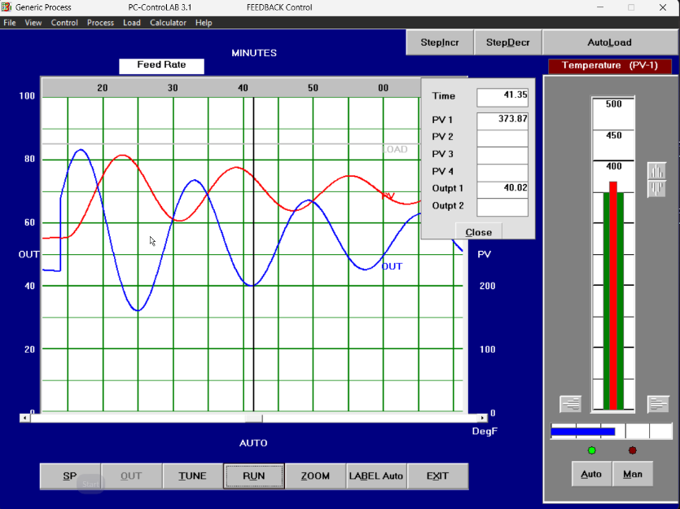
Figure 7: SP increased to 350 degF: closed-loop response with the PV swinging above the new setpoint (readout: Time = 41.35 min, PV1 = 373.87, Output1 = 40.02).
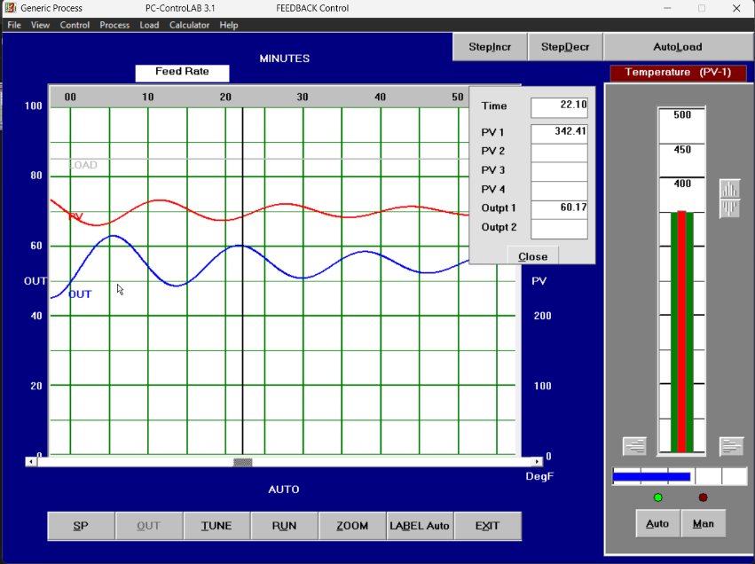
Figure 8: SP = 350 degF: damped oscillation of the PV about the new setpoint, with the response parameters marked on the trend (readout: Time = 22.10 min, PV1 = 342.41, Output1 = 60.17).
Q. What is the PV overshoot? (see the response-parameter figure at the back of the exercise)
A. (410 - 350) / (350 - 275) = 17.14 %
Q. What is the period of oscillation?
A. 38 - 22 = 16 minutes
Q. Does the controller do a good job?
A. No, as we notice it takes more than 1 cycle to settle.
For a damped response, the industry standard is that a well-tuned controller will bring the PV to the SP in at most one cycle and with an overshoot not exceeding 5%.
Parameter | Value
a (peak above final value) | 410 - 350 = 60 DegF
b (total change: final value - initial value) | 350 - 275 = 75 DegF
Overshoot OS = a / b * 100% | 17.14 %
Period of oscillation | 16 minutes
Table 2: Response parameters (a and b read from the traces in Figures 7 and 8).

2.6 Load Disturbance in Automatic Mode
Change the LOAD by pressing StepIncr or StepDecr twice in rapid succession.
Q. Does the controller manage to bring the PV back to the setpoint?
A. Yes, it settles again fast.
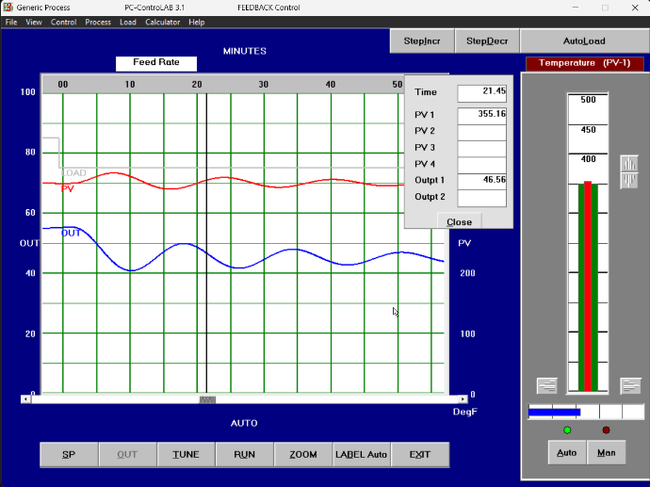
Figure 9: AUTO mode: PV held at the setpoint after a load disturbance (readout: Time = 21.45 min, PV1 = 355.16, Output1 = 46.56).

2.7 Fluctuating Load (AutoLoad)
Switch the controller to MAN. Allow the LOAD to fluctuate like real life situations (AutoLoad). Try to keep the PV as close as possible to the SP (keep changing the controller output up and down for few minutes).
Q. How easy is this task?
A. Very hard, almost cannot get an ideal value.
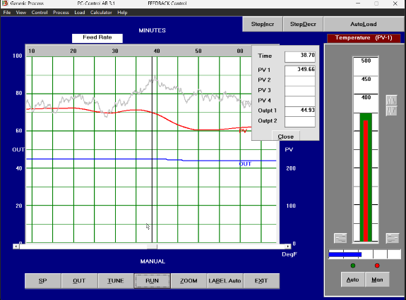
Figure 10: Manual control under fluctuating load (AutoLoad): the noisy LOAD trace disturbs the PV while OUT is held constant (readout: Time = 30.70 min, PV1 = 343.86, Output1 = 44.93).
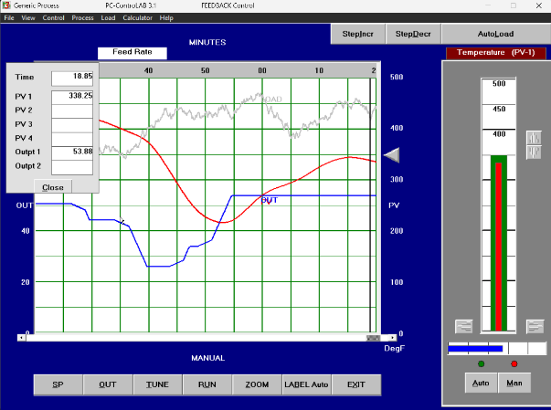
Figure 11: Manual control under fluctuating load (AutoLoad), second capture showing the PV drifting away from SP (readout: Time = 18.85 min, PV1 = 338.25, Output1 = 53.96).
While the LOAD is still fluctuating, switch the controller to AUTO.
Q. Observe PV fluctuations around SP. Do they seem to be acceptable for operation, i.e., confined within a relatively small range (say 1% or even 2% of the PV range)?
A. we noticed that there was a fluctuations within 3% so it’s not acceptable.
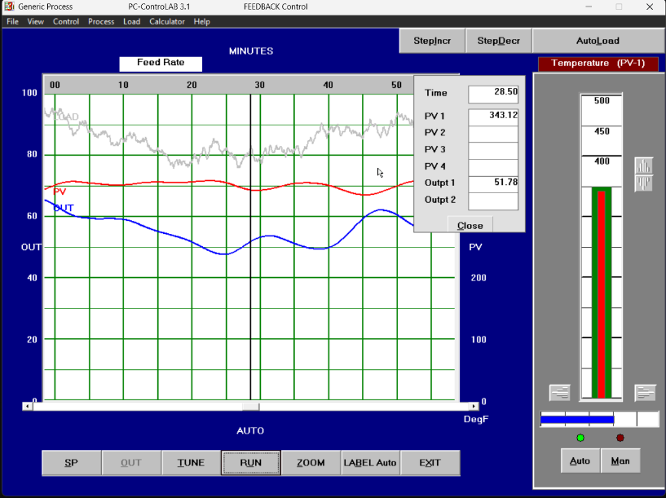
Figure 12: Automatic control under fluctuating load (AutoLoad): the PV stays close to the setpoint while OUT moves to absorb the disturbance (readout: Time = 28.50 min, PV1 = 343.12, Output1 = 51.76).

2.8 Undamped Oscillations
Switch off AutoLoad. Keep the controller in AUTO. Change the controller tuning parameters such that the PV exhibits sustained (UNDAMPED) oscillations. Hint: click TUNE then increase the controller gain. Record this gain.
Q. Controller gain for sustained oscillations
A. Gain = 3 , high gain in general but I chose 3 since its almost the starting gain that cause sustained oscillations
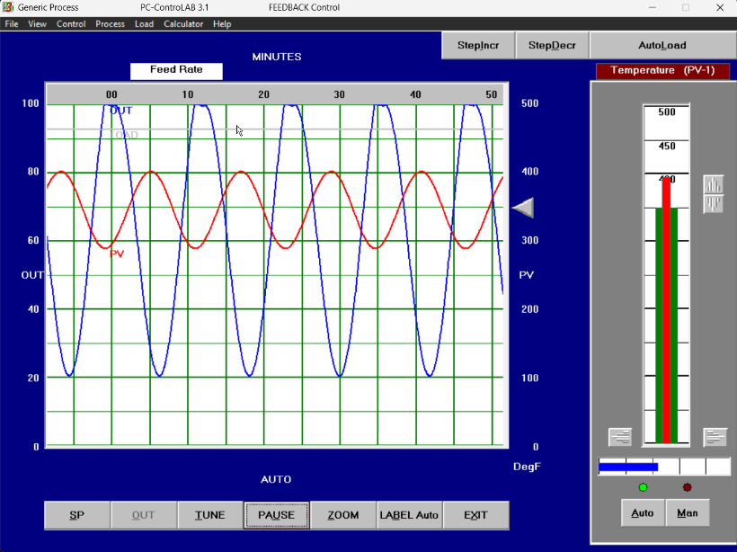
Figure 13: Sustained (undamped) oscillations obtained with the controller gain set to 3: the PV oscillates with constant amplitude and OUT swings over its full range.
Quantity | Value
Controller gain for sustained oscillations | 3
Table 3: Gain at sustained oscillations.

2.9 Low Gain
Reduce the controller gain to 0.1. Change the setpoint again.
Q. What do you observe?
A. No oscillation; it settles to the new SP fast and perfectly.
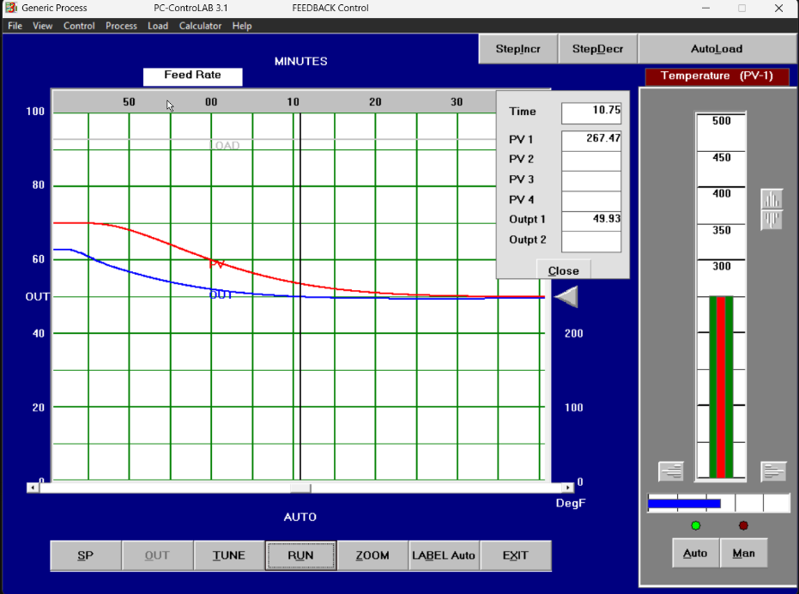
Figure 14: Controller gain reduced to 0.1: the PV moves to the new setpoint without any oscillation (readout: Time = 10.75 min, PV1 = 267.47, Output1 = 49.93).
Reference Figure: Determining Response Parameters
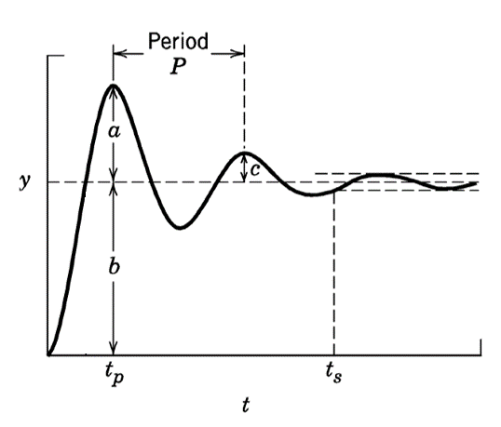
Response-parameter figure supplied with the exercise (a, b, c, Period P, tp, ts).

Overshoot: OS = a / b %
a = peak value above the final value, b = total change (final value - initial value).

