Information Technology Institute (ITI) Analog IC Design

Lab 07
Five-Transistor OTA Design

Table of Contents
- Part 1: OTA Design (Hand Analysis) 2
- Part 2: Open-Loop OTA Simulation 6
  - DC operating point 6
  - Differential small-signal AC 7
  - Common-mode small-signal AC 9
  - CMRR 9
  - Avcm vs VICM (CMIR sweep) 10
  - Differential large-signal sweep 10
  - CM large-signal sweep (GBW vs VICM → actual CMIR) 11
- Part 3: Closed-Loop OTA Simulation (Unity-Gain Buffer) 12
  - Loop gain (STB analysis) 12
- Part 4: Effect of Mismatch on CMRR 13

Part 1: OTA Design (Hand Analysis)

Specs recap
Parameter | Value
Supply VDD | 1.8 V
Load C_{L} | 5 pF
Open-loop DC gain | ≥ 34 dB
CMRR @ DC | ≥ 74 dB
Phase margin | ≥ 70◦
Reference (seed) current | 10 µA
CMIR low | ≤ 1.2 V
CMIR high | ≥ 1.5 V
GBW | ≥ 5 MHz
Current consumption / Area | Minimize

Q: NMOS or PMOS?
A: NMOS, since the CMIR is closer to VDD we will choose nmos.

Bias current – simple approach
The dominant pole is at the output node, so GBW = g_{m1}/(2πC_{L}):
g_{m1} ≥ 2π · GBW · C_{L} = 2π(5 MHz)(5 pF) = 157.1 µA/V
Assume g_{m}/I_{D}|₁ = 15 as a first guess (moderate inversion):
g_{m1} 157.1
I = = = 10.47 µA

so ID1 will be 10 µA
^{D1} g_{m}/I_{D} 15
157.1

g_{m}/I_{D}|₁ =
= 15.7 S/A
10

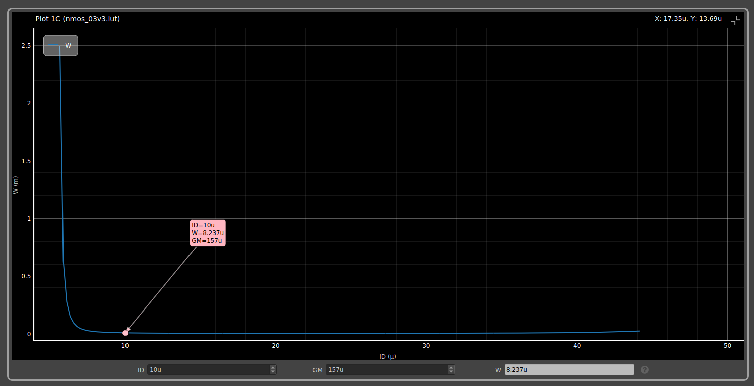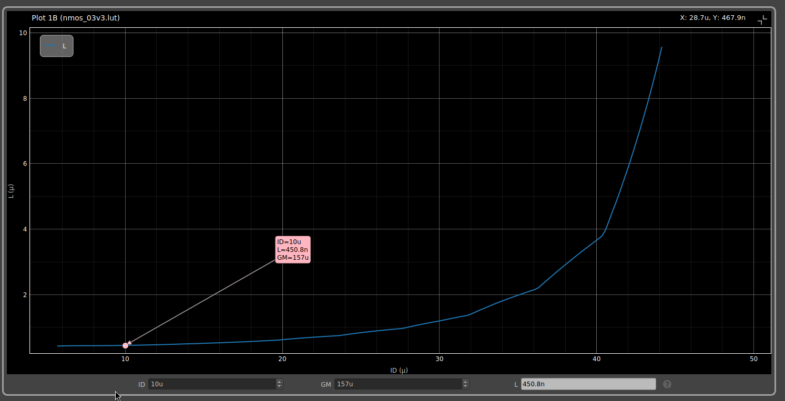
Figure 1: W vs I_{D} (left) and L vs I_{D} (right) assume the tail has V_{DS,tail} = 0.3 V, and plot V_{icm,min} = V_{GS1} + 0.3 vs ID:

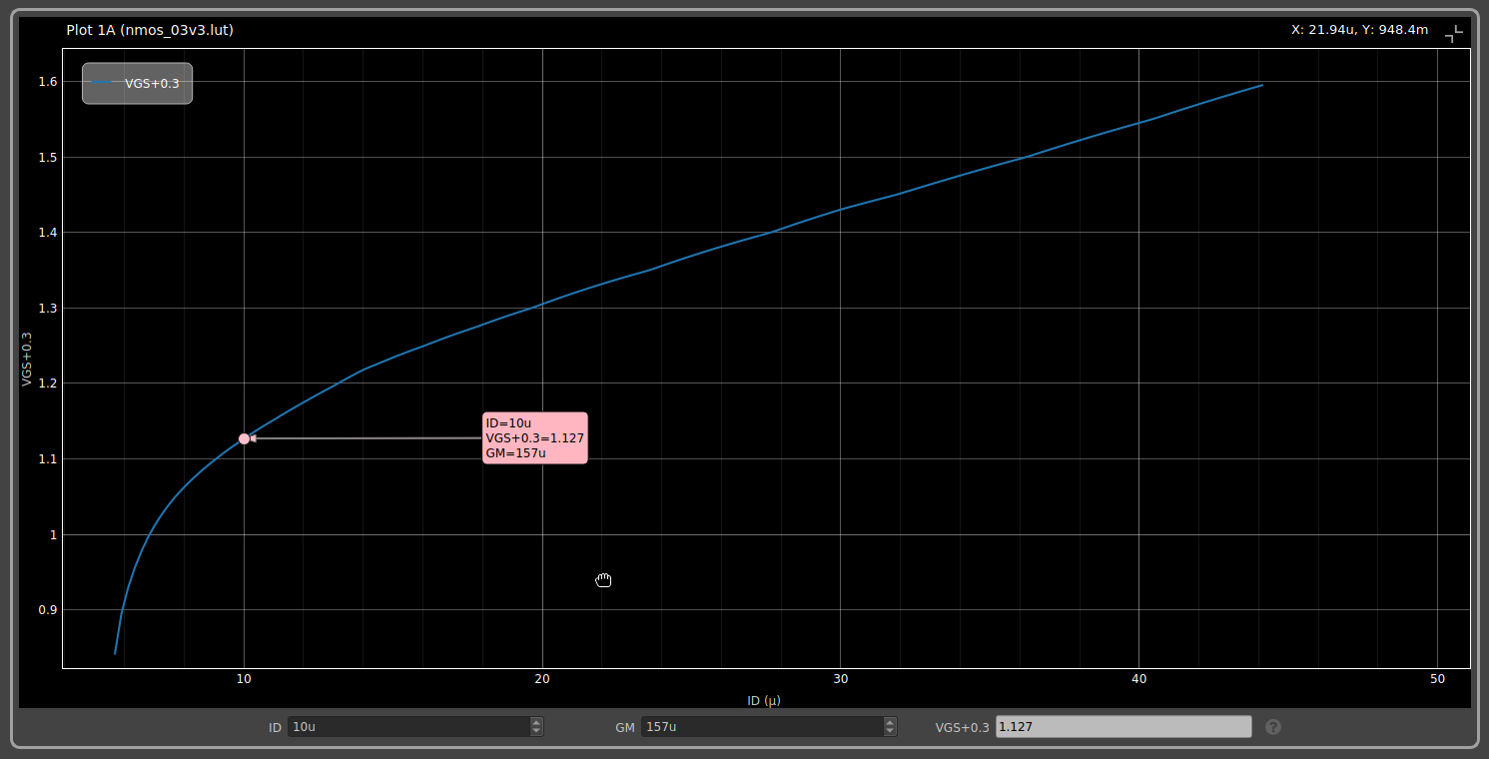
Figure 2: V_{icm,min} = V_{GS1} + 0.3 V vs I_{D}

At I_{D} = 10 µA: V_{icm,min} = 1.127 V, which is below the 1.2 V.
Gain spec → sizing M3/M4 (load)

Av0
= g_{m1}
(r_{o2}
∥ r_{o4}
g_{m1}
) = ≥ 50.1 V/V (34 dB) 2λ_{L}I_{D}

g_{m1} 157.1µ
λ ≤ =
= 0.157 V ⁻¹, ro = 634kohm

^{L} 2I_{D} · 50.1 2(10µ)(50.1)
picking g_{m}/I_{D}|_{3,4} = 10 S/A for the load devices. Using CMIR-Max:
CMIR_{MAX} = 1.5 = V_{DD} + V gs_{1,2} − V dsat_{1,2} − V gs_{3,4} (Using V alue of V th₂ from SA)
→ V gs_{3,4} = 1.023 ≈ 1V
CMRR spec → sizing M5 (tail)
CMRR_{spec} − A_{v0,spec} = 74 − 34 = 40 dB
CMRR = A_{v0} + 20 log10(2 g_{m3} r_{o5}) ⇒ 2 g_{m3} r_{o5} = 100 ⇒ g_{m3}r_{o5} = 50 With g_{m}/I_{D}|₃ = 10 ⇒ g_{m3} = 100 µA/V :

ro5
50
=
100 µA/V
= 500 kΩ ⇒ λ₅
1
=
ro5I5
1
=
(500k)(20µ)
= 0.1 V ⁻¹

assumed V_{DS,tail} = 0.3 V, g_{m}/I_{D} = 10 for the tail.

Final sizing table

Table 1: Final transistor sizes and operating point (from ADT)
Device | W (µm) | L (nm) | I_{D} (µA) | g_{m} (µA/V) | g_{m}/I_{D} (S/A) | V ∗ | (V) | Vov | (V) | Vdsat | (V)
M1, M2 | 10 | 450 | 10 | 157 | 15.76 | 0.128 |  | 0.031 |  | 0.104
M3, M4 | 7.5 | 450 | 10 | 100.0 | 9.9 | 0.201 |  | 0.156 |  | 0.174
M5 | 2 × 4.2 | 900 | 19.70 | 199.0 | 10 | 0.202 |  | 0.147 |  | 0.173
M6 | 4.2 | 900 | 10.0 | 100.8 | 9.86 | 0.202 |  | 0.147 |  | 0.173

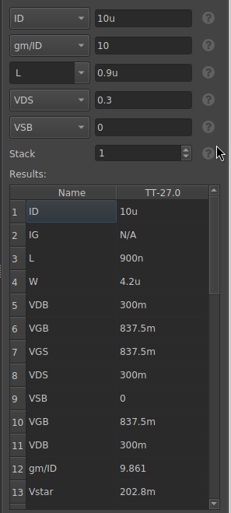
Figure 3: Tail / reference device (M5, M6) sizing

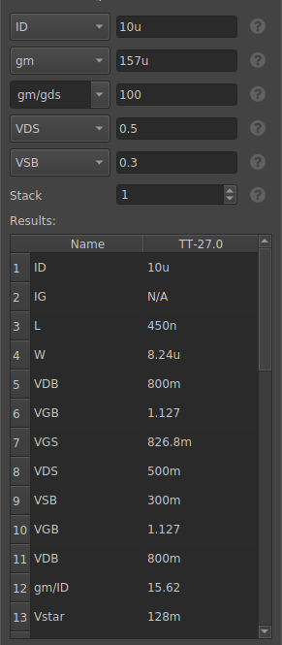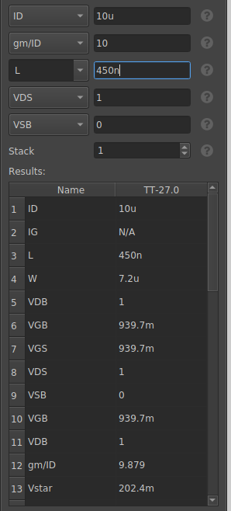
Figure 4: Input pair (M1/M2) sizing (left) and Load (M3/M4) sizing (right) The width of M1,2 is 8.5u but can be increased to 9.5u to achieve GBW=5MHz.

Part 2: Open-Loop OTA Simulation

DC operating point
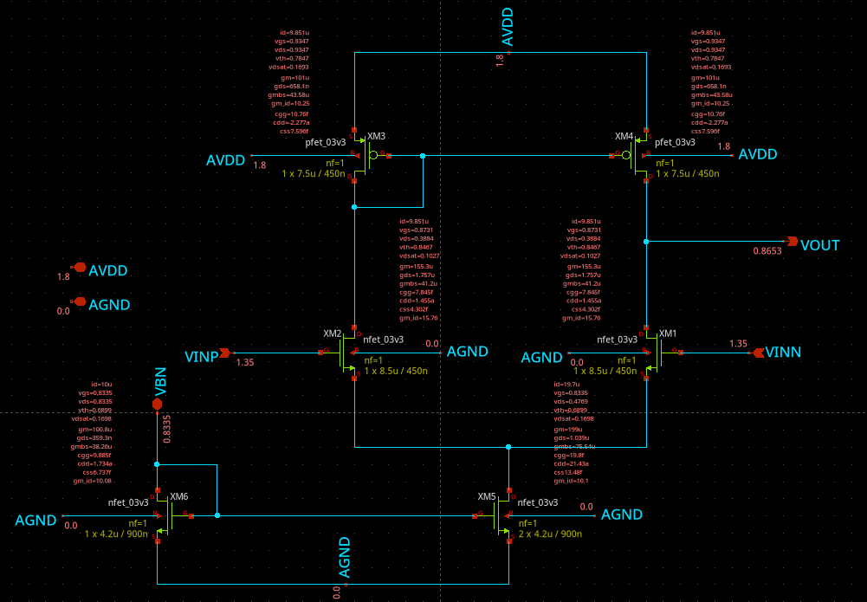

Figure 5: Open-loop schematic with DC node voltages annotated (VICM = 1.35 V, middle of CMIR)

Q: Is the current and gm in the input pair exactly equal?
A: Yes, because the circuit is perfectly symmetric: both inputs have the same common-mode signal there’s no feedback to introduce any imbalance.

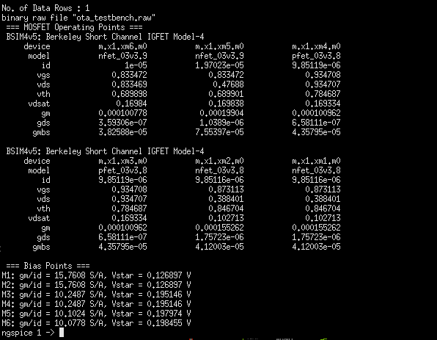

Figure 6: Ngspice op-point console output

Q: What is the DC voltage at VOUT? Why?
A: V_{OUT} = 0.8653 V. it follows VF = V DD − V_{SG3} = 1.8 − 0.9347 = 0.8653 V, since the circuit is symmetric.

Differential small-signal AC
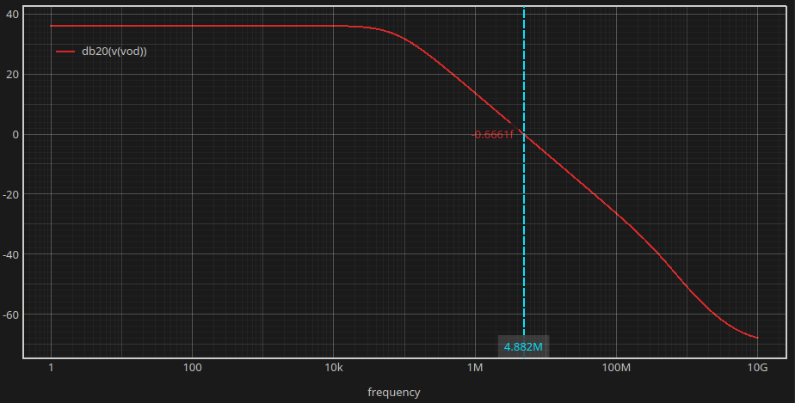
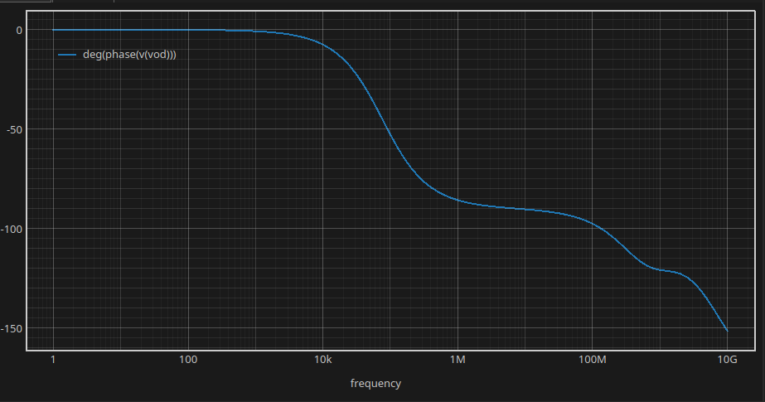
Figure 7: |A_{v,diff} | vs frequency (dB) (left) and ̸ A_{v,diff} vs frequency (right) (g_{m1} = 155.26 µA/V , g_{ds2} = 1.757 µA/V , g_{ds4} = 0.658 µA/V ):
g_{m1} 155.26
A = = = 64.3 V/V = 36.16 dB

v,diff
gds2 + gds4
2.415

f = g_{ds2} + g_{ds4} = 2.415 µA/V ≈ 76.9 kHz

p,out
2πC_{L}
2π(5 pF )

g_{m1} 155.26 µA/V
GBW = =
≈ 4.94 MHz

2πC_{L} 2π(5 pF )
Since it’s a single dominant pole, PM should be close to 90◦.

Table 2: Differential AC – hand calc vs sim

Quantity | Hand calc | Simulation
Av,diff | 36.16 dB | 36.13 dB
BWdiff | 76.9 kHz | 76.1 kHz
GBW | 4.94 MHz | 4.877 MHz
PM | ≈ 90◦ | 90.51◦

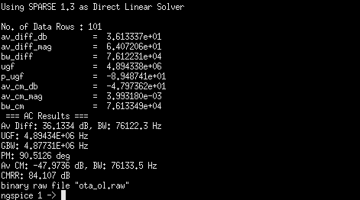

Figure 8: Ngspice AC measurement summary

To obtain GBW larger we can increase the width of M1,2 to be 9.5u instead of 8.5u
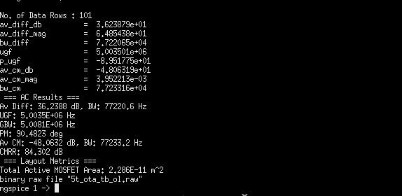

Figure 9: Ngspice AC after increasing width

Common-mode small-signal AC
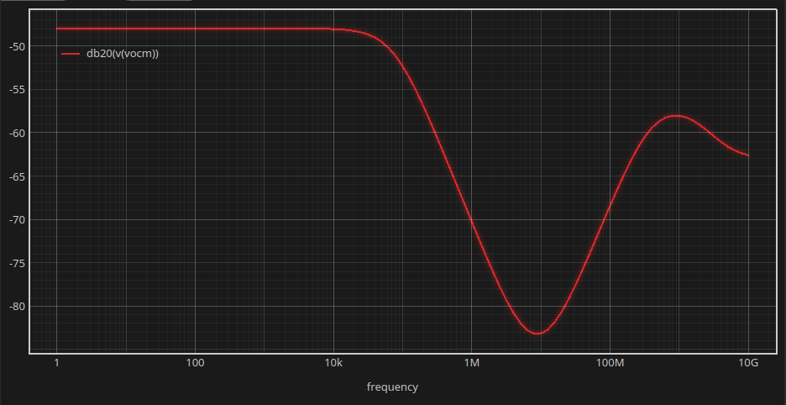
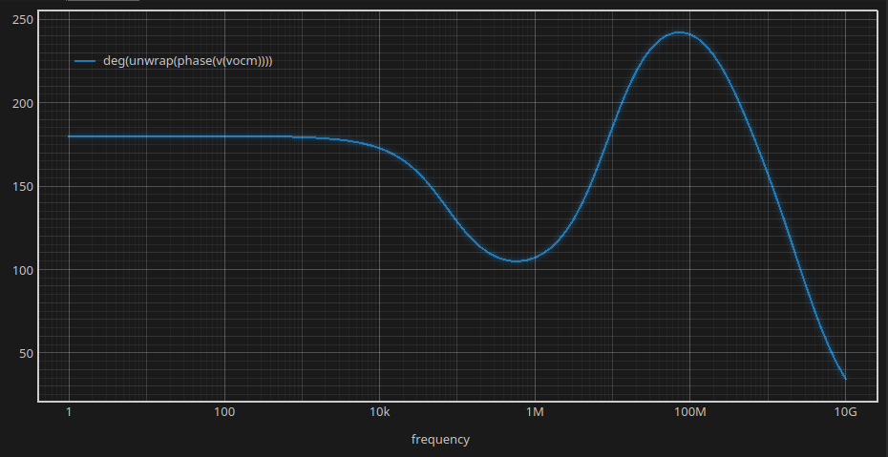
Figure 10: |A_{v,cm}| vs frequency (dB) (left) and ̸ A_{v,cm} vs frequency (right) CM gain of a 5T OTA (matched devices) is approximately:
1

Av,cm ≈ −
2 g
m3
ro5

Using g_{m3} = 100.96 µA/V and r_{o5} = 1/g_{ds5} = 1/1.0389 µA/V = 962.6 kΩ:

Av,cm
1
= −
2(100.96µ)(962.6k)
1
= −
194.4
= −5.14 × 10⁻³ = −45.8 dB

Table 3: Common-mode AC – hand calc vs sim

Quantity | Hand calc | Simulation
Av,cm | −45.8 dB | −47.97 dB
BW_{cm} | 76.9 khz | 76.1 kHz
2.4 CMRR
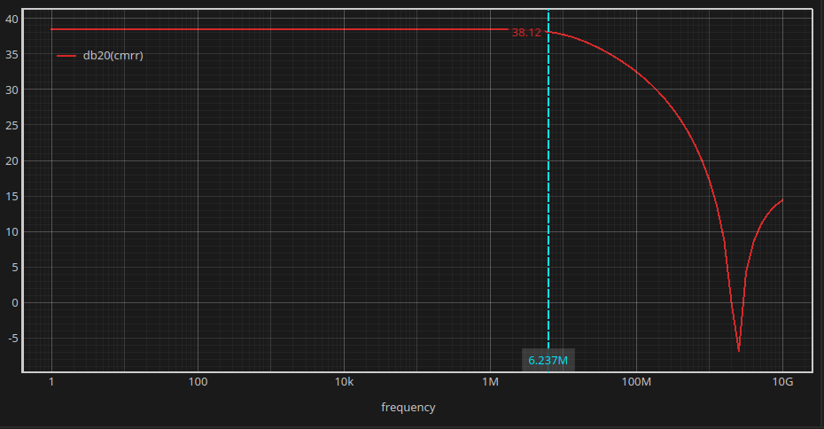

Figure 11: CMRR vs frequency

CMRR_{hand} = A_{v,diff} (dB) − A_{v,cm}(dB) = 36.16 − (−45.8) = 81.9 dB
Simulation gives CMRR = A_{v,diff} _{db} − A_{v,cm} _{db} = 36.13 − (−47.97) = 84.1 dB .

Table 4: CMRR – hand calc vs sim

Quantity | Hand calc | Simulation
CMRR | 82 dB | 84 dB

Avcm vs VICM (CMIR sweep)
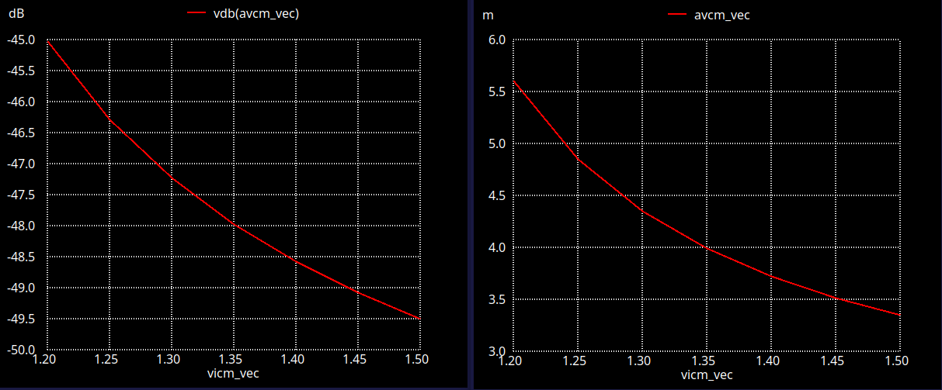

Figure 12: A_{v,cm} (dB, left) and (linear, right) vs VICM, swept across the CMIR

Q: Does Avcm increase or decrease vs VICM? Why?
A: It decreases As VICM goes up, V_{DS} of the tail transistor M5 increases (it goes deeper into sat-uration), which increases r_{o5}. Since A_{v,cm} ∝ 1/r_{o5}, a bigger r_{o5} means smaller CM gain, improving CMRR.

Differential large-signal sweep
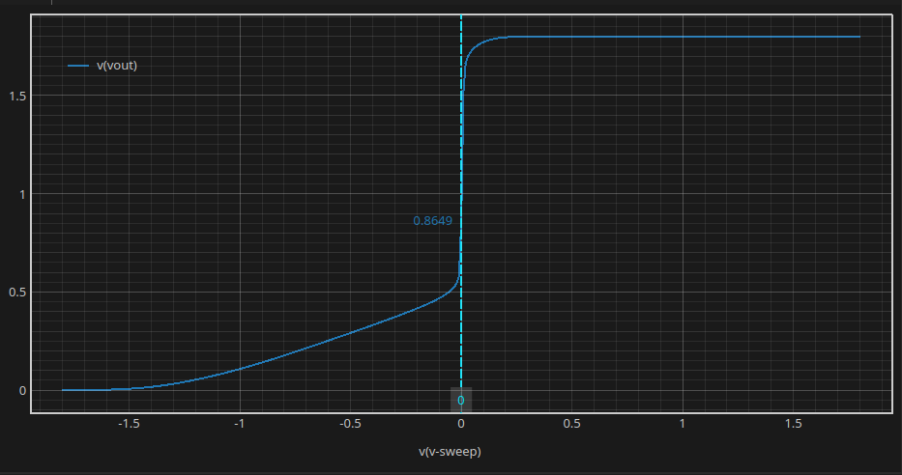
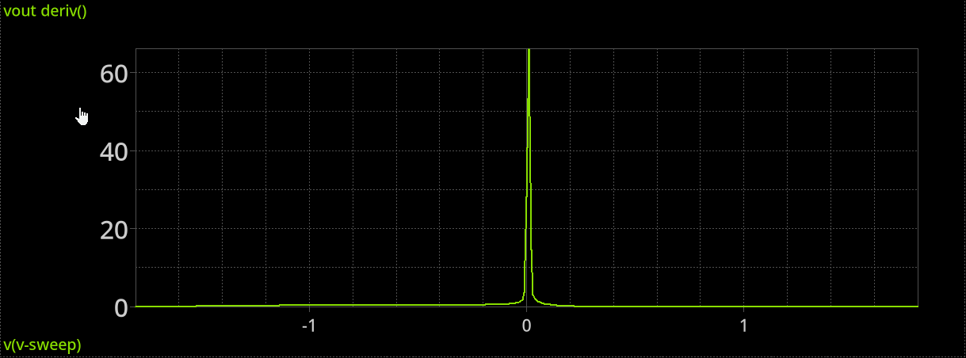
Figure 13: V_{OUT} vs V_{ID} (left) and dV_{OUT} /dV_{ID} vs V_{ID} (right)

Q: What is Vout at VID=0? Why? How does the derivative peak compare to Avd?

A: V_{OUT} (V_{ID} = 0) = 0.8649 V as the open-loop DC bias point (0.8653 V).
The derivative dV_{OUT} /dV_{ID} peaks at about 65 V/V at V_{ID} = 0, which is the gain A_{v,diff} = 64.3 V/V , the derivative of the large-signal DC transfer curve at the origin is the small-signal gain.

CM large-signal sweep (GBW vs VICM → actual CMIR)
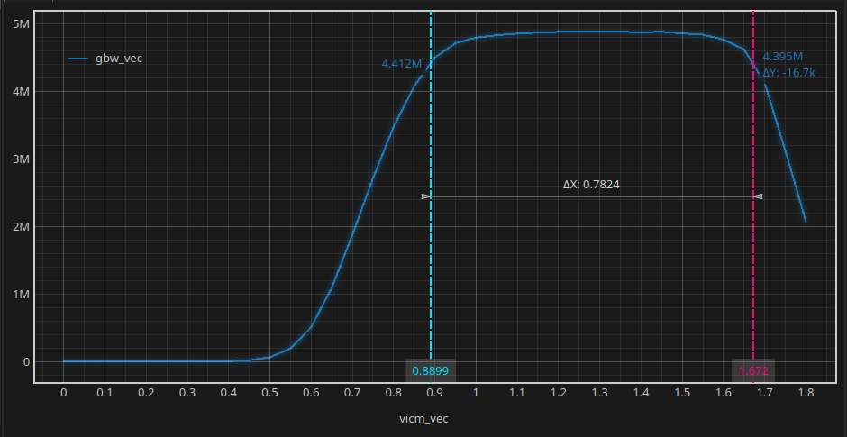
Figure 14: GBW vs VICM, with 90%-of-max

The 90% threshold (≈4.41 MHz) is crossed at VICM=0.89 V on the low side and VICM=1.6 V on the high side, giving a simulated CMIR of about [0.89 V, 1.6 V].

Part 3: Closed-Loop OTA Simulation (Unity-Gain Buffer)

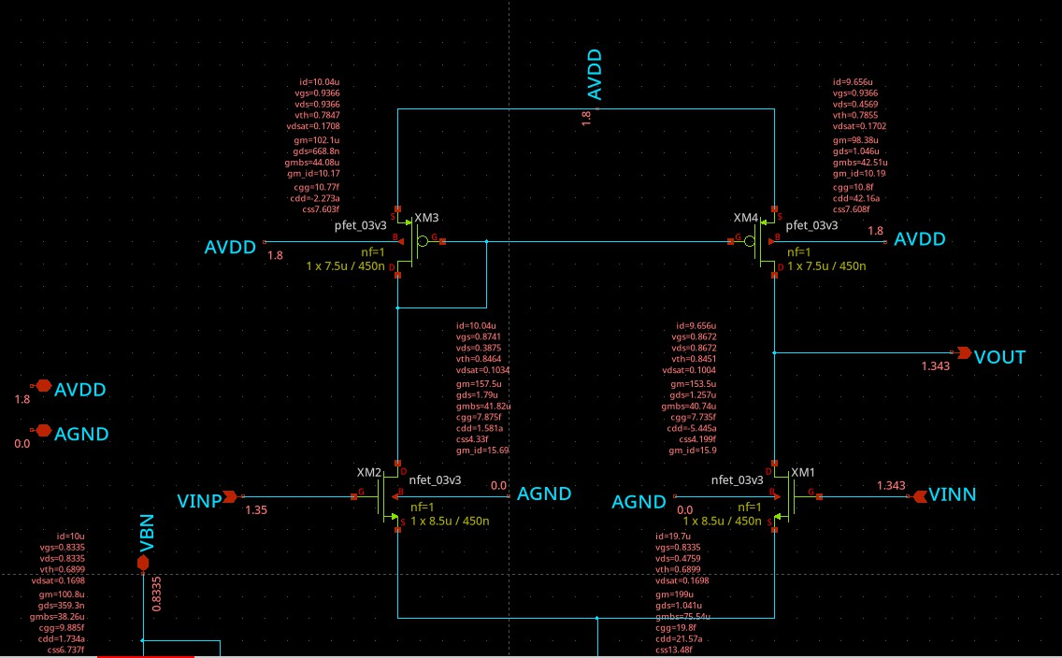
Figure 15: Closed-loop DC OP annotated

Q: Is the current (and gm) in the input pair exactly equal ? Why?
A: No, I_{D}(M 2) = 10.04 µA while I_{D}(M 1) = 9.656 µA – a difference of about ∆I_{D} ≈ 0.38 µA (∼3.9% mismatch ).
in the unity-gain buffer, VOUT follows VINP (=VICM= 1.35V) but only through a finite-gain loop, so it can’t track perfectly – V_{OUT} settles at 1.343 V, not 1.350 V. That small difference becomes
a differential input V_{id} = V_{INP} − V_{INN} = 1.35 − 1.343 ≈ 7 mV . This V_{id} makes the differential pair
unbalanced like a mismatch.

Loop gain (STB analysis)
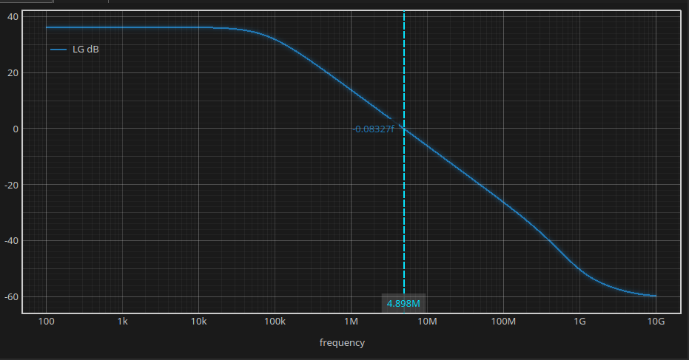
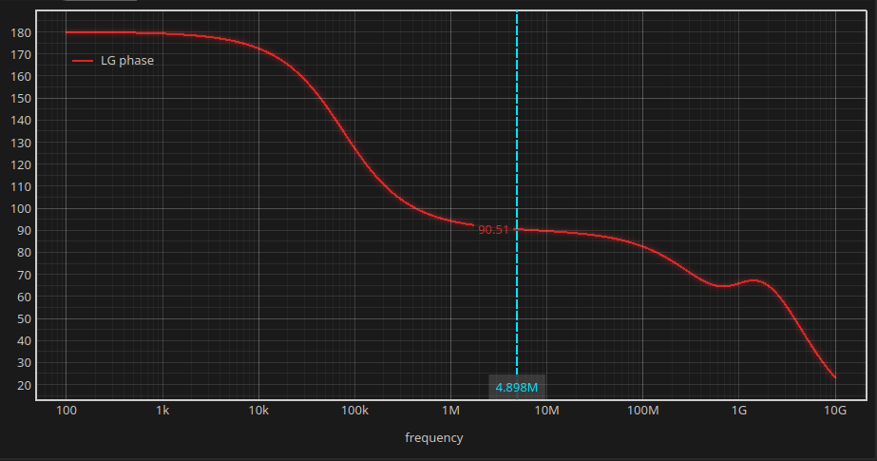
Figure 16: Loop gain magnitude (dB) (left) and Loop gain phase (right)

Table 5: Loop gain vs open-loop dif f results

Quantity | Open-loop (Part 2) | Loop gain (Part 3, STB) | Hand calc
DC gain | 36.13 dB | ≈36 dB | 36.16 dB
Crossover freq. | UGF = 4.894 MHz | GX = 4.898 MHz | GBW = 4.94 MHz
Phase margin | 90.51◦ | 90.51◦ (at GX) | ≈ 90◦
this is a unity-feedback buffer, so the feedback factor β = 1, and loop gain LG = β · A_{v,diff} = A_{v,diff} .

Part 4: Effect of Mismatch on CMRR

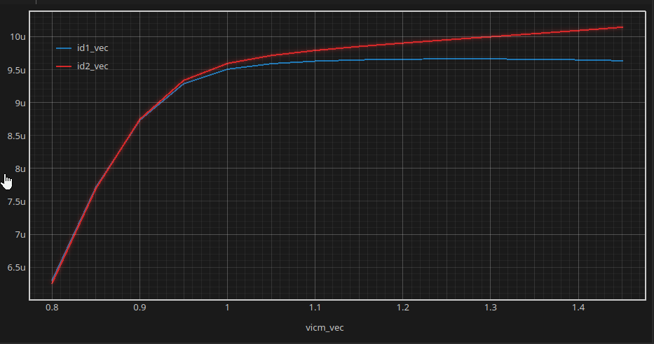
Figure 17: I_{D1}, I_{D2} vs VICM (overlaid)
For VICM below about 1.0 V, I_{D1} and I_{D2} are rising equally. Above ∼1.0 V they start to split apart: I_{D2} (red) keeps rising while I_{D1} (blue) is const(or we can say its deacreasing a little because the addition of them is const) 9.7 µA. this is because there is a mismatch in the input due to the feedback.

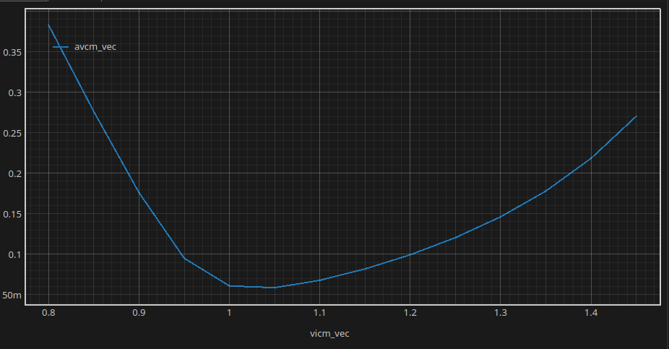

Figure 18: CM gain (linear) vs VIN

when VIcm is low the tail mosfet is not in sat so RSS is very small so the AVcm is large as VIcm increases RSS increases till The common-mode gain will reach its minimum best performance exactly at the point where VIN equals the voltage at the mirror node, because the input pair is perfectly balanced. also due to the feedback there is a systematic mismatch so the current differs.

