TIME IMPACT ANALYSIS REPORT
Executive Delay Analysis Package | Fragnet-Based TIA | EOT Claim Support
Project: [Project Name] | Contract: [Contract No.] | Data Date: [DD-MMM-YYYY] | Revision: [Rev. 00]
Purpose: quantify the schedule impact of delay events by inserting approved fragnet logic into the accepted CPM programme and measuring movement to the critical / longest path and project completion.

1. Report Map and Usage Protocol
This page explains how decision makers should read the report and how the planning team should update it.

Step | Report Area | Management Question Answered
01 | Executive dashboard | Immediate understanding of claimed days, evidence maturity, criticality, and EOT position.
02 | Data readiness matrix | Confirms whether the analysis is supported by reliable baseline, updates, logic, progress and records.
03 | Delay event register | Shows what happened, where it happened, which activity was affected, and whether the event is valid for TIA.
04 | Fragnet logic | Shows the digital inserted sub-network, activity durations, predecessors, successors and evidence basis.
05 | Impact calculation | Compares pre-impact and post-impact schedule dates to quantify delay days.
06 | Criticality and causation | Confirms whether the impacted activity is critical / longest path and caused downstream delay.
07 | EOT claim position | Converts schedule analysis into a management-level claim recommendation.
How to use: edit the input tables first, refresh the companion Excel dashboard, then update the charts/images in this Word report for formal issue. Keep all assumptions, exclusions and missing evidence visible; do not hide weaknesses from directors.

2. Executive TIA Dashboard
Board-level snapshot of delay exposure, potential entitlement and evidence risk.

64  Total Recorded Working Delay Days  Sum of current event register | 37  Potential EOT Days  Valid-for-TIA sample events only | 3  Critical Events  Events affecting critical / longest path | 1  Missing Evidence Items  Requires immediate close-out

Executive conclusion  • The current sample analysis indicates that only events with complete or sufficiently traceable evidence and demonstrable critical / longest path impact should proceed as TIA claim events.  • Commercial-only matters must remain outside the EOT calculation unless schedule causation is proven through contemporaneous records and critical activity impact.  • The director decision should focus on approving the valid TIA package, closing missing evidence, and separating non-excusable / commercial issues from the delay claim. | 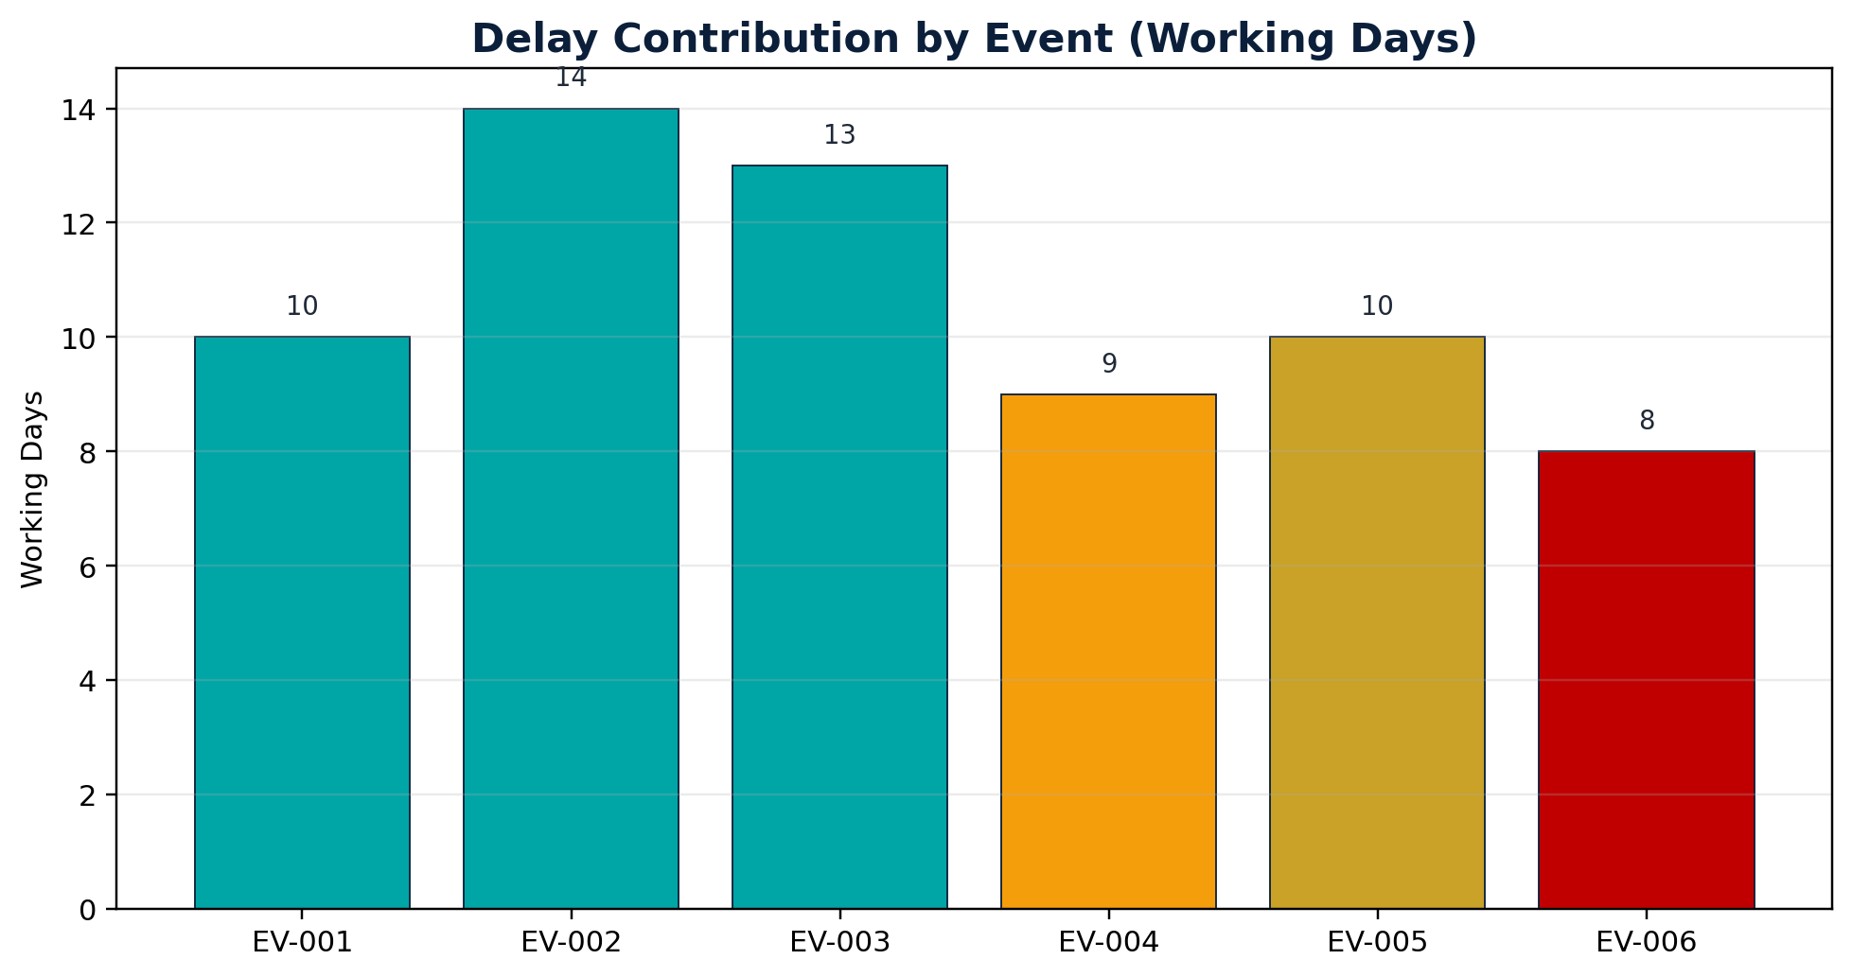
Source Table: Event | Working Days | Classification
EV-001 | 10 | Valid for TIA
EV-002 | 14 | Valid for TIA
EV-003 | 13 | Valid for TIA
EV-004 | 9 | Supporting Evidence Only
EV-005 | 10 | Commercial Only
EV-006 | 8 | Not Suitable

3. Project, Contract and Schedule Control Data
Replace placeholders with contract-specific information before formal submission.

Control Item | Input Value | Why It Matters
Project Name | [Insert project name] | Required to identify claim package and affected contract.
Employer / Client | [Insert employer name] | Party receiving EOT / TIA submission.
Contractor | [Insert contractor name] | Claiming / defending party.
Contract Form / Clause | [Insert contract clause] | Defines notice, EOT, concurrency and compensation rules.
Accepted Baseline Programme | [BL Rev / Date] | Primary logic benchmark.
Impacted Update Programme | [Update Rev / Data Date] | Programme into which fragnet is inserted.
Calendar Basis | [5-day / 6-day / 7-day / project calendar] | Must match P6 calculation basis.
Data Date | [DD-MMM-YYYY] | Separates actual progress from forecast logic.
Key governance requirement: the TIA programme must be traceable. Save the native P6 file, XER export, PDF layout, activity/relationship exports, calendars, settings screenshots and schedule log with every TIA issue.

4. Data Readiness Matrix
A TIA is only persuasive when the schedule model and supporting records are complete, contemporaneous and logically connected.

Data Input | Priority | Reason for TIA | Status
Accepted baseline / approved update | Mandatory | Confirms valid starting model for impact insertion. | [Complete / Missing]
Native P6/XER file | Mandatory | Allows independent recalculation and logic review. | [Complete / Missing]
Activity list export | Mandatory | Shows activities, dates, float, WBS and status. | [Complete / Missing]
Relationship export | Mandatory | Shows predecessor/successor logic and lag. | [Complete / Missing]
Calendars and constraints | Mandatory | Prevents incorrect delay day calculation. | [Complete / Missing]
Progress records / daily reports | Mandatory | Verifies actual status up to data date. | [Complete / Missing]
RFI / correspondence / instructions | Mandatory | Proves cause and party responsibility. | [Complete / Missing]
Delivery / inspection / approval records | As applicable | Proves dates, hold points, and causation chain. | [Complete / Missing]
Mitigation evidence | Recommended | Shows reasonable steps to reduce delay. | [Complete / Missing]
Director checkpoint: if mandatory schedule files or causation records are missing, classify the item as NOT ENOUGH DATA rather than claiming unsupported EOT days.

5. Time Impact Analysis Methodology
The report is structured to show cause, fragnet insertion, schedule recalculation and quantified effect.

Step | Method Action | Control Requirement
1 | Define delay event | Identify the delaying event, responsible party, date window and affected scope.
2 | Select correct programme | Use the accepted baseline or most appropriate update immediately before the event impact.
3 | Validate status and data date | Confirm actual progress is correct and no future progress is mixed into the model.
4 | Build fragnet | Create event-specific activities with evidence-backed durations and logical ties.
5 | Insert into CPM logic | Connect fragnet to predecessor/successor activities without manipulating unrelated logic.
6 | Recalculate schedule | Measure change to critical / longest path and completion / key milestones.
7 | Test causation and concurrency | Confirm the event caused real downstream delay and identify concurrent contractor risk.
8 | Prepare EOT position | Classify entitlement: valid TIA, supporting only, not suitable, not enough data, or commercial only.
Methodology basis: AACE RP 52R-06 and SCL Delay and Disruption Protocol terminology are used as reference language. The contract remains the governing document.

6. Delay Event Register and Classification
Each delay event must be classified before it is allowed into the EOT calculation.

Event | Description | Party | Affected Activity | Working Days | Critical / LP? | Evidence | Decision
EV-001 | Late IFC drawing / design clarification | Employer | ST-1200 | 10 | Yes | Complete | Valid for TIA
EV-002 | Delayed approval of steel shop drawings | Engineer | ENG-0450 | 14 | Yes | Partial | Valid for TIA
EV-003 | Late material delivery to site | Employer | PRC-0300 | 13 | Yes | Complete | Valid for TIA
EV-004 | Area access restriction by third party | Authority | CIV-2200 | 9 | No | Partial | Supporting Evidence Only
EV-005 | Payment delay affecting subcontractor cashflow | Employer | SUB-0180 | 10 | TBD | Missing | Commercial Only
EV-006 | Contractor manpower shortage | Contractor | MEP-1500 | 8 | No | Complete | Not Suitable
Decision rules: YES means valid for TIA; Supporting Evidence Only means useful context but not standalone TIA; Not Suitable means no schedule delay entitlement; Not Enough Data means missing proof; Commercial Only means payment/cost issue unless critical schedule causation is proven.

7. Fragnet Design Requirements
The fragnet is the core technical object in a TIA. It must be clear enough for an independent reviewer to reconstruct.

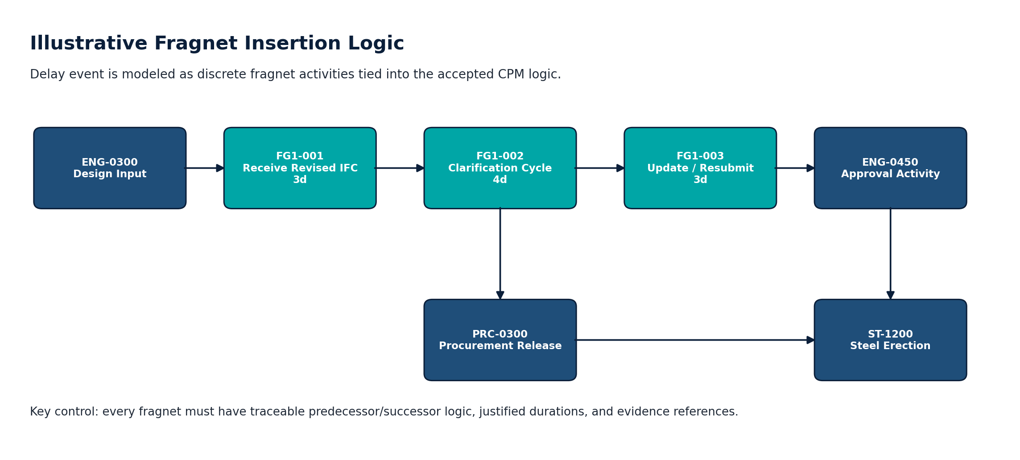 | Fragnet quality gates  • Discrete activities: Do not hide delays inside existing activity durations.  • Evidence-backed duration: Every fragnet duration must be linked to a record.  • Logic integrity: Connect to real predecessors and successors. Avoid artificial open ends.  • Calendar consistency: Use applicable project calendars for working day calculation.  • No manipulation: Do not delete constraints, float, or logic unless justified and recorded.  • Traceability: Fragnet ID must match event ID, activity ID, and document reference.
Fragnet | Frag Act | Description | Dur. | Pred. | Rel. | Succ. | Evidence
FG-001 | FG1-001 | Receive revised IFC drawing | 3 | ENG-0300 | FS+0 | FG1-002 | IFC-DRG-778
FG-001 | FG1-002 | Clarification response cycle | 4 | FG1-001 | FS+0 | FG1-003 | RFI-118
FG-001 | FG1-003 | Update and resubmit shop drawings | 3 | FG1-002 | FS+0 | ENG-0450 | SD-Rev-C

8. Impact Calculation: Baseline vs Pre-Impact vs Impacted
The report must show exactly how delay days were calculated.

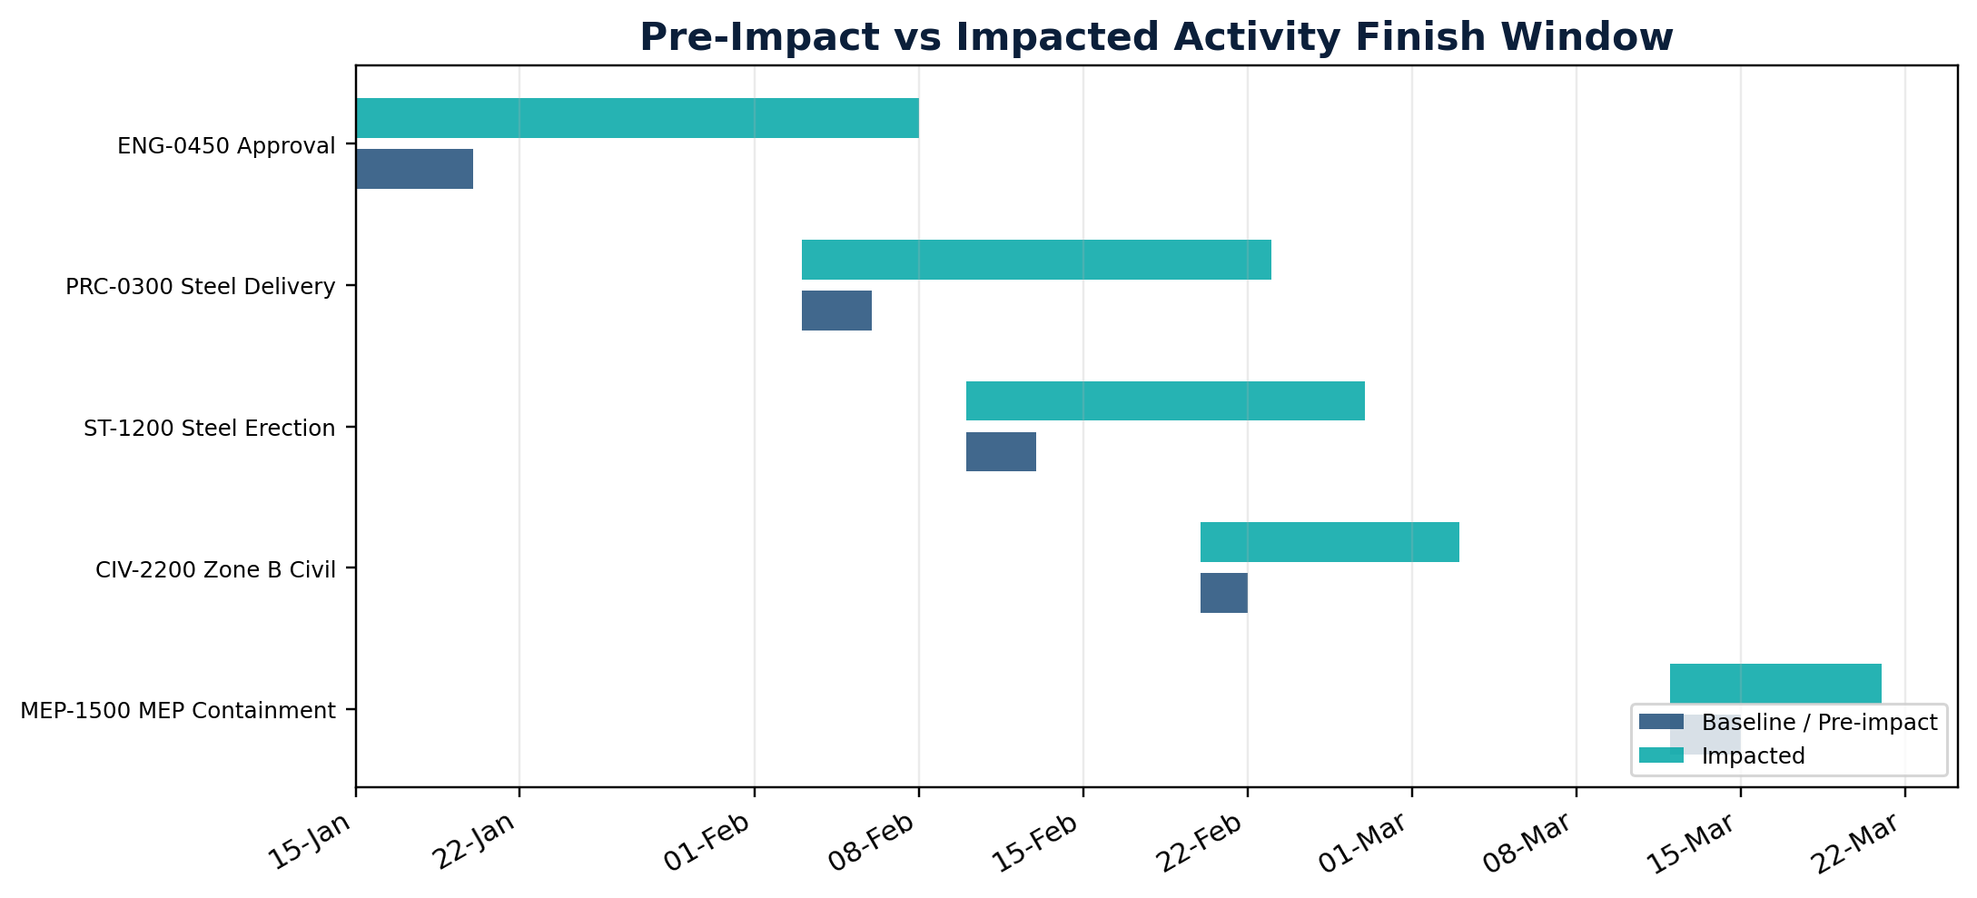 | 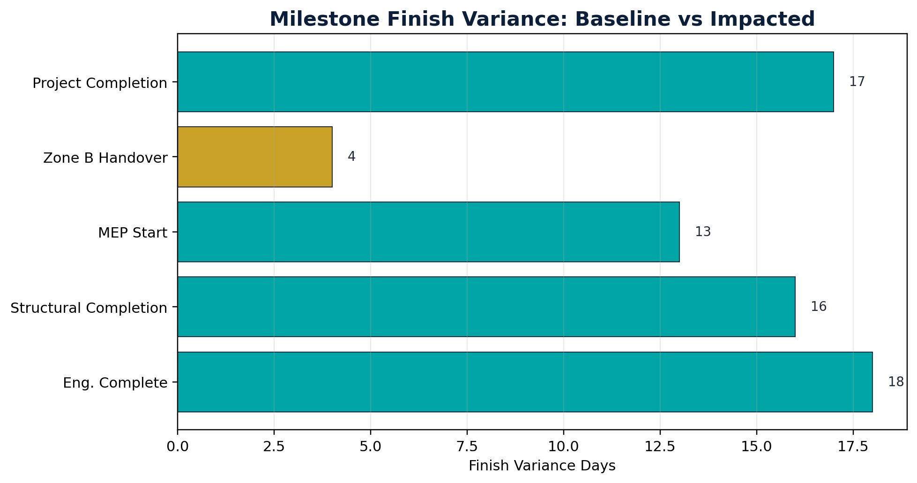
Calculation Item | Value | Interpretation
Baseline Completion | 10-Apr-2026 | Approved contractual / baseline finish.
Pre-Impact Forecast Completion | 10-Apr-2026 | Forecast before inserting the delay fragnet.
Impacted Forecast Completion | 27-Apr-2026 | Forecast after inserting fragnet and recalculating.
Net Impact | 17 days | Impacted finish minus pre-impact finish.
Potential EOT Position | Subject to entitlement | Only after criticality, causation and concurrency tests.
Formula to show in every TIA: Net Delay = Impacted Forecast Finish - Pre-Impact Forecast Finish. Do not compare impacted finish to the original baseline if the project had already moved before the event, unless the contract/methodology specifically requires that basis.

9. Affected Activities, Criticality and Longest Path Review
A delay event is persuasive only when it impacts a critical or longest-path activity and causes downstream delay.

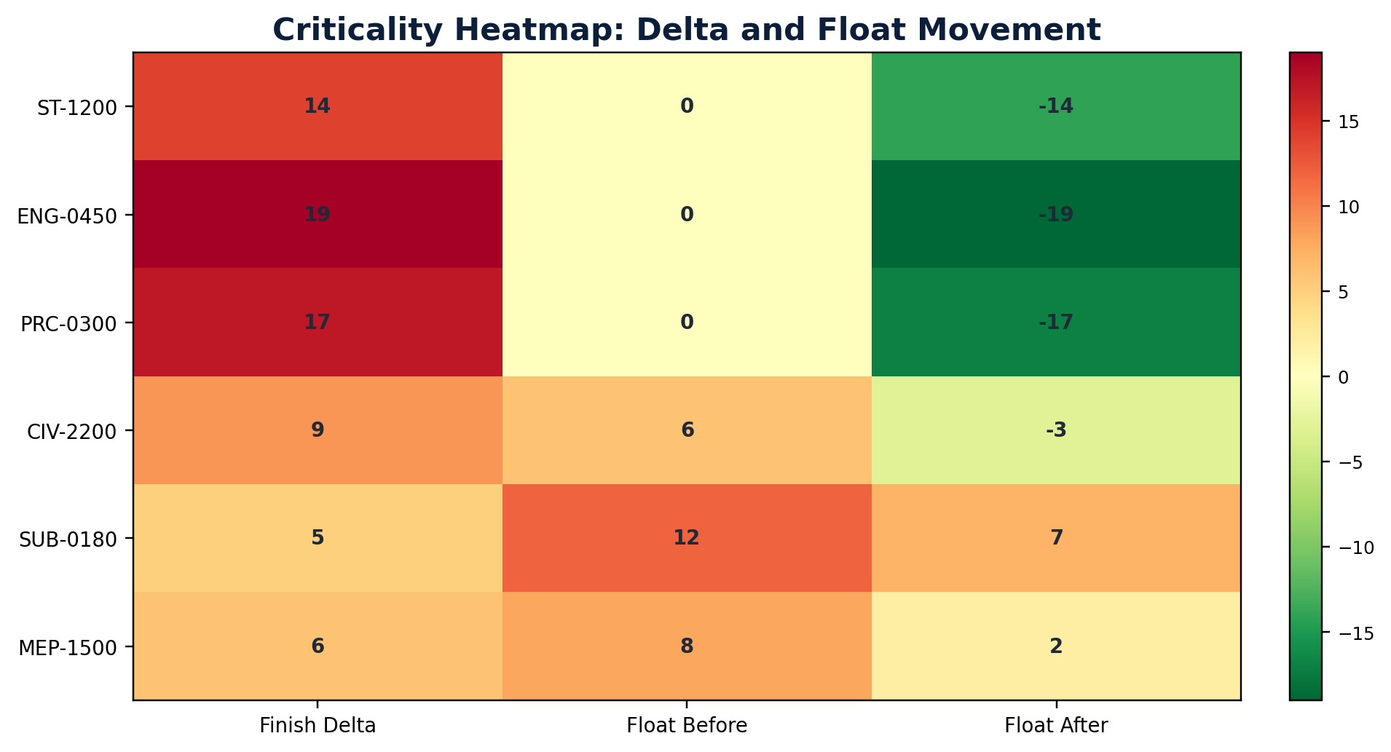 | Criticality review logic  • Check total float before and after fragnet insertion.  • Confirm whether affected activity sits on the current critical / longest path.  • Confirm milestone and project completion movement after schedule recalculation.  • Separate local delay from project completion delay.  • Document every schedule setting used during the recalculation.
Activity | Name | Delta | TF Before | TF After | Critical? | Downstream Milestone
ST-1200 | Erect main steel frames - Area A | 14 | 0 | -14 | Yes | MS-02 Structural Completion
ENG-0450 | Approve steel shop drawings | 19 | 0 | -19 | Yes | MS-02 Structural Completion
PRC-0300 | Deliver structural steel batch 2 | 17 | 0 | -17 | Yes | MS-02 Structural Completion
CIV-2200 | Complete civil works Zone B | 9 | 6 | -3 | No | MS-04 Zone B Handover
SUB-0180 | Maintain subcontractor production rate | 5 | 12 | 7 | No | None
MEP-1500 | Install MEP containment - Level 1 | 6 | 8 | 2 | No | MS-05 MEP Completion

10. Downstream Delay and Cumulative Delay Trend
A clear trend curve helps directors understand when exposure accumulated and which events require management action.

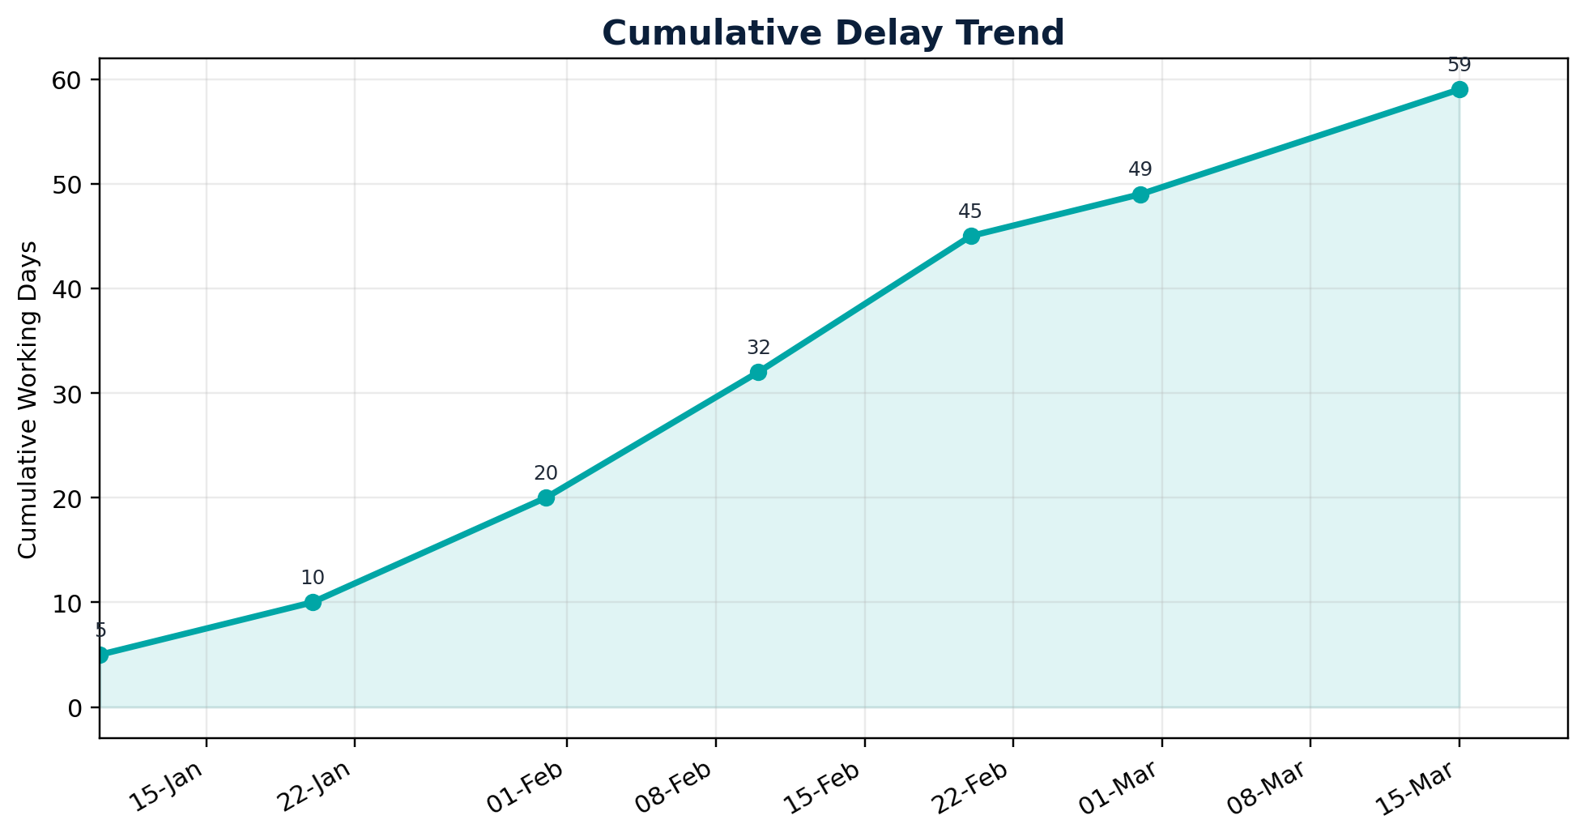 | Period Cumulative Delay Days  10-Jan-26 5  20-Jan-26 10  31-Jan-26 20  10-Feb-26 32  20-Feb-26 45  28-Feb-26 49  15-Mar-26 59
Use the curve to support management decisions, not as a substitute for CPM causation. The final EOT days must come from the recalculated schedule, not from a manual cumulative bar total.

11. Causation, Concurrency and Entitlement Matrix
This section protects the claim by separating time impact from commercial pressure and contractor risk.

Event | Cause | Critical Impact Proven? | Concurrency / Risk Test | Claim Treatment | Required Action
EV-001 | Design clarification | Yes | No material contractor concurrency identified | Proceed as TIA event | Include in EOT narrative.
EV-002 | Approval delay | Yes | Check contractor resubmission quality | Proceed subject to evidence close-out | Attach RFI and approval timestamps.
EV-003 | Late steel delivery | Yes | Check procurement responsibility under contract | Proceed if employer supply responsibility is proven | Attach delivery notes and site readiness records.
EV-004 | Access restriction | Not proven | Possible local float available | Supporting evidence only | Need critical path run and daily reports.
EV-005 | Payment delay | Not proven | Commercial issue only | Commercial only | Need production records proving critical delay.
EV-006 | Manpower shortage | No | Contractor-owned productivity risk | Exclude from EOT | Track as recovery/mitigation item.
Management rule: do not claim an event merely because it occurred. Claim only when the causal chain is complete: event -> affected activity -> critical / longest path -> downstream milestone/project delay -> contractual entitlement.

12. Primavera P6 / CPM Calculation Control Sheet
Record these settings with screenshots and exports so the analysis is repeatable.

Control Item | Recorded Value | Why It Must Be Shown
Schedule file name | [XER / P6 file name] | Native file used for TIA run.
Data date | [DD-MMM-YYYY] | Must match progress cut-off.
Schedule options | [Record settings] | Calculation setting changes can affect critical path.
Longest path / critical path basis | [Longest Path / Total Float threshold] | State how criticality is defined.
Retained logic / progress override | [Setting used] | Must be consistent with accepted project practice.
Out-of-sequence progress handling | [Treatment] | Document any logic anomalies.
Constraints | [List constraints] | Constraints may mask or create artificial criticality.
Calendars | [List calendars] | Affects day count and finish dates.
Open ends | [Count / treatment] | Open starts/finishes can invalidate CPM reliability.
Negative float | [Before / after] | Indicator of schedule pressure and entitlement sensitivity.
Attach: activity export, relationship export, WBS export, calendar list, schedule log, critical path/longest path layout, baseline comparison and impacted XER file.

13. EOT Claim Position and Director Decision Matrix
Convert schedule analysis into a clear decision paper.

Decision Bucket | Events | Delay Days Treatment | Management Action
Valid for TIA | EV-001, EV-002, EV-003 | 37 working days in sample register | Proceed to formal EOT narrative and substantiation pack.
Supporting evidence only | EV-004 | 9 working days local exposure | Keep as contextual support unless critical impact is proven.
Commercial only | EV-005 | 10 working days not included in EOT | Handle under commercial claim track; do not include as schedule delay unless causation is proven.
Not suitable | EV-006 | 8 working days excluded | Exclude from EOT and treat as contractor mitigation/recovery matter.
Not enough data | [Insert if applicable] | TBD | Hold until mandatory records are completed.
EV-001 / EV-002 / EV-003  Approve for EOT Narrative  Evidence-backed sample events | EV-004 / EV-005  Close Evidence Gap  Before claim conversion | EV-006  Exclude from EOT  Contractor-risk sample item

14. Appendices: Evidence Checklist and Glossary
Use this appendix to control completeness before issuing to the Employer / Engineer.

Checklist Item | Status | Required Evidence
Notice issued within contract period | [Yes / No / NA] | Notice letter and delivery confirmation.
Cause established | [Yes / No / NA] | Instruction, RFI, drawing, delivery record, access restriction, etc.
Activity affected | [Yes / No / NA] | Activity ID and WBS shown in P6 export.
Critical / longest path effect | [Yes / No / NA] | Before/after calculation and float movement.
Downstream milestone delay | [Yes / No / NA] | Milestone comparison table and chart.
Concurrency reviewed | [Yes / No / NA] | Contractor delay check and narrative.
Mitigation documented | [Yes / No / NA] | Recovery actions, resequencing, resource mitigation.
Claim value separated from EOT | [Yes / No / NA] | Time entitlement and cost entitlement separated.
Term | Practical Meaning
Fragnet | A small logic-linked sub-network inserted into the CPM schedule to model a delay event.
Data Date | The cut-off date separating actual progress from forecast logic.
Longest Path | The sequence of activities driving project completion in the current schedule model.
Total Float | Available time before an activity delays the project or relevant milestone, depending on schedule rules.
Concurrent Delay | Overlapping delays by different parties that affect the same completion period and require contractual treatment.
End of report template - replace demonstration values before submission.

