TIME IMPACT ANALYSIS REPORT
Executive Delay Analysis Package | Fragnet-Based TIA | EOT Claim Support
Project: Project Intelligence Hub - Delay TIA | Contract: NOT PROVIDED IN UPLOADED FILES | Data Date: 08-Jun-2026 | Revision: Rev. 00
Purpose: quantify the schedule impact of delay events by inserting approved fragnet logic into the accepted CPM programme and measuring movement to the critical / longest path and project completion.

1. Report Map and Usage Protocol
This page explains how decision makers should read the report and how the planning team should update it.

Step | Report Area | Management Question Answered
01 | Executive dashboard | Immediate understanding of claimed days, evidence maturity, criticality, and EOT position.
02 | Data readiness matrix | Confirms whether the analysis is supported by reliable baseline, updates, logic, progress and records.
03 | Delay event register | Shows what happened, where it happened, which activity was affected, and whether the event is valid for TIA.
04 | Fragnet logic | Shows the digital inserted sub-network, activity durations, predecessors, successors and evidence basis.
05 | Impact calculation | Compares pre-impact and post-impact schedule dates to quantify delay days.
06 | Criticality and causation | Confirms whether the impacted activity is critical / longest path and caused downstream delay.
07 | EOT claim position | Converts schedule analysis into a management-level claim recommendation.
How to use: edit the input tables first, refresh the companion Excel dashboard, then update the charts/images in this Word report for formal issue. Keep all assumptions, exclusions and missing evidence visible; do not hide weaknesses from directors.

2. Executive TIA Dashboard
Board-level snapshot of delay exposure, potential entitlement and evidence risk.

111  Total Recorded Working Delay Days  Sum of current event register | 0  Potential EOT Days  Valid-for-TIA sample events only | 0  Critical Events  Events affecting critical / longest path | 0  Missing Evidence Items  Requires immediate close-out

Executive conclusion  • The current uploaded Delay TIA run does not yet prove a director-level EOT case without further evidence and stronger CPM linkage. | 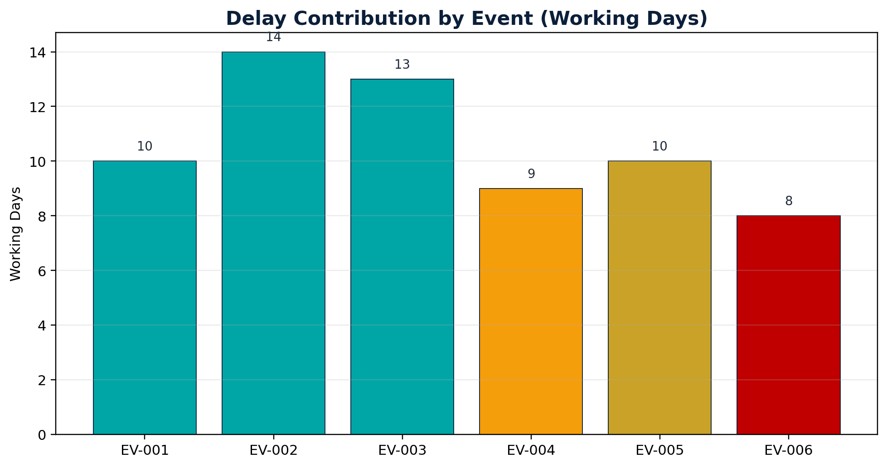
Source Table: Event | Working Days | Classification
EV-001 | 10 | Valid for TIA
EV-002 | 14 | Valid for TIA
EV-003 | 13 | Valid for TIA
EV-004 | 9 | Supporting Evidence Only
EV-005 | 10 | Commercial Only
EV-006 | 8 | Not Suitable

3. Project, Contract and Schedule Control Data
Replace placeholders with contract-specific information before formal submission.

Control Item | Input Value | Why It Matters
Project Name | Project Intelligence Hub - Delay TIA | Required to identify claim package and affected contract.
Employer / Client | ROYA / Employer | Party receiving EOT / TIA submission.
Contractor | SAMCO / Contractor | Claiming / defending party.
Contract Form / Clause | From uploaded contract library and matched clauses | Defines notice, EOT, concurrency and compensation rules.
Accepted Baseline Programme | BL fixed package plus uploaded activity export | Primary logic benchmark.
Impacted Update Programme | Current uploaded Delay TIA analysis context | Programme into which fragnet is inserted.
Calendar Basis | Working-day logic based on uploaded activity schedule context | Must match P6 calculation basis.
Data Date | 08-Jun-2026 | Separates actual progress from forecast logic.
Key governance requirement: the TIA programme must be traceable. Save the native P6 file, XER export, PDF layout, activity/relationship exports, calendars, settings screenshots and schedule log with every TIA issue.

4. Data Readiness Matrix
A TIA is only persuasive when the schedule model and supporting records are complete, contemporaneous and logically connected.

Data Input | Priority | Reason for TIA | Status
Accepted baseline / approved update | Mandatory | Confirms valid starting model for impact insertion. | Complete
Activity list export | Mandatory | Shows activities, dates, float, WBS and status. | Complete
Relationship export | Mandatory | Shows predecessor/successor logic and lag. | Complete
Master activity steel analysis | Mandatory | Provides activity-level shortage and requirement evidence. | Complete
Employer steel supply | Mandatory | Provides employer delivery timing and quantity basis. | Complete
Contract library | High | Supports entitlement, notice, and claim treatment. | Complete
IFC / RFI / payment records | High | Supports concurrency and non-steel causation review. | Complete
BL critical path fixed package | Recommended | Supports baseline criticality comparison. | Complete
SAMCO site supply visibility | Low | Display-only stream for management visibility, excluded from TIA calculations. | Complete
Director checkpoint: if mandatory schedule files or causation records are missing, classify the item as NOT ENOUGH DATA rather than claiming unsupported EOT days.

5. Time Impact Analysis Methodology
The report is structured to show cause, fragnet insertion, schedule recalculation and quantified effect.

Step | Method Action | Control Requirement
1 | Define delay event | Identify the delaying event, responsible party, date window and affected scope.
2 | Select correct programme | Use the accepted baseline or most appropriate update immediately before the event impact.
3 | Validate status and data date | Confirm actual progress is correct and no future progress is mixed into the model.
4 | Build fragnet | Create event-specific activities with evidence-backed durations and logical ties.
5 | Insert into CPM logic | Connect fragnet to predecessor/successor activities without manipulating unrelated logic.
6 | Recalculate schedule | Measure change to critical / longest path and completion / key milestones.
7 | Test causation and concurrency | Confirm the event caused real downstream delay and identify concurrent contractor risk.
8 | Prepare EOT position | Classify entitlement: valid TIA, supporting only, not suitable, not enough data, or commercial only.
Methodology basis: AACE RP 52R-06 and SCL Delay and Disruption Protocol terminology are used as reference language. The contract remains the governing document.

6. Delay Event Register and Classification
Each delay event must be classified before it is allowed into the EOT calculation.

Event | Description | Party | Affected Activity | Working Days | Critical / LP? | Evidence | Decision
EV-001 | Late IFC drawing / design clarification | Employer | ST-1200 | 10 | Yes | Complete | Valid for TIA
EV-002 | Delayed approval of steel shop drawings | Engineer | ENG-0450 | 14 | Yes | Partial | Valid for TIA
EV-003 | Late material delivery to site | Employer | PRC-0300 | 13 | Yes | Complete | Valid for TIA
EV-004 | Area access restriction by third party | Authority | CIV-2200 | 9 | No | Partial | Supporting Evidence Only
EV-005 | Payment delay affecting subcontractor cashflow | Employer | SUB-0180 | 10 | TBD | Missing | Commercial Only
EV-006 | Contractor manpower shortage | Contractor | MEP-1500 | 8 | No | Complete | Not Suitable
Decision rules: YES means valid for TIA; Supporting Evidence Only means useful context but not standalone TIA; Not Suitable means no schedule delay entitlement; Not Enough Data means missing proof; Commercial Only means payment/cost issue unless critical schedule causation is proven.

7. Fragnet Design Requirements
The fragnet is the core technical object in a TIA. It must be clear enough for an independent reviewer to reconstruct.

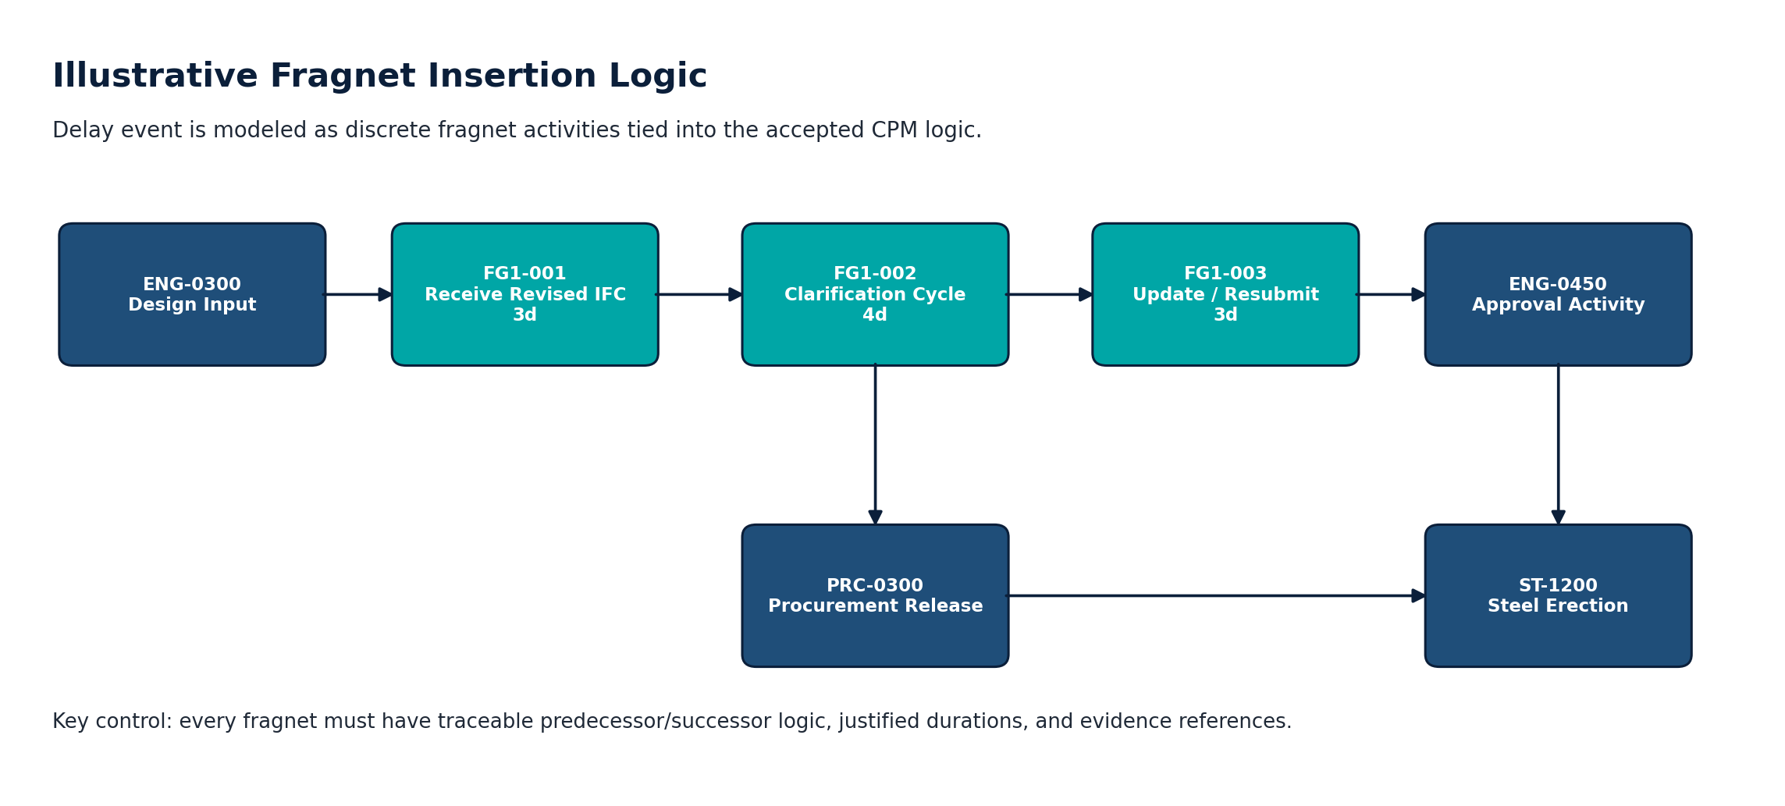 | Fragnet quality gates  • Discrete activities: Do not hide delays inside existing activity durations.  • Evidence-backed duration: Every fragnet duration must be linked to a record.  • Logic integrity: Connect to real predecessors and successors. Avoid artificial open ends.  • Calendar consistency: Use applicable project calendars for working day calculation.  • No manipulation: Do not delete constraints, float, or logic unless justified and recorded.  • Traceability: Fragnet ID must match event ID, activity ID, and document reference.
Fragnet | Frag Act | Description | Dur. | Pred. | Rel. | Succ. | Evidence
FG-001 | FG1-001 | Receive revised IFC drawing | 3 | ENG-0300 | FS+0 | FG1-002 | IFC-DRG-778
FG-001 | FG1-002 | Clarification response cycle | 4 | FG1-001 | FS+0 | FG1-003 | RFI-118
FG-001 | FG1-003 | Update and resubmit shop drawings | 3 | FG1-002 | FS+0 | ENG-0450 | SD-Rev-C

8. Impact Calculation: Baseline vs Pre-Impact vs Impacted
The report must show exactly how delay days were calculated.

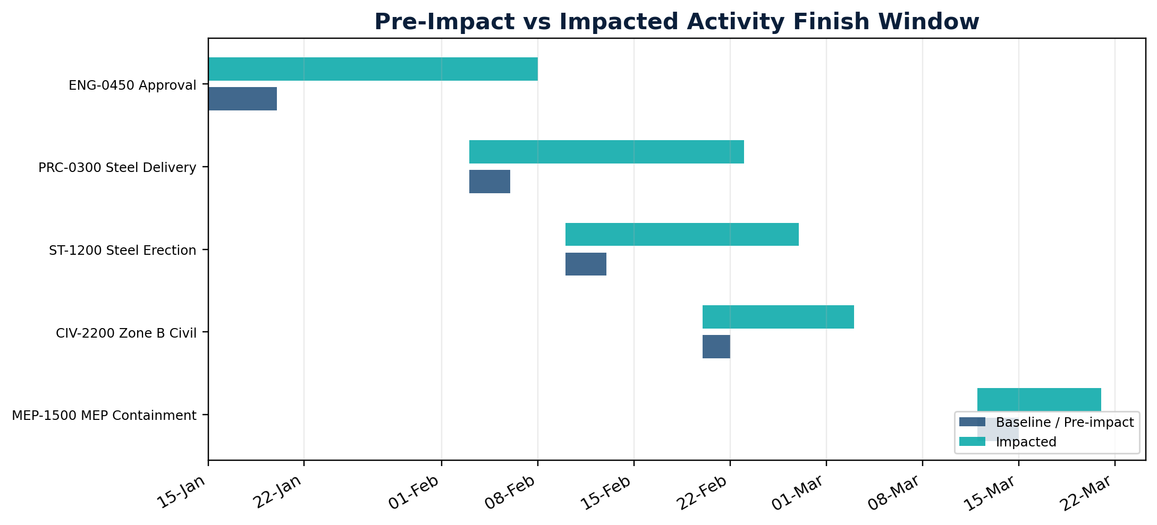 | 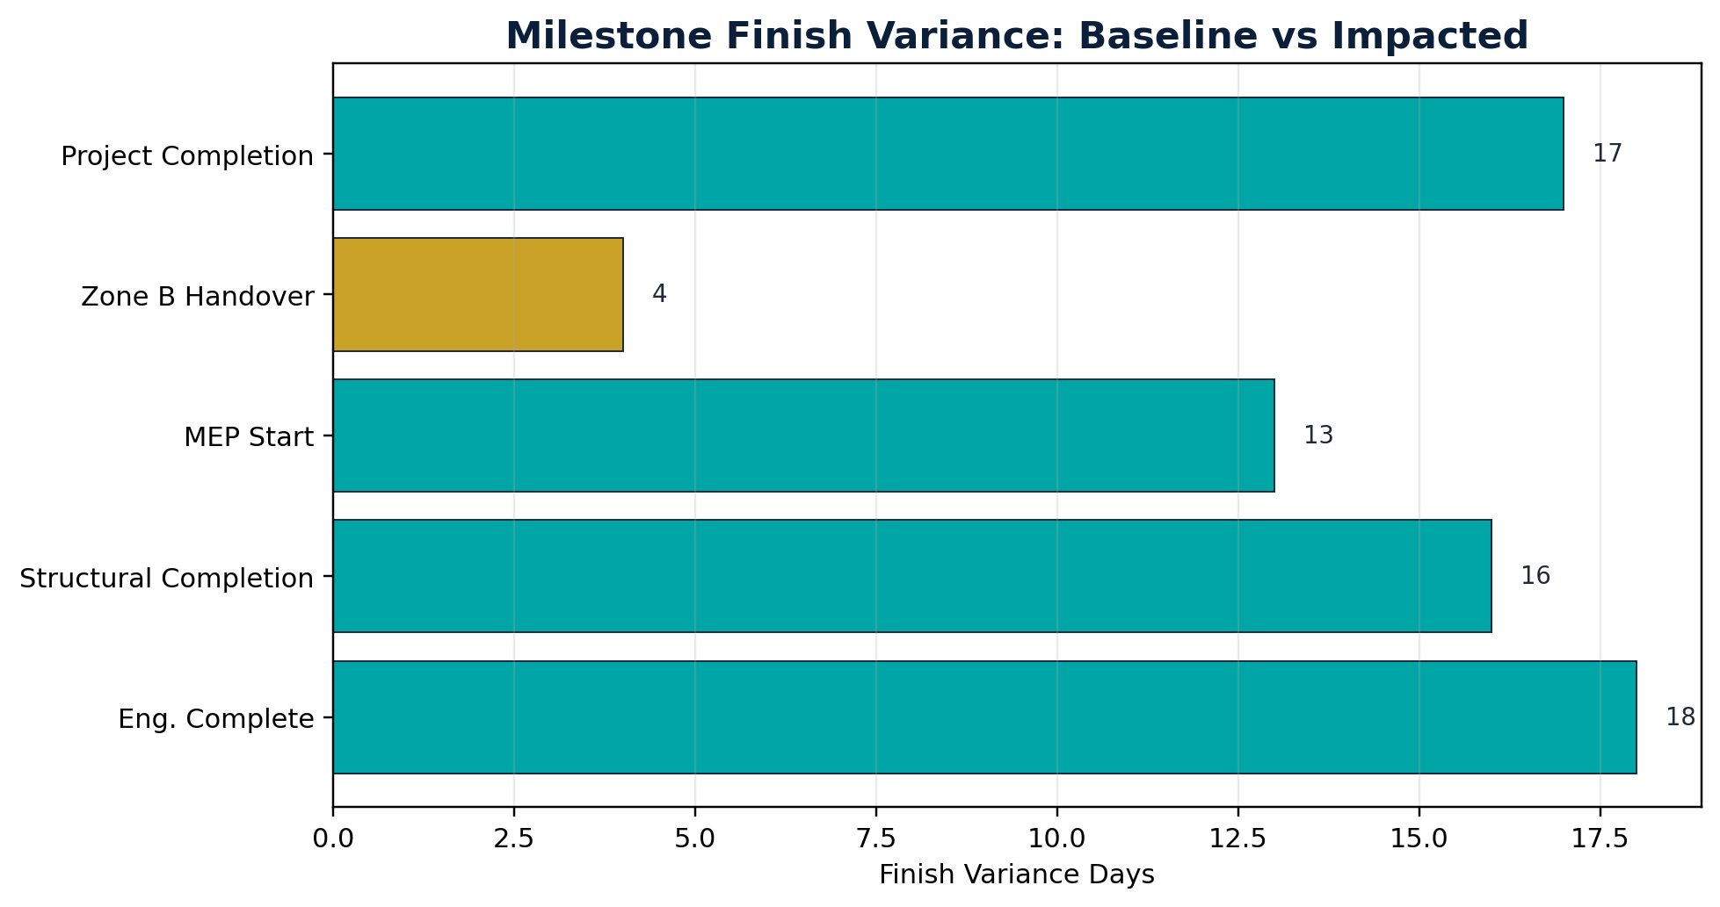
Calculation Item | Value | Interpretation
Baseline Completion | NOT ENOUGH DATA | Baseline finish from uploaded activity evidence.
Pre-Impact Forecast Completion | NOT ENOUGH DATA | Forecast before applying the current fragnet recommendation.
Impacted Forecast Completion | NOT ENOUGH DATA | Forecast represented by the current Delay TIA impact window.
Net Impact | NOT ENOUGH DATA | Impacted finish minus pre-impact finish.
Potential EOT Position | 0 working days | Subject to entitlement, evidence, and concurrency review.
Formula to show in every TIA: Net Delay = Impacted Forecast Finish - Pre-Impact Forecast Finish. Do not compare impacted finish to the original baseline if the project had already moved before the event, unless the contract/methodology specifically requires that basis.

9. Affected Activities, Criticality and Longest Path Review
A delay event is persuasive only when it impacts a critical or longest-path activity and causes downstream delay.

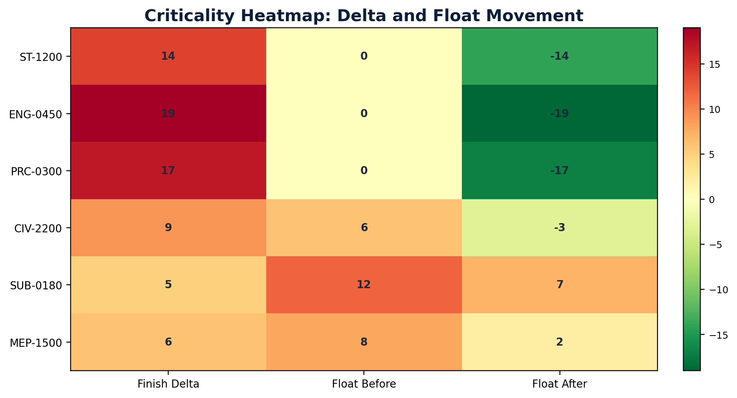 | Criticality review logic  • Check total float before and after fragnet insertion.  • Confirm whether affected activity sits on the current critical / longest path.  • Confirm milestone and project completion movement after schedule recalculation.  • Separate local delay from project completion delay.  • Document every schedule setting used during the recalculation.
Activity | Name | Delta | TF Before | TF After | Critical? | Downstream Milestone
ST-1200 | Erect main steel frames - Area A | 14 | 0 | -14 | Yes | MS-02 Structural Completion
ENG-0450 | Approve steel shop drawings | 19 | 0 | -19 | Yes | MS-02 Structural Completion
PRC-0300 | Deliver structural steel batch 2 | 17 | 0 | -17 | Yes | MS-02 Structural Completion
CIV-2200 | Complete civil works Zone B | 9 | 6 | -3 | No | MS-04 Zone B Handover
SUB-0180 | Maintain subcontractor production rate | 5 | 12 | 7 | No | None
MEP-1500 | Install MEP containment - Level 1 | 6 | 8 | 2 | No | MS-05 MEP Completion

10. Downstream Delay and Cumulative Delay Trend
A clear trend curve helps directors understand when exposure accumulated and which events require management action.

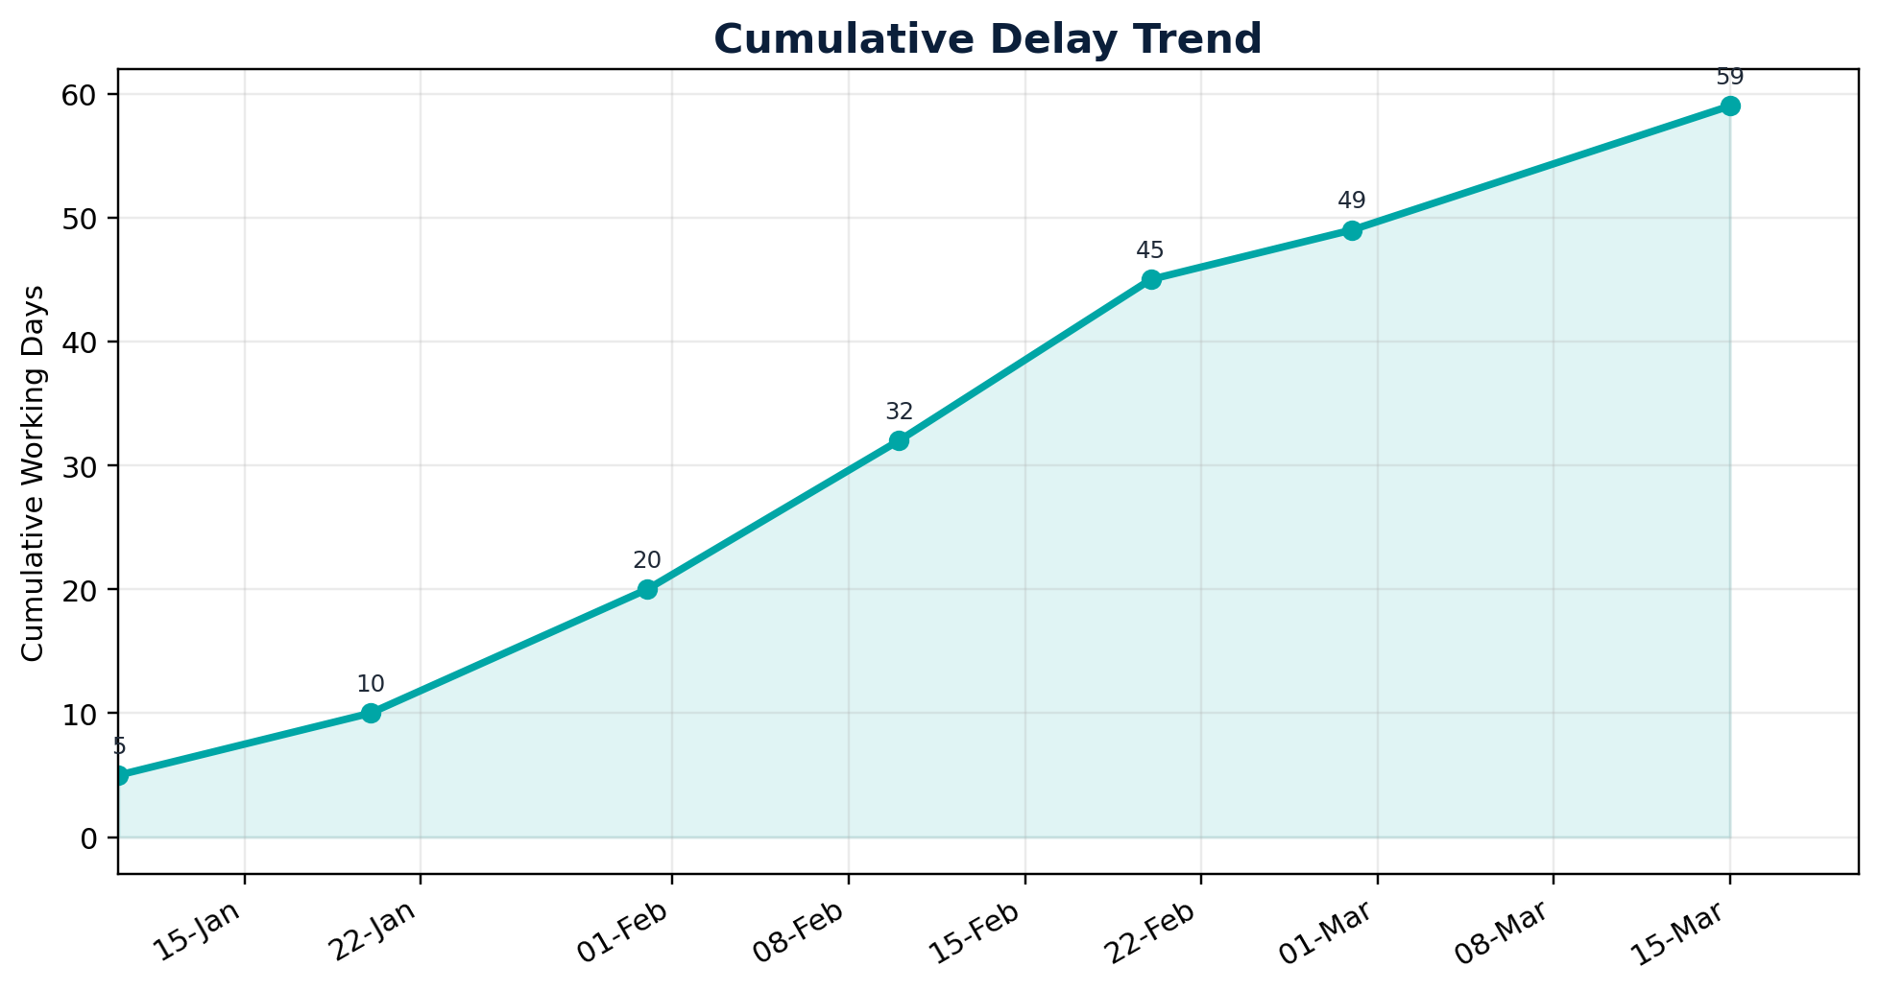 | Period Cumulative Delay Days  10-Jan-26 5  20-Jan-26 10  31-Jan-26 20  10-Feb-26 32  20-Feb-26 45  28-Feb-26 49  15-Mar-26 59
Use the curve to support management decisions, not as a substitute for CPM causation. The final EOT days must come from the recalculated schedule, not from a manual cumulative bar total.

11. Causation, Concurrency and Entitlement Matrix
This section protects the claim by separating time impact from commercial pressure and contractor risk.

Event | Cause | Critical Impact Proven? | Concurrency / Risk Test | Claim Treatment | Required Action
EV-001 | Client Steel Shortage - B01 - RFT - Before CON-B01-FOOT-1050 | No | Concurrent non-steel streams identified for the same activity: RFI 003, SD-REV-001. Review overlapping windows before final entitlement. | Not Enough Data | Close evidence and schedule-link gaps before reliance.
EV-002 | Client Steel Shortage - B04 - RFT - Before CON-B04-FOOT-1050 | No | Needs further concurrency review. | Not Enough Data | Close evidence and schedule-link gaps before reliance.
EV-003 | Client Steel Shortage - B04 - RFT - Before CON-B04-FOOT-1070 | No | Needs further concurrency review. | Not Enough Data | Close evidence and schedule-link gaps before reliance.
EV-004 | Client Steel Shortage - B02 - RFT - Before CON-B02-BAS02-1010 | No | Needs further concurrency review. | Not Enough Data | Close evidence and schedule-link gaps before reliance.
EV-005 | Payment delay | Not proven | Commercial issue only | Commercial only | Need production records proving critical delay.
EV-006 | Manpower shortage | No | Contractor-owned productivity risk | Exclude from EOT | Track as recovery/mitigation item.
Management rule: do not claim an event merely because it occurred. Claim only when the causal chain is complete: event -> affected activity -> critical / longest path -> downstream milestone/project delay -> contractual entitlement.

12. Primavera P6 / CPM Calculation Control Sheet
Record these settings with screenshots and exports so the analysis is repeatable.

Control Item | Recorded Value | Why It Must Be Shown
Schedule file name | 03- p6_activity_export.csv | Primary activity export used for Delay TIA context.
Data date | 2026-06-08 00:00:00 | Must match the reporting cut-off for the TIA run.
Schedule options | Derived from uploaded activity export only | Clarifies that no hidden P6 recalculation options were imported.
Longest path / critical path basis | Critical flag plus near-critical float threshold = 10 days | Defines how TIA criticality was classified.
Retained logic / progress override | Not recorded in uploaded files | Required for full forensic repeatability.
Out-of-sequence progress handling | Not recorded in uploaded files | Can affect critical path movement.
Constraints | Not explicitly recorded | Constraints may create artificial criticality.
Calendars | Not explicitly recorded | Delay days depend on the governing calendar.
Open ends | Not explicitly recorded | Open ends weaken CPM reliability.
Negative float | Derived from current candidate / fragnet outputs only | Supports the severity of affected activities.
Attach: activity export, relationship export, WBS export, calendar list, schedule log, critical path/longest path layout, baseline comparison and impacted XER file.

13. EOT Claim Position and Director Decision Matrix
Convert schedule analysis into a clear decision paper.

Decision Bucket | Events | Delay Days Treatment | Management Action
Not Enough Data | EV-001, EV-002, EV-003, EV-004 | 111 working days | Keep for management visibility until CPM linkage and evidence are closed.
Supporting evidence only | EV-004 | 9 working days local exposure | Keep as contextual support unless critical impact is proven.
Commercial only | EV-005 | 10 working days not included in EOT | Handle under commercial claim track; do not include as schedule delay unless causation is proven.
Not suitable | EV-006 | 8 working days excluded | Exclude from EOT and treat as contractor mitigation/recovery matter.
Not enough data | [Insert if applicable] | TBD | Hold until mandatory records are completed.
EV-001 / EV-002 / EV-003  Approve for EOT Narrative  Evidence-backed sample events | EV-004 / EV-005  Close Evidence Gap  Before claim conversion | EV-006  Exclude from EOT  Contractor-risk sample item

14. Appendices: Evidence Checklist and Glossary
Use this appendix to control completeness before issuing to the Employer / Engineer.

Checklist Item | Status | Required Evidence
Client Steel Shortage - B01 - RFT - Before CON-B01-FOOT-1050 | Medium | Need fuller linked notice or CPM evidence
Client Steel Shortage - B04 - RFT - Before CON-B04-FOOT-1050 | Medium | Need fuller linked notice or CPM evidence
Client Steel Shortage - B04 - RFT - Before CON-B04-FOOT-1070 | Medium | Need fuller linked notice or CPM evidence
Client Steel Shortage - B02 - RFT - Before CON-B02-BAS02-1010 | Medium | Need fuller linked notice or CPM evidence
Downstream milestone delay | [Yes / No / NA] | Milestone comparison table and chart.
Concurrency reviewed | [Yes / No / NA] | Contractor delay check and narrative.
Mitigation documented | [Yes / No / NA] | Recovery actions, resequencing, resource mitigation.
Claim value separated from EOT | [Yes / No / NA] | Time entitlement and cost entitlement separated.
Term | Practical Meaning
Fragnet | A small logic-linked sub-network inserted into the CPM schedule to model a delay event.
Data Date | The cut-off date separating actual progress from forecast logic.
Longest Path | The sequence of activities driving project completion in the current schedule model.
Total Float | Available time before an activity delays the project or relevant milestone, depending on schedule rules.
Concurrent Delay | Overlapping delays by different parties that affect the same completion period and require contractual treatment.
End of report template - replace demonstration values before submission.

