PROFESSIONAL COURSE SERIES
MARKETING PROJECT
MANAGEMENT
LECTURE  07 | MEASUREMENT AND ANALYTICS
COURSE POSITIONING
Strategy | Governance | Delivery | Measurement | Applied Learning
PREPARED FOR | Ahmed Labib
EDITION | Lecture-Based Professional Course
ISSUE DATE | July 2026
A standalone lecture from the premium Marketing Project Management professional course.
CONFIDENTIAL | PROFESSIONAL LEARNING MATERIAL

LECTURE 07 | MEASUREMENT AND ANALYTICS
Building an auditable path from project activity to business value
LECTURE 07 BRIEF | 90 MINUTES
LEARNING OUTCOMES | 1. Design a measurement plan before campaign build and launch.  2. Create a KPI hierarchy spanning delivery, output, outcome and business value.  3. Select attribution or incrementality methods appropriate to the decision and data maturity.
SESSION FLOW | 10 min measurement architecture | 25 min KPI design | 20 min attribution | 25 min KPI-tree workshop | 10 min review
APPLIED OUTPUT | Measurement plan, KPI dictionary and dashboard blueprint.

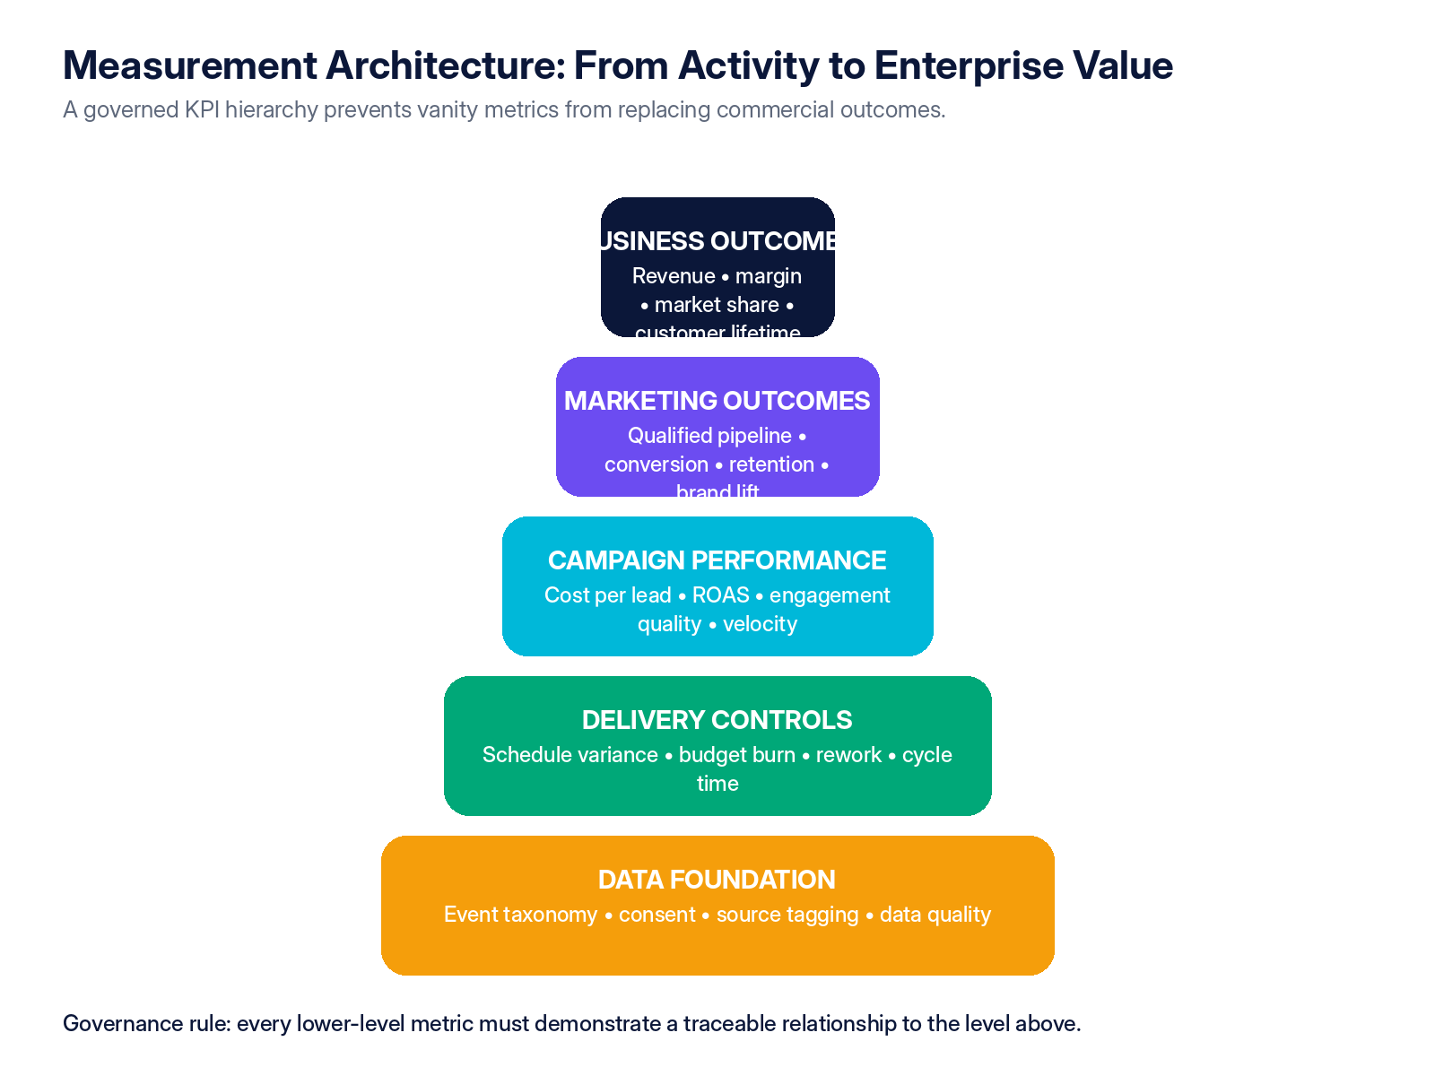
Figure 1 — Recommended KPI hierarchy for governed marketing project management.

7.1 Measurement plan
The source identifies lead generation, lead conversion, utilization and profit margin as example metrics, but a comprehensive system must define exactly how data is created, validated and interpreted. [S1] Google Analytics guidance illustrates the need to identify meaningful events, classify important outcomes as key events and govern how those events feed reporting and attribution. [R2]
Measurement-plan field | Required definition
Business question | The decision the metric must support.
Metric and formula | Precise definition, numerator, denominator, exclusions and currency/time basis.
Baseline and target | Current state, target value, target date and confidence level.
Event / data source | System, event name, parameters, source owner and collection method.
Attribution / causality | How credit is assigned and what the model cannot prove.
Segmentation | Audience, market, product, channel, creative, lifecycle stage or cohort.
Frequency and latency | Real-time, daily, weekly, monthly and expected data delay.
Data quality checks | Completeness, duplication, invalid traffic, consent and reconciliation rules.
Owner and action threshold | Accountable owner, tolerance, alert trigger and required response.

7.2 KPI classes
KPI class | Examples | Caution
Business outcomes | Revenue, contribution margin, market share, customer lifetime value, retention. | Often affected by multiple non-marketing factors.
Marketing outcomes | Qualified pipeline, conversion, incremental sales, brand lift, share of search. | Requires consistent definitions and causal humility.
Campaign metrics | Reach quality, engagement, CTR, cost per result, ROAS, frequency, completion rate. | May reward platform behavior without proving enterprise value.
Project controls | Milestone variance, schedule reliability, cost variance, cycle time, rework, approval latency. | Measures delivery health, not campaign effectiveness.
Data quality | Tag coverage, event validity, identity match, consent rate, source completeness. | Poor data can make every downstream metric unreliable.
Learning metrics | Hypotheses tested, decision velocity, reusable insights, test confidence. | Quantity of tests is not equivalent to learning quality.

7.3 Attribution and incrementality
Attribution allocates observed credit; it does not automatically establish causal impact. Marketing leaders should distinguish platform-reported attribution from independent analytics, matched-market or holdout tests, lift studies and broader commercial evidence. The appropriate method depends on decision value, data availability, risk and cost.
Method | Best use | Principal limitation
Rule-based attribution | Operational reporting and transparent channel comparison. | Sensitive to the selected rule and customer-journey visibility.
Data-driven attribution | Large datasets with stable event collection. | Model opacity and dependence on platform data.
Marketing mix modeling | Strategic budget allocation across channels and time. | Requires sufficient history and statistical expertise.
Incrementality / holdout testing | Estimating causal lift for a specific intervention. | Operational complexity and potential sample-size constraints.
Brand lift / research | Awareness, consideration and perception effects. | Survey design, cost and response bias.
Qualitative evidence | Complex B2B journeys, strategic accounts and new-category learning. | Not directly scalable or fully attributable.

DASHBOARD DESIGN RULE
Every executive dashboard should show outcomes, forecast, delivery variance, data quality and required decisions—not only historical campaign metrics.

Applied learning and assessment
LECTURE 07 APPLICATION
APPLIED WORKSHOP | Build a KPI tree for one marketing project. For each KPI define formula, owner, data source, frequency, target, decision threshold and known limitation. Add a practical attribution or incrementality approach.
KNOWLEDGE CHECK | 1. Why should output metrics not be treated as business outcomes?  2. What makes a KPI auditable and decision-useful?  3. When is experimental incrementality preferable to multi-touch attribution?

