PROFESSIONAL COURSE SERIES
MARKETING PROJECT
MANAGEMENT
LECTURE  11 | TARGET OPERATING MODEL
COURSE POSITIONING
Strategy | Governance | Delivery | Measurement | Applied Learning
PREPARED FOR | Ahmed Labib
EDITION | Lecture-Based Professional Course
ISSUE DATE | July 2026
A standalone lecture from the premium Marketing Project Management professional course.
CONFIDENTIAL | PROFESSIONAL LEARNING MATERIAL

LECTURE 11 | TARGET OPERATING MODEL
An integrated value stream with embedded controls and clear accountability
LECTURE 11 BRIEF | 90 MINUTES
LEARNING OUTCOMES | 1. Translate governance principles into an end-to-end marketing delivery value stream.  2. Define process ownership, accountability, information flows and control points.  3. Establish a governance calendar for portfolio, project, performance and learning reviews.
SESSION FLOW | 10 min operating-model concept | 25 min value stream | 20 min roles and controls | 25 min current-to-target workshop | 10 min review
APPLIED OUTPUT | Target operating model blueprint and governance calendar.

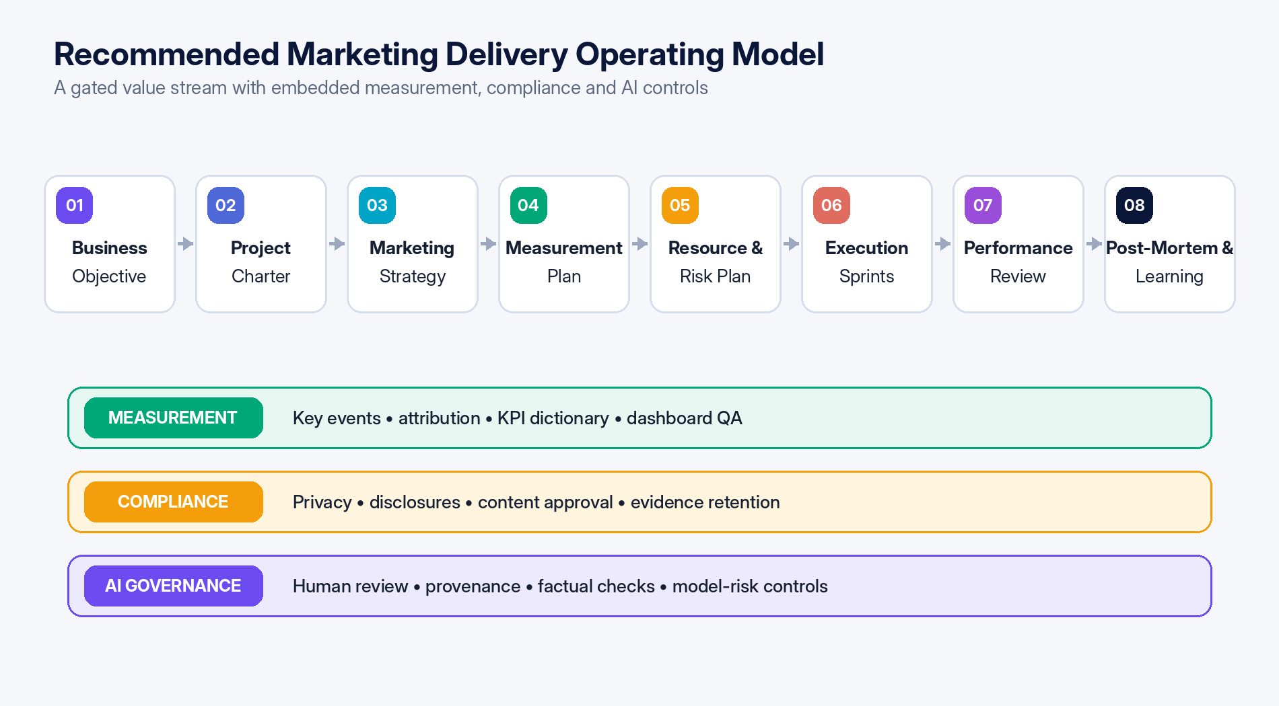
Figure 2 — Target operating model: eight delivery stages supported by measurement, compliance and AI control lanes.

11.1 Operating principles
1. Outcome before output: every project begins with a business question and measurable intended effect.
2. One approved baseline: scope, milestones, budget, resources, risk and measurement are version-controlled.
3. Governed flow: intake, feasibility, baseline, launch and closure each have explicit exit criteria.
4. Data by design: measurement and consent are specified before build, not after launch.
5. Human accountability: tools and AI support decisions but do not own them.
6. Exception-driven management: routine delivery is visible; leadership attention is reserved for variance and decisions.
7. Learning compounds: post-mortem actions update templates, estimates, controls and reusable assets.

11.2 Accountability model
Role | Primary accountability | Key artifacts
Executive sponsor | Business outcome, funding, priority and escalation decisions. | Business case, gate approvals and exception decisions.
Marketing operations / PMO | Framework, portfolio intake, standards, reporting and maturity. | Templates, portfolio dashboard, governance calendar and process metrics.
Project / campaign manager | Integrated plan, coordination, forecast, risk and change control. | Charter, WBS, schedule, status, logs and closure.
Workstream owner | Quality and on-time delivery of assigned outputs. | Work plan, deliverables, estimates and evidence.
Analytics / RevOps owner | Measurement design, data quality, attribution and performance interpretation. | Measurement plan, event specification, dashboard and QA.
Legal / privacy / security | Risk-based approval and policy compliance. | Review criteria, approvals and exception records.
Finance / procurement | Budget integrity, commitment control and commercial assurance. | Cost baseline, forecast, contracts, PO and reconciliation.
System owner | Configuration, integration, access and platform reliability. | Architecture, roles, support process and audit evidence.

11.3 Governance calendar
Cadence | Governance activity | Decision focus
Continuous | Intake and triage | Completeness, urgency and routing.
Weekly | Delivery and risk review | Forecast, blockers, changes and short-term capacity.
Biweekly | Portfolio and resource review | Priorities, demand-capacity trade-offs and cross-project dependencies.
Monthly | Executive performance review | Outcomes, budget, risk, data quality and major decisions.
Quarterly | Capability and tool review | Maturity, process efficiency, adoption, architecture and training needs.
Per project | Launch gate and closure review | Readiness, acceptance, value and lessons learned.

Applied learning and assessment
LECTURE 11 APPLICATION
APPLIED WORKSHOP | Map the current marketing workflow from intake to benefits review. Mark delays, handoff failures, duplicate entry and control gaps; redesign the target flow with owners, stage gates, systems and decision forums.
KNOWLEDGE CHECK | 1. What is the difference between a process map and an operating model?  2. Where should measurement, privacy and approval controls enter the value stream?  3. How does a governance calendar improve decision velocity?

