PROFESSIONAL COURSE SERIES
MARKETING PROJECT
MANAGEMENT
LECTURE  12 | 90-DAY IMPLEMENTATION ROADMAP
COURSE POSITIONING
Strategy | Governance | Delivery | Measurement | Applied Learning
PREPARED FOR | Ahmed Labib
EDITION | Lecture-Based Professional Course
ISSUE DATE | July 2026
A standalone lecture from the premium Marketing Project Management professional course.
CONFIDENTIAL | PROFESSIONAL LEARNING MATERIAL

LECTURE 12 | 90-DAY IMPLEMENTATION ROADMAP
Deploying a controlled pilot before scaling process and technology
LECTURE 12 BRIEF | 90 MINUTES
LEARNING OUTCOMES | 1. Sequence design, pilot and scale activities into a controlled 90-day program.  2. Define phase exit criteria, ownership, dependencies and measurable adoption outcomes.  3. Develop an indicative implementation budget and risk-adjusted rollout plan.
SESSION FLOW | 10 min roadmap logic | 20 min Days 1–30 | 20 min Days 31–60 | 15 min Days 61–90 | 15 min roadmap workshop | 10 min review
APPLIED OUTPUT | Owned 90-day implementation plan with gates, budget and success criteria.

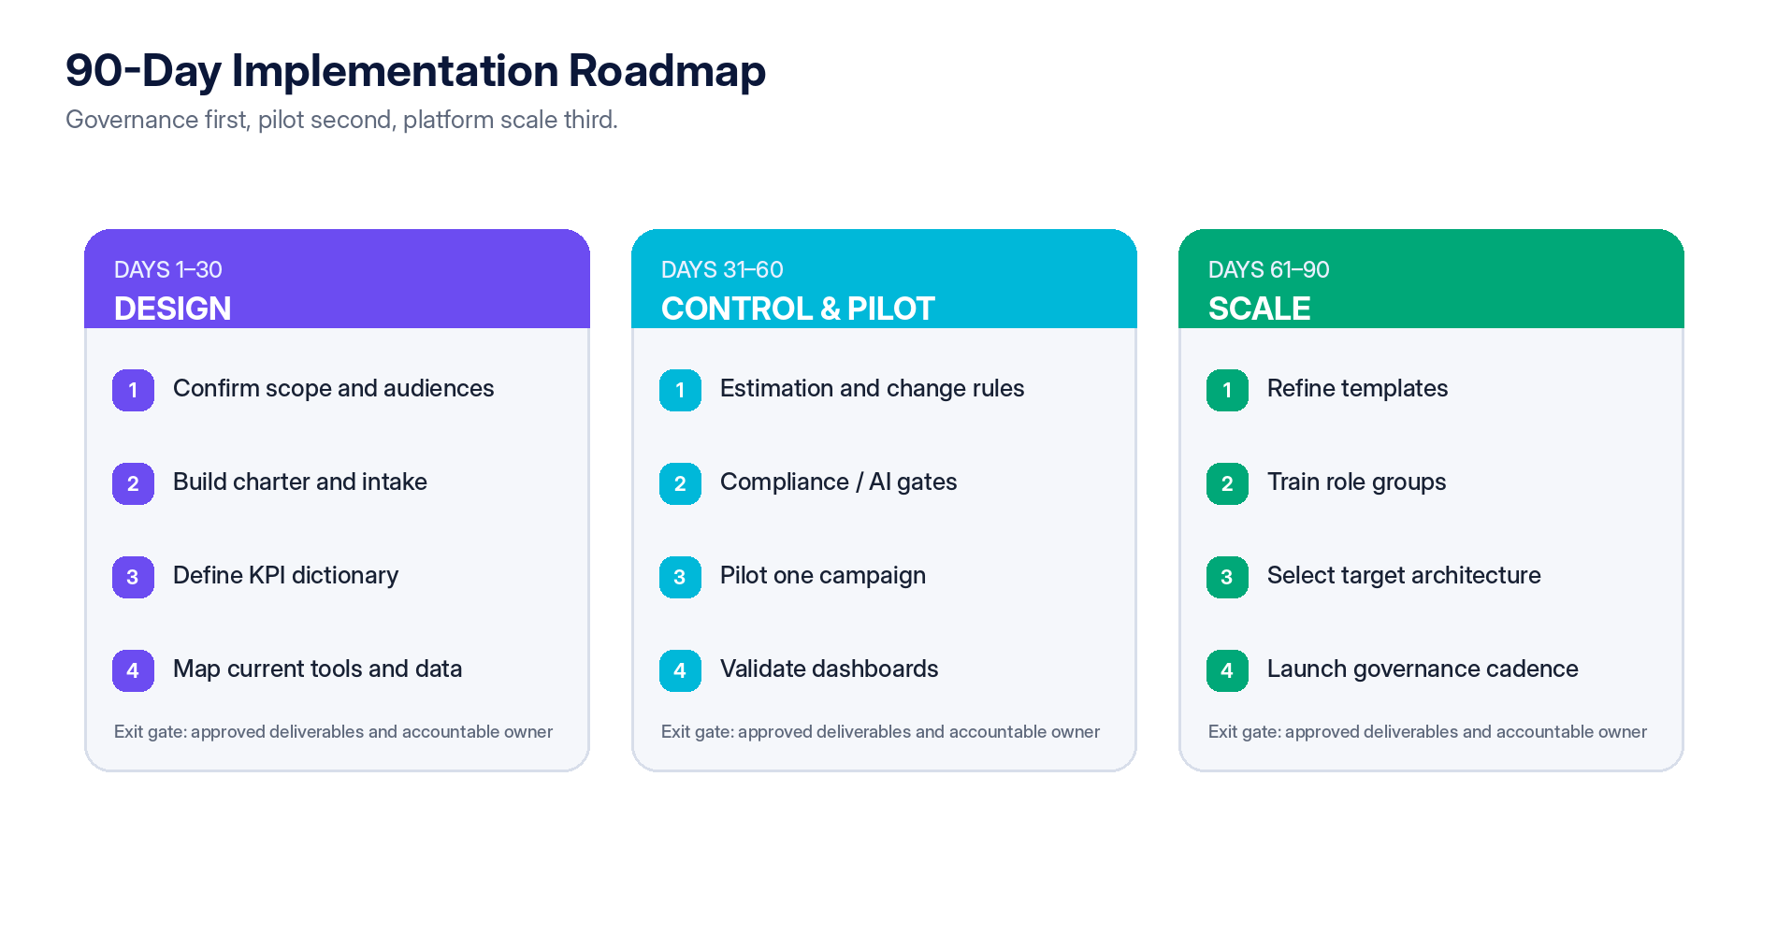
Figure 3 — Recommended 90-day roadmap with design, pilot and scale phases.

12.1 Phase 1 — Design (Days 1–30)
Work package | Deliverable | Exit criterion
Scope and stakeholder alignment | Defined audience, campaign types, objectives and governance sponsor. | Leadership confirms target use cases and authority.
Process mapping | Current-state intake-to-closure workflow and pain-point analysis. | Major handoffs, delays, duplicate data and control gaps are documented.
Core templates | Charter, intake, status, risk, change, measurement and closeout templates. | Templates approved for pilot.
KPI and data design | KPI dictionary, event taxonomy, data owners and quality checks. | Measurement owner signs off.
Tool inventory | Systems, integrations, licenses, duplication and constraints. | Architecture baseline completed.

12.2 Phase 2 — Controls and pilot (Days 31–60)
Work package | Deliverable | Exit criterion
Governance rules | Stage gates, tolerance thresholds, approval SLAs and change authority. | Decision rights approved.
Compliance and AI | Launch checklist, disclosure, privacy and AI-review controls. | Control owners approve pilot use.
Pilot campaign | One representative project managed through the full framework. | Baseline established and weekly control cycle operating.
Dashboard validation | Delivery, budget, outcome and data-quality dashboard. | Metrics reconcile to source systems.
Training | Role-based training for sponsor, PM, workstream, analytics and reviewers. | Users demonstrate required tasks.

12.3 Phase 3 — Scale (Days 61–90)
Work package | Deliverable | Exit criterion
Pilot review | Benefits, friction, defects, adoption and lessons report. | Corrective actions agreed.
Template refinement | Updated standards and campaign-archetype variants. | Version 1.0 control pack approved.
Architecture decision | Target platform / integration model and vendor shortlist. | Business case and procurement plan approved.
Rollout plan | Team sequence, migration, training, support and governance schedule. | Owners and dates committed.
Maturity baseline | Capability score and 12-month improvement backlog. | Executive review completed.

12.4 Illustrative implementation budget
The following figures are planning assumptions only. They must be replaced with local labor rates, vendor quotations, integration requirements and regulatory scope before approval.
Cost element | Lean retrofit | Consolidated rollout | Governance-first transformation
Process design and templates | $4,000 | $8,000 | $15,000
Analytics and KPI setup | $3,000 | $7,500 | $18,000
Privacy / compliance design | $2,000 | $5,000 | $12,000
AI governance and policy | $1,500 | $4,000 | $10,000
Tool configuration / migration | $3,500 | $12,000 | $30,000
Training and enablement | $2,000 | $5,000 | $12,000
Contingency | $2,000 | $6,500 | $18,000
Estimated total | $18,000 | $48,000 | $115,000

Applied learning and assessment
LECTURE 12 APPLICATION
APPLIED WORKSHOP | Create a 90-day roadmap for one pilot campaign. Define workstreams, owners, dependencies, phase exit gates, adoption metrics, training, data migration, governance forums and scale/no-scale decision criteria.
KNOWLEDGE CHECK | 1. Why should process design precede broad technology rollout?  2. What evidence is required to exit the pilot phase?  3. Which adoption and control metrics should be measured during implementation?

