PROFESSIONAL COURSE SERIES
MARKETING PROJECT
MANAGEMENT
LECTURE  13 | MATURITY MODEL, CAPSTONE AND EXECUTIVE ACTION
COURSE POSITIONING
Strategy | Governance | Delivery | Measurement | Applied Learning
PREPARED FOR | Ahmed Labib
EDITION | Lecture-Based Professional Course
ISSUE DATE | July 2026
A standalone lecture from the premium Marketing Project Management professional course.
CONFIDENTIAL | PROFESSIONAL LEARNING MATERIAL

LECTURE 13 | MATURITY MODEL, CAPSTONE AND EXECUTIVE ACTION
Sequencing capability development and executive action
LECTURE 13 BRIEF | 90 MINUTES
LEARNING OUTCOMES | 1. Assess current capability across governance, delivery, resources, finance, data, risk and technology.  2. Prioritize improvements based on value, feasibility, dependency and organizational readiness.  3. Integrate the course outputs into a decision-ready marketing project management transformation plan.
SESSION FLOW | 10 min maturity model | 20 min assessment dimensions | 20 min recommendations | 30 min capstone integration | 10 min review
APPLIED OUTPUT | Capstone: executive marketing project management transformation roadmap.

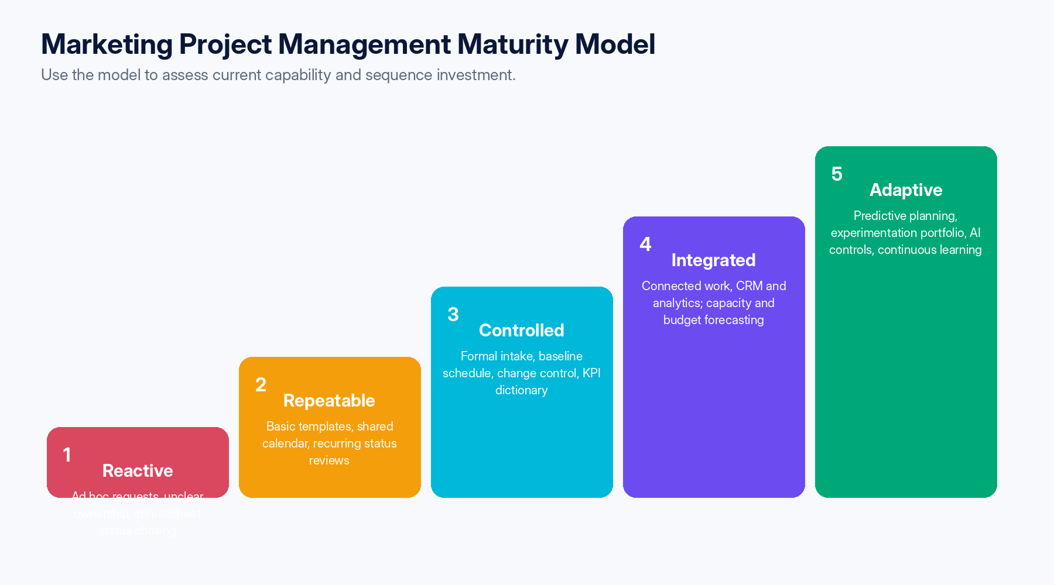
Figure 4 — Five-level maturity model for marketing project management.

13.1 Maturity assessment dimensions
Dimension | Level 1 signal | Level 3 signal | Level 5 signal
Strategy and portfolio | Requests arrive ad hoc. | Formal intake and prioritization. | Dynamic portfolio optimized for value and learning.
Planning and control | Dates and scope are informal. | Approved baselines and change control. | Predictive forecasts and reference-class planning.
Resources | Assignments are reactive. | Role-based capacity and utilization controls. | Scenario planning and capability-market intelligence.
Finance | Spend tracked after the fact. | Time-phased budget and EAC. | Integrated value, profitability and optimization decisions.
Measurement | Vanity metrics and manual reports. | KPI dictionary, events and dashboard ownership. | Causal testing, predictive insight and governed automation.
Risk and compliance | Late review and undocumented approvals. | Embedded gates and evidence retention. | Risk sensing and policy-as-workflow automation.
Technology | Fragmented tools and duplicate data. | Defined authoritative systems and integrations. | Adaptive architecture with strong data lineage and portability.
Learning | Lessons remain personal. | Post-mortems and improvement log. | Reusable knowledge and continuous process optimization.

13.2 Executive recommendations
Priority | Recommendation | Expected result
1 | Mandate a standard charter, intake gate and accountable sponsor for material marketing projects. | Reduces low-value work and ambiguity.
2 | Create a governed measurement architecture before expanding dashboards or automation. | Improves trust, attribution discipline and decision quality.
3 | Introduce a baseline and formal change-control process with explicit trade-offs. | Protects schedule, budget and quality.
4 | Plan capacity by skill, timing and complexity; limit work-in-progress. | Improves throughput and reduces hidden overload.
5 | Embed privacy, disclosures, rights, accessibility and AI review into launch readiness. | Reduces legal, brand and rework risk.
6 | Select tools through a weighted pilot based on the target operating model. | Avoids tool-first transformation and lock-in.
7 | Institutionalize post-mortems, estimation actuals and maturity reviews. | Creates compounding operational learning.

FINAL POSITION
The attachment is a credible starting point, especially for agency environments, but not a complete governance model. Its lifecycle should be retained and strengthened with portfolio gates, measurement design, formal change control, compliance, AI governance and evidence-based tool selection.

Applied learning and assessment
LECTURE 13 APPLICATION
APPLIED WORKSHOP | Complete the maturity assessment, select the three highest-priority capability gaps and consolidate the charter, controls, KPI architecture, risk pack, operating model and 90-day roadmap into a concise executive proposal.
KNOWLEDGE CHECK | 1. Why should maturity improvement be sequenced rather than pursued in parallel?  2. Which capability gaps create the greatest enterprise exposure?  3. What evidence should leadership require before approving scale-up?

