AUTOPHAGY, FASTING, AND CANCER
Evidence Review and 100-Day Safety Framework
مراجعة علمية وخطة أمان لمدة 100 يوم

REPORT STATUS
Formal evidence-based working report. This document is not a prescription and must not replace the treating oncologist or oncology dietitian.

CRITICAL SAFETY POSITION
No 100-day fasting protocol has been proven to cure cancer. During active cancer treatment, fasting is not routinely recommended because malnutrition, muscle loss, dehydration, and treatment intolerance can be dangerous.

Prepared for: Ahmed Labib
Issue Date: 2 July 2026

تنبيه طبي مهم
هذا الملف لا يقدّم علاجًا للسرطان ولا يوصي بالصيام كبديل للجراحة أو العلاج الكيميائي أو الإشعاعي أو المناعي أو الهرموني. لا توجد حتى الآن خطة صيام لمدة 100 يوم ثبت علميًا أنها تعالج السرطان أو تمنع عودته.
بالنسبة لمريض السرطان الذي يتلقى علاجًا نشطًا، الأولوية الطبية هي الحفاظ على الوزن والعضلات والطاقة والسوائل والقدرة على تحمّل العلاج. أي تجربة للصيام يجب أن تتم فقط بعد موافقة صريحة من طبيب الأورام وأخصائي التغذية العلاجية، ويفضّل داخل بروتوكول بحثي معتمد.
الخطة الواردة في هذا التقرير مقسمة إلى مسارين: مسار حماية التغذية أثناء العلاج، ومسار اختياري محدود لتوقيت الوجبات لدى المتعافي المستقر بعد انتهاء العلاج، بشرط عدم وجود فقدان وزن أو سوء تغذية.

Emergency stop rules
Stop any fasting attempt and contact the medical team for fainting, confusion, repeated vomiting, severe diarrhea, inability to drink, reduced urine, chest pain, palpitations, low blood glucose symptoms, rapidly worsening weakness, or ongoing unintentional weight loss.

Table of Contents
1. Executive Summary
2. Yoshinori Ohsumi and the Nobel Prize
3. What Autophagy Is—and Is Not
4. Fasting, Autophagy, and Human Evidence
5. Fasting and Cancer: Current Evidence
6. 100-Day Safety Framework for Cancer Patients
7. 100-Day General Adult Fasting Plan
8. Monitoring, Stop Criteria, and Medical Review
9. Frequently Repeated Claims: Evidence Check
10. Practical Food and Hydration Framework
11. References

1. Executive Summary
Yoshinori Ohsumi received the 2016 Nobel Prize in Physiology or Medicine for discovering key mechanisms of autophagy—the cellular system that degrades and recycles damaged or unnecessary components. His experiments established fundamental biology; they did not prove that prolonged fasting cures cancer.
Autophagy is active at baseline and changes with nutrient availability, exercise, infection, cellular damage, and other stress signals. In humans, there is no validated clock stating that autophagy “starts” after exactly 16, 24, 48, or 72 hours of fasting. Direct measurement in human tissues is difficult, and findings from yeast, cultured cells, and animals cannot be converted into a universal fasting prescription.
Cancer creates an additional complexity: autophagy may help prevent early cellular damage, yet established tumors can sometimes use autophagy to survive stress. Therefore, increasing autophagy is not automatically anti-cancer.
The European Society for Clinical Nutrition and Metabolism (ESPEN) advises against energy-restricting diets in patients who are malnourished or at risk of malnutrition. Its cancer nutrition guideline states that available human fasting studies are small and do not establish benefit during chemotherapy; fasting before, during, or after anticancer agents is therefore not recommended as routine care.
This report provides two distinct 100-day pathways:
- Active treatment / weight loss / poor intake: no therapeutic fasting. Follow the nutrition-protection pathway to preserve body weight, muscle mass, hydration, and treatment tolerance.
- Stable survivor / off active treatment / no malnutrition: an optional, cautious meal-timing pathway beginning with 12:12 and generally not exceeding 14:10 unless the oncology team approves. This is a wellness strategy, not cancer treatment.
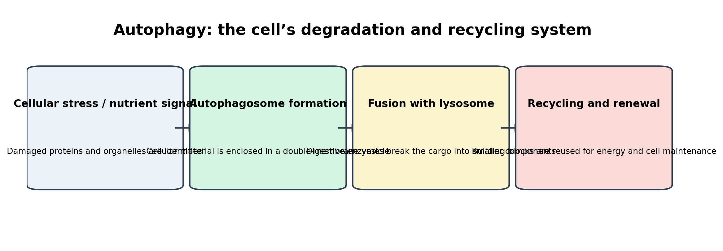
Figure 1. Simplified cellular recycling pathway.

2. Yoshinori Ohsumi and the Nobel Prize
The Nobel Prize in Physiology or Medicine 2016 was awarded solely to Yoshinori Ohsumi “for his discoveries of mechanisms for autophagy.” His decisive work used baker’s yeast because yeast provides a controllable model for studying fundamental cellular pathways.
Ohsumi blocked degradation inside the yeast vacuole, then stimulated autophagy by starving the cells. Autophagosomes accumulated and became visible under the microscope. He subsequently screened thousands of yeast mutants and identified approximately 15 genes essential for autophagy. Later work showed that closely related machinery operates in human cells.

What the discovery established
- Cells package damaged proteins, organelles, and other material into autophagosomes.
- Autophagosomes fuse with lysosomes, where the contents are broken down.
- The resulting components can be reused as building blocks and energy sources.
- Autophagy is relevant to starvation responses, infection, development, aging, neurodegeneration, and cancer biology.

What the discovery did not establish
- It did not prove that fasting cures cancer.
- It did not establish a universal fasting duration for humans.
- It did not show that more autophagy is always better.
- It did not validate internet claims that every person should undertake prolonged water fasting.

3. What Autophagy Is—and Is Not
Concept | Evidence-based meaning | Common misconception
Baseline activity | Autophagy occurs continuously at different levels in living cells. | Autophagy is completely “off” while eating.
Fasting response | Nutrient deprivation can increase autophagy signaling in experimental systems. | Every person reaches the same autophagy level at the same hour.
Cancer biology | Autophagy may suppress damage in normal cells but can also support established tumor survival. | Any intervention that increases autophagy must kill cancer.
Clinical application | Drugs targeting autophagy are an active research area. | Self-directed fasting is equivalent to a tested cancer drug.
Measurement | Human autophagy is tissue-specific and difficult to measure directly. | Ketones, hunger, or a glucose reading prove therapeutic autophagy.

Key interpretation
Autophagy is a regulated cellular process, not a simple on/off switch. A laboratory mechanism should not be converted directly into a self-treatment protocol.

4. Fasting, Autophagy, and Human Evidence
Fasting changes glucose, insulin, glycogen, fatty-acid use, ketone production, and nutrient-sensing pathways. These changes can influence autophagy-related signaling. However, the clinical importance of these changes depends on the person, tissue, duration, health status, medications, and disease context.

Evidence hierarchy
Evidence level | Typical finding | Strength | Clinical interpretation
Yeast / cell culture | Clear molecular mechanisms and gene pathways | High for mechanism | Cannot define a safe human fasting prescription
Animal models | Fasting or fasting-mimicking diets can alter tumor growth and treatment responses | Promising but preclinical | Requires human confirmation
Small pilot human studies | Feasibility and tolerability in selected patients | Low certainty | Not enough to establish routine care
Large randomized trials with survival endpoints | Limited or unavailable for most fasting-cancer questions | Insufficient | No proven cancer-curing fasting protocol

Common timing claims
Claims such as “autophagy starts at 16 hours,” “deep autophagy begins at 24 hours,” or “cancer cells die after 72 hours” are not validated as universal clinical thresholds. Human metabolic transitions occur gradually, and the response varies substantially.

5. Fasting and Cancer: Current Evidence
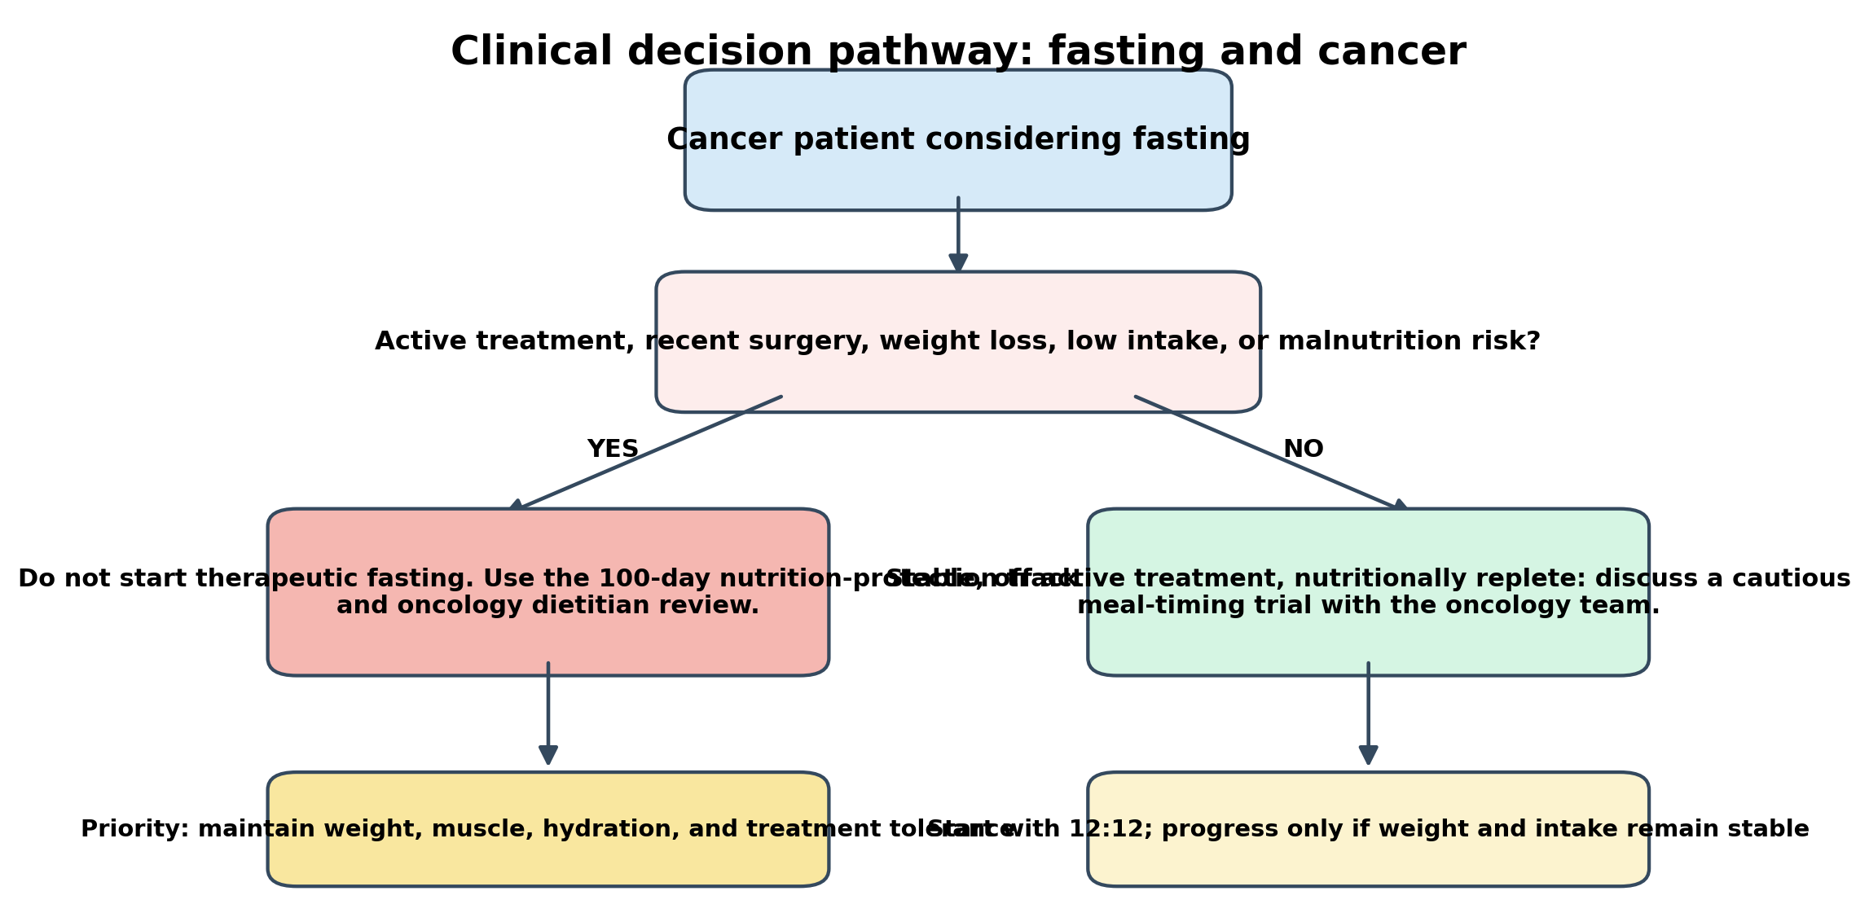
Figure 2. Clinical decision pathway for a cancer patient considering fasting.

What has been studied
- Small case series and pilot trials of short-term fasting around chemotherapy.
- Fasting-mimicking diets administered in cycles under research supervision.
- Preclinical studies in cells and animals examining tumor stress, glucose, IGF-1, immune effects, and treatment sensitivity.
- Meal-timing and time-restricted eating studies in non-cancer populations for weight and metabolic outcomes.

What remains unproven
- Improved overall survival or cure from self-directed fasting.
- A universal schedule that is safe across cancer types, stages, treatments, and body compositions.
- An exact fasting duration that produces beneficial autophagy without increasing malnutrition or treatment risk.
- Safety in patients with cachexia, low BMI, swallowing problems, gastrointestinal obstruction, kidney disease, liver disease, diabetes medications, or intensive treatment toxicity.
ESPEN clinical position
ESPEN recommends against energy-restricting diets in cancer patients who are malnourished or at risk. The guideline reports that small human studies did not establish a benefit of fasting during chemotherapy and therefore does not recommend fasting before, during, or after anticancer agents as routine practice.

Why cancer patients are different from healthy adults
Cancer and its treatments can increase protein breakdown, inflammation, nausea, vomiting, taste changes, mouth sores, diarrhea, constipation, fatigue, early fullness, and reduced appetite. Losing muscle can occur even when body weight appears normal. A fasting schedule that is tolerable for a healthy adult can therefore be harmful for a patient undergoing treatment.

6. 100-Day Safety Framework for Cancer Patients
Purpose of this framework
This is not a 100-day cancer-fasting treatment. It is a safety-controlled decision framework designed to protect nutrition during active treatment and, only in stable survivors, to test gentle meal timing with medical approval.

Eligibility gate before Day 1
- Written or clearly documented approval from the treating oncologist.
- Nutrition assessment by an oncology dietitian whenever available.
- No active unintentional weight loss, dehydration, uncontrolled vomiting/diarrhea, severe mouth sores, bowel obstruction, or inability to meet nutritional needs.
- Medication review, especially insulin, sulfonylureas, blood-pressure medicines, anticoagulants, steroids, and medicines that must be taken with food.
- Baseline record: weight trend, appetite, oral intake, muscle/strength status, treatment schedule, hydration, and relevant laboratory monitoring decided by the medical team.

100-day plan: active treatment or malnutrition-risk track
Days | Primary objective | Daily structure | Decision rule
1–10 | Medical and nutrition baseline | Regular meals; no intentional fasting; hydration plan; symptom log | Any weight loss or poor intake → dietitian/oncology review
11–20 | Stabilize intake | 3 meals plus 1–3 snacks as tolerated; protein source at each eating opportunity | Do not extend overnight gap beyond what the team approves
21–30 | Treatment tolerance | Coordinate foods with nausea, mouth pain, bowel symptoms, and medication timing | No fasting around treatment unless part of an approved trial
31–40 | Protect muscle | Add light resistance or physiotherapy only if cleared; maintain protein/energy | Worsening weakness → reassessment, not restriction
41–50 | Hydration and electrolytes | Use oral fluids and medical oral rehydration when advised | Dizziness, reduced urine, repeated vomiting → stop and call team
51–60 | Review adequacy | Compare intake with requirements; consider oral nutrition supplements if prescribed | <50% of needs for >1 week or 50–75% for >2 weeks requires medical nutrition review
61–70 | Adapt to treatment cycle | Use higher-intake days when appetite is better; prepare easy foods | Avoid “compensatory” fasting after high-intake days
71–80 | Consolidate symptom control | Taste, swallowing, bowel, and fatigue strategies | Any new swallowing difficulty or obstruction symptom → urgent review
81–90 | Reassess body composition | Review weight, strength, clothes fit, and function | Continuing loss means the plan must become more energy/protein dense
91–100 | Long-term plan | Agree on sustainable nutrition schedule with oncology team | Only discuss meal-timing experiments after active treatment and nutritional stability

100-day plan: stable survivor / off active treatment track
This optional track applies only when the oncology team confirms that the person is medically stable, not malnourished, not losing weight, and not taking medicines that make fasting unsafe. It is intended for general metabolic health—not cancer treatment.
Days | Eating window | Frequency | Nutrition priority | Advance only when…
1–10 | 12 hours eating / 12 hours overnight fast | Daily | Regular balanced meals; no calorie target | Weight, energy, and intake remain stable
11–20 | 12:12 | Daily | Earlier dinner; avoid late-night eating | No dizziness, weakness, or medication conflict
21–30 | 13:11 | 5 days/week; 12:12 on 2 days | Protein and vegetables at each main meal | No unintentional weight loss
31–40 | 13:11 | Daily if tolerated | Hydration; adequate total calories | Training and daily function remain normal
41–50 | 14:10 | 3–5 days/week | Two or three meals; optional snack | Oncology team agrees to progression
51–60 | 14:10 | 5 days/week; 12:12 recovery days | Do not skip protein or prescribed supplements | Weekly weight trend remains stable
61–70 | 14:10 | Daily or most days | Resistance exercise if medically cleared | No persistent hunger causing under-eating
71–80 | 14:10 | Daily | Maintain diet quality and total energy | No symptom or laboratory concern
81–90 | Optional 15:9 | Maximum 2 days/week | Only with clinician approval | Stable weight and no treatment-related risk
91–100 | Choose 12:12 to 14:10 as maintenance | Individualized | Sustainability over intensity | Medical and nutrition review is satisfactory
Not included in this report
Water-only fasting for 24–72 hours, repeated multi-day fasting, dry fasting, “detox” fasting, or fasting around chemotherapy without a research protocol. These approaches carry material risk and require specialist oversight.

7. 100-Day General Adult Fasting Plan
The following progression is for generally healthy adults, not for cancer patients, pregnant or breastfeeding individuals, minors, people with eating disorders, underweight individuals, or people using glucose-lowering medication without medical supervision.
Days | Schedule | Example eating window | Weekly pattern | Focus
1–10 | 12:12 | 08:00–20:00 | Daily | Remove late-night snacks; hydrate
11–20 | 13:11 | 08:00–19:00 | 5 days; 12:12 on 2 days | Balanced meals; adequate protein
21–30 | 14:10 | 09:00–19:00 | 5 days; 12:12 on 2 days | Observe hunger and sleep
31–40 | 14:10 | 09:00–19:00 | Daily if comfortable | Add resistance exercise
41–50 | 15:9 | 10:00–19:00 | 3 days; 14:10 on 4 days | Avoid compensatory overeating
51–60 | 16:8 | 10:00–18:00 | 3 days; 14:10 on 4 days | Maintain total nutrition
61–70 | 16:8 | 10:00–18:00 | 5 days; 14:10 on 2 days | Monitor energy and training
71–80 | 16:8 | Flexible 8-hour window | 5–6 days | Prefer earlier rather than late eating
81–90 | 16:8 | 10:00–18:00 | 6 days; one 14:10 day | Sustainability and sleep
91–100 | Maintenance | 12:12 to 16:8 | Choose the least restrictive effective pattern | Long-term adherence

Permitted non-caloric drinks during a fasting window
- Water.
- Unsweetened tea.
- Black coffee if tolerated and not contraindicated.
- Prescribed medicines exactly as directed; do not change medication timing to protect a fasting window.

8. Monitoring, Stop Criteria, and Medical Review
Measure | Frequency | Acceptable direction | Action threshold
Body weight | At least weekly | Stable unless supervised weight loss is specifically intended | Any ongoing unintentional loss → pause fasting and review
Food intake | Daily during treatment | Meeting the medical team’s targets | <50% for >1 week or 50–75% for >2 weeks → urgent nutrition review
Hydration / urine | Daily | Normal thirst, urine frequency, and color | Reduced urine, persistent dizziness, vomiting, or diarrhea → contact team
Strength / function | Weekly | Stable walking, stairs, and daily activity | Clear decline → assess muscle loss and intake
Glucose | As prescribed | Within clinician-set range | Hypoglycemia symptoms or low reading → treat and seek advice
Treatment symptoms | Daily | Controlled enough to eat and drink | Severe mouth sores, swallowing difficulty, obstruction symptoms, uncontrolled nausea → medical review

Immediate stop criteria
- Fainting, confusion, chest pain, severe palpitations, or new shortness of breath.
- Repeated vomiting, severe diarrhea, inability to keep fluids down, or markedly reduced urine.
- Symptoms of hypoglycemia: sweating, tremor, confusion, severe weakness, or loss of consciousness.
- Rapid or continuing unintentional weight loss, worsening weakness, or inability to meet energy/protein needs.
- Any instruction from the oncology team to stop.

9. Frequently Repeated Claims: Evidence Check
Claim | Evidence rating | Accurate interpretation
“Ohsumi proved fasting cures cancer.” | False | He discovered mechanisms of autophagy using yeast; he did not establish a cancer-fasting cure.
“Autophagy begins exactly at 16 hours.” | Not established | Autophagy is ongoing and tissue-specific; no universal human threshold is validated.
“Longer fasting always means more benefit.” | False / unsafe | Risk rises with duration, especially dehydration, muscle loss, electrolyte problems, and malnutrition.
“Cancer feeds only on sugar, so zero food starves it.” | Misleading | Human metabolism maintains blood glucose and tumors use multiple fuels; the patient may be harmed before the tumor is controlled.
“Fasting around chemotherapy protects normal cells.” | Experimental | Small studies are not enough for routine clinical recommendation.
“A fasting-mimicking diet is proven cancer treatment.” | Not proven | It remains a research strategy and must not replace standard care.

10. Practical Food and Hydration Framework
The eating window is only one part of nutrition. For a cancer patient, food quality and adequacy are usually more important than extending the fasting period.
Priority | Examples | Clinical note
Protein | Eggs, fish, poultry, dairy, legumes, tofu, medically prescribed supplements | Distribute across meals; exact target is individualized
Energy density | Olive oil, tahini, avocado, nuts/nut butter, full-fat dairy when appropriate | Useful when appetite or portion size is low
Vegetables and fruit | Cooked or raw according to tolerance and infection precautions | Variety matters; no single food cures cancer
Carbohydrates | Rice, potatoes, oats, whole grains, bread, fruit | Adapt texture and fiber to symptoms
Hydration | Water, soups, oral rehydration solutions when prescribed | Needs vary with fever, vomiting, diarrhea, kidney and heart status
Food safety | Well-cooked foods and safe handling when immunity is low | Follow the oncology team’s neutropenia guidance

Sample day: nutrition-protection track
- Breakfast: eggs or yogurt with oats/bread and fruit, adjusted to tolerance.
- Snack: yogurt, milk, cheese, nut butter, or prescribed oral nutrition supplement.
- Lunch: rice/potato/bread plus poultry/fish/legumes and cooked vegetables.
- Snack: fruit with dairy or a high-protein alternative.
- Dinner: easy-to-tolerate protein, carbohydrate, vegetables, and fluids.
For nausea, mouth sores, swallowing difficulty, diarrhea, constipation, kidney impairment, liver impairment, diabetes, or ostomy care, the plan must be modified by the clinical team.

11. References
1. Nobel Prize Outreach. The Nobel Prize in Physiology or Medicine 2016 — Summary. Source
2. Nobel Prize Outreach. Press release: Yoshinori Ohsumi and mechanisms for autophagy. 3 October 2016. Source
3. Muscaritoli M, Arends J, Bachmann P, et al. ESPEN practical guideline: Clinical Nutrition in cancer. Clinical Nutrition. 2021;40:2898–2913. Source
4. de Groot S, Vreeswijk MPG, Welters MJP, et al. The effects of short-term fasting on tolerance to (neo)adjuvant chemotherapy in HER2-negative breast cancer patients: a randomized pilot study. BMC Cancer. 2015;15:652. Source
5. Safdie FM, Dorff T, Quinn D, et al. Fasting and cancer treatment in humans: a case series report. Aging. 2009;1:988–1007. Source
6. Di Tano M, Raucci F, Vernieri C, et al. Synergistic effect of fasting-mimicking diet and vitamin C against KRAS mutated cancers. Nature Communications. 2020;11:2332. Source
7. Pavlou V, Cienfuegos S, Lin S, et al. Effect of Time-Restricted Eating on Weight Loss in Adults With Type 2 Diabetes: A Randomized Clinical Trial. JAMA Network Open. 2023. Source

Clinical handover checklist
Item | Status | Notes / clinician instruction
Cancer type and stage confirmed | ☐
Current treatment and dates recorded | ☐
Weight trend reviewed | ☐
Dietitian assessment completed | ☐
Medication/diabetes risk reviewed | ☐
Hydration and kidney status reviewed | ☐
Approved meal-timing window documented | ☐
Stop criteria explained | ☐
Follow-up date scheduled | ☐
Final conclusion
Ohsumi’s work transformed cell biology by defining the mechanisms of autophagy. It does not justify unsupervised prolonged fasting as cancer therapy. For patients receiving active treatment, protecting nutrition is the evidence-based priority. For stable survivors, gentle meal timing may be considered only as a general health strategy under medical supervision.

