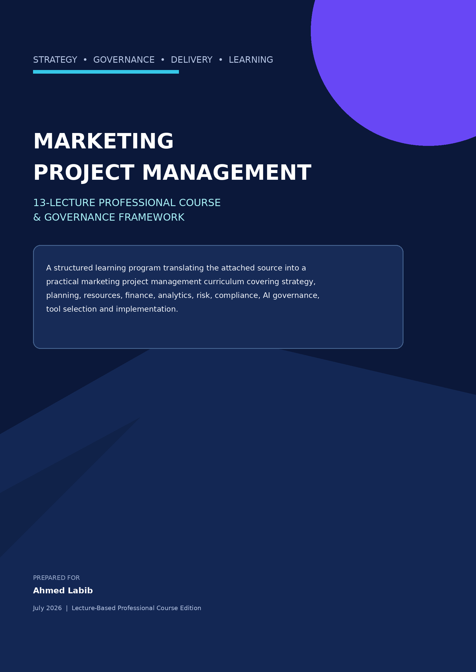

DOCUMENT PROFILE
Marketing Project Management
Comprehensive Study, Governance Framework & Applied Course
DOCUMENT CONTROL  Prepared for: Ahmed Labib  Issue: Lecture-Based Professional Course Edition  Date: July 2026 | STATUS  Confidential working paper  Suitable for internal strategy, PMO and procurement use  Illustrative budgets require local validation

Purpose and scope
This course manual converts the attached 17-page marketing project management article into a decision-grade, 13-lecture professional learning program. It preserves the source document’s practical lifecycle structure, critically evaluates its commercial bias and evidence base, and adds the governance, measurement, compliance, AI, financial and implementation controls required for contemporary marketing operations. [S1]
The course is designed for executives, PMO leaders, marketing operations managers, agency directors, project managers, campaign owners, analytics teams, finance stakeholders and procurement teams. Each lecture combines decision concepts, applied controls, a workshop and a tangible course output that contributes to the final capstone.
SOURCE INTEGRITY NOTE
The attached document is a vendor-led explainer that repeatedly promotes Productive. Its operational concepts are useful, but its quantitative claims should be treated as contextual signals unless independently verified. The recommendations in this report separate general project-management principles from vendor-specific conclusions.

How to use this course manual
- Use Lectures 1–3 to establish evidence discipline, core concepts, strategic alignment and governance.
- Use Lectures 4–9 to design practical controls for planning, resources, finance, analytics, risk and communication.
- Use Lecture 10 to evaluate tool architecture without defaulting to a single vendor.
- Use Lectures 11–13 and the appendices to build the operating model, implementation roadmap and capstone proposal.

COURSE OVERVIEW
A structured learning path that converts the research study into thirteen applied professional lectures.

Course delivery model
13 | 90 min | 19.5 hrs | 1
LECTURES | EACH SESSION | CONTACT TIME | INTEGRATED CAPSTONE

Integrated course outcomes
COURSE  OUTCOMES | 1. Convert marketing strategy into governed projects, portfolios and measurable deliverables.  2. Build credible charters, WBS structures, schedules, budgets and formal change controls.  3. Manage cross-functional capacity, utilization, commercial performance and delivery risk.  4. Design auditable KPI, data, attribution, privacy, compliance and AI-control architectures.  5. Evaluate technology through requirements, weighted evidence, pilots, TCO and exit controls.  6. Develop a target operating model and a controlled 90-day implementation roadmap.

CONTENTS
Lecture structure and learning path
Executive Summary | Decision-level findings, gaps and recommended direction
LECTURE 01 | Source Document Assessment | Evidence quality, bias assessment and defensible use of source claims
LECTURE 02 | Marketing Project Management Fundamentals | Definitions, archetypes, lifecycle and multidimensional success criteria
LECTURE 03 | Governance And Strategic Alignment | Portfolio intake, prioritization, sponsorship, stage gates and decision rights
LECTURE 04 | Planning, Scheduling And Change Control | Charter, WBS, estimates, milestones, baseline control and formal change management
LECTURE 05 | Resource And Capacity Management | Demand forecasting, capacity, utilization, workload balancing and resilience
LECTURE 06 | Financial And Commercial Control | Cost baselines, forecasting, profitability, value realization and commercial decisions
LECTURE 07 | Measurement And Analytics | Measurement plans, KPI hierarchy, data quality, attribution and incrementality
LECTURE 08 | Risk, Compliance And Ai Governance | Risk responses, privacy, disclosures, content assurance and responsible AI
LECTURE 09 | Stakeholder Communication And Collaboration | Stakeholder mapping, RACI, reporting cadence, status control and escalation
LECTURE 10 | Tool Strategy And Vendor Evaluation | Architecture options, requirements, weighted selection, pilot controls and TCO
LECTURE 11 | Target Operating Model | End-to-end value stream, roles, controls, systems and governance calendar
LECTURE 12 | 90-Day Implementation Roadmap | Design, pilot, scale, ownership, exit gates, adoption and implementation budget
LECTURE 13 | Maturity Model, Capstone And Executive Action | Maturity assessment, prioritized recommendations and integrated capstone
Appendices | Editable templates, scorecards and checklists
References | Primary and supporting sources

EXECUTIVE SUMMARY
Decision-grade interpretation of the attached source
17 pages  PRIMARY SOURCE  Vendor-led operational primer | 5  CONTROL GAPS  Measurement, compliance, AI, prioritization, change control | 90 days  TARGET HORIZON  Design, pilot and scale | 1 operating model  TARGET STATE  Work + performance + governance

The source document correctly argues that marketing work benefits from project discipline. It identifies practical project examples, emphasizes resource efficiency, warns against scope creep and unrealistic deadlines, and promotes centralized documentation and real-time visibility. These are valid operating principles. [S1]
However, the attachment is not neutral and should not be used as a standalone software-selection or governance standard. Its structure progressively moves from general project-management guidance toward the claim that a unified agency platform—specifically Productive—is the preferred answer. The source does not sufficiently prove that one suite is always superior to a governed, integrated best-of-breed architecture. [S1]
EXECUTIVE CONCLUSION
Retain the source document’s lifecycle logic, but upgrade it into a governed value-delivery system. The target model should establish one authoritative work system, one authoritative performance layer, and one accountable governance framework spanning finance, analytics, legal/privacy, AI and campaign owners.

Core findings
Finding | Assessment | Management implication
The lifecycle backbone is sound | Planning, milestone control, monitoring, resource allocation and risk management are all relevant. | Use it as the base process, not the full control model.
The evidence base is uneven | Several statistics lack complete methodology, context or full bibliographic detail. | Treat figures as directional; validate before use in a business case.
The document is agency-oriented | Billable hours, utilization, client profitability and retainer economics dominate. | Adapt metrics and governance for in-house teams.
Measurement is under-specified | KPIs are discussed without a formal event, attribution or data-quality architecture. | Create a governed KPI dictionary and measurement plan.
Compliance and AI are material omissions | Modern marketing delivery requires privacy, disclosure, provenance and human-review controls. | Embed compliance and AI gates within the workflow.
Tool consolidation is presented too strongly | A suite can reduce fragmentation, but cannot replace process ownership and data governance. | Define the operating model before selecting software.

Recommended enterprise priorities
1. Approve a standard marketing project charter and intake gate tied to measurable business outcomes.
2. Establish a KPI dictionary, event taxonomy, attribution approach and dashboard ownership model.
3. Implement estimation, baseline, milestone and formal change-control rules.
4. Embed privacy, disclosure, content approval and AI governance checks before launch.
5. Pilot the framework on one representative campaign before platform consolidation or enterprise rollout.
6. Use post-mortems and maturity scoring to institutionalize continuous improvement.

LECTURE 01 | SOURCE DOCUMENT ASSESSMENT
Reconstructing the attachment and separating valid guidance from vendor promotion
LECTURE 01 BRIEF | 90 MINUTES
LEARNING OUTCOMES | 1. Distinguish operational guidance, evidence-backed claims and vendor-led promotion.  2. Audit quantitative claims for source quality, context, relevance and decision useability.  3. Establish evidence rules for executive papers, business cases and procurement decisions.
SESSION FLOW | 10 min framing | 25 min source reconstruction | 25 min evidence audit | 20 min workshop | 10 min review
APPLIED OUTPUT | One-page source integrity and evidence assessment.

1.1 Structural reconstruction
The attachment follows a clear educational-to-commercial sequence: definition, examples, benefits, recurring challenges, project lifecycle phases, communication, tool categories, a dedicated Productive recommendation and closing best practices. The screenshots reinforce the narrative through workload boards, profitability views, project progress reports, documentation screens and task views. [S1]
Source component | What it contributes | Critical assessment
Definition and examples | Frames product launches, social campaigns, content, email, SEO, paid advertising, research and website improvement as projects. | Useful and accessible; lacks segmentation by complexity and operating context.
Benefits | Highlights workflow efficiency, engagement, financial control, risk visibility, transparency and collaboration. | Directionally sound; causality and evidence quality are not fully demonstrated.
Challenges | Addresses resource efficiency, strategic alignment, scope creep and delivery dates. | Strong practical content; should include prioritization and demand-management failure modes.
Lifecycle phases | Covers planning, realistic deadlines, performance monitoring, capacity and risk. | Good backbone; missing benefits realization, compliance and controlled closure.
Tool taxonomy | Distinguishes task tools, integrated agency tools and marketing suites. | Helpful, but product categories and decision criteria are simplified.
Productive promotion | Positions Productive as the best all-in-one platform. | Commercial conclusion requires independent evaluation and total-cost analysis.
Best practices | Stakeholder buy-in, skills, post-mortems and tool rationalization. | Useful; should be expanded into formal governance and maturity practices.

1.2 Quantitative claims audit
The source includes multiple numerical claims. Because the attachment does not consistently provide full study designs, sample definitions, dates and limitations, the figures should not be treated as universal benchmarks. The audit below records how they should be used in management decision-making. [S1]
Claim reported in source | Useability | Recommended treatment
Organized marketers are 649% more likely to report success. | Contextual only | Use as an advocacy signal; obtain the original CoSchedule methodology before quoting in a board paper.
47% of agencies lack a fully defined digital strategy. | Contextual only | Validate sector, geography, company size and survey year.
31% of project managers report unrealistic deadlines. | Contextual only | Use to justify estimation controls, not as a local benchmark.
Marketing plans commonly take 8–12 weeks. | Low transferability | Replace with historical throughput by campaign archetype and complexity.
Project managers may lead 2–10 projects simultaneously. | Highly context-dependent | Use capacity units and complexity-weighted workload, not project counts alone.
86% link failures to collaboration or communication. | Contextual only | Use as a risk theme; define local root-cause data.
37% report too many digital tools. | Contextual only | Perform an internal tool inventory and workflow-friction analysis.

DECISION RULE
No external benchmark should replace the organization’s own historical actuals, campaign archetypes, channel economics and resource productivity data.

1.3 Strengths, limitations and implications
Strengths to retain | Limitations to correct
Clear explanation of marketing work as structured projects. | Promotional bias toward a single platform.
Strong emphasis on resource allocation and real-time visibility. | No formal portfolio prioritization or demand governance.
Practical scope-creep controls and documentation advice. | Insufficient measurement architecture and attribution design.
Recognition of cross-functional dependencies. | Limited privacy, disclosure, security and records-management controls.
Post-mortem learning and skills development. | AI writing tools are referenced without governance requirements.
Unified data and workflow principle. | Insufficient distinction between agencies and in-house marketing teams.

Applied learning and assessment
LECTURE 01 APPLICATION
APPLIED WORKSHOP | Select one quantitative or product-related claim from the source. Classify it as decision-grade, contextual only or unverified; document the rationale, evidence gap and recommended management treatment.
KNOWLEDGE CHECK | 1. Which characteristics make a source vendor-led rather than independent?  2. When can a weak external benchmark still be useful?  3. What minimum evidence should support a board-level recommendation?

LECTURE 02 | MARKETING PROJECT MANAGEMENT FUNDAMENTALS
Turning marketing intent into controlled, measurable value delivery
LECTURE 02 BRIEF | 90 MINUTES
LEARNING OUTCOMES | 1. Define marketing project management as a governed value-delivery discipline.  2. Classify common marketing project archetypes and their complexity drivers.  3. Connect lifecycle stages, success dimensions and project-control requirements.
SESSION FLOW | 10 min definition | 25 min project archetypes | 25 min lifecycle and controls | 20 min case exercise | 10 min review
APPLIED OUTPUT | Marketing project archetype and success-criteria profile.

2.1 Working definition
Marketing project management is the disciplined conversion of a defined marketing objective into an approved scope of work, a time-phased delivery plan, an accountable cross-functional team, a controlled budget, a measurement architecture and a documented decision trail. A marketing project is complete only when outputs are delivered, performance is assessed and lessons are captured—not merely when content is published.

2.2 Marketing project archetypes
Archetype | Primary objective | Typical complexity drivers | Core deliverables
Product launch | Awareness, adoption and commercial readiness | Product dependencies, market timing, legal claims, channel coordination | Launch plan, messaging, landing pages, enablement, media assets, performance dashboard
Integrated campaign | Demand generation or brand activation | Multiple channels, creative variants, data tagging, approvals | Brief, media plan, content, automations, tracking plan, campaign report
Content / SEO program | Organic visibility and audience authority | Editorial capacity, search volatility, technical dependencies | Topic strategy, briefs, content calendar, technical actions, content performance
Lifecycle / email | Nurture, conversion, retention or reactivation | Segmentation, data quality, consent, automation logic | Journey map, segments, email sequence, tests, conversion report
Brand refresh | Repositioning and visual consistency | Stakeholder alignment, research, change adoption | Brand strategy, identity system, guidelines, rollout plan
Event / experience | Attendance, engagement, pipeline or advocacy | Vendors, venue, speakers, logistics, sponsorship, safety | Event plan, promotional assets, runbook, attendee data, post-event analysis
Marketing technology | Capability, automation or data improvement | Integration, privacy, migration, training and adoption | Requirements, configuration, testing, migration, governance, training

2.3 Success dimensions
A modern marketing project should be evaluated across five dimensions. Optimizing only delivery efficiency can create campaigns that are on time and on budget but commercially ineffective; optimizing only performance can conceal uncontrolled rework, compliance exposure or unsustainable resource loading.
Value  OUTCOME  Commercial and customer impact | Delivery  CONTROL  Scope, schedule and budget reliability | Quality  EFFECTIVENESS  Creative, technical and data standards | Risk  ASSURANCE  Compliance, brand and operational exposure | Learning  ADAPTATION  Tests, insights and reusable knowledge

2.4 Lifecycle and project controls
Lifecycle stage | Key management question | Minimum control artifact
Intake | Why should this project exist now? | Business case, project type, sponsor and prioritization score
Initiation | What is approved and who is accountable? | Project charter, stakeholders, high-level budget and success criteria
Planning | How will value be delivered and measured? | WBS, schedule, resource plan, risk register, measurement plan
Execution | Are teams producing approved deliverables? | Task workflow, quality checks, issue log, decisions and approvals
Monitoring and control | Are variance and risk within tolerance? | Status report, forecast, budget burn, change log, KPI dashboard
Launch / transition | Are release, compliance and operational-readiness criteria met? | Launch checklist, go/no-go approval, support plan
Closure and learning | What value was realized and what should change? | Post-mortem, benefits review, archive and reusable assets

Applied learning and assessment
LECTURE 02 APPLICATION
APPLIED WORKSHOP | Choose a product launch, campaign, content program or website initiative. Define its objective, deliverables, constraints, lifecycle, success dimensions and the minimum controls required to manage it.
KNOWLEDGE CHECK | 1. What makes a marketing initiative a project rather than routine operations?  2. How do complexity drivers change the control approach?  3. Why must delivery success and business-outcome success be assessed separately?

LECTURE 03 | GOVERNANCE AND STRATEGIC ALIGNMENT
Ensuring every project has a defensible purpose, owner and decision path
LECTURE 03 BRIEF | 90 MINUTES
LEARNING OUTCOMES | 1. Translate strategic objectives into governed marketing project demand.  2. Apply intake, prioritization and stage-gate criteria across a project portfolio.  3. Define decision rights, escalation paths and accountable ownership.
SESSION FLOW | 10 min strategic alignment | 25 min intake and gating | 20 min prioritization | 25 min portfolio workshop | 10 min review
APPLIED OUTPUT | Portfolio intake, prioritization and decision-rights sheet.

3.1 From request intake to approved portfolio
The source emphasizes alignment between marketing projects and business goals, but a scalable model needs a formal intake and prioritization mechanism. Without it, marketing teams become demand receivers, urgent requests displace strategic work, and resource plans lose credibility. [S1]
Gate | Decision criteria | Approver | Output
G0 – Request validation | Defined problem, requester, target audience, due-date rationale and required decision | Marketing operations | Complete intake or return for clarification
G1 – Strategic fit | Contribution to enterprise objective, customer need and portfolio balance | Marketing leadership / sponsor | Prioritized concept
G2 – Feasibility | Capacity, budget, data, channel, technology, legal and dependency viability | Cross-functional review | Approved / deferred / rejected
G3 – Baseline approval | Scope, milestones, budget, risk, measurement and governance are complete | Sponsor / steering group | Authorized project baseline
G4 – Launch readiness | Quality, tracking, consent, disclosure, operational support and evidence are complete | Go/no-go authority | Launch authorization
G5 – Closure | Outputs accepted, data available, finances reconciled and learning captured | Sponsor and project manager | Formal closure and benefits follow-up

3.2 Portfolio prioritization model
Criterion | Suggested weight | Scoring guidance
Strategic alignment | 25% | Directly supports a committed enterprise or business-unit priority.
Commercial / customer value | 20% | Expected revenue, margin, retention, advocacy, market or customer impact.
Urgency and timing | 15% | Market window, launch dependency, contractual commitment or regulatory date.
Evidence strength | 10% | Quality of customer insight, prior results, test data and causal hypothesis.
Feasibility | 10% | Availability of skills, technology, data, approvals and channel access.
Risk-adjusted effort | 10% | Complexity, uncertainty, compliance exposure and opportunity cost.
Learning value | 10% | Potential to validate a strategic assumption or create reusable knowledge.

GOVERNANCE PRINCIPLE
A high-priority project must still satisfy minimum feasibility, compliance and measurement gates. Strategic urgency does not justify an unmeasurable or uncontrolled launch.

3.3 Decision rights
Decision | Accountable role | Required evidence
Approve project initiation | Executive sponsor | Business case, priority score, initial budget and measurable outcome
Approve baseline | Sponsor / steering group | Charter, schedule, resource plan, risk and measurement plan
Approve scope change | Change authority | Impact on outcome, schedule, budget, resources, risk and dependencies
Approve campaign launch | Go/no-go authority | Quality, legal/privacy, tracking, support and contingency readiness
Stop or pivot campaign | Sponsor with channel / analytics owner | Performance evidence, risk threshold or changed business condition
Close project | Sponsor and project manager | Acceptance, financial reconciliation, archive and lessons learned

Applied learning and assessment
LECTURE 03 APPLICATION
APPLIED WORKSHOP | Score three candidate marketing initiatives using strategic fit, expected value, urgency, risk, effort and capacity. Recommend approve, defer, redesign or reject, and assign the required decision authority.
KNOWLEDGE CHECK | 1. Why is a high-value idea not automatically a high-priority project?  2. Which decisions should remain with the sponsor rather than the project manager?  3. How do stage gates prevent low-quality demand from consuming capacity?

LECTURE 04 | PLANNING, SCHEDULING AND CHANGE CONTROL
Building credible baselines and controlling the impact of change
LECTURE 04 BRIEF | 90 MINUTES
LEARNING OUTCOMES | 1. Develop a minimum viable charter, scope baseline and deliverable-oriented WBS.  2. Create realistic estimates, dependencies, milestones and acceptance criteria.  3. Operate formal change control using quantified time, cost, resource and benefit impacts.
SESSION FLOW | 10 min charter | 25 min WBS and logic | 20 min estimation and milestones | 25 min change-control exercise | 10 min review
APPLIED OUTPUT | Approved baseline pack: charter, WBS, milestone plan and change log.

4.1 Minimum project charter
Charter section | Required content
Purpose and business outcome | Problem or opportunity, target audience, intended business effect and strategic linkage.
Scope and deliverables | In-scope and out-of-scope work, acceptance criteria and required formats.
Success measures | Outcome KPIs, leading indicators, delivery measures, baselines and targets.
Timeline and constraints | Required dates, market windows, dependencies, assumptions and tolerances.
Budget and commercial model | Internal labor, media, production, technology, vendor and contingency budgets.
Governance | Sponsor, project manager, workstream owners, approval authorities and meeting cadence.
Risk and compliance | Top risks, privacy requirements, disclosures, brand and regulatory controls.
Measurement plan | Events, tagging, data sources, attribution, reporting cadence and data owner.
AI use declaration | Permitted AI use cases, human-review requirement, data restrictions and evidence retention.

4.2 Work breakdown structure and deliverable logic
A WBS should be organized around verifiable deliverables, not only departments or generic task lists. Each work package should have one accountable owner, a completion criterion, a forecast date and a clear dependency. Campaign-level work commonly decomposes into strategy, audience and offer, creative, content, channel setup, data and measurement, approvals, launch operations and performance optimization.
WBS level | Illustrative structure | Control purpose
L1 – Project | Integrated product launch campaign | Defines the management boundary.
L2 – Workstream | Strategy; creative; paid media; CRM; analytics; legal; sales enablement | Creates accountable delivery streams.
L3 – Deliverable | Campaign brief; hero video; landing page; lead journey; tracking specification | Creates testable outputs.
L4 – Work package | Concept approval; copy finalization; build; QA; deployment | Supports scheduling, cost and ownership.
L5 – Task / checklist | Specific action and acceptance step | Supports daily execution and evidence.

4.3 Estimation and milestone realism
The source correctly warns that force-fitting plans into externally imposed deadlines creates quality, budget and burnout risk. [S1] A credible plan should combine historical actuals, expert judgment, dependency analysis, complexity factors and explicit contingency. Estimation should be performed by the people responsible for delivery and then challenged through cross-functional review.
Technique | Application | Strength / caution
Analogous estimation | Compare with a similar prior campaign or deliverable. | Fast; accuracy depends on comparability and quality of historical data.
Parametric estimation | Use drivers such as number of assets, markets, channels, segments or variants. | Scalable; requires a validated productivity model.
Bottom-up estimation | Estimate work packages and aggregate. | Most transparent; can be time-intensive.
Three-point estimation | Use optimistic, most likely and pessimistic durations or costs. | Makes uncertainty visible; assumptions must be documented.
Reference-class forecasting | Use outcome distributions from comparable completed projects. | Reduces optimism bias; requires consistent data capture.
Capacity-constrained scheduling | Sequence work based on real skill availability, not nominal headcount. | Improves credibility; may expose unavoidable deadline trade-offs.

4.4 Change control
Scope change is not automatically negative. It becomes damaging when the impact is hidden or the baseline is not updated. Every requested change should be recorded, assessed and explicitly approved, rejected, deferred or exchanged for another scope item.
Change assessment field | Management question
Business rationale | What new information or priority justifies the request?
Scope impact | Which deliverables, acceptance criteria or markets change?
Schedule impact | Which milestones and dependencies move, and by how much?
Resource impact | Which skills, teams or vendors must be added or reallocated?
Budget impact | What additional internal, media, production or technology cost is required?
Measurement impact | Do events, baselines, targets, test design or reporting change?
Risk and compliance impact | Does the change alter claims, consent, disclosures, data use or approval needs?
Decision and baseline update | Who approved the decision and where is the revised baseline recorded?

TRADE-OFF LANGUAGE
When a stakeholder requests additional work, respond with an explicit trade-off: add budget, extend time, add capacity, reduce other scope or accept a documented increase in risk.

Applied learning and assessment
LECTURE 04 APPLICATION
APPLIED WORKSHOP | Build a three-level WBS for a campaign and define five milestone acceptance criteria. Then assess a late request for an additional channel, identifying impact, options, approval authority and revised baseline requirements.
KNOWLEDGE CHECK | 1. Why should a WBS be deliverable-oriented?  2. What separates a target date from a credible baseline date?  3. Which impacts must be assessed before a scope change is approved?

LECTURE 05 | RESOURCE AND CAPACITY MANAGEMENT
Balancing skills, workload, utilization and delivery resilience
LECTURE 05 BRIEF | 90 MINUTES
LEARNING OUTCOMES | 1. Forecast demand by role, skill, period and priority.  2. Interpret utilization without incentivizing overload or local optimization.  3. Select practical interventions for shortages, bottlenecks and delivery risk.
SESSION FLOW | 10 min capacity principles | 25 min demand and supply model | 20 min utilization | 25 min heatmap workshop | 10 min review
APPLIED OUTPUT | Four-week role-based capacity and intervention plan.

5.1 Why marketing capacity is difficult
Marketing projects combine creative, analytical, technical, commercial and governance roles whose availability is rarely interchangeable. A designer’s unused hours cannot automatically offset a shortage of marketing automation specialists or legal reviewers. Project counts are therefore a weak workload measure; capacity should be assessed by role, skill, timing, complexity and interruption load.

5.2 Capacity planning model
Planning layer | Required analysis | Key output
Demand forecast | Approved and probable projects by campaign type, timing and complexity. | Forward workload by workstream and skill.
Supply forecast | Available hours adjusted for leave, non-project work, training and realistic productivity. | Net capacity by person, role and period.
Skill fit | Required proficiency, seniority and domain knowledge. | Qualified capacity, not gross headcount.
Allocation | Priority, dependency, continuity and critical-path needs. | Time-phased assignment plan.
Utilization guardrails | Billable/project work, non-project obligations and recovery time. | Sustainable workload bands.
Contingency | Single points of failure, leave, vendor delays and surge requirements. | Back-up coverage and escalation triggers.

5.3 Utilization: use with care
The source presents utilization as an important efficiency indicator. [S1] It is useful, particularly in agencies, but should not be maximized in isolation. Persistently high utilization can reduce time for quality review, experimentation, learning, mentoring and recovery. Persistently low utilization can indicate weak demand, poor intake, blocked work, inaccurate time capture or capability mismatch.
Indicator | Healthy interpretation | Failure signal
Planned utilization | Within a role-specific target that reserves time for non-project obligations. | Plans assume all nominal hours are productive.
Actual utilization | Consistent with completed value and quality. | High hours with low throughput or rework.
Allocation stability | Critical resources remain focused through key deliverables. | Frequent context switching and priority churn.
Overtime / after-hours work | Exceptional and time-bound. | Becomes the hidden mechanism for meeting baseline dates.
Work-in-progress | Limited to an agreed level per team or specialist. | Many open tasks and long cycle times.
Skill concentration | Critical knowledge has documented back-up. | One individual becomes a permanent bottleneck.

5.4 Resource interventions
- Resequence non-critical work to protect launch-critical specialists.
- Reduce concurrent work and create WIP limits for scarce functions.
- Cross-train staff and document repeatable procedures for critical tasks.
- Use pre-qualified vendors for controlled surge capacity or specialist delivery.
- Standardize templates, reusable assets and approval packs to reduce avoidable effort.
- Escalate demand-capacity gaps early with quantified business trade-offs.

Applied learning and assessment
LECTURE 05 APPLICATION
APPLIED WORKSHOP | Create a simple capacity heatmap for design, copy, analytics and web development. Identify over-allocation, under-allocation and single-point-of-failure risks; recommend resequencing, WIP limits, cross-training or controlled vendor support.
KNOWLEDGE CHECK | 1. Why can very high utilization reduce delivery performance?  2. What information is required before assigning work to a resource?  3. Which interventions protect the critical path without creating hidden cost?

LECTURE 06 | FINANCIAL AND COMMERCIAL CONTROL
Connecting campaign delivery to cost, profitability and benefits realization
LECTURE 06 BRIEF | 90 MINUTES
LEARNING OUTCOMES | 1. Build a complete cost baseline covering labor, media, vendors, technology and overhead.  2. Track actual cost, commitments, forecast-at-completion and budget burn.  3. Evaluate agency profitability and in-house projects using the appropriate value model.
SESSION FLOW | 10 min cost structure | 25 min baseline and forecast | 20 min profitability and value | 25 min calculation workshop | 10 min review
APPLIED OUTPUT | Financial control sheet with baseline, actuals, forecast and value case.

6.1 Cost structure
Cost category | Illustrative components | Control approach
Internal labor | Strategy, creative, project management, analytics, engineering, review and administration. | Rate card or standard cost by role; planned versus actual hours.
Media | Paid search, social, display, sponsorship and promotion. | Committed spend, pacing, performance and reallocation rules.
Production | Video, photography, design adaptation, translation, print and physical assets. | Purchase orders, milestones, acceptance and change control.
Technology | Platforms, data services, integrations, automation and temporary tools. | License ownership, usage, renewal and implementation cost.
External services | Agency, freelancer, event, PR, legal and research fees. | Statement of work, deliverables, rate basis and acceptance.
Contingency | Known uncertainty and risk exposure. | Controlled reserve with defined approval authority.

6.2 Budget baseline and forecast
Each project should have a time-phased cost baseline and an estimate at completion. A single total budget does not reveal whether overspend is occurring early, whether media is pacing correctly or whether remaining work can be completed within the authorized amount.
Metric | Definition | Management use
Budget at completion (BAC) | Approved total project budget. | Baseline authorization.
Actual cost (AC) | Cost incurred to the reporting date. | Spend visibility.
Committed cost | Approved obligations not yet invoiced or paid. | True remaining exposure.
Estimate to complete (ETC) | Forecast cost of remaining work. | Forward-looking control.
Estimate at completion (EAC) | AC + committed / remaining forecast, depending on model. | Expected final cost.
Budget variance | BAC − EAC. | Early escalation of projected overrun.
Budget burn rate | Spend or hours consumed relative to time and deliverable completion. | Detects front-loading, blocked work and scope growth.

6.3 Agency profitability versus in-house value
Operating context | Primary financial focus | Key measures
Agency / professional services | Client and engagement profitability, utilization and revenue realization. | Gross margin, realization, write-offs, billable utilization, retainer burn, pipeline coverage.
In-house marketing | Incremental enterprise value and efficiency of constrained spend. | Contribution margin, pipeline value, customer acquisition economics, retention, cost avoidance, brand and strategic value.
Shared services / internal agency | Service economics plus business-unit value. | Chargeback, unit cost, SLA performance, internal satisfaction and outcome contribution.

FINANCIAL CONTROL PRINCIPLE
Do not confuse delivery profitability with campaign effectiveness. Both must be visible: the cost and efficiency of producing the work, and the commercial or strategic value the work creates.

Applied learning and assessment
LECTURE 06 APPLICATION
APPLIED WORKSHOP | Using a sample campaign budget, calculate committed cost, actual cost, estimate-to-complete, forecast-at-completion, variance and margin or value contribution. Identify the management action triggered by each variance.
KNOWLEDGE CHECK | 1. Why are commitments as important as paid invoices?  2. How does agency margin analysis differ from an in-house benefits case?  3. What does budget burn reveal when schedule progress is considered at the same time?

LECTURE 07 | MEASUREMENT AND ANALYTICS
Building an auditable path from project activity to business value
LECTURE 07 BRIEF | 90 MINUTES
LEARNING OUTCOMES | 1. Design a measurement plan before campaign build and launch.  2. Create a KPI hierarchy spanning delivery, output, outcome and business value.  3. Select attribution or incrementality methods appropriate to the decision and data maturity.
SESSION FLOW | 10 min measurement architecture | 25 min KPI design | 20 min attribution | 25 min KPI-tree workshop | 10 min review
APPLIED OUTPUT | Measurement plan, KPI dictionary and dashboard blueprint.

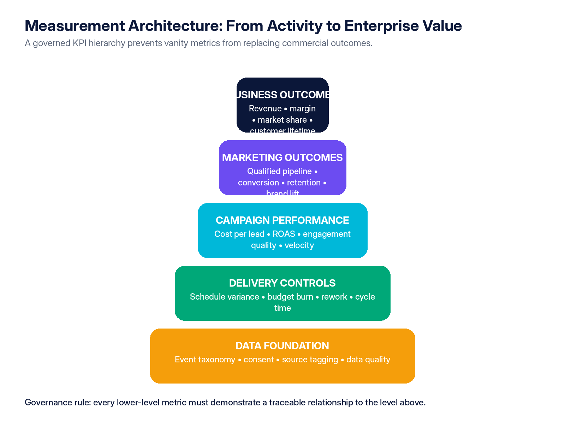
Figure 1 — Recommended KPI hierarchy for governed marketing project management.

7.1 Measurement plan
The source identifies lead generation, lead conversion, utilization and profit margin as example metrics, but a comprehensive system must define exactly how data is created, validated and interpreted. [S1] Google Analytics guidance illustrates the need to identify meaningful events, classify important outcomes as key events and govern how those events feed reporting and attribution. [R2]
Measurement-plan field | Required definition
Business question | The decision the metric must support.
Metric and formula | Precise definition, numerator, denominator, exclusions and currency/time basis.
Baseline and target | Current state, target value, target date and confidence level.
Event / data source | System, event name, parameters, source owner and collection method.
Attribution / causality | How credit is assigned and what the model cannot prove.
Segmentation | Audience, market, product, channel, creative, lifecycle stage or cohort.
Frequency and latency | Real-time, daily, weekly, monthly and expected data delay.
Data quality checks | Completeness, duplication, invalid traffic, consent and reconciliation rules.
Owner and action threshold | Accountable owner, tolerance, alert trigger and required response.

7.2 KPI classes
KPI class | Examples | Caution
Business outcomes | Revenue, contribution margin, market share, customer lifetime value, retention. | Often affected by multiple non-marketing factors.
Marketing outcomes | Qualified pipeline, conversion, incremental sales, brand lift, share of search. | Requires consistent definitions and causal humility.
Campaign metrics | Reach quality, engagement, CTR, cost per result, ROAS, frequency, completion rate. | May reward platform behavior without proving enterprise value.
Project controls | Milestone variance, schedule reliability, cost variance, cycle time, rework, approval latency. | Measures delivery health, not campaign effectiveness.
Data quality | Tag coverage, event validity, identity match, consent rate, source completeness. | Poor data can make every downstream metric unreliable.
Learning metrics | Hypotheses tested, decision velocity, reusable insights, test confidence. | Quantity of tests is not equivalent to learning quality.

7.3 Attribution and incrementality
Attribution allocates observed credit; it does not automatically establish causal impact. Marketing leaders should distinguish platform-reported attribution from independent analytics, matched-market or holdout tests, lift studies and broader commercial evidence. The appropriate method depends on decision value, data availability, risk and cost.
Method | Best use | Principal limitation
Rule-based attribution | Operational reporting and transparent channel comparison. | Sensitive to the selected rule and customer-journey visibility.
Data-driven attribution | Large datasets with stable event collection. | Model opacity and dependence on platform data.
Marketing mix modeling | Strategic budget allocation across channels and time. | Requires sufficient history and statistical expertise.
Incrementality / holdout testing | Estimating causal lift for a specific intervention. | Operational complexity and potential sample-size constraints.
Brand lift / research | Awareness, consideration and perception effects. | Survey design, cost and response bias.
Qualitative evidence | Complex B2B journeys, strategic accounts and new-category learning. | Not directly scalable or fully attributable.

DASHBOARD DESIGN RULE
Every executive dashboard should show outcomes, forecast, delivery variance, data quality and required decisions—not only historical campaign metrics.

Applied learning and assessment
LECTURE 07 APPLICATION
APPLIED WORKSHOP | Build a KPI tree for one marketing project. For each KPI define formula, owner, data source, frequency, target, decision threshold and known limitation. Add a practical attribution or incrementality approach.
KNOWLEDGE CHECK | 1. Why should output metrics not be treated as business outcomes?  2. What makes a KPI auditable and decision-useful?  3. When is experimental incrementality preferable to multi-touch attribution?

LECTURE 08 | RISK, COMPLIANCE AND AI GOVERNANCE
Embedding assurance into the workflow instead of adding it after production
LECTURE 08 BRIEF | 90 MINUTES
LEARNING OUTCOMES | 1. Identify, assess, assign and monitor project and campaign risks.  2. Embed privacy, consent, disclosure, claims and rights controls into stage gates.  3. Apply responsible-AI controls covering data, human review, provenance and accountability.
SESSION FLOW | 10 min risk framework | 25 min compliance controls | 20 min AI governance | 25 min risk-register workshop | 10 min review
APPLIED OUTPUT | Risk register, compliance checklist and AI approval gate.

8.1 Risk management framework
The source describes avoidance, reduction, transfer and acceptance as common responses. [S1] A complete risk process also requires identification, probability and impact assessment, ownership, response deadlines, residual-risk evaluation and escalation thresholds.
Risk category | Illustrative exposure | Typical controls
Strategic | Campaign does not support priority or customer need. | Business case, portfolio gate, hypothesis and sponsor review.
Scope / schedule | Late additions, approval delays, unrealistic dates. | Baseline, change control, approval SLA and dependency tracking.
Resource | Critical skill shortage, overload or vendor failure. | Capacity plan, back-up owner, WIP limits and contingency vendor.
Financial | Budget burn, media inefficiency, unplanned production cost. | Time-phased budget, forecast, commitment log and reallocation rules.
Data / analytics | Broken tags, poor consent, invalid attribution or data latency. | Measurement specification, QA, reconciliation and data-owner sign-off.
Legal / regulatory | Misleading claims, missing disclosures, privacy or usage-rights failure. | Legal review, disclosure checklist, consent design and evidence archive.
Brand / quality | Inconsistent creative, factual error, cultural harm or accessibility issue. | Brand QA, factual review, localization and accessibility checklist.
Technology / cyber | Integration failure, unauthorized access or platform outage. | Testing, permissions, back-up process and incident plan.
AI / model risk | Hallucinated facts, undisclosed synthetic content, data leakage or bias. | Approved use cases, human review, provenance, restricted data and evaluation.

8.2 Disclosure and privacy controls
The FTC advises that material relationships in endorsements should be disclosed clearly and conspicuously with the endorsement itself, not hidden in a profile or behind additional clicks. [R3] The exact legal framework varies by jurisdiction, but the project workflow should always make the disclosure decision, wording, placement and approval evidence explicit.
Control point | Minimum requirement
Data collection | Approved purpose, lawful basis / consent as applicable, defined retention and access.
Audience and targeting | Permitted attributes, exclusion rules, sensitive-data restrictions and platform terms.
Cookies and tracking | Consent behavior, tag firing rules, regional configuration and evidence of testing.
Endorsements and creators | Material relationship identified, disclosure approved and placement validated.
Claims and substantiation | Objective claims supported by retained evidence and approved wording.
Rights and licensing | Usage rights for images, music, testimonials, data and generated assets.
Accessibility | Content, landing pages, documents and media meet applicable accessibility requirements.
Records | Final assets, approvals, disclosures, test evidence and key decisions archived.

8.3 Responsible AI controls
NIST’s AI Risk Management Framework and Playbook organize AI risk management around Govern, Map, Measure and Manage. [R1] For marketing teams, these functions can be translated into practical workflow controls rather than a separate policy document.
NIST-aligned function | Marketing implementation
Govern | Approved AI use cases, accountable owner, training, restricted data, supplier requirements and incident escalation.
Map | Document the audience, task, model, content type, risk context, affected stakeholders and potential harm.
Measure | Evaluate factual accuracy, bias, brand alignment, privacy, originality, disclosure needs and output reliability.
Manage | Apply human approval, revise or reject outputs, record provenance, monitor incidents and improve controls.

AI RELEASE GATE
No AI-generated output should be published solely because it is fast or grammatically polished. The accountable human owner must verify facts, rights, claims, audience suitability, disclosure obligations and brand standards.

Applied learning and assessment
LECTURE 08 APPLICATION
APPLIED WORKSHOP | Create a risk register for a data-driven campaign using probability, impact, owner, response, trigger and residual risk. Add privacy, disclosure, intellectual-property and generative-AI approval checks to the launch gate.
KNOWLEDGE CHECK | 1. What is the difference between a risk response and a contingency action?  2. Which compliance controls must be designed before content production?  3. Why does human review not remove the need for AI provenance and accountability?

LECTURE 09 | STAKEHOLDER COMMUNICATION AND COLLABORATION
Creating decision velocity, transparency and disciplined escalation
LECTURE 09 BRIEF | 90 MINUTES
LEARNING OUTCOMES | 1. Map stakeholder interest, influence, information needs and decision authority.  2. Design a communication cadence that supports action rather than reporting volume.  3. Produce a concise status report with decisions, exceptions and escalation triggers.
SESSION FLOW | 10 min stakeholder architecture | 20 min RACI and authority | 20 min cadence | 30 min status-report workshop | 10 min review
APPLIED OUTPUT | Stakeholder map, RACI, communication plan and one-page status report.

9.1 Stakeholder architecture
Stakeholder group | Primary interest | Required engagement
Executive sponsor | Business outcome, risk, investment and strategic alignment. | Decision-focused updates, forecast, exceptions and recommendations.
Marketing leadership | Portfolio balance, capability and brand / channel performance. | Portfolio review and resource trade-offs.
Project team | Requirements, priorities, dependencies and fast decisions. | Daily workflow visibility and short operational cadence.
Sales / product / operations | Launch readiness, lead handling, product claims and customer experience. | Joint milestones, acceptance and transition planning.
Analytics / RevOps | Tracking, attribution, data quality and reporting. | Early design involvement and QA sign-off.
Legal / privacy / security | Claims, data use, rights, disclosures and risk tolerance. | Risk-based review with agreed turnaround times.
Finance / procurement | Budget, commitments, vendor terms and value realization. | Forecast, PO / contract controls and closure reconciliation.
Client / external partner | Scope, approvals, deliverables, dependencies and feedback. | Shared status, formal decisions and documented change control.

9.2 Communication cadence
Forum | Cadence | Purpose | Output
Delivery stand-up | Daily or 2–3 times weekly | Blockers, priorities and immediate dependencies. | Updated tasks and issue ownership.
Project status review | Weekly | Progress, forecast, budget, risk and decisions. | One-page status report and action log.
Creative / technical review | By milestone | Quality, consistency, feasibility and acceptance. | Approved deliverable or revision actions.
Steering review | Biweekly or monthly | Exceptions, trade-offs, scope changes and strategic alignment. | Decisions and revised direction.
Performance optimization | Weekly / campaign-specific | Channel results, tests and budget shifts. | Optimization actions and updated forecast.
Post-mortem | Within 1–2 weeks of closure | Outcome, delivery, root causes and reusable learning. | Lessons log and process improvements.

9.3 One-page status report
Section | Required content
Overall status | RAG status with a one-sentence rationale.
Outcome and scope | Objective, approved scope and any pending change.
Milestones | Baseline, current forecast and variance.
Budget | Budget, actual, committed, EAC and variance.
Performance | Outcome KPIs, leading indicators and data-quality note.
Top risks / issues | Owner, response, due date and residual exposure.
Decisions required | Decision, options, recommendation and deadline.
Next period | Critical deliverables and stakeholder obligations.

Applied learning and assessment
LECTURE 09 APPLICATION
APPLIED WORKSHOP | Prepare a RACI and one-page status report for a delayed campaign. Include objective, milestone status, budget, KPI readiness, top risks, changes, decisions required, owners and due dates.
KNOWLEDGE CHECK | 1. How does decision authority differ from consultation?  2. Which information belongs in an executive status report?  3. What conditions should trigger formal escalation?

LECTURE 10 | TOOL STRATEGY AND VENDOR EVALUATION
Selecting an architecture that supports governance rather than substituting for it
LECTURE 10 BRIEF | 90 MINUTES
LEARNING OUTCOMES | 1. Compare unified platforms, integrated best-of-breed stacks and specialized tools.  2. Build a weighted scorecard linked to operating requirements and risk.  3. Run controlled demonstrations, pilots, due diligence and total-cost evaluation.
SESSION FLOW | 10 min architecture options | 25 min requirements | 20 min scorecard and TCO | 25 min vendor exercise | 10 min review
APPLIED OUTPUT | Weighted vendor evaluation and recommendation memorandum.

10.1 Architecture options
The source distinguishes task and workflow tools, all-in-one agency platforms and specialized marketing suites. [S1] The decision should be based on operating-model fit, data ownership, integration, governance, adoption and total cost—not the length of a feature list.
Architecture | Strengths | Limitations | Best fit
All-in-one agency operations platform | Work, resourcing, time, budget, documents and profitability in one environment. | May be heavy for in-house teams and not best-in-class for CRM or analytics. | Agencies and professional-service teams requiring engagement economics.
CRM-led marketing suite + PM layer | Strong customer record, automation, lead management and campaign execution. | Delivery and capacity control may be split across systems. | In-house growth, demand generation and lifecycle teams.
Enterprise work management + specialist stack | Strong portfolio control with CRM, analytics, DAM, consent and channel tools. | Integration and governance burden. | Larger organizations with mature systems and operating discipline.
Lightweight task tool + manual reporting | Fast adoption and low direct cost. | Weak financial, resource, data and governance visibility. | Small, low-complexity teams or short pilot phase.

10.2 Weighted vendor scorecard
Evaluation domain | Weight | Illustrative criteria
Workflow and project control | 18% | Templates, dependencies, approvals, baselines, change log, milestones, portfolio views.
Resource and capacity | 14% | Role / skill capacity, heatmaps, allocation, utilization, leave and scenario planning.
Financial control | 14% | Budgets, rates, actuals, commitments, forecasts, profitability and billing integration.
Measurement and reporting | 12% | Custom metrics, data integration, dashboards, export, data lineage and report governance.
Collaboration and client access | 10% | Docs, comments, permissions, portals, notifications and decision tracking.
Automation and AI | 8% | Workflow automation, summaries, responsible AI controls, auditability and human approval.
Integration and architecture | 8% | APIs, identity, CRM, analytics, DAM, finance, webhooks and data ownership.
Security, privacy and compliance | 8% | Roles, audit logs, retention, residency, certifications and supplier controls.
Adoption and administration | 5% | Usability, mobile, training, configuration, support and admin effort.
Commercial / total cost | 3% | Licenses, implementation, migration, integrations, support and exit costs.

10.3 Procurement controls
- Use a scripted demonstration based on real workflows, not vendor-selected scenarios.
- Require proof of baseline, change, resource, financial and audit-log capabilities.
- Evaluate data export, API access and migration before signing—not at renewal.
- Run a time-boxed pilot with measurable adoption and cycle-time criteria.
- Include security, privacy, AI, records, support and exit requirements in the contract.
- Calculate three-year total cost including configuration, integration, migration and administration.
ARCHITECTURE DECISION
Tool consolidation is valuable when it reduces handoffs, duplicate data and reporting effort. It is harmful when it forces weak functionality, obscures data ownership or creates a new single point of failure.

Applied learning and assessment
LECTURE 10 APPLICATION
APPLIED WORKSHOP | Evaluate three hypothetical tools against workflow, resource, financial, analytics, integration, security, data portability, AI and support criteria. Apply weights, score evidence and recommend pilot, reject or negotiate.
KNOWLEDGE CHECK | 1. Why is feature count an unreliable procurement criterion?  2. Which requirements should be proved through a scripted demonstration?  3. What costs and risks are commonly omitted from a software business case?

LECTURE 11 | TARGET OPERATING MODEL
An integrated value stream with embedded controls and clear accountability
LECTURE 11 BRIEF | 90 MINUTES
LEARNING OUTCOMES | 1. Translate governance principles into an end-to-end marketing delivery value stream.  2. Define process ownership, accountability, information flows and control points.  3. Establish a governance calendar for portfolio, project, performance and learning reviews.
SESSION FLOW | 10 min operating-model concept | 25 min value stream | 20 min roles and controls | 25 min current-to-target workshop | 10 min review
APPLIED OUTPUT | Target operating model blueprint and governance calendar.

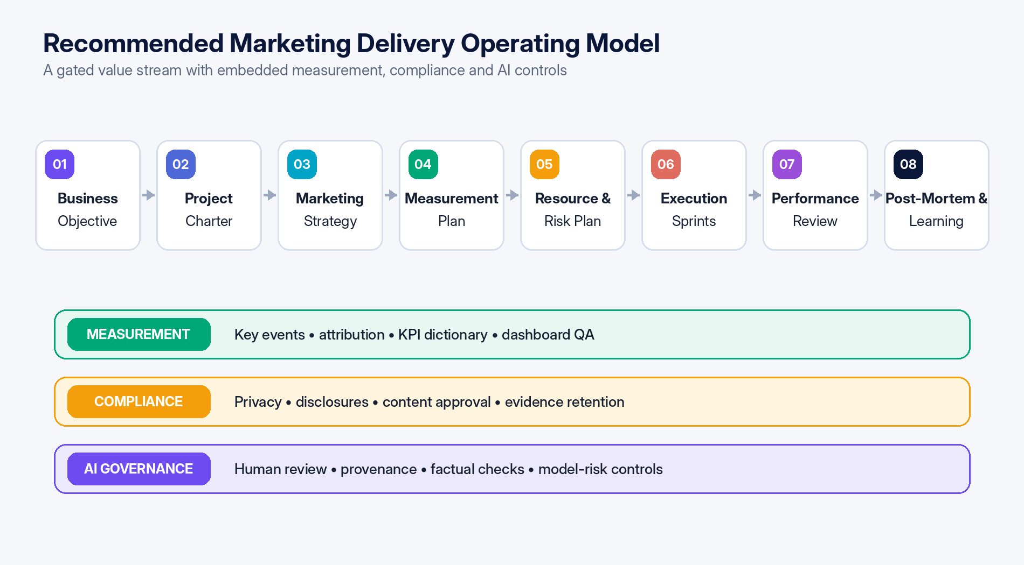
Figure 2 — Target operating model: eight delivery stages supported by measurement, compliance and AI control lanes.

11.1 Operating principles
1. Outcome before output: every project begins with a business question and measurable intended effect.
2. One approved baseline: scope, milestones, budget, resources, risk and measurement are version-controlled.
3. Governed flow: intake, feasibility, baseline, launch and closure each have explicit exit criteria.
4. Data by design: measurement and consent are specified before build, not after launch.
5. Human accountability: tools and AI support decisions but do not own them.
6. Exception-driven management: routine delivery is visible; leadership attention is reserved for variance and decisions.
7. Learning compounds: post-mortem actions update templates, estimates, controls and reusable assets.

11.2 Accountability model
Role | Primary accountability | Key artifacts
Executive sponsor | Business outcome, funding, priority and escalation decisions. | Business case, gate approvals and exception decisions.
Marketing operations / PMO | Framework, portfolio intake, standards, reporting and maturity. | Templates, portfolio dashboard, governance calendar and process metrics.
Project / campaign manager | Integrated plan, coordination, forecast, risk and change control. | Charter, WBS, schedule, status, logs and closure.
Workstream owner | Quality and on-time delivery of assigned outputs. | Work plan, deliverables, estimates and evidence.
Analytics / RevOps owner | Measurement design, data quality, attribution and performance interpretation. | Measurement plan, event specification, dashboard and QA.
Legal / privacy / security | Risk-based approval and policy compliance. | Review criteria, approvals and exception records.
Finance / procurement | Budget integrity, commitment control and commercial assurance. | Cost baseline, forecast, contracts, PO and reconciliation.
System owner | Configuration, integration, access and platform reliability. | Architecture, roles, support process and audit evidence.

11.3 Governance calendar
Cadence | Governance activity | Decision focus
Continuous | Intake and triage | Completeness, urgency and routing.
Weekly | Delivery and risk review | Forecast, blockers, changes and short-term capacity.
Biweekly | Portfolio and resource review | Priorities, demand-capacity trade-offs and cross-project dependencies.
Monthly | Executive performance review | Outcomes, budget, risk, data quality and major decisions.
Quarterly | Capability and tool review | Maturity, process efficiency, adoption, architecture and training needs.
Per project | Launch gate and closure review | Readiness, acceptance, value and lessons learned.

Applied learning and assessment
LECTURE 11 APPLICATION
APPLIED WORKSHOP | Map the current marketing workflow from intake to benefits review. Mark delays, handoff failures, duplicate entry and control gaps; redesign the target flow with owners, stage gates, systems and decision forums.
KNOWLEDGE CHECK | 1. What is the difference between a process map and an operating model?  2. Where should measurement, privacy and approval controls enter the value stream?  3. How does a governance calendar improve decision velocity?

LECTURE 12 | 90-DAY IMPLEMENTATION ROADMAP
Deploying a controlled pilot before scaling process and technology
LECTURE 12 BRIEF | 90 MINUTES
LEARNING OUTCOMES | 1. Sequence design, pilot and scale activities into a controlled 90-day program.  2. Define phase exit criteria, ownership, dependencies and measurable adoption outcomes.  3. Develop an indicative implementation budget and risk-adjusted rollout plan.
SESSION FLOW | 10 min roadmap logic | 20 min Days 1–30 | 20 min Days 31–60 | 15 min Days 61–90 | 15 min roadmap workshop | 10 min review
APPLIED OUTPUT | Owned 90-day implementation plan with gates, budget and success criteria.

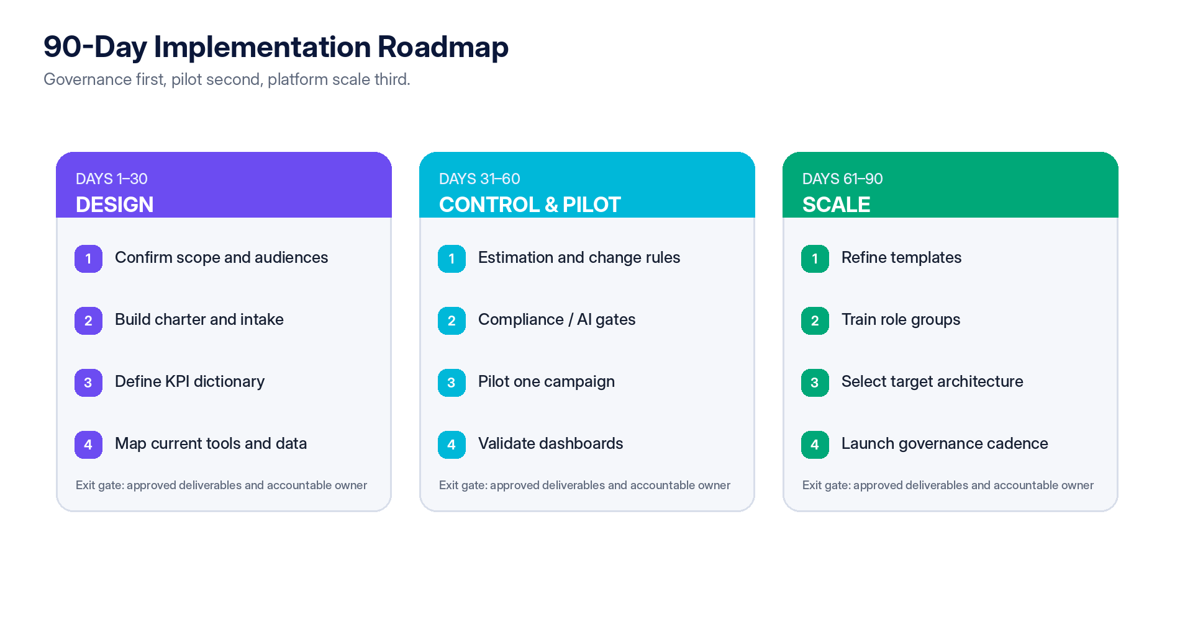
Figure 3 — Recommended 90-day roadmap with design, pilot and scale phases.

12.1 Phase 1 — Design (Days 1–30)
Work package | Deliverable | Exit criterion
Scope and stakeholder alignment | Defined audience, campaign types, objectives and governance sponsor. | Leadership confirms target use cases and authority.
Process mapping | Current-state intake-to-closure workflow and pain-point analysis. | Major handoffs, delays, duplicate data and control gaps are documented.
Core templates | Charter, intake, status, risk, change, measurement and closeout templates. | Templates approved for pilot.
KPI and data design | KPI dictionary, event taxonomy, data owners and quality checks. | Measurement owner signs off.
Tool inventory | Systems, integrations, licenses, duplication and constraints. | Architecture baseline completed.

12.2 Phase 2 — Controls and pilot (Days 31–60)
Work package | Deliverable | Exit criterion
Governance rules | Stage gates, tolerance thresholds, approval SLAs and change authority. | Decision rights approved.
Compliance and AI | Launch checklist, disclosure, privacy and AI-review controls. | Control owners approve pilot use.
Pilot campaign | One representative project managed through the full framework. | Baseline established and weekly control cycle operating.
Dashboard validation | Delivery, budget, outcome and data-quality dashboard. | Metrics reconcile to source systems.
Training | Role-based training for sponsor, PM, workstream, analytics and reviewers. | Users demonstrate required tasks.

12.3 Phase 3 — Scale (Days 61–90)
Work package | Deliverable | Exit criterion
Pilot review | Benefits, friction, defects, adoption and lessons report. | Corrective actions agreed.
Template refinement | Updated standards and campaign-archetype variants. | Version 1.0 control pack approved.
Architecture decision | Target platform / integration model and vendor shortlist. | Business case and procurement plan approved.
Rollout plan | Team sequence, migration, training, support and governance schedule. | Owners and dates committed.
Maturity baseline | Capability score and 12-month improvement backlog. | Executive review completed.

12.4 Illustrative implementation budget
The following figures are planning assumptions only. They must be replaced with local labor rates, vendor quotations, integration requirements and regulatory scope before approval.
Cost element | Lean retrofit | Consolidated rollout | Governance-first transformation
Process design and templates | $4,000 | $8,000 | $15,000
Analytics and KPI setup | $3,000 | $7,500 | $18,000
Privacy / compliance design | $2,000 | $5,000 | $12,000
AI governance and policy | $1,500 | $4,000 | $10,000
Tool configuration / migration | $3,500 | $12,000 | $30,000
Training and enablement | $2,000 | $5,000 | $12,000
Contingency | $2,000 | $6,500 | $18,000
Estimated total | $18,000 | $48,000 | $115,000

Applied learning and assessment
LECTURE 12 APPLICATION
APPLIED WORKSHOP | Create a 90-day roadmap for one pilot campaign. Define workstreams, owners, dependencies, phase exit gates, adoption metrics, training, data migration, governance forums and scale/no-scale decision criteria.
KNOWLEDGE CHECK | 1. Why should process design precede broad technology rollout?  2. What evidence is required to exit the pilot phase?  3. Which adoption and control metrics should be measured during implementation?

LECTURE 13 | MATURITY MODEL, CAPSTONE AND EXECUTIVE ACTION
Sequencing capability development and executive action
LECTURE 13 BRIEF | 90 MINUTES
LEARNING OUTCOMES | 1. Assess current capability across governance, delivery, resources, finance, data, risk and technology.  2. Prioritize improvements based on value, feasibility, dependency and organizational readiness.  3. Integrate the course outputs into a decision-ready marketing project management transformation plan.
SESSION FLOW | 10 min maturity model | 20 min assessment dimensions | 20 min recommendations | 30 min capstone integration | 10 min review
APPLIED OUTPUT | Capstone: executive marketing project management transformation roadmap.

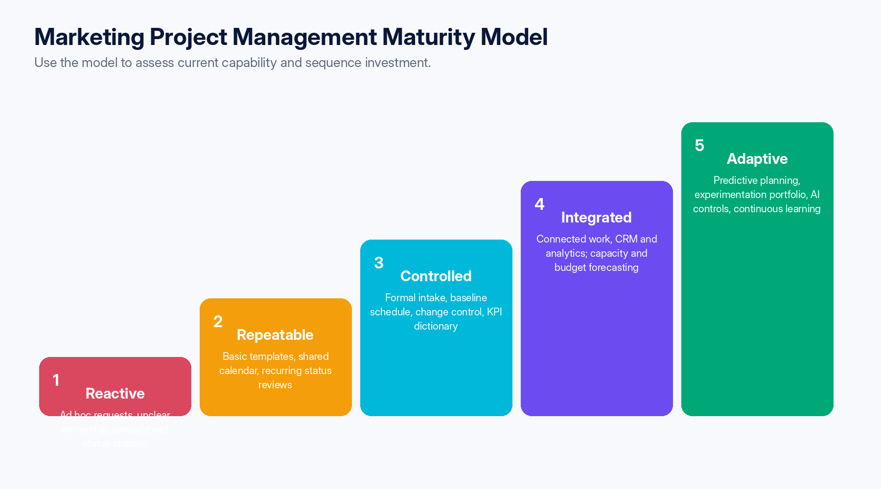
Figure 4 — Five-level maturity model for marketing project management.

13.1 Maturity assessment dimensions
Dimension | Level 1 signal | Level 3 signal | Level 5 signal
Strategy and portfolio | Requests arrive ad hoc. | Formal intake and prioritization. | Dynamic portfolio optimized for value and learning.
Planning and control | Dates and scope are informal. | Approved baselines and change control. | Predictive forecasts and reference-class planning.
Resources | Assignments are reactive. | Role-based capacity and utilization controls. | Scenario planning and capability-market intelligence.
Finance | Spend tracked after the fact. | Time-phased budget and EAC. | Integrated value, profitability and optimization decisions.
Measurement | Vanity metrics and manual reports. | KPI dictionary, events and dashboard ownership. | Causal testing, predictive insight and governed automation.
Risk and compliance | Late review and undocumented approvals. | Embedded gates and evidence retention. | Risk sensing and policy-as-workflow automation.
Technology | Fragmented tools and duplicate data. | Defined authoritative systems and integrations. | Adaptive architecture with strong data lineage and portability.
Learning | Lessons remain personal. | Post-mortems and improvement log. | Reusable knowledge and continuous process optimization.

13.2 Executive recommendations
Priority | Recommendation | Expected result
1 | Mandate a standard charter, intake gate and accountable sponsor for material marketing projects. | Reduces low-value work and ambiguity.
2 | Create a governed measurement architecture before expanding dashboards or automation. | Improves trust, attribution discipline and decision quality.
3 | Introduce a baseline and formal change-control process with explicit trade-offs. | Protects schedule, budget and quality.
4 | Plan capacity by skill, timing and complexity; limit work-in-progress. | Improves throughput and reduces hidden overload.
5 | Embed privacy, disclosures, rights, accessibility and AI review into launch readiness. | Reduces legal, brand and rework risk.
6 | Select tools through a weighted pilot based on the target operating model. | Avoids tool-first transformation and lock-in.
7 | Institutionalize post-mortems, estimation actuals and maturity reviews. | Creates compounding operational learning.

FINAL POSITION
The attachment is a credible starting point, especially for agency environments, but not a complete governance model. Its lifecycle should be retained and strengthened with portfolio gates, measurement design, formal change control, compliance, AI governance and evidence-based tool selection.

Applied learning and assessment
LECTURE 13 APPLICATION
APPLIED WORKSHOP | Complete the maturity assessment, select the three highest-priority capability gaps and consolidate the charter, controls, KPI architecture, risk pack, operating model and 90-day roadmap into a concise executive proposal.
KNOWLEDGE CHECK | 1. Why should maturity improvement be sequenced rather than pursued in parallel?  2. Which capability gaps create the greatest enterprise exposure?  3. What evidence should leadership require before approving scale-up?

COURSE TOOLKIT | APPENDICES
Editable templates, control checklists and capstone support materials

Appendix A1 — Project charter template
Field | Template prompt
Project title / code | Unique name and reference.
Sponsor | Accountable business owner.
Project manager | Accountable delivery owner.
Business problem / opportunity | Why this project is required now.
Target audience | Who must change awareness, behavior or relationship.
Outcome and value hypothesis | Expected measurable effect and causal logic.
Scope in / out | Explicit boundaries and exclusions.
Key deliverables | Outputs with acceptance criteria.
Milestones and tolerances | Baseline dates and escalation thresholds.
Budget | Internal, external, media, technology and contingency.
Success measures | Outcome, leading, delivery and data-quality metrics.
Dependencies and assumptions | External inputs, decisions and constraints.
Top risks | Exposure, owner and planned response.
Compliance / AI requirements | Privacy, disclosures, rights, claims, AI and records.
Governance | RACI, approvals, meetings and change authority.

Appendix A2 — RACI template
Deliverable / decision | Sponsor | PM | Workstream | Analytics | Legal / Privacy | Finance
Approve business case | A | R | C | C | C | C
Approve baseline | A | R | C | C | C | C
Develop deliverables | I | A | R | C | C | I
Approve measurement plan | I | C | C | A/R | C | I
Approve claims / disclosures | I | C | C | C | A/R | I
Approve scope change | A | R | C | C | C | C
Approve launch | A | R | C | C | C | I
Close and review value | A | R | C | C | I | C

Appendix A3 — Risk register fields
Field | Definition
Risk ID and category | Unique reference and classification.
Risk statement | Cause–event–effect statement.
Probability / impact | Defined rating scale and rationale.
Exposure score | Pre-response risk level.
Owner | Person accountable for response.
Response strategy | Avoid, reduce, transfer, accept or exploit opportunity.
Actions / due dates | Specific preventive or contingent actions.
Trigger | Observable condition requiring escalation or contingency.
Residual risk | Expected exposure after response.
Status / evidence | Current state, decisions and supporting records.

Appendix A4 — Change request template
Field | Required content
Change ID / requester / date | Administrative control.
Requested change | Precise addition, deletion or modification.
Business rationale | New information or priority.
Options considered | Include no-change and trade-off options.
Scope impact | Deliverables and acceptance criteria affected.
Schedule impact | Milestones, dependencies and forecast.
Resource impact | Skills, capacity, vendors and opportunity cost.
Budget impact | Incremental cost, commitment and contingency.
Measurement / compliance impact | Events, data, claims, consent, rights and approvals.
Recommendation | Project manager’s recommended option.
Decision | Approved, rejected, deferred or exchanged.
Baseline update | Version, date and communication completed.

Appendix A5 — Campaign launch readiness checklist
Control area | Readiness questions
Business and scope | Outcome, audience, offer, scope and owner remain valid.
Deliverables | Final versions accepted; links, formats, localization and accessibility checked.
Technology | Build, integrations, automation, permissions, fallbacks and monitoring tested.
Measurement | Events, parameters, UTM / source tagging, dashboard and data QA complete.
Privacy and consent | Regional consent behavior and data-use requirements verified.
Claims / disclosures | Claims substantiated; creator, sponsorship or affiliate disclosures visible.
Rights | Image, music, testimonial, data and AI-generated asset rights documented.
Operations | Sales, support, fulfillment, lead routing and escalation are ready.
Budget | Media pacing, vendor commitments and approval thresholds confirmed.
Risk and contingency | Top risks reviewed; stop / rollback criteria and owners confirmed.
Approval | Named go/no-go authority records the decision and evidence.

Appendix A6 — Project closeout checklist
- Confirm deliverable acceptance and unresolved obligations.
- Reconcile budget, commitments, invoices, time and vendor deliverables.
- Validate final performance data and document attribution limitations.
- Record actual milestone dates, effort, cost, scope changes and root causes.
- Complete post-mortem with actions, owners and due dates.
- Archive final assets, approvals, rights, disclosures, data specifications and decisions.
- Schedule benefits-realization review when outcomes mature after project closure.
- Update templates, estimates, risks, reusable assets and the organizational knowledge base.

REFERENCES
Primary source, supporting authority and course evidence base
S1 | Marketing for pm.docx. User-supplied 17-page source document on marketing project management, challenges, lifecycle phases, Productive platform and best practices.
R1 | National Institute of Standards and Technology (NIST). AI Risk Management Framework and AI RMF Playbook.  NIST AI Risk Management Framework
R2 | Google Analytics Help. “Tutorial: Set up a key event.” Guidance on events and key events in Google Analytics.  Google Analytics key event tutorial
R3 | U.S. Federal Trade Commission. “Disclosures 101 for Social Media Influencers.”  FTC disclosure guidance
R4 | “Time Pressure in Software Engineering: A Systematic Review.” arXiv:1901.05771.  arXiv 1901.05771
R5 | “Predicting the Impact of Scope Changes on Project Cost and Schedule Using Machine Learning Techniques.” arXiv:2412.02041.  arXiv 2412.02041
R6 | “The Impact of IT Projects Complexity on Cost Overruns and Schedule Delays.” arXiv:2203.00430.  arXiv 2203.00430
R7 | “Do Cookie Banners Respect My Choice? Measuring Legal Compliance of Banners from IAB Europe’s Transparency and Consent Framework.” arXiv:1911.09964.  arXiv 1911.09964
R8 | “Measuring Google AI Overviews: Activation, Source Quality, Claim Fidelity, and Publisher Impact.” arXiv:2605.14021.  arXiv 2605.14021

Citation and evidence note
The source document is the primary object of analysis. Supporting sources were selected to strengthen the report’s treatment of AI governance, analytics, disclosures, privacy and project-control risks. Research from adjacent technical project domains is used as supportive evidence and analogy; it should not be interpreted as a substitute for organization-specific marketing data.
MARKETING PROJECT MANAGEMENT
A 13-lecture system for strategy, delivery, measurement and applied learning
Prepared for Ahmed Labib | July 2026 | Lecture-Based Professional Course Edition
END OF COURSE MANUAL

