Full Marketing Campaign Data Analysis Project
This comprehensive report covers the full analysis of a marketing campaign dataset using Python. It includes detailed exploration, visualization, statistical testing, segmentation, clustering, and insights. Each step includes the code used and visual output to provide complete transparency and learning.

1. Data Loading
The dataset was loaded using pandas, and the initial structure was reviewed.
```python
import pandas as pd
df = pd.read_csv('WA_Marketing-Campaign.csv')
df.head()
```

2. Exploratory Data Analysis (EDA)
We checked for missing values, data types, and descriptive statistics to understand the structure of the data.
```python
df.isnull().sum()
df.describe()
df.dtypes
```

3. Distribution Visualizations

Sales Distribution (Boxplot)
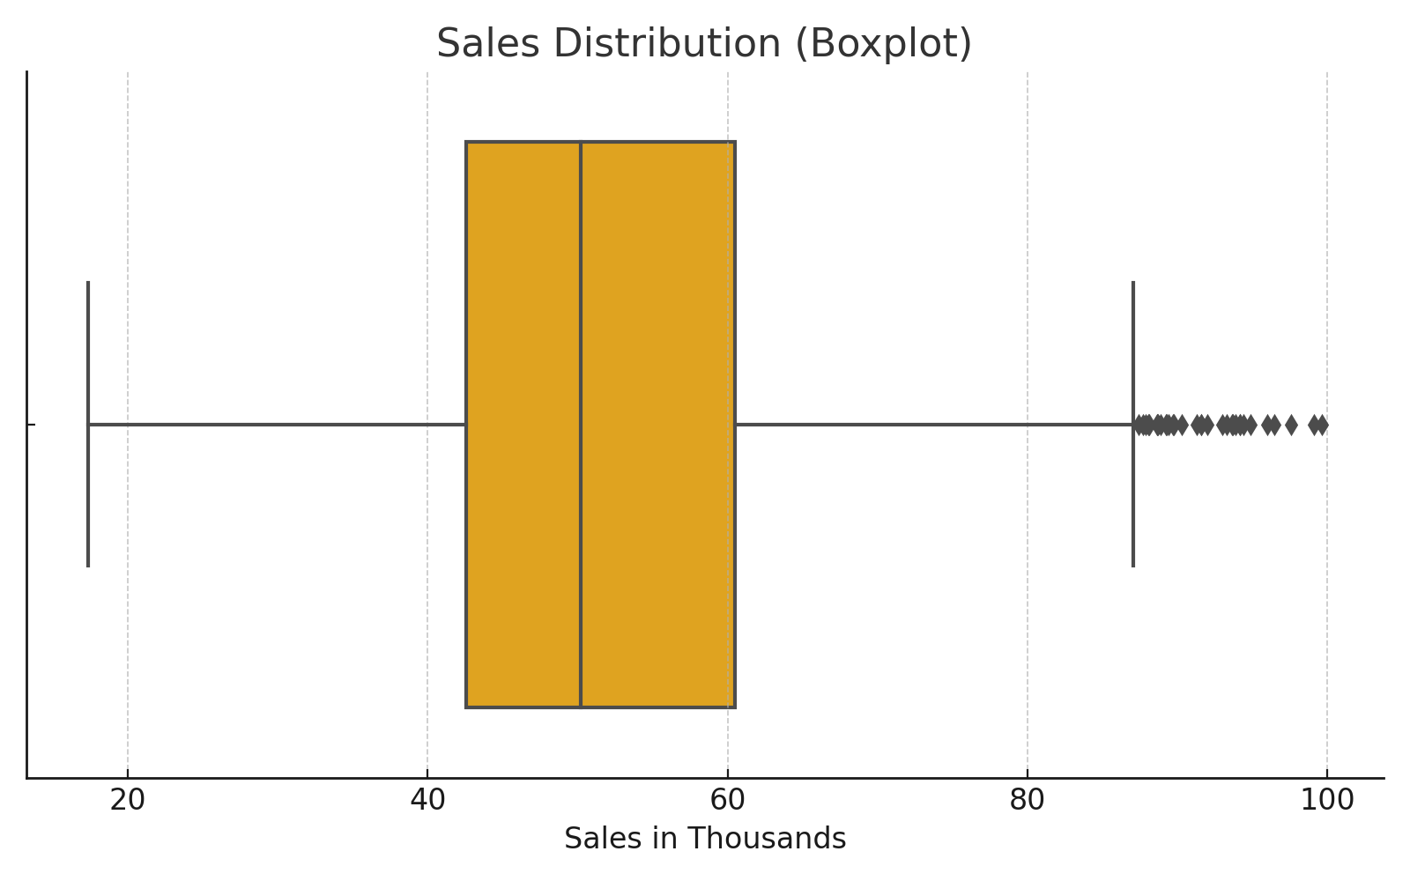
Sales vary from 17k to 99k, most values are between 40k–60k.

Store Age Distribution
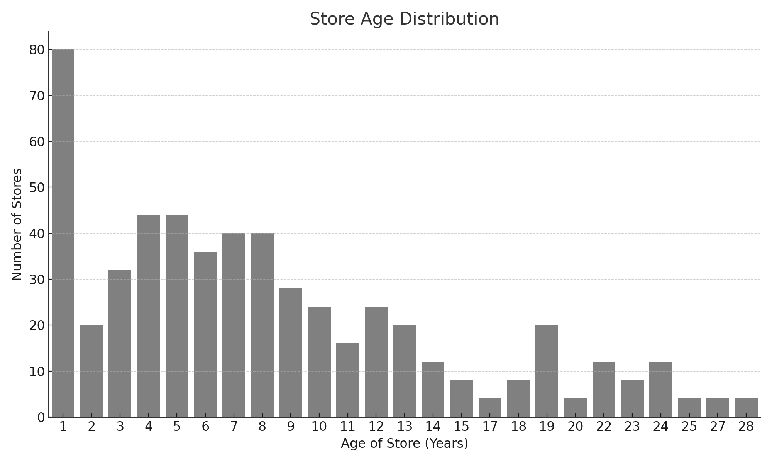
Stores are mostly 4–8 years old.

Promotion Type Distribution
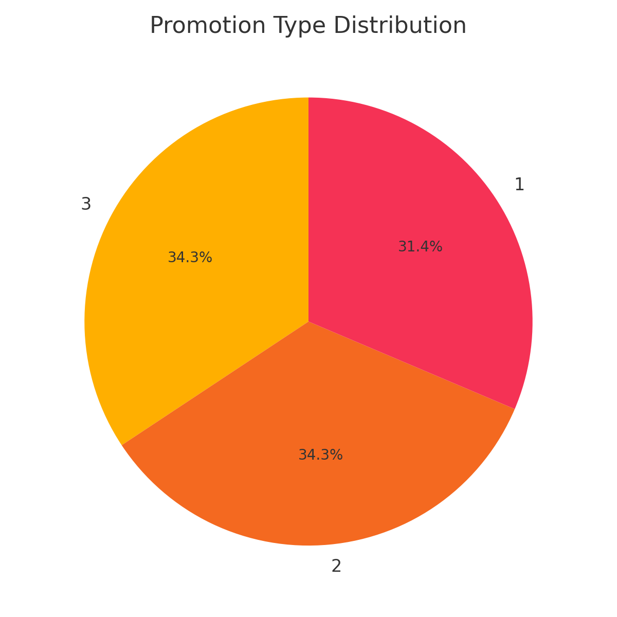
Promotions are evenly distributed.

Market Size Distribution
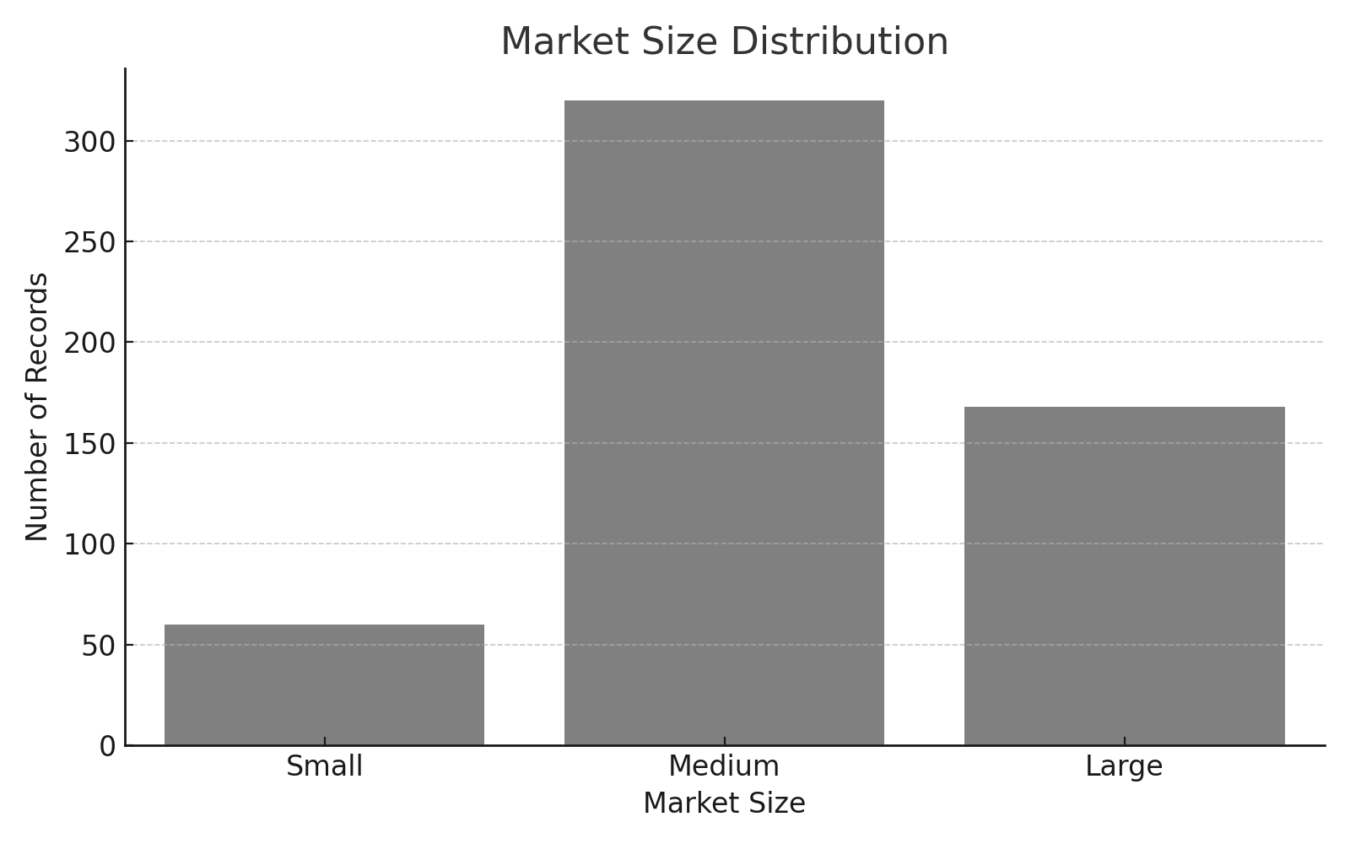
Medium markets dominate.

4. Promotion Effect on Sales
We used boxplots and statistical tests (ANOVA) to compare sales across different promotions.
```python
from scipy.stats import f_oneway
f_stat, p_value = f_oneway(sales_promo_1, sales_promo_2, sales_promo_3)
```
Result: F-statistic = 21.95, p-value = 6.77e-10 → Significant difference in sales by promotion.

5. Sales by Promotion Across Market Sizes
We compared average sales per promotion within each market size.
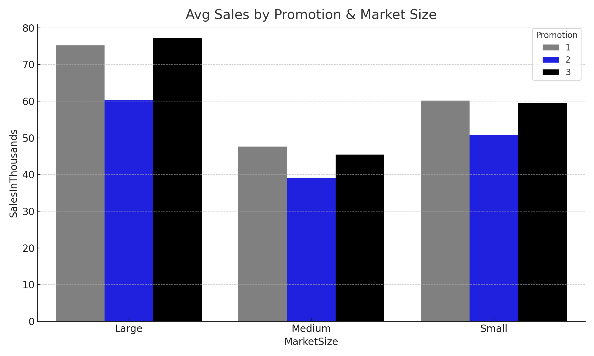
Promotion 1 works well in small and medium markets. Promotion 3 performs best in large markets.

6. Promotion Effect by Store Age
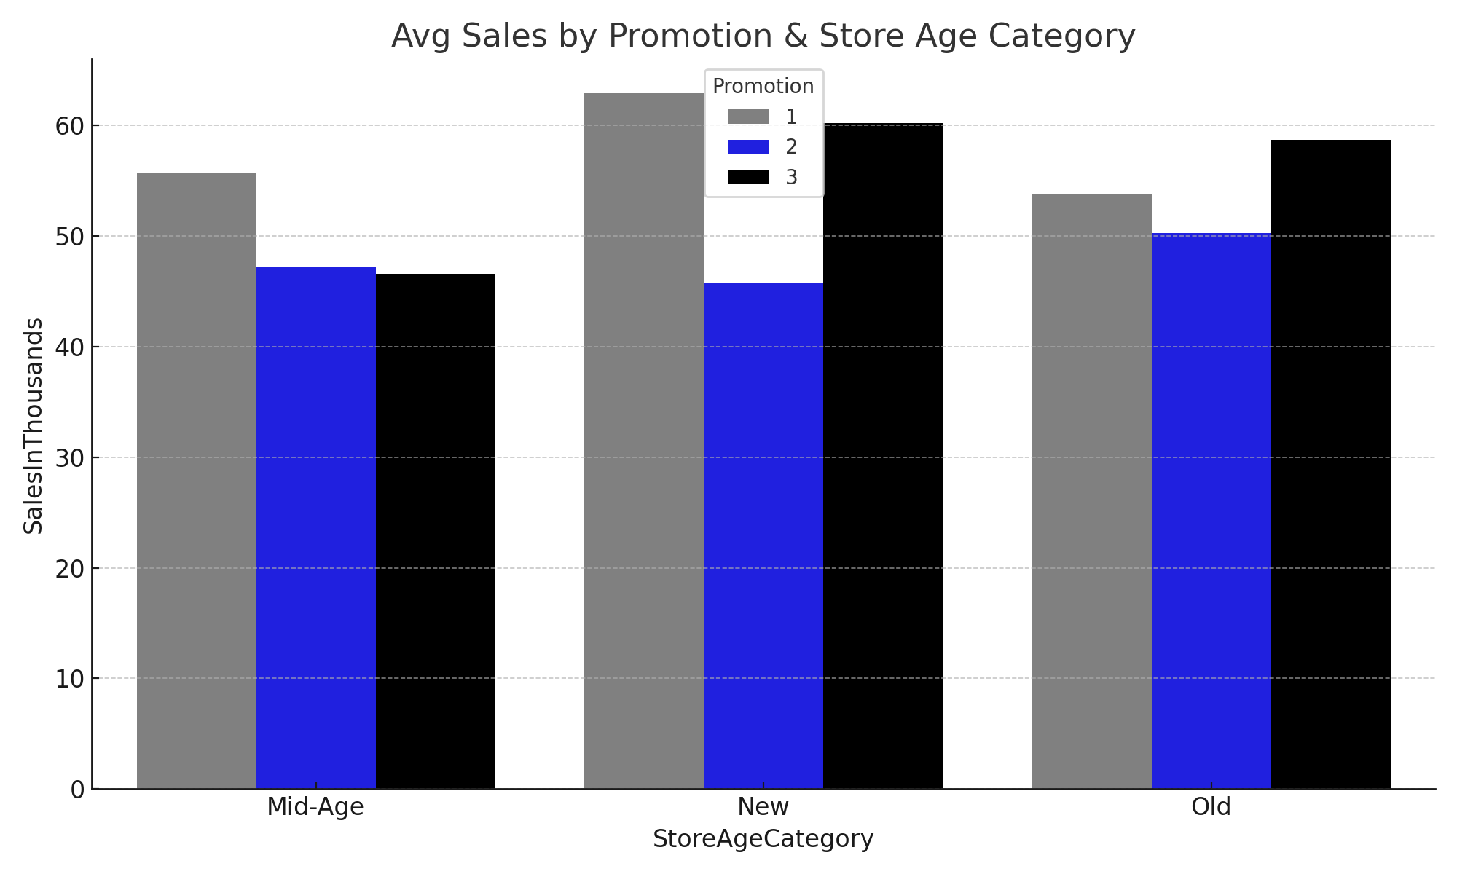
Promotion 1 performs consistently across all store ages. Promotion 2 is consistently weaker.

7. Weekly Sales Trends
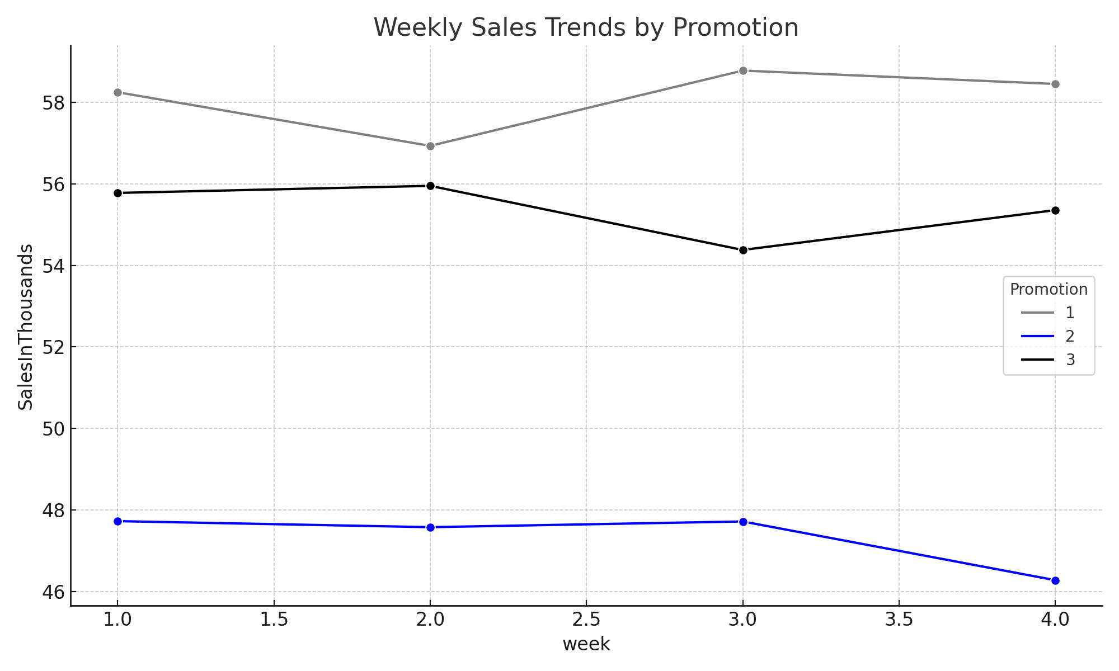
Promotions 1 and 3 peak in week 3. Promotion 2 remains flat.

8. Top Performing Locations
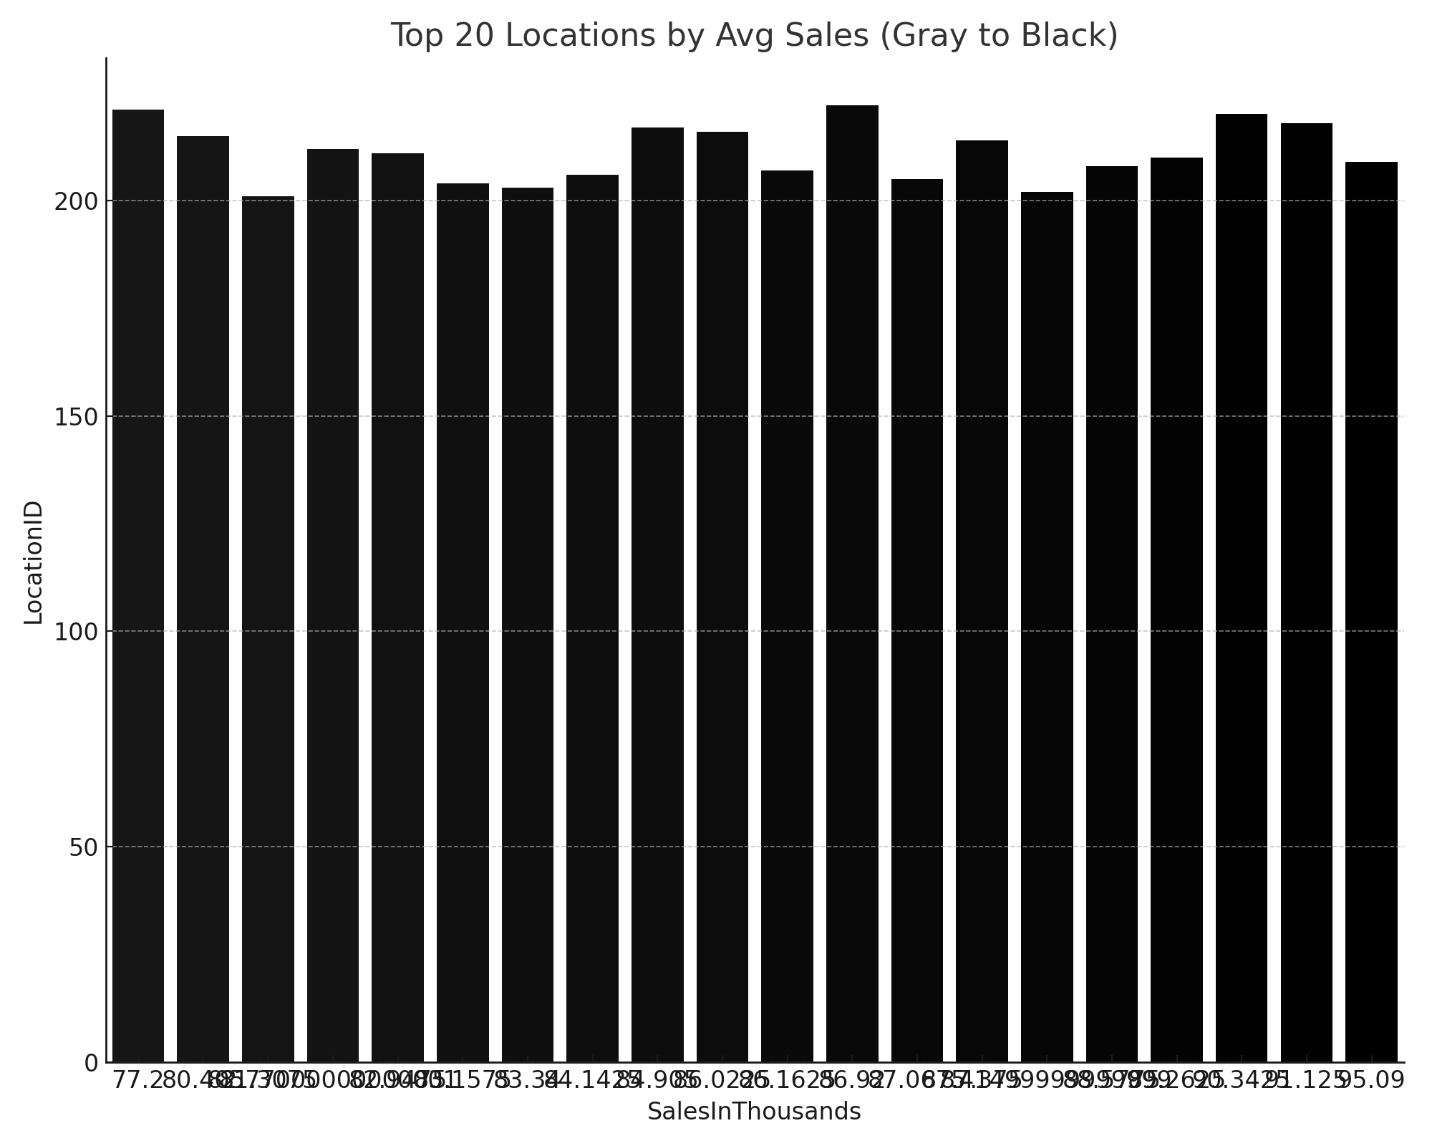
Locations sorted from lowest to highest. Darker bars represent higher performers.

9. Store Segmentation (K-Means Clustering)
We used KMeans to group stores based on sales, age, market size, and promotion. PCA was applied for 2D visualization.
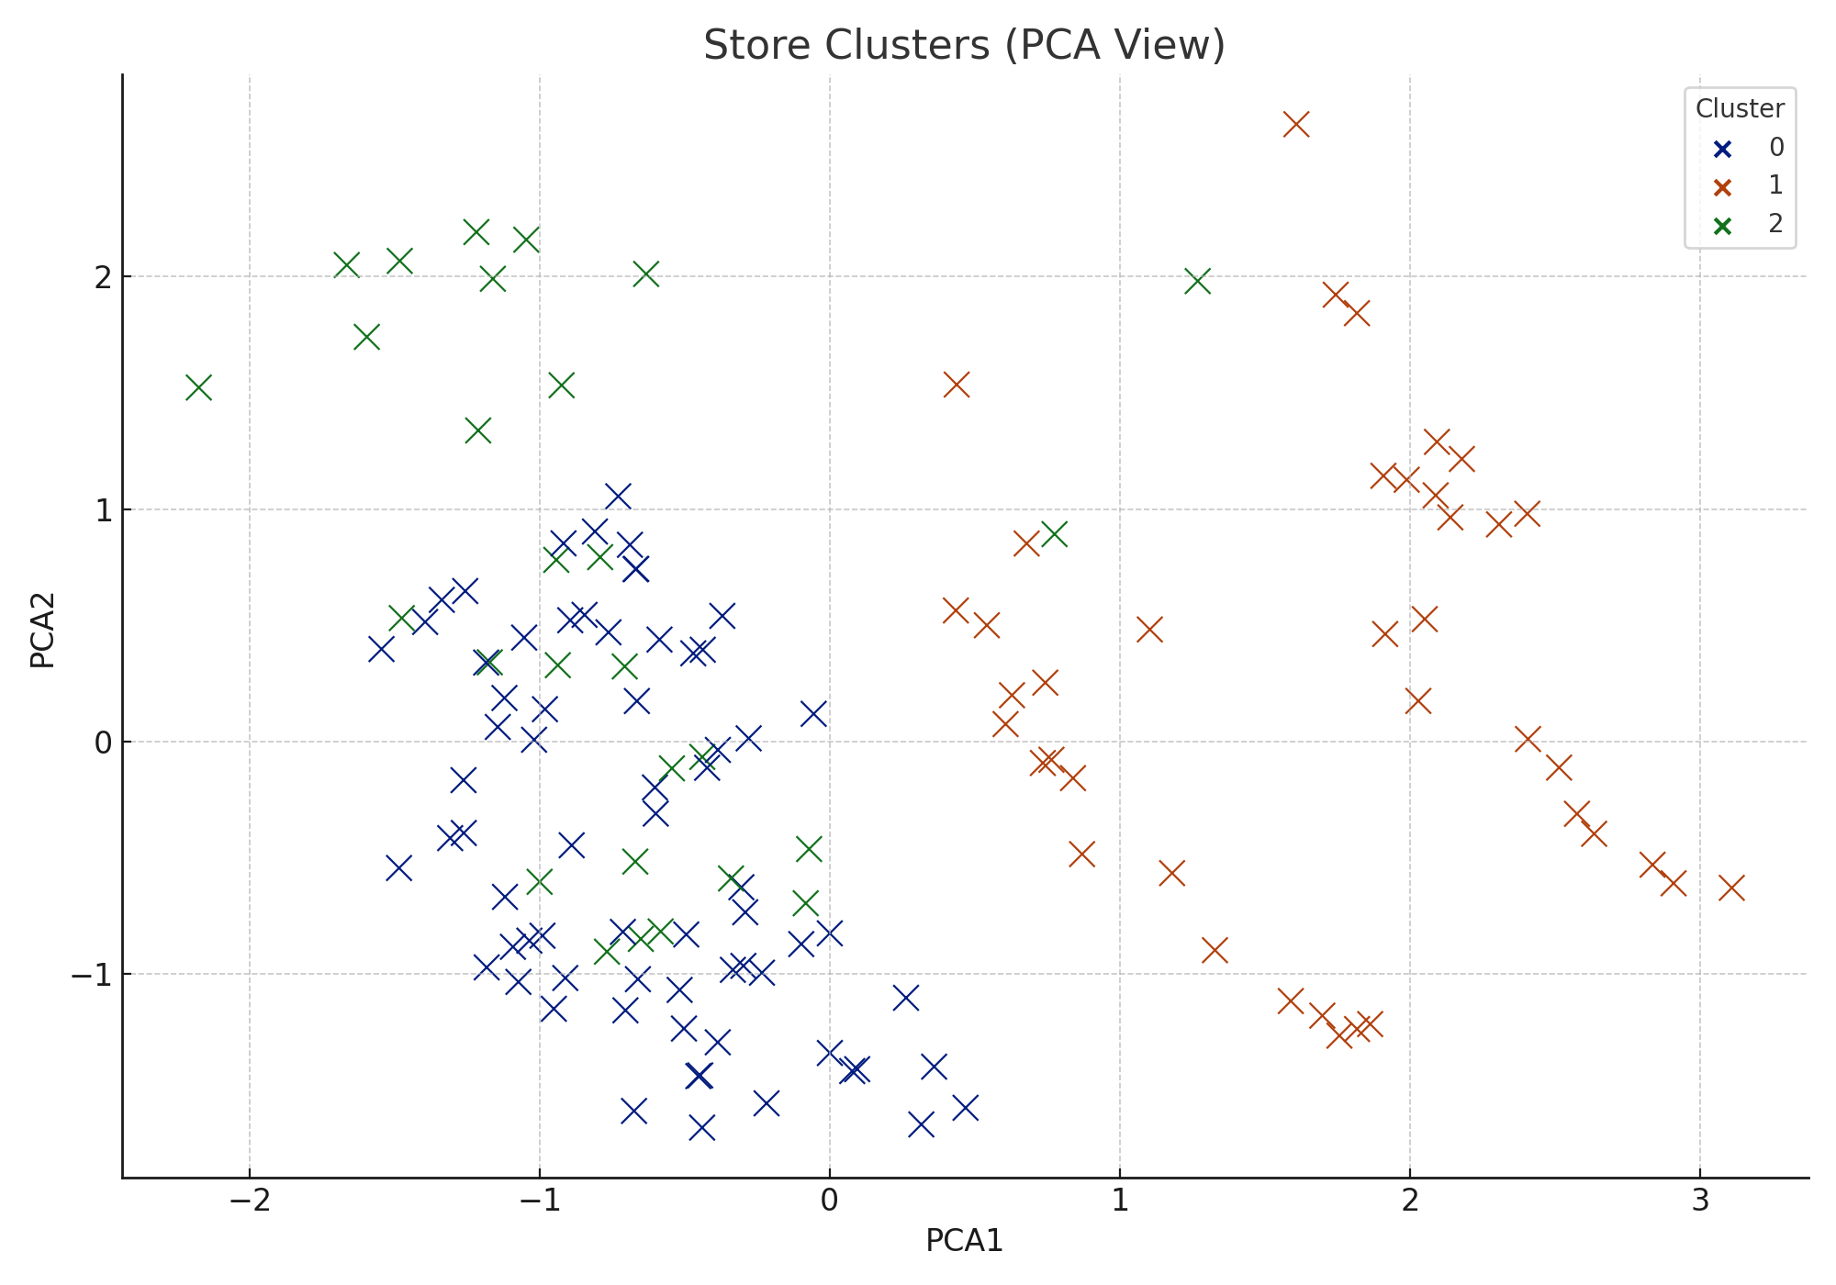
Three store clusters were identified, each with distinct characteristics.

