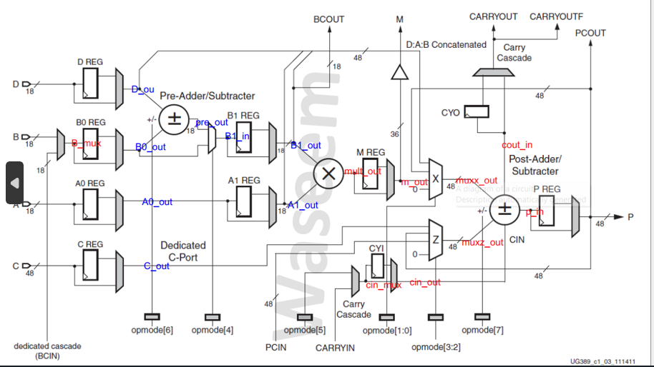
- RTL code
- module r_m_m #(parameter WIDTH = 4 , parameter PIPELINE_ENABLE = 1 , parameter RSTTYP = "SYNC" ) (

- input [WIDTH-1:0] a,

- input clk , rst , ce ,

- output [WIDTH-1:0] out

- );

- reg [WIDTH-1 :0] out_seq ;

- generate
- if ( RSTTYP == "ASYNC")begin
- always @ (posedge clk or posedge rst ) begin
- if (rst)
- out_seq <= {WIDTH{1'b0}};

- else if (ce) begin
- out_seq <= a ;

- end
- end
- end

- else begin
- always @ (posedge clk ) begin
- if (rst)
- out_seq <= {WIDTH{1'b0}};

- else if (ce) begin
- out_seq <= a ;

- end
- end
- end

- endgenerate

- assign out = ( PIPELINE_ENABLE )? out_seq : a ;

- endmodule

- module dsp #(
- // Parameters
- parameter A0REG = 0,
- parameter A1REG = 1,
- parameter B0REG = 0,
- parameter B1REG = 1,
- parameter CREG = 1,
- parameter DREG = 1,
- parameter MREG = 1,
- parameter PREG = 1,
- parameter CARRYINREG = 1,
- parameter CARRYOUTREG = 1,
- parameter OPMODEREG = 1,
- parameter CARRYINSEL = "OPMODE5",
- parameter B_INPUT = "DIRECT",
- parameter RSTTYPE = "SYNC"
- )(
- // Input Ports
- input wire [17:0] A,
- input wire [17:0] B,
- input wire [17:0] D,
- input wire [47:0] C,
- input wire CLK,
- input wire CARRYIN,
- input wire [7:0] opmode_in,
- input wire [17:0] BCIN,
- input wire RSTA,
- input wire RSTB,
- input wire RSTM,
- input wire RSTP,
- input wire RSTC,
- input wire RSTD,
- input wire RSTCARRYIN,
- input wire RSTOPMODE,
- input wire CEA,
- input wire CEB,
- input wire CEM,
- input wire CEP,
- input wire CEC,
- input wire CED,
- input wire CECARRYIN,
- input wire CEOPMODE,
- input wire [47:0] PCIN,

- // Output Ports
- output wire [17:0] BCOUT, // assign BCOUT = B1_OUT ; // CONCAT_D_A_B { D[11:0] , A1_OUT , B1_OUT }
- output wire [47:0] PCOUT, // assign pcout = p ;
- output wire [47:0] P,
- output reg [35:0] M,
- output wire CARRYOUT,
- output wire CARRYOUTF
- );
- // internal signals
- wire [ 17:0 ] D_OUT ;
- wire [ 17:0 ] A0_OUT ;
- wire [ 17:0 ] A1_OUT ;
- wire [ 17:0 ] B0_OUT ;
- wire [ 17:0 ] B1_OUT ;
- wire [ 47:0 ] C_OUT ;
- wire [ 47:0 ] CONCAT_D_A_B ;
- reg [ 17:0 ] B_MUX_BCIN ;
- wire [ 17:0 ] PRE_OUT ;
- wire [ 35:0 ] MULT_OUT ;
- wire [ 35:0 ] M_OUT ;
- reg OPMAODE_MUX_CARRYIN ;
- reg [ 47:0 ] MUX_X_OUT ;
- reg [ 47:0 ] MUX_Z_OUT ;
- wire [ 47:0 ] POST_OUT ;
- wire [47:0] P_OUT ;
- wire CARRYOUT_OUT ;
- wire CARRYOUT_IN ;
- wire [17:0] PRE_OUT_MUX_B0_OUT ;
- wire CARRYIN_OUT ;
- wire [7:0] opmode ;

- // CONNECTIONS
- assign CONCAT_D_A_B = { D[11:0] , A1_OUT , B1_OUT } ;
- assign BCOUT = B1_OUT ;
- assign CARRYOUT = CARRYOUT_OUT ;
- assign CARRYOUTF = CARRYOUT_OUT ;
- assign PCOUT = P_OUT ;
- assign P = P_OUT ;

- // mux for carryin

- always @(*) begin
- case (CARRYINSEL)
- "OPMODE5" : OPMAODE_MUX_CARRYIN = opmode [5] ;
- "CARRYIN" : OPMAODE_MUX_CARRYIN = CARRYIN ;
- default : OPMAODE_MUX_CARRYIN = 1'b0 ;

- endcase
- end

- // mux for B
- always @(*) begin
- case (B_INPUT)
- "DIRECT" : B_MUX_BCIN = B ;
- "CASCADE" : B_MUX_BCIN = BCIN ;
- default : B_MUX_BCIN = 18'b0 ;

- endcase
- end

- // PRE IMP

- assign PRE_OUT = ( opmode [6])? ( D_OUT - B0_OUT ) : ( D_OUT + B0_OUT ) ;

- // mux for pre or b0_out

- assign PRE_OUT_MUX_B0_OUT = ( opmode [4])? PRE_OUT : B0_OUT ;

- // mult imp

- assign MULT_OUT = B1_OUT * A1_OUT ;

- // mux x
- always @(*) begin
- case (opmode [1:0])
- 2'b00 : MUX_X_OUT = 48'b0 ;
- 2'b01 : MUX_X_OUT = {12'b0 , M_OUT } ;
- 2'b10 : MUX_X_OUT = P_OUT ;
- 2'b11 : MUX_X_OUT = CONCAT_D_A_B ;

- endcase
- end

- // mux x
- always @(*) begin
- case (opmode [3:2])
- 2'b00 : MUX_Z_OUT = 48'b0 ;
- 2'b01 : MUX_Z_OUT = PCIN ;
- 2'b10 : MUX_Z_OUT = P_OUT ;
- 2'b11 : MUX_Z_OUT = C_OUT ;

- endcase
- end

- // POST IMP
- assign { CARRYOUT_IN , POST_OUT } = (opmode [7] )? (MUX_Z_OUT - (MUX_X_OUT+CARRYIN_OUT)) : (MUX_Z_OUT + MUX_X_OUT );

- // instantiate the r_m_m

- // 5 modules with WIDTH = 18
- r_m_m #(18, A0REG, RSTTYPE) u0 (.a(A), .clk(CLK), .rst(RSTA), .ce(CEA), .out(A0_OUT));
- r_m_m #(18, A1REG, RSTTYPE) u4 (.a(A0_OUT), .clk(CLK), .rst(RSTA), .ce(CEA), .out(A1_OUT));
- r_m_m #(18, B0REG, RSTTYPE) u3 (.a(B_MUX_BCIN), .clk(CLK), .rst(RSTB), .ce(CEB), .out(B0_OUT));
- r_m_m #(18, B1REG, RSTTYPE) u1 (.a(PRE_OUT_MUX_B0_OUT), .clk(CLK), .rst(RSTB), .ce(CEB), .out(B1_OUT));
- r_m_m #(18, DREG, RSTTYPE) u2 (.a(D), .clk(CLK), .rst(RSTD), .ce(CED), .out(D_OUT));

- // 2 modules with WIDTH = 48
- r_m_m #(48, CREG, RSTTYPE) u5 (.a(C), .clk(CLK), .rst(RSTC), .ce(CEC), .out(C_OUT));
- r_m_m #(48, PREG, RSTTYPE) u6 (.a(POST_OUT), .clk(CLK), .rst(RSTP), .ce(CEP), .out(P_OUT));

- // 1 module with WIDTH = 36
- r_m_m #(36, MREG, RSTTYPE) u7 (.a(MULT_OUT), .clk(CLK), .rst(RSTM), .ce(CEM), .out(M_OUT));

- // 1 module with WIDTH = 8
- r_m_m #(8, OPMODEREG, RSTTYPE) u8 (.a(opmode_in), .clk(CLK), .rst(RSTOPMODE), .ce(CEOPMODE), .out(opmode));

- // 2 modules with WIDTH = 1
- r_m_m #(1, CARRYINREG, RSTTYPE) u9 (.a(OPMAODE_MUX_CARRYIN), .clk(CLK), .rst(RSTCARRYIN), .ce(CECARRYIN), .out(CARRYIN_OUT));
- r_m_m #(1, CARRYOUTREG, RSTTYPE) u10 (.a(CARRYOUT_IN), .clk(CLK), .rst(RSTCARRYIN), .ce(CECARRYIN), .out(CARRYOUT_OUT));

- // BUFFER FOR M

- always @(posedge CLK ) begin

- M <= M_OUT;

- end

- endmodule

2. Testbench code
module dsp_tb();

reg [17:0] A ;
reg [17:0] B ;
reg [17:0] D ;
reg [47:0] C ;
reg CLK ;
reg CARRYIN ;
reg [7:0] opmode_in ;
reg [17:0] BCIN ;
reg RSTA ;
reg RSTB ;
reg RSTM ;
reg RSTP ;
reg RSTC ;
reg RSTD ;
reg RSTCARRYIN ;
reg RSTOPMODE ;
reg CEA ;
reg CEB ;
reg CEM ;
reg CEP ;
reg CEC ;
reg CED ;
reg CECARRYIN ;
reg CEOPMODE ;
reg [47:0] PCIN ;

wire [17:0] BCOUT_dut;
wire [47:0] PCOUT_dut;
wire [47:0] P_dut;
wire [35:0] M_dut;
wire CARRYOUT_dut ;
wire CARRYOUTF_dut ;

// Clock generation
initial CLK = 0;
always #5 CLK = ~CLK;

// DUT instantiation
dsp dut(
A, B, D, C,
CLK, CARRYIN, opmode_in, BCIN,
RSTA, RSTB, RSTM, RSTP, RSTC, RSTD,
RSTCARRYIN, RSTOPMODE,
CEA, CEB, CEM, CEP, CEC, CED,
CECARRYIN, CEOPMODE,
PCIN,
BCOUT_dut, PCOUT_dut, P_dut, M_dut,
CARRYOUT_dut, CARRYOUTF_dut
);

initial begin
A = $random;
B = $random;
D = $random;
C = $random;
CARRYIN = 0;
opmode_in = $random;
BCIN = $random;
RSTA = 1; RSTB = 1; RSTM = 1; RSTP = 1;
RSTC = 1; RSTD = 1; RSTCARRYIN = 1; RSTOPMODE = 1;
CEA = 0; CEB = 0; CEM = 0; CEP = 0;
CEC = 0; CED = 0; CECARRYIN = 0; CEOPMODE = 0;
PCIN = $random;

@(negedge CLK);

if (BCOUT_dut != 0 || PCOUT_dut != 0 || P_dut != 0 || M_dut != 0 || CARRYOUT_dut != 0 || CARRYOUTF_dut != 0) begin
$display("error in resetting");
$stop;
end

RSTA = 0; RSTB = 0; RSTM = 0; RSTP = 0;
RSTC = 0; RSTD = 0; RSTCARRYIN = 0; RSTOPMODE = 0;
CEA = 1; CEB = 1; CEM = 1; CEP = 1;
CEC = 1; CED = 1; CECARRYIN = 1; CEOPMODE = 1;

// path1
opmode_in = 8'b11011101;
A = 18'd20; B = 18'd10; C = 48'd350; D = 18'd25;
BCIN = $random; PCIN = $random; CARRYIN = $random;

repeat (4) @(negedge CLK);

if (BCOUT_dut != 18'hf || M_dut != 36'h12c || P_dut != 48'h32 || PCOUT_dut != 48'h32 || CARRYOUT_dut != 0 || CARRYOUTF_dut != 0) begin
$display("error in path1");
$stop;
end

// path2
opmode_in = 8'b00010000;
A = 18'd20; B = 18'd10; C = 48'd350; D = 18'd25;
BCIN = $random; PCIN = $random; CARRYIN = $random;

repeat (4) @(negedge CLK);

if (BCOUT_dut != 18'h23 || M_dut != 36'h2bc || P_dut != 0 || PCOUT_dut != 0 || CARRYOUT_dut != 0 || CARRYOUTF_dut != 0) begin
$display("error in path2");
$stop;
end

// path3
opmode_in = 8'b00001010;
A = 18'd20; B = 18'd10; C = 48'd350; D = 18'd25;
BCIN = $random; PCIN = $random; CARRYIN = $random;

repeat (4) @(negedge CLK);

if (BCOUT_dut != 18'ha || M_dut != 36'hc8 || P_dut != PCOUT_dut || CARRYOUT_dut != CARRYOUTF_dut) begin
$display("error in path3");
$stop;
end

// path4
opmode_in = 8'b10100111;
A = 18'd5; B = 18'd6; C = 48'd350; D = 18'd25;
BCIN = $random; PCIN = 48'd3000; CARRYIN = $random;

repeat (4) @(negedge CLK);

if (BCOUT_dut != 18'h6 || M_dut != 36'h1e || P_dut != 48'hfe6fffec0bb1 || PCOUT_dut != 48'hfe6fffec0bb1 || CARRYOUT_dut != 1 || CARRYOUTF_dut != 1) begin
$display("error in path4");
$stop;
end

$stop;
end

endmodule

3. Do file
vlib work
vlog dsp48A1_tb.v dsp48A1.v
vsim -voptargs=+acc dsp_tb
add wave *
run -all
#quit -sim
4. QuestaSim Snippets
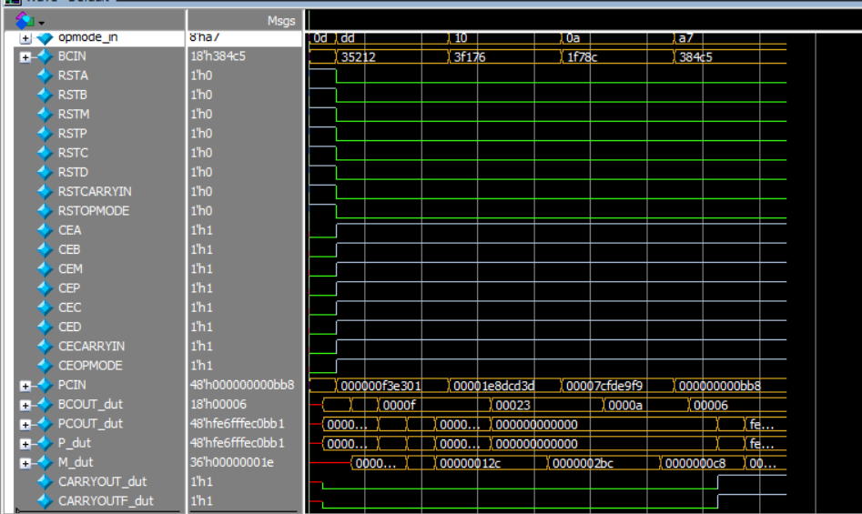
5. Constraint File
## Clock signal
set_property -dict { PACKAGE_PIN W5 IOSTANDARD LVCMOS33 } [get_ports clk]
create_clock -add -name sys_clk_pin -period 10.00 -waveform {0 5} [get_ports clk]

6. Elaboration (“Messages” tab & Schematic snippets)
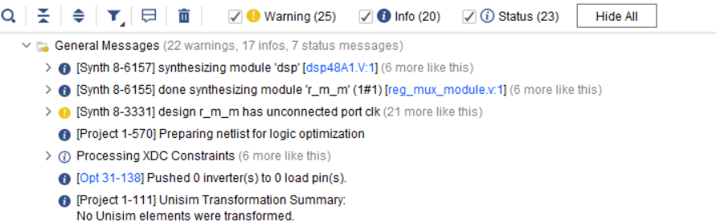
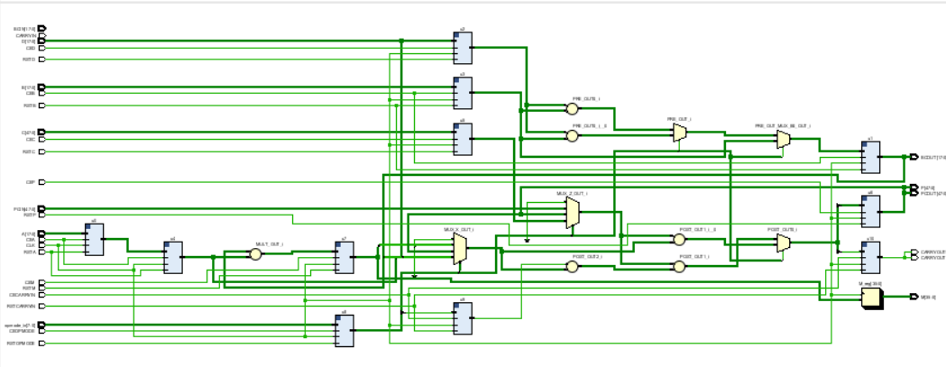
7. Synthesis (“Messages” tab, Utilization report, timing report & Schematic snippets)
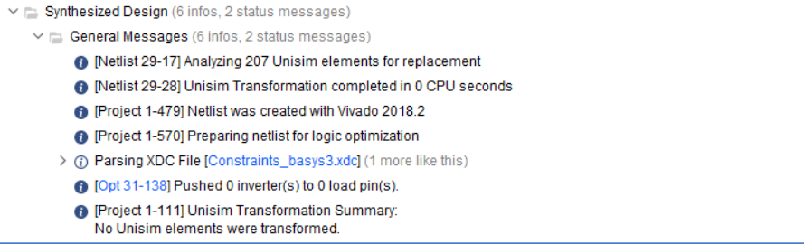
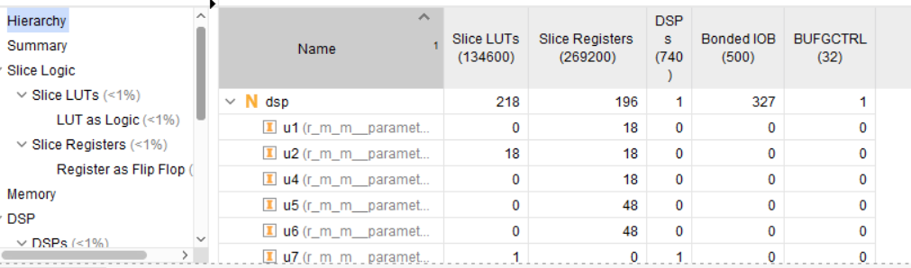

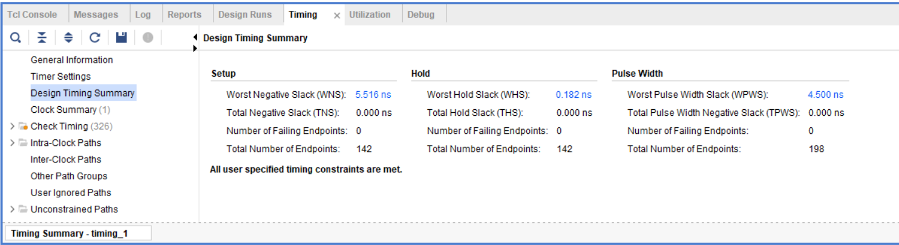
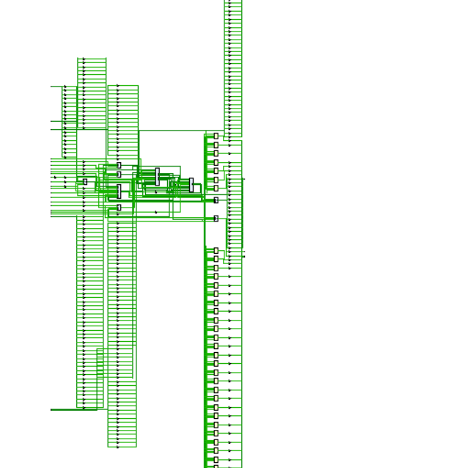
8. Implementation (“Messages” tab, Utiliz

9. Linting (snippets showing no errors)
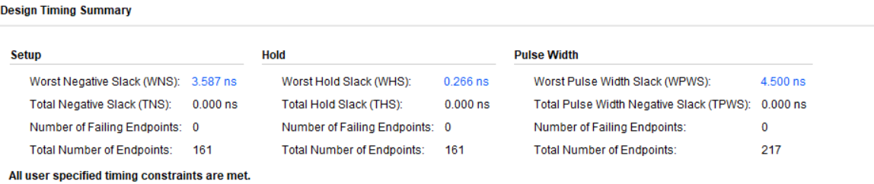
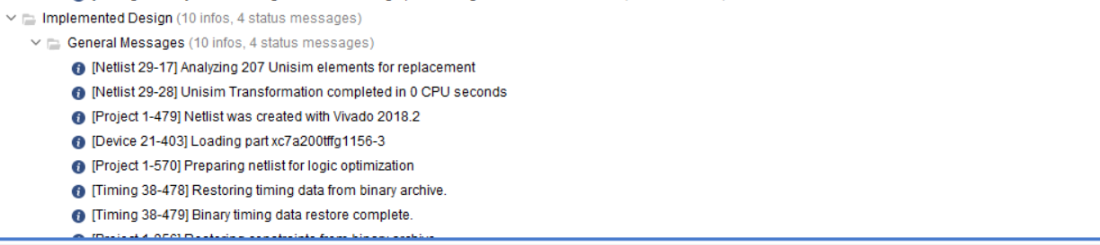
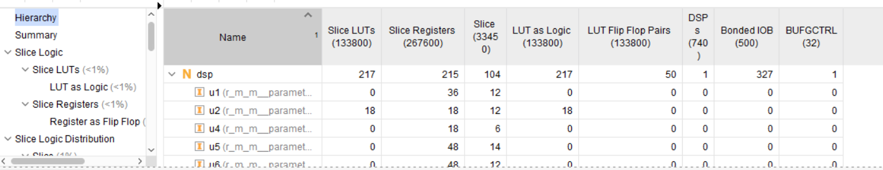
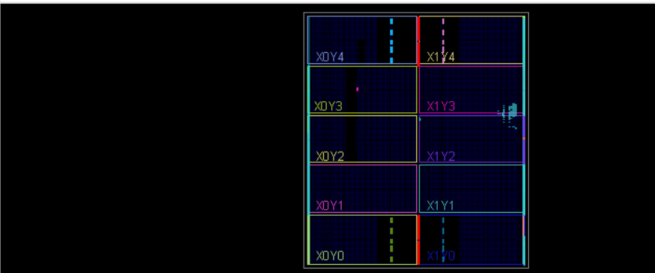
Qlint dosnt work on my device

