MOSFET Characterization Suite
TSMC 180nm BSIM3 | LTspice 26 | May 2026

1. Purpose
Every analog design decision, transistor sizing, bias current, gain, bandwidth, depends on knowing how the transistor behaves in the target process. This project directly sweeps and measures NMOS and PMOS transistors in the TSMC 180nm BSIM3 model. The output is a personal reference that replaces guesswork with reasoning in every future project.

2. Why This Project Exists
Textbook Level-1 SPICE models are too crude for real analog design. A TSMC 180nm transistor exhibits velocity saturation, mobility degradation, subthreshold conduction, and channel-length modulation, none of which Level-1 captures. Without characterizing the real model first, a designer cannot:

- Predict gm at a given bias current without trial-and-error simulation
- Choose between low-power (high gm/Id) and high-speed (low gm/Id) operating points
- Estimate output resistance ro or intrinsic gain Av = gm x ro
- Explain why PMOS needs ~2x the width of NMOS for matched transconductance

3. What Was Done
Five simulation sweeps were performed for both NMOS and PMOS. All schematics use W = 10 um, L = 0.18 um, VDD = 1.8 V, TSMC 180nm BSIM3v3 model (MOSIS wafer run T14B).

Sweep | What It Shows | Key Finding
Id vs Vgs | Turn-on curve, threshold voltage | Vth ~ 0.35 V (NMOS), 0.42 V (PMOS)
Id vs Vds | Triode / saturation boundary | Knee at Vds = Vov = Vgs - Vth
gm vs Vgs | Transconductance across bias range | NMOS peak 4.0 mA/V; PMOS 2.2 mA/V
gm/Id vs Vgs | Efficiency: low-power vs high-speed | Range 27 (sub-Vth) to 4 V-1 (strong inv.)
.op extraction | Exact small-signal parameters at bias | Reference point: Vgs = Vds = 0.9 V

4. Simulation Results

4.1 NMOS - Id vs Vgs
Vth ~ 0.35 V visible as the knee. Three curves at Vds = 0.1 V, 0.95 V, 1.8 V.

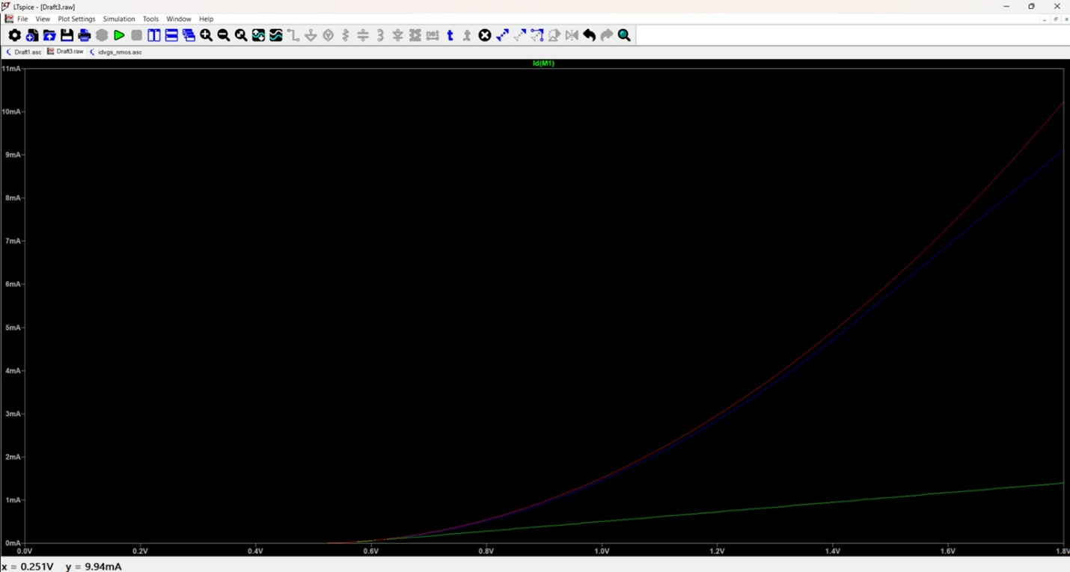

4.2 NMOS - Id vs Vds
Six curves (Vgs = 0.5 V to 1.5 V, step 0.2 V). Triode-to-saturation knee shifts right as Vgs increases. Upward slope in saturation = channel-length modulation (finite ro).
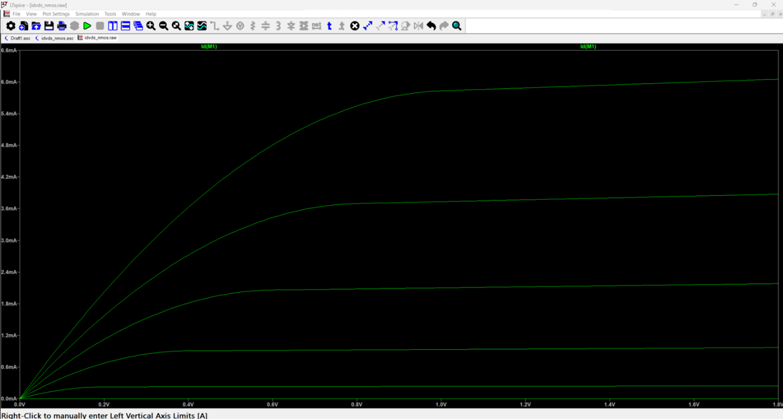

4.3 NMOS - gm and gm/Id vs Vgs
The primary design plot. gm/Id starts at ~27 V-1 in subthreshold and falls to ~4 V-1 in deep strong inversion. Used to select the bias point for every future amplifier.

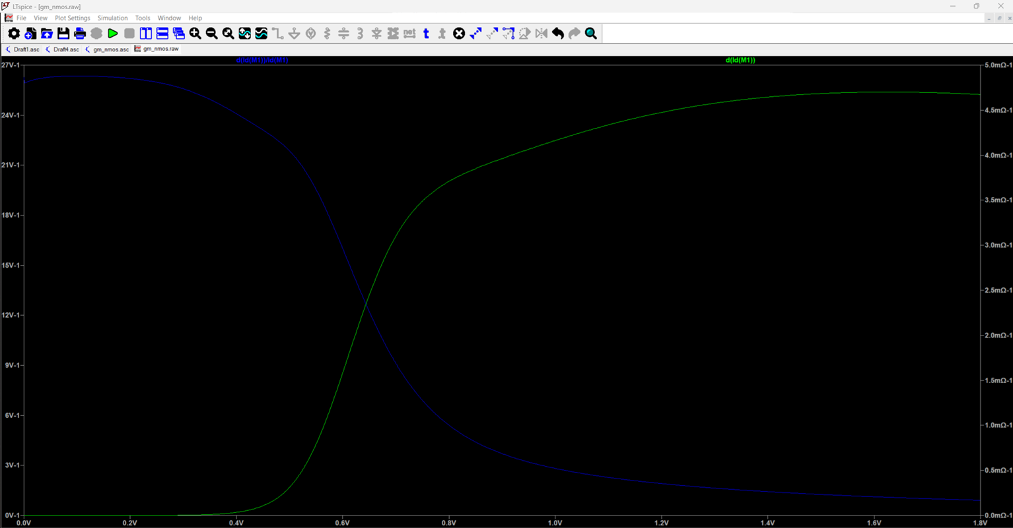

4.4 PMOS - Id vs Vgs
Mirror image of NMOS: fully ON at Vgs = 0 V, turns off near Vgs ~ 1.38 V (= VDD - |Vth|).
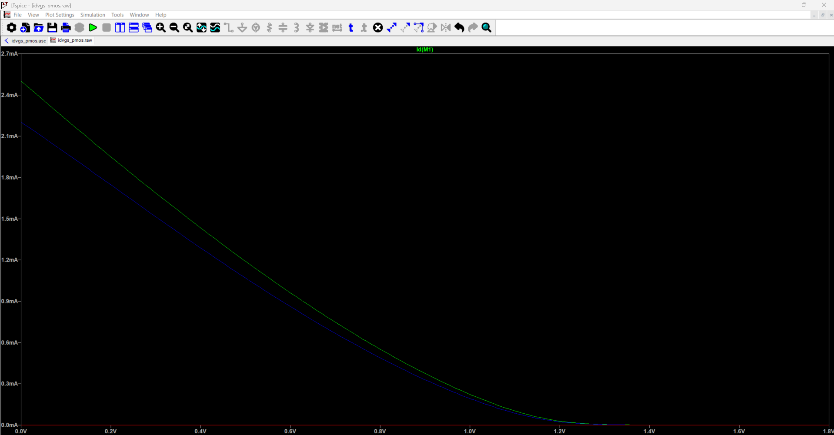

4.5 PMOS - Id vs Vds
Current is highest at low Vds and reduces as Vds rises toward VDD.

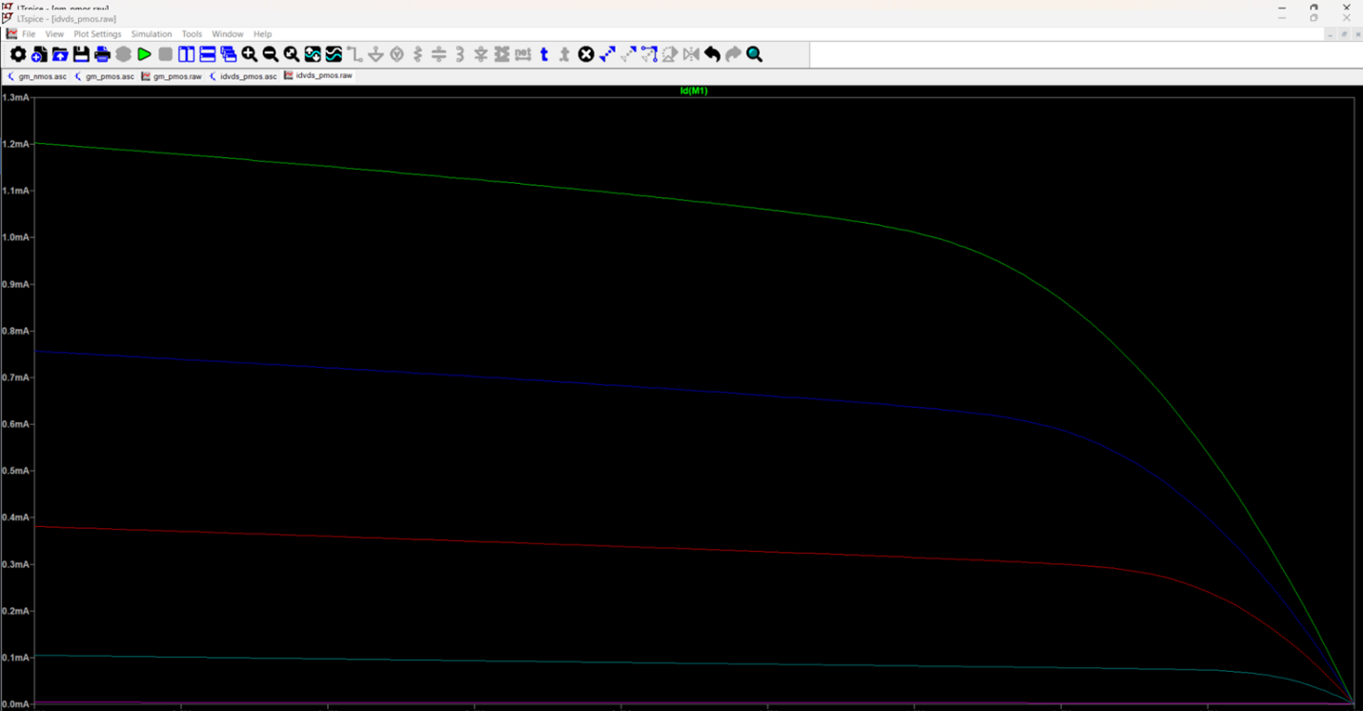

4.6 PMOS - gm and gm/Id vs Vgs
gm is negative (current decreases with increasing Vgs). Peak magnitude ~2.2 mA/V, roughly 55% of NMOS, reflecting lower hole mobility.

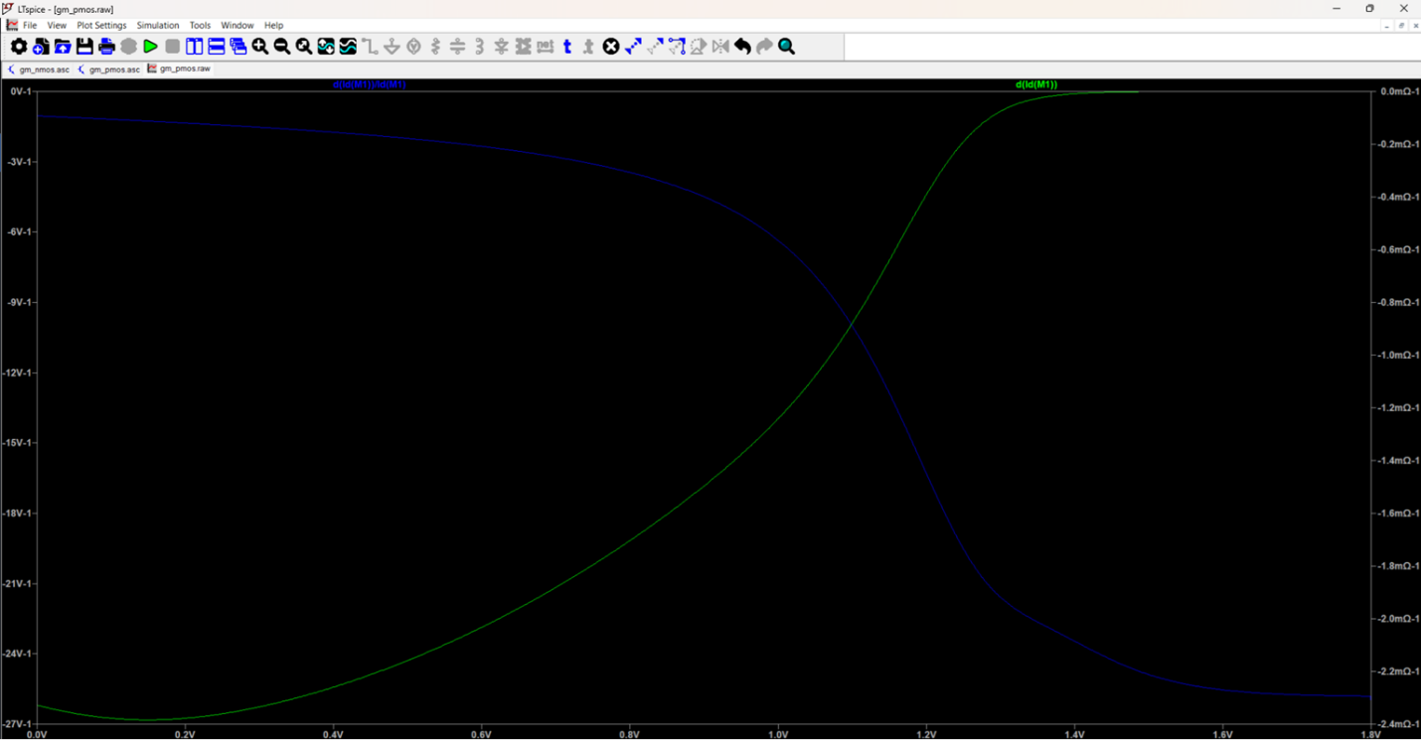

5. Extracted Parameters - Reference Bias
Bias point: Vgs = 0.9 V, Vds = 0.9 V, W/L = 10 um / 0.18 um, VDD = 1.8 V.

Parameter | NMOS | PMOS
Vth | ~ 0.35 V | ~ -0.42 V
Vov = Vgs - Vth | ~ 0.55 V | ~ 0.48 V
Id | 1.07 mA | -
gm | 4.0 mA/V | ~ 2.2 mA/V
gm/Id | 3.79 V-1 | 4.5 V-1
ro = 1/gds | ~ 2.86 kOhm | -
Intrinsic gain (gm x ro) | ~ 11.4 V/V | -

6. Key Design Insights
- Vth ~ 0.35 V (NMOS) and 0.42 V (PMOS). Vds > Vov to confirm saturation.
- gm/Id = 15-20 V-1 = low-power / low-noise region. gm/Id = 5-10 V-1 = high-speed region. This is the primary bias selection knob.
- PMOS gm ~ 55% of NMOS gm at same current. PMOS needs ~2x wider W for matched gm in a differential pair.
- Intrinsic gain at L = 0.18 um is only ~11 V/V due to low ro. Increasing L to 0.5-1 um raises gain to 60-160 V/V. Analog gain stages always use longer L.
- Minimum L is reserved for speed-critical paths only. Never use for gain stages.

7. Project Files

File | Description
gm_pmos | PMOS gm and gm/Id vs Vgs
idvds_pmos | PMOS Id vs Vds sweep
idvgs_pmos | PMOS Id vs Vgs sweep
gm_nmos | NMOS gm and gm/Id vs Vgs
idvds_nmos | NMOS Id vs Vds sweep
idvgs_nmos | NMOS Id vs Vgs sweep

