__________________________
Inventar : number of itmes : example
10 Laptop : office itmes IT , 420
5 table , office itmes 421
4 Car , Car 500
Inventur : Amount of Items :
10 x100 = 1000
5 x10 = 50
4x1000 = 4000
_______________________
- EB : opening Balance transaction : in Journal : Inverntory :
__________________________
Dashboard : DATEV : here you can find/search for you company and branches ( different companies must be there )
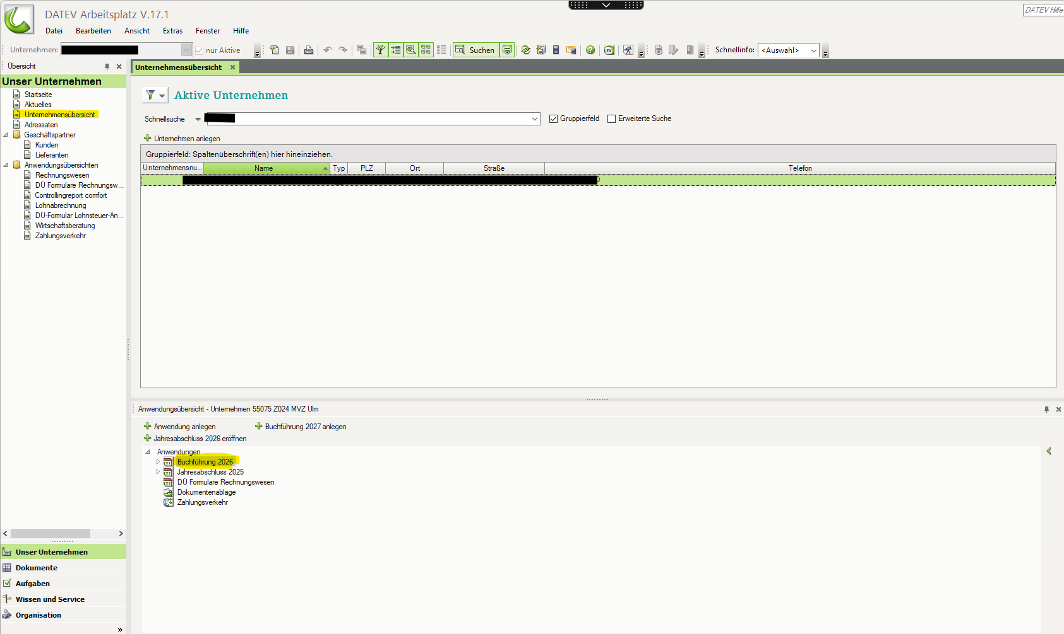

Journal : Buchungstapel ::
Neu BuchungsStapel anlegen :
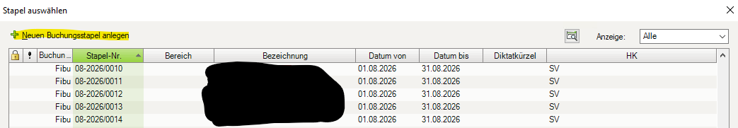

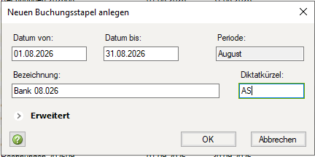

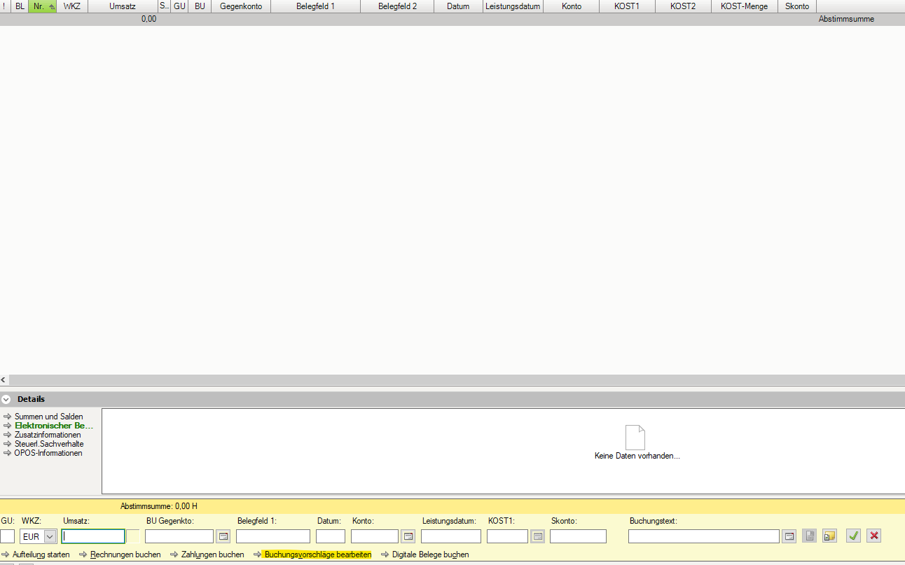
As above : Amount , Account In S , Account in H , Invoice Nr , Tax rate , Booking description , LesitungDatum , GU , KST , Skonto

Ledger : Kontoblatt :

-Chart of accounts : List 50 account : implement : DATV Kontenplan Skr03 :
Create a new account :
And that we can also adjust another Chart of account :
Cash Box : 1000
Bank : 1200
-Suppliers : start from 7000
-Customers : start from 4000
Insurance cost : start from : 9000
_______________
Bilanz :
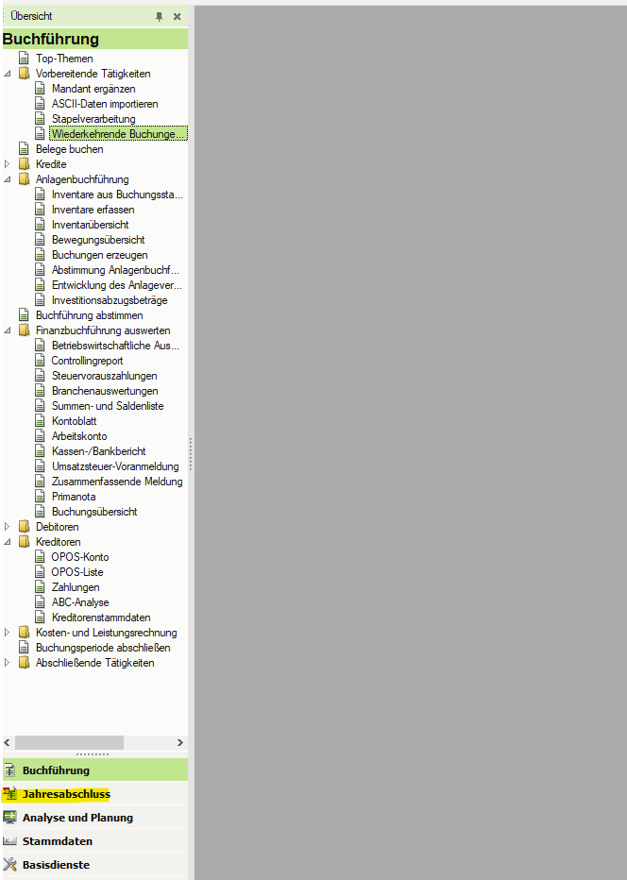

Zeitraum :
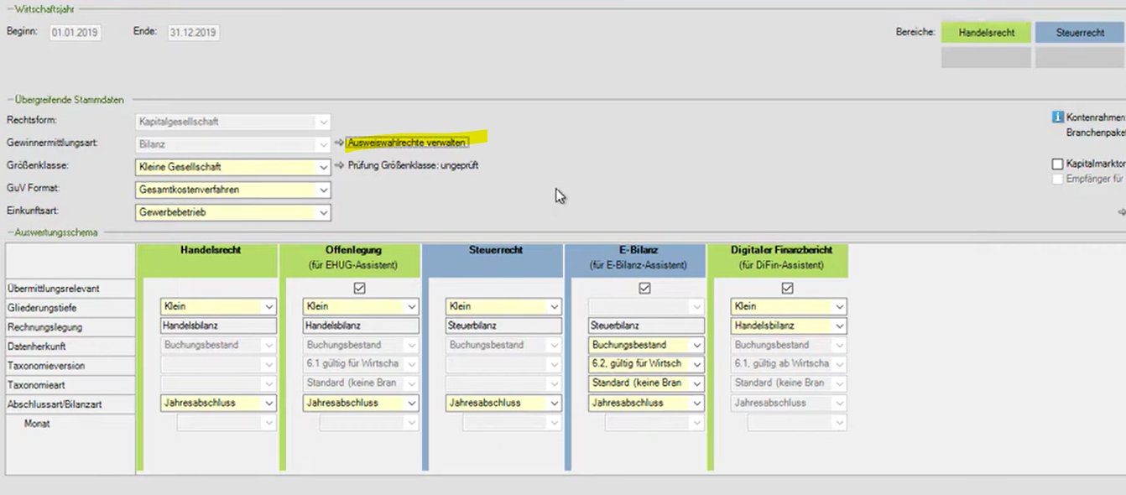
Einstellung
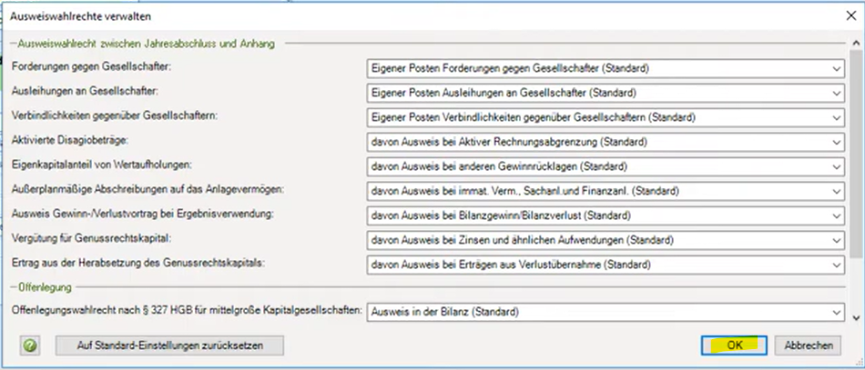
OK
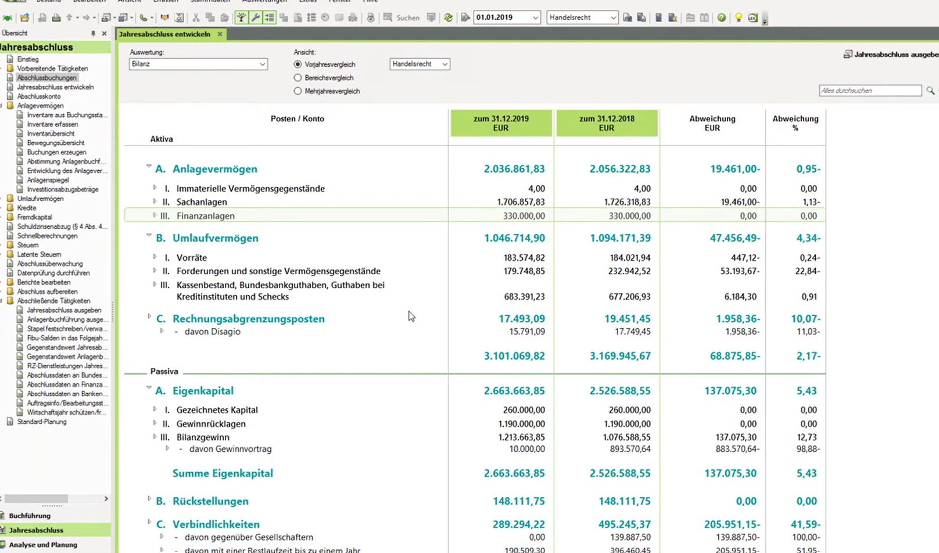
Konten anschauen :
