**Scheduler plugin user manual**

**How to install moodle:**

1. open Xampp control pane.
2. Click in admin in apache section.

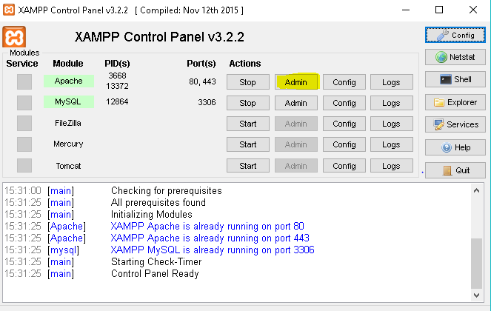

First of all, you will need to download the Moodle installation package. You can download it from its official site “moodle.org”.

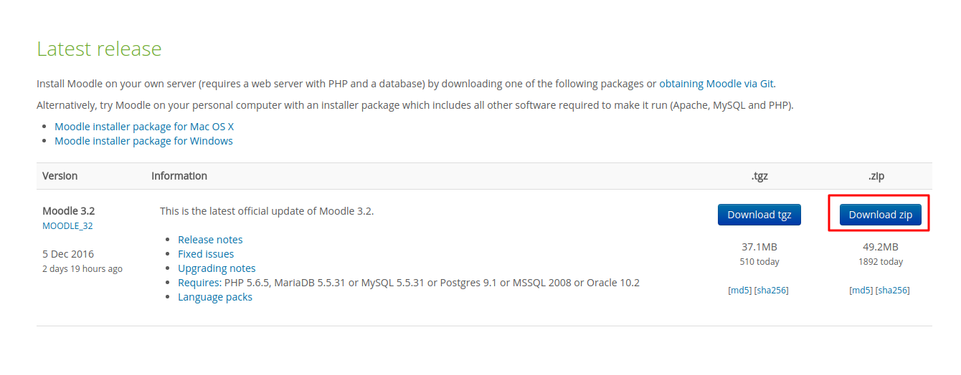

**Second step :Uploading the Moodle Files to Your Hosting Account** There are a few ways on how to upload files to your Hosting Account. You can use either an **FTP client** like **FileZilla** or the **File Manager** in your cPanel. Please note that the location you choose to upload your files to matters. For example, if you wish to install Moodle on your main domain name (**www.yourdomain.com**), you will need to upload the files directly to your **/public_html/** folder

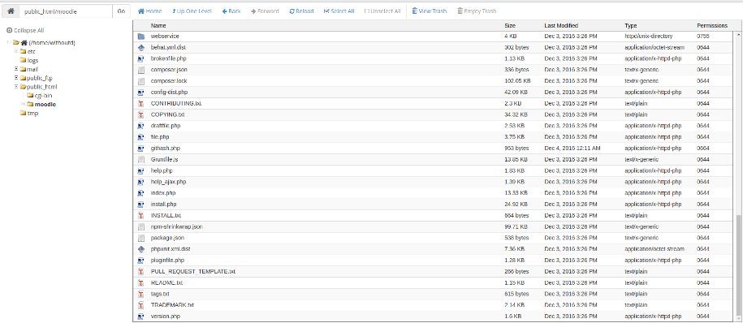

## Third step : Creating MySQL Database for Moodle

Just like most scripts, Moodle uses MySQL databases to store its information. Make sure to keep the database name, username and password close, as you will need them later.

## Fourth Step :The Moodle installation process

Now that you’ve uploaded all the Moodle files and created a MySQL database, let’s go ahead and start the installation process.

1. Access the location of the Moodle files with your domain. (For example, the files are located in the **public_html** folder so you just need to access your domain (www.yourdomain.com). In this case they are located in **/public_html/moodle** so it can be accessed

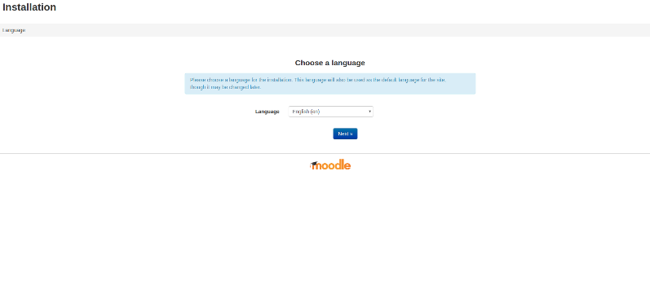

1. On the second step you will be able to see your website address (domain name) and the destination to your Moodle installation. These values cannot be changed, although you should make sure that this information is displayed correctly.

You can set the **Data directory** here. This directory will be used for storage of files and content uploaded by your users. You can leave the default location for your **Data directory**. Click **Next** to continue with the process.

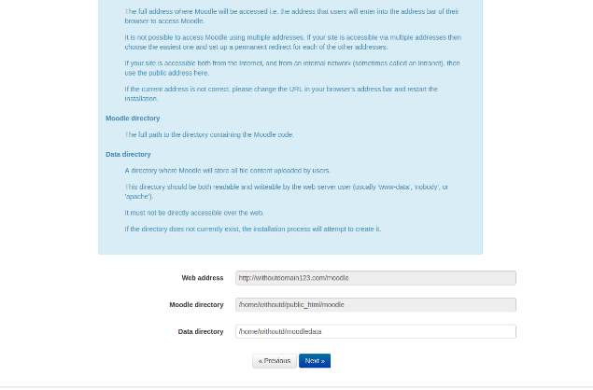

* 1. .Now you can select the database type you wish to use. You can either use **Improved MySQL** or **MariaDB**. In this case let’s select **Improved MySQL**. Both are usually available on most hosting providers. Click **Next** to continue with the process.

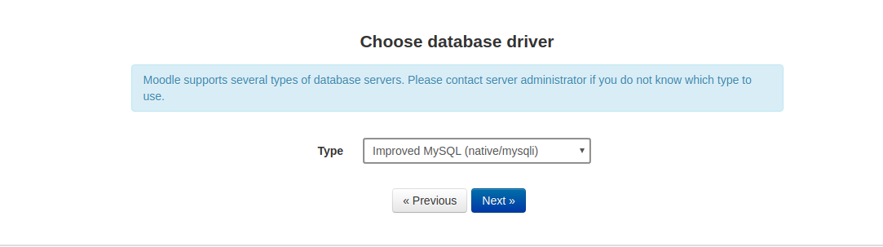

* 1. .Now you will need to enter the information of your MySQL database that you created on **Step 3** and click **Next**.

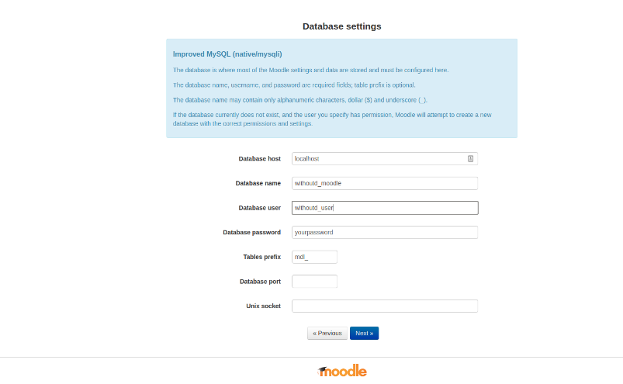

* 1. .If the information you have entered is correct, you will see a copyright agreement. Click **Continue** and the Moodle installation will start checking if all the needed settings and configurations are setup or enabled properly on your host.

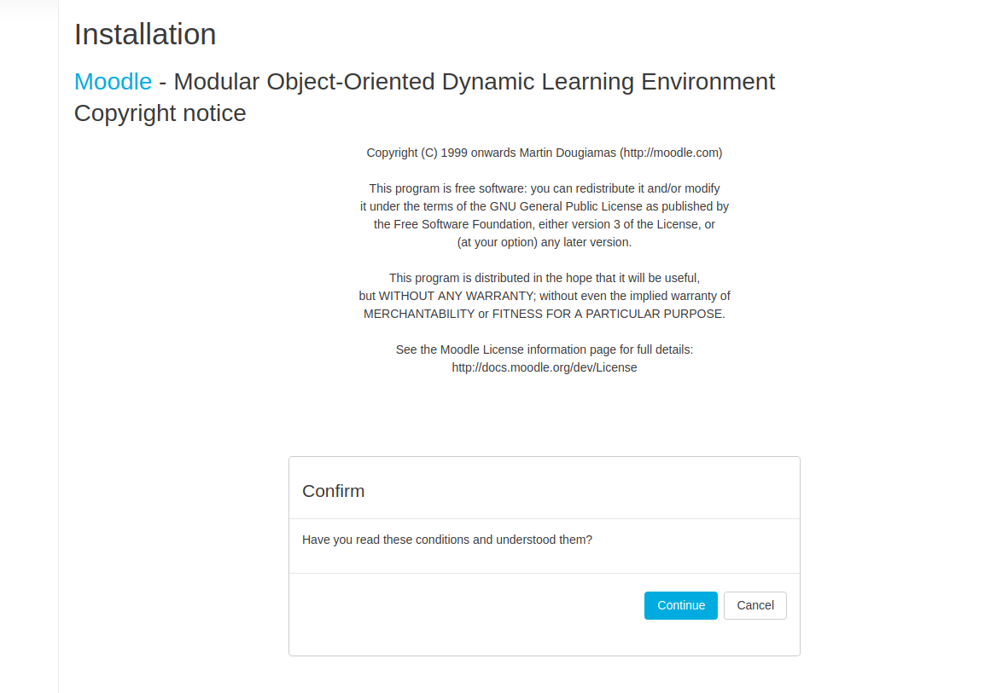

* 1. .Keep clicking **Continue** during every check until you see this window. (If there are any errors, you should contact your hosting provider to check if the missing extensions or settings can be enabled.)  
     Here you will need to setup your Administrator account. Fill in the required information and click **Update Profile**

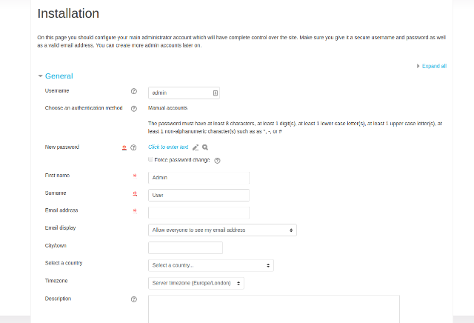

* 1. .Now you just need to type in your Front Page information. (Your website full name, a shorter name, and a summary). You can also select the timezone for your website. Then you can also disable or enable user self-registration (either their accounts are activated via email or by Administrator approval).

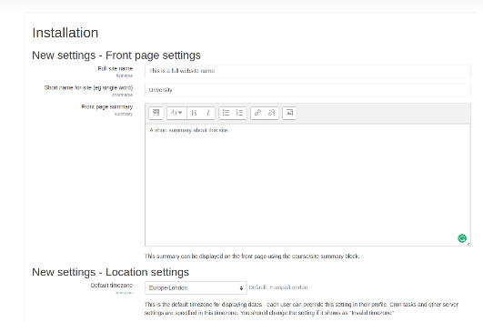

And that’s it! You have finished the installation process!

**How to install plugin :**

**1 .**You should download plugin

1. .Go to site administration

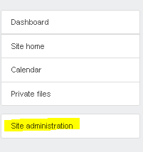

1. .Select plugins



4 .Go to plugins section

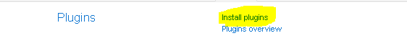

1. .go to choose file and select the plugin file which you downloaded

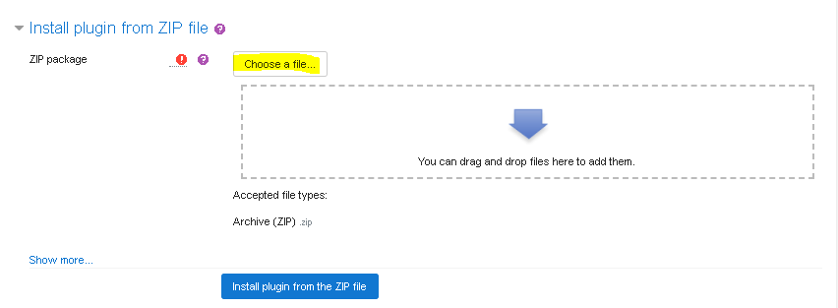

1. .press select install plugin from the zip file

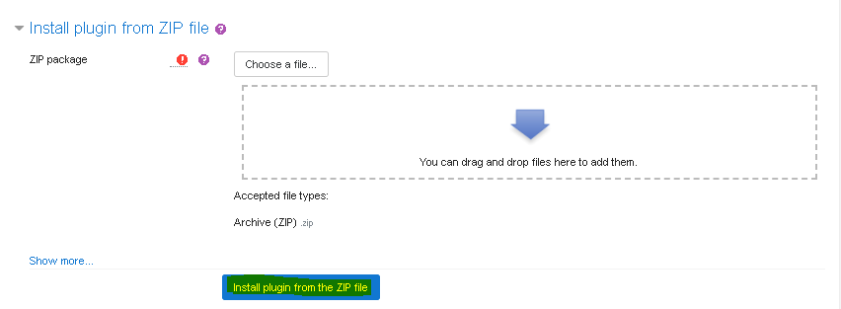

**If you want to add new user** :

1. Go to site administration

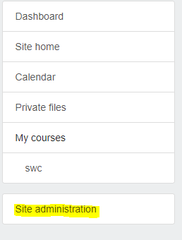

1. Select users



1. Select add a new user from accounts section

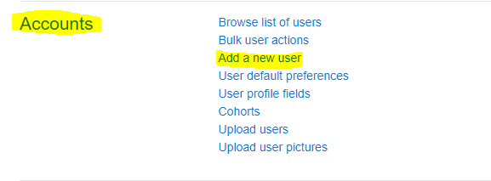

1. Fill user information
2. Click create user



**How to Assign Role to Any User**

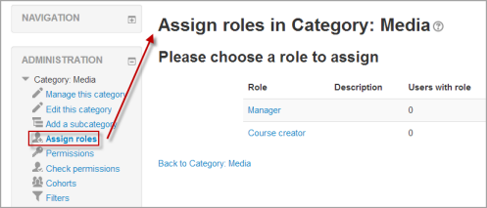

* Apart from the manager and course creator, users do not normally have a site-wide (or system) role. Even though you may be a teacher offline, when you are in Moodle you could have a teacher role in the course you teach in but a student role in another course where you are studying for a diploma.
* Because of the way Moodle works, assigning roles is done for a particular context. A site and course are examples of two different contexts. When you create a new role or tweak a pre-existing role via *Administration > Site Administration > Users > Permissions > Define roles*, you are asked in which context(s) you want the role to be assigned:

[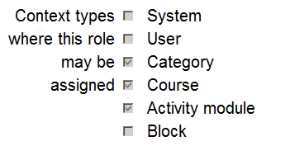](https://docs.moodle.org/34/en/File:rolecontexttypes.png)

System context

To assign a role in the system context, go to 'Assign system roles' in the Site administration.

Any roles assigned here apply across the whole site. It makes sense therefore that only roles that need this functionality can be assigned here. The [Manager](https://docs.moodle.org/34/en/Manager) role and [Course creator](https://docs.moodle.org/34/en/Course_creator) role are examples of two such roles. Assigning a teacher or student here would result in their being able to teach/study in every single course on the site, which is not usually desirable.

Assigning system roles by CSV

Where certain custom roles are applied in the system context, it is possible to upload users to that role in bulk by adding the field *sysrole1* (etc) to a CSV file.

[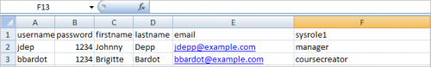](https://docs.moodle.org/34/en/File:GlobalRoles1.png)

Sysrole column

When previewed, there is a column indicating their system role:

[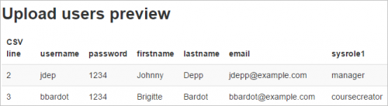](https://docs.moodle.org/34/en/File:GlobalRoles2.png)

Preview screen

Once uploaded, the users are present on the 'Assign system roles' screen:

[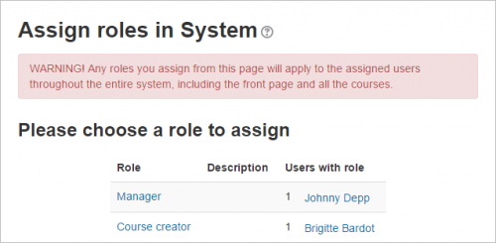](https://docs.moodle.org/34/en/File:GlobalRoles3.png)

Assign system roles screen

See [Upload users](https://docs.moodle.org/34/en/Upload_users) for information on adding users to roles via CSV.

Front page context

* *Administration > Site Administration > Front Page>Users>Permissions>Assigned roles*
* Those with a role in the system context do not need to be assigned a role here as well.
* However you might want to allow a teacher to manage items on the front page; in this instance, you would assign them the role on the Front page.

Course Category context

* See [Category enrolments](https://docs.moodle.org/34/en/Category_enrolments)
* Users may be enrolled in the category to save enrolling them in each individual course in that category.

Course context

[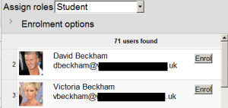](https://docs.moodle.org/34/en/File:enrolusers.png)

Enrol users

* Go to the Participants page
* Click the "Enrol users" button and click those users you wish to enrol

The dropdown menu at the top shows roles for which you are allowed to enrol; typically those users with lower roles than you. See [Participants](https://docs.moodle.org/34/en/Participants) for more details.

Block context

* (Within the block) *Administration > Assign roles*
* You may wish to assign roles to a block if, for instance you want specific people to see the block but for it to be hidden from others

Activity Module context

* (Within the activity settings) *Administration > Locally assigned roles*
* An example of this is assigning a student the teacher role locally in an individual activity like a forum so they can moderate their classmates' posts while still retaining the student role in the rest of the course.

User context

The user context is used for roles such as mentor, team leader or the [Parent role](https://docs.moodle.org/34/en/Parent_role). The role to be assigned must have 'User' ticked as the context type where it is to be assigned.

To assign a user the role of mentor in the context of their mentee, click the mentee's profile, then Preferences then 'Assign roles relative to this user'.

If a mentor has lots of mentees, the role of mentor can be assigned to them all in one go as follows:

1. Put all mentees in a cohort
2. Go to *Site administration > Users > Permissions > Assign user roles to cohort*

Hierarchy

By assigning a role to a user in a certain context, you grant them the permissions contained in that role for the current context and all lower contexts.

The list of contexts in hierarchical order is as follows:

* System (no parent)
* Front page (parent = system) -
* Course category (parent = parent category or system)
* Course (parent = category or system)
* Module (parent = course or system)
* Block (parent = course or system)
* User (parent = system)

Roles can be inherited. For example if a user is assigned a Teacher role in a specific course category then the user will have this role in ALL courses within the category. Tip: use the override feature in a specific context for exceptions.

Roles will only work if the role assignment is made in the correct context. Some examples: a Teacher role should be assigned to a user in the course or course category context, a Forum moderator for a particular forum should be assigned in that specific forum.

Assigning someone the role of Site administrator

* Site administrators are assigned via a special page: *Administration > Site Administration > Users > Permissions > Site Administrators*. Select the name from the right and move it over to the left:

[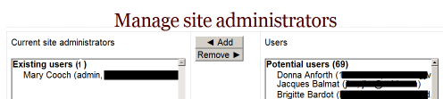](https://docs.moodle.org/34/en/File:managesiteadmins.png)

* The original (primary) administrator cannot be deleted.

Checking a user's role assignments

To check a user's role assignments go to their profile page, then under the Administration heading, click on 'Preferences'. On the Preferences page, under the 'Roles' heading click on 'This user's role assignments'.

Hidden roles

If you want to provide users with access to the course, but don't want them to be visible in the participants list, use the [Other users](https://docs.moodle.org/34/en/Other_users) link in the course administration menu (*Administration > Course Administration > Users > Other Users*). Assigning roles here provides course access, and editing rights according to the permissions set for the role assigned without actually enrolling the user in the course. This is similar to the functionality of the "hidden user" check box in previous versions of Moodle.

Note: By default, the only role which can be assigned to other users is the manager role. To enable other roles, such as teacher to be assigned, the capability [moodle/course:view](https://docs.moodle.org/34/en/Capabilities/moodle/course:view" \o "Capabilities/moodle/course:view) should be allowed for the role (see below).

Enabling teachers to assign the role of teacher

By default, teachers are only allowed to assign the roles of non-editing teacher, student and guest. To enable teachers to assign the role of teacher:

1. Access *Site Administration > Users > Permissions > Define roles*.
2. Click the tab "Allow role assignments".
3. Click the checkbox where the teacher row and column intersect.
4. Click the "Save changes" button.

Beware of assignments that don't make sense

There are many role assignments that do not make sense as the underlying functionality does not exist. Just because you give someone the "right" to do something does not guarantee that the interface or facility actually exists within the context that you have assigned that right. For example, you can assign a user the right to create new categories in the category context. However there is no interface within Moodle to do that (category creation is only available at the system level).

Multiple assignments

A significant part of the roles infrastructure is the ability to assign a user into multiple roles (at the same time). The capabilities of each role are merged to produce the effective set of capabilities. For example, a user could be both a Teacher and Student in the same course. You should be careful to ensure that if you change a user's role that you remove them from any other roles as required as this will no longer be done automatically.

**How to generate new course :**

1.First you should create course to add scheduler to it.

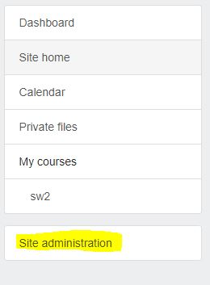

2.Click on Site administration. Click on Courses.

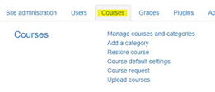

1. Click on Manage courses and categories.



1. Click on create new course.



5.Fill all fields with the information about your course.

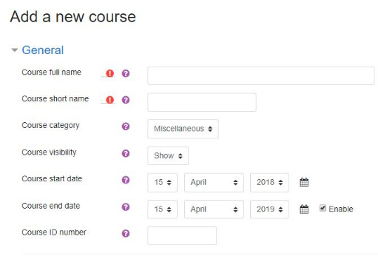

6.Click on Save.



7.Course added Successfully

Deleting a course

Teachers cannot delete courses. Managers (i.e. users with a role for which the capability [moodle/course: delete](https://docs.moodle.org/34/en/Capabilities/moodle/course:delete" \o "Capabilities/moodle/course:delete) is allowed) can delete courses and [course creators](https://docs.moodle.org/34/en/Course_creator) can delete courses they have created themselves, but only within 24 hours of creating the course. This is so that courses created by mistake may be deleted without needing to ask an administrator.

Administrators can always delete courses.

To delete a course (as an admin or manager):

1. From the Site administration link, click Courses > Manage courses and categories
2. Click the course's category and click the course in the screen on the right.
3. Click the Delete link.

|  |
| --- |
| [https://docs.moodle.org/34/en/images_en/thumb/0/06/26coursedelete.png/200px-26coursedelete.png](https://docs.moodle.org/34/en/File:26coursedelete.png)  Deleting a course |

You can delete multiple courses by:

* Creating a new (temporary) category. You can name it "To be deleted".
* Select and **move** the "About to be deleted" courses to that category ("To be deleted").
* Delete the category ("To be deleted") and choose "Delete ALL - cannot be undone".

There is no user interface for course creators to delete courses they have created; however they can do so by editing the URL of the course from http://yourmoodlesite.net/course/view.php?id=N to http://yourmoodlesite.net/course/delete.php?id=N (replacing 'view' with 'delete').

Sorting courses

Courses may be sorted by an admin or manager from *Administration>Site administration>Courses>Manage courses and categories.*

Courses may be sorted by ascending/descending and by time created.

[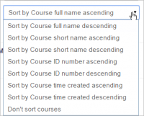](https://docs.moodle.org/34/en/File:coursesort.png)

Sorting courses

Course requests

The course request feature can be enabled by an administrator in *Administration > Site administration > Courses > Course request*.

An admin can set the default category for course requests, whether users can select a category when requesting a course, and who can receive notification of course requests (from a list of users with the capability [moodle/site:approvecourse](https://docs.moodle.org/34/en/Capabilities/moodle/site:approvecourse" \o "Capabilities/moodle/site:approvecourse)).

A 'Request a new course' button will then appear on the 'All courses' page. The All courses page can be accessed via a link in the [Courses block](https://docs.moodle.org/34/en/Courses_block).

If course requests are enabled, by default all authenticated users can make course requests. See [Course requester role](https://docs.moodle.org/34/en/Course_requester_role) for details of how to restrict users who can make course requests.

Bulk course creation

For full details on how to bulk create courses and use course templates, see [Upload courses](https://docs.moodle.org/34/en/Upload_courses).

1. Go to *Administration > Site Administration > Courses > Upload courses*.
2. Upload a CSV file either by dragging and dropping or using the button to select from the File picker.
3. Select your import options and click Preview. If the settings are acceptable, click Upload.

Course templates

It is possible, from *Administration>Site Administration>Courses>Upload courses* to specify a course and settings to use as template for future courses.

Default blocks for new courses can also be configured in config.php.

Using an existing course as a template

First, create or locate on your Moodle the course you wish to use as a template and make a note of its shortname. A template course might for example have common headings or section summaries or policy agreements used throughout the site for consistency.

*Note that only the content of the course will be restored; not its settings. Settings are added separately.*

Method 1

* Create your csv file. See [Upload courses](https://docs.moodle.org/34/en/Upload_courses) for accepted fields.
* From the Site administration link, click Courses>Upload courses and add your file.
* Preview it and scroll down to 'Course process'. In the box 'Restore from this course after upload', add the shortname of your template course.
* If you are creating several courses using the same template and you wish them all to have the same settings, you can specify these in the Default course values.
* Upload your csv file.

|  |  |  |
| --- | --- | --- |
| [https://docs.moodle.org/34/en/images_en/thumb/c/c5/template1.png/400px-template1.png](https://docs.moodle.org/34/en/File:template1.png)  Adding shortname of template course |  | [https://docs.moodle.org/34/en/images_en/thumb/1/14/26defaultcoursevalues.png/300px-26defaultcoursevalues.png](https://docs.moodle.org/34/en/File:26defaultcoursevalues.png)  Default course values |

Method 2

* All the settings and the chosen template course can be specified in the csv file you create. Use *templatecourse* as the field for your chosen template course, and use the course shortname. See [Upload courses](https://docs.moodle.org/34/en/Upload_courses) for full list of fields you can include.
* Here is an example of a csv file for restoring a course to be used as a template. It specifies for example the theme, language, enrolment method and alternative names for student and teacher.

shortname,fullname,category,newsitems,theme,lang,format,enrolment_1,enrolment_1_role,role_student,role_teacher,templatecourse

Knit,Knitting,2,0,afterburner,fr,topics,manual,student,NewKnitter,MasterKnitter,OMT

* Go to Administration>Site administration>Courses>Upload courses and add your csv file.

How to Add Teacher and Students to Any Course

Add Teacher:

Once a course is created by an administrator or course creator, a user should be assigned the role of teacher for the course. Otherwise, administrators or course creators are the only ones who can edit a course.

To assign a teacher to a course, click on the course title from the main Moodle page.

[](https://docs.moodle.org/19/en/File:selectacourse.png)

Find the admin block inside this course (default is the lower, left-hand side) and choose the "Assign roles" option.

[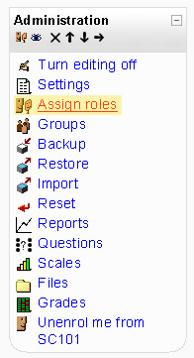](https://docs.moodle.org/19/en/File:assignroleshighlightedadminblock.png)

When the "Assign roles" page loads, choose the teacher link from the list.

[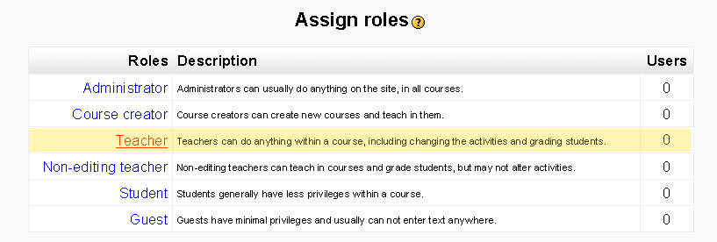](https://docs.moodle.org/19/en/File:assignroleteacherhighlighted.png) On "Assign roles" page, there are two lists separated by two arrows. The left-hand list displays the current users assigned to this role (teacher in this case) and the right-hand list displays the available users. Highlight the users on the right-hand list that will be assigned the role of teacher. Next click the arrow pointing to the left.

[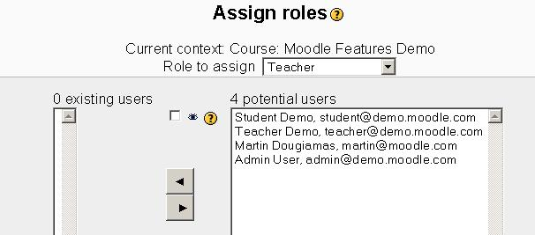](https://docs.moodle.org/19/en/File:assignroleteacherhighlighted-2.png)

Whoever is in the left-hand list is now a teacher for this particular course. In the example below, we have added Teacher Demo and Martin Dougiamas as teachers.

[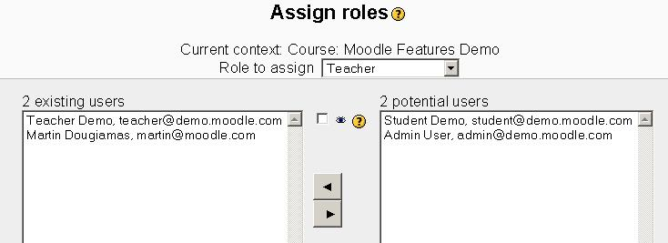](https://docs.moodle.org/19/en/File:assignroleteacherhighlighted-3.png)

To remove a user from a teacher role, highlight the teacher on the left hand list and click on the right arrow button.

Add Students:

1. In your course, look for the Administration block and click **Users** -> **Enrolled users**. You will see a list of the participants in your course.  
   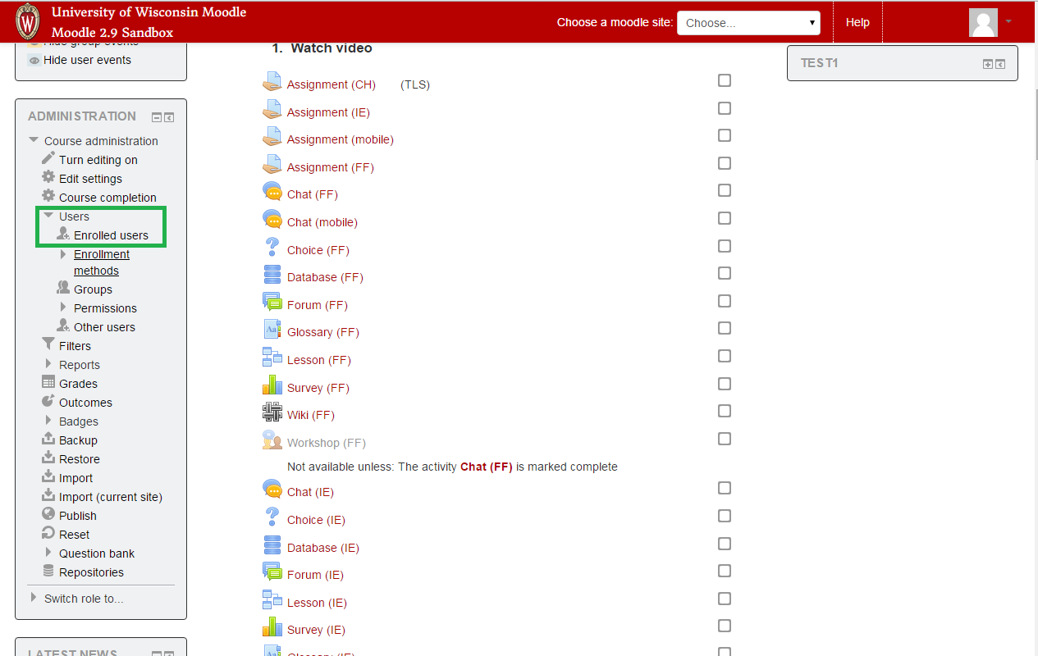
2. Click **Enroll users**in the top or bottom right of the page  
   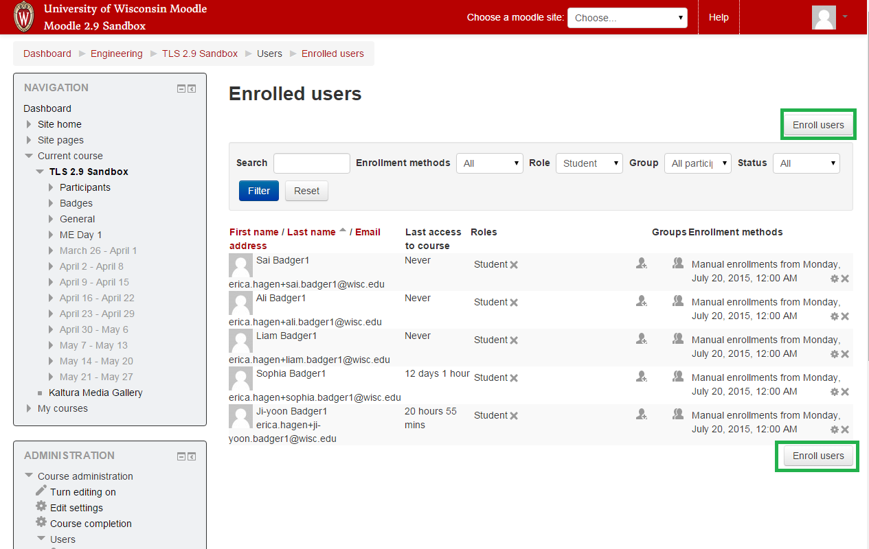
3. Set the Assign roles menu to the appropriate role.  Typical roles are instructor or student.  Sometimes TAs are given a Grader role.  This allows a TA to see what the instructor sees, but doesn't allow editing of activities within the course.
4. Use the Name or Net ID search box at the bottom to find the participant's name.
   * If you cannot find someone by name, type the net ID into the search box and press Enter.  The name should appear.
5. When you've located the right participant, click **Enroll**next to their name.  If the button says "Add + Enroll", it means that the person does not have an account yet.  It will be created when you click the button.   
   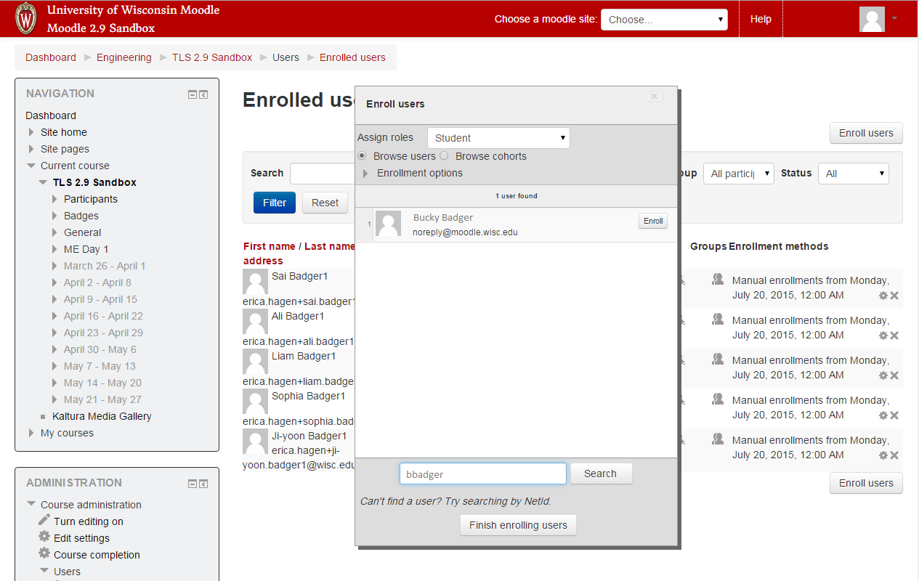
6. Click **Finish enrolling users**.  You'll be returned to the Enrolled users page, with the new users visible in the list.

How to Remove Moodle

1. Remove the database that you created while Moodle installation.
2. Remove the MoodleData folder
3. Remove the Moodle code

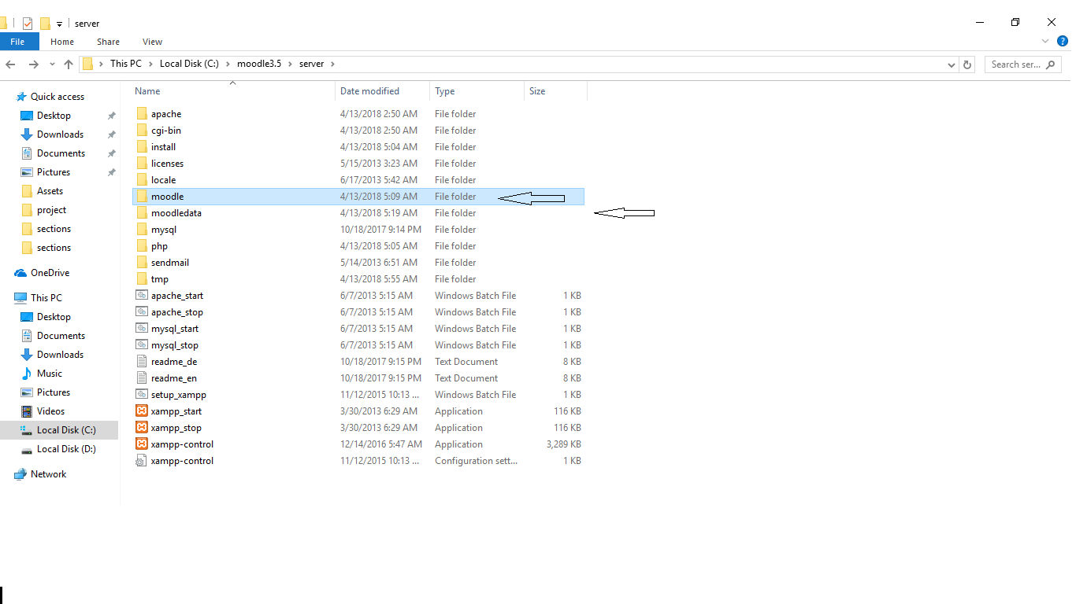

How to use scheduler :

Click on this link   
[mailto:https://www.kepware.com/en-us/products/kepserverex/advanced-plug-ins/scheduler/documents/scheduler-manual.pdf](https://www.kepware.com/en-us/products/kepserverex/advanced-plug-ins/scheduler/documents/scheduler-manual.pdf)