**Simple Shell**

**Description:**

-it’s a simple shell is simply a program that conveniently allows you to run other programs. Read up on your favorite shell to see what it does.

**Organization of the code:**

-the code take the commands of the user in infinite loop not be terminated except by close the program or write exit.

-then if it’s a process then it will do fork and check the parent id and child id to do it and in a child it will execute it by execvp function and the parent will wait or continue according to the ‘&’ to make it run in background or not.

-and then use the signal function to write in log file when the process is terminated.

Note: - my code handles the zombie mode too.

**Sample runs:**

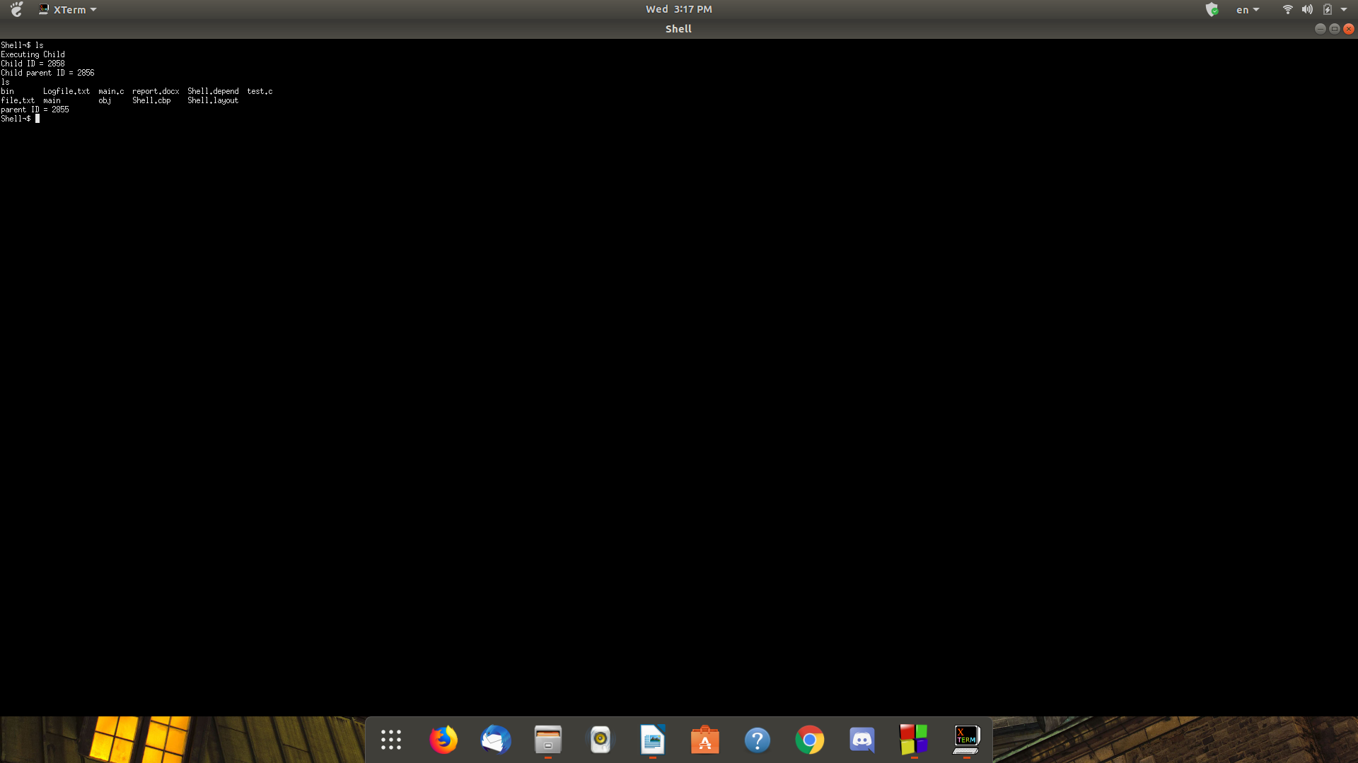commands with no arguments:

commands with arguments:

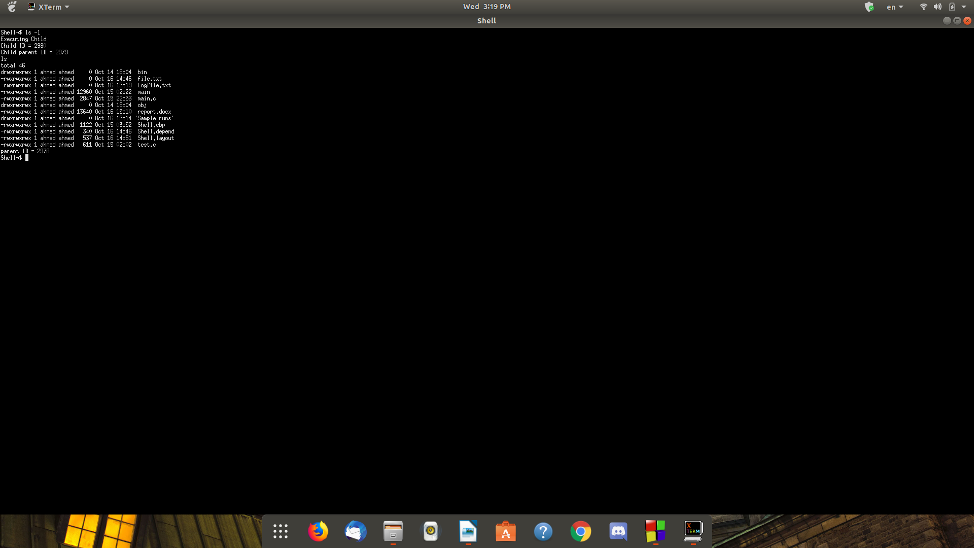

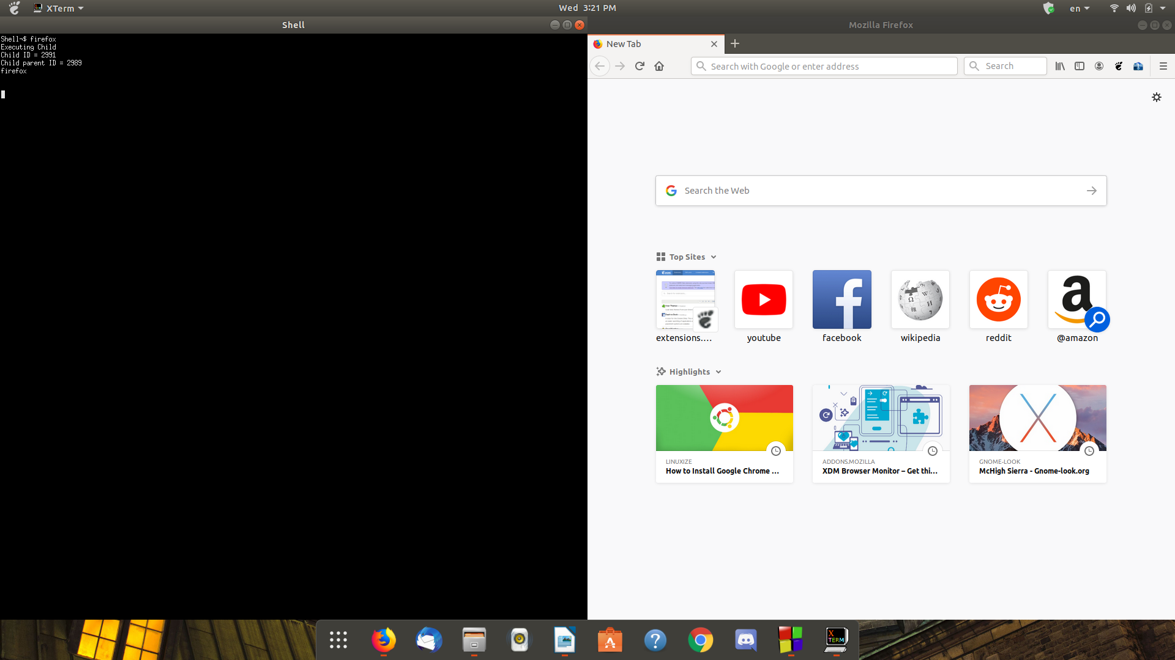commands without &:

commands with ‘&’:

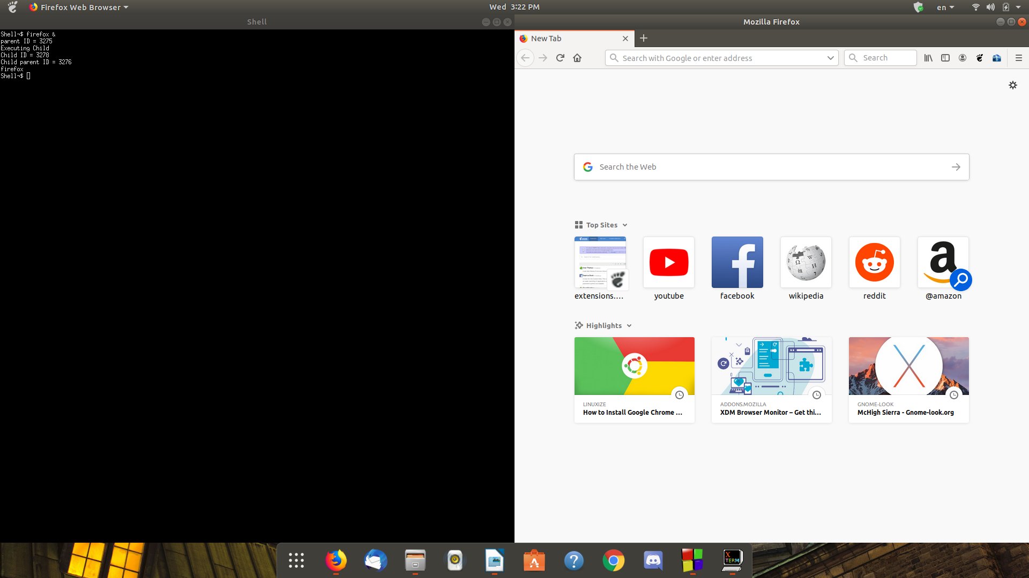

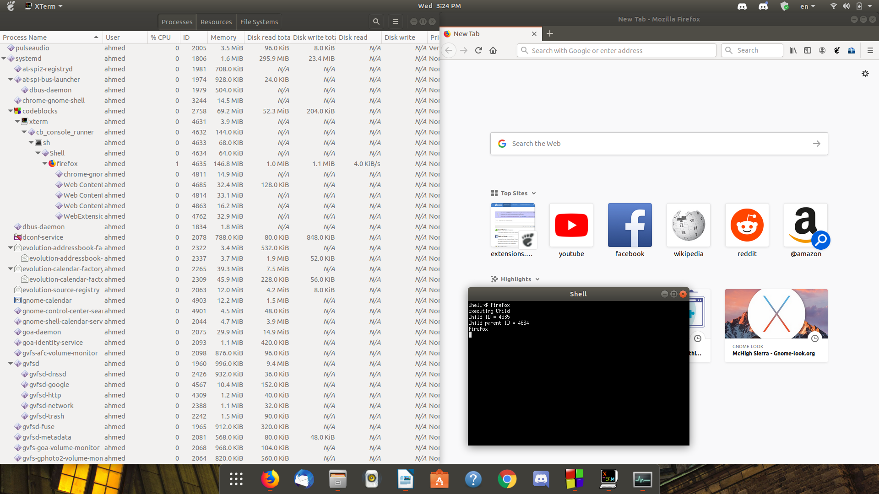The process hierarchy with system monitor: