**Assignment 1**

**Fundamentals of Programming**

**CS-114**

**FALL 2023**

**Question 1:**

Write a C++ program to display factors of a number using for loops.

**Program:**

#include<iostream>

using namespace std;

int main()

{

int n,f;

// f is taken as factor of n

cout<<"Enter a number"<<endl;

cin>>n;

cout<<"The factors of the number are"<<endl;

for (f=1; f<=n; f++)

{

if (n%f==0)

{

cout<<f<<endl;

}

}

return 0;

}

**Output**

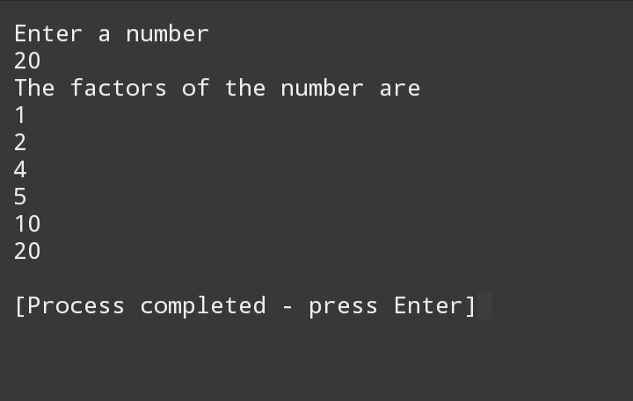

**Question 2:**

Write output to the following code.

**Output:**

x is 5 and y is 10

**Question 3:**

Write a C++ program, take an integer value from user and check if it’s greater than 10 and less than equal to 20. Print 1 if yes and print 0 if no. Use appropriate datatype for output.

**Program:**

#include<iostream>

using namespace std;

int main()

{

int n;

cout<<"Enter a number"<<endl;

cin>>n;

if (n>10&&n<=20)

{

cout<<"1"<<endl;

}

else {

cout<<"0"<<endl;

}

}

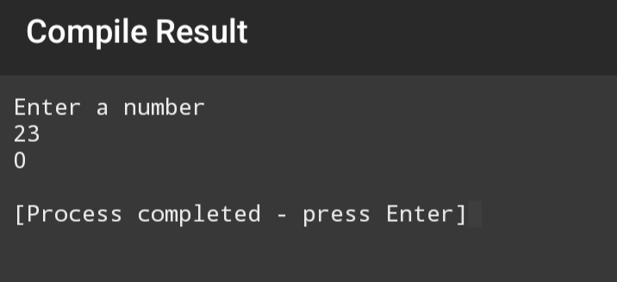**Output:**

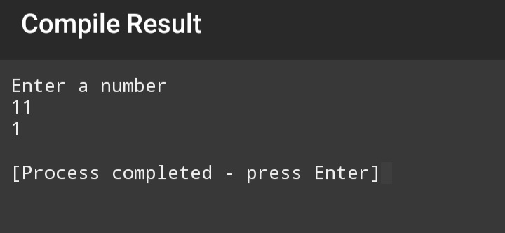

**Question 4:**

Write a C++ program that uses a while loop to find the largest prime number less than a given positive integer N. Your program should take the value of N as input from the user and then find the largest prime number less than or equal to N. You are not allowed to use any library or pre-existing functions to check for prime numbers.

**Program:**

#include<iostream>

using namespace std;

int main()

{

int N, i; // N is user input Integer

bool prime_n = false;

cout << "Enter a positive Integer." << endl;

cin >> N;

i = N;

while (i >= 2)

{

prime_n=true;

int j = 2;

while (j <= i / 2)

{

if (i % j == 0)

{

prime_n = false;

break;

}

j++;

}

if (prime_n)

{

break;

}

i--;

}

if (prime_n)

{

cout << "The largest Prime Number, less than or equal to the input integer is " << i << endl;

}

return 0;

}

**Output:**

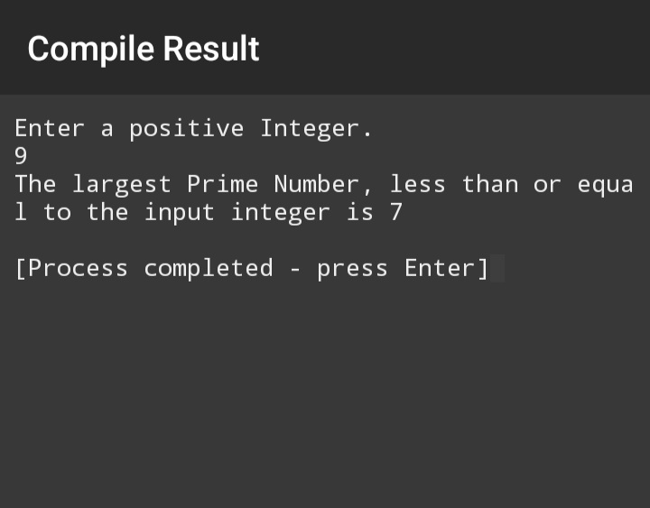

**Question 5:**

Write a C++ program, take two string as input from user and check if both

strings are equal or not. If they are equal make them unequal by rotating string.

e.g., Hello is turned into olleH etc.

**Program:**

#include <iostream>

#include <string>

using namespace std;

string rotateString(const string& str)

{

return str.substr(1) + str[0];

}

int main() {

string string1, string2;

cout << "Enter the first string: "<<endl;

cin >> string1;

cout << "Enter the second string: "<<endl;

cin >> string2;

if (string1 == string2) {

cout << "The strings are equal." << endl;

string1 = rotateString(string1);

cout << "After rotation, the first string is: " << string1 << endl;

cout << "The second string is: " << string2 << endl;

} else {

cout << "The strings are unequal." << endl;

}

return 0;

}

**Output:**

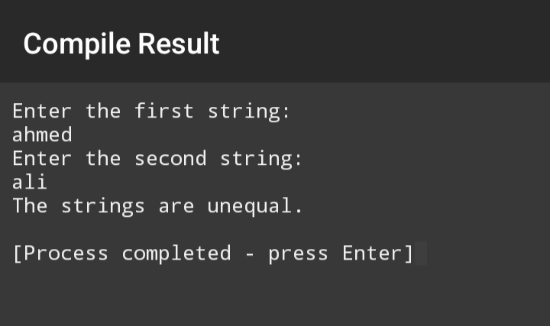

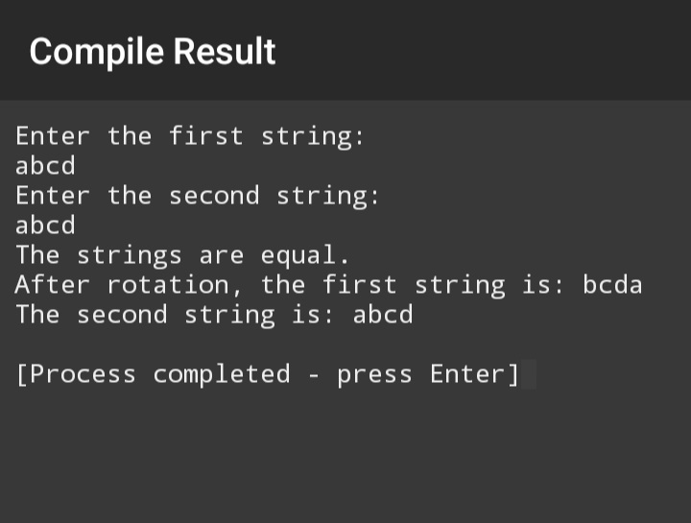

**Question 6:**

Perform division in C++ without / using for loops. You can use / only to display

the final results. Your dividend must be greater than divisor.

**Program:**

#include <iostream>

Using namespace std;

Int main() {

Int dividend, divisor;

Int quotient = 0;

Cout << “Enter dividend: “<<endl;

Cin >> dividend;

Cout << “Enter divisor: “<<endl;

Cin >> divisor;

If (dividend<divisor)

{

Cout<<”Kindly input dividend, greater than divisor.”<<endl;

Return 0;

}

For (dividend; dividend >= divisor; dividend -= divisor)

{

Quotient++;

}

Cout << “Quotient: “ << quotient << endl;

Return 0;

}

**Output:**

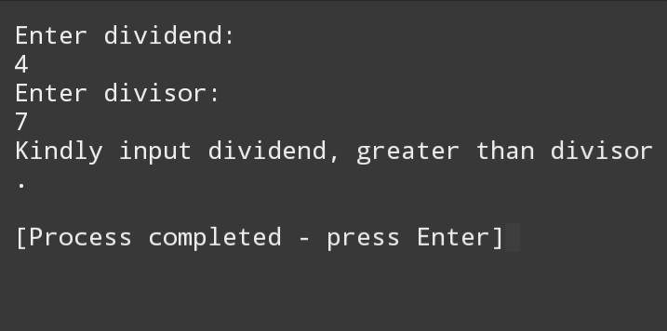

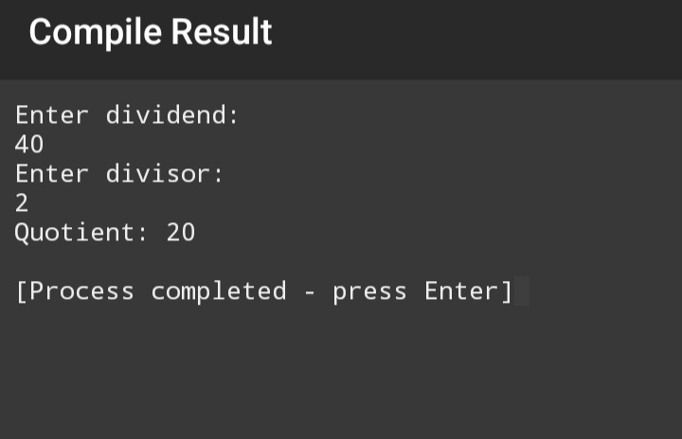

**Question 7:**

Write a C++program for a string which may contain lowercase and uppercase

characters. The task is to remove all duplicate characters from the string and find

the resultant string.

**Program:**

#include<iostream>

#include<string>

using namespace std;

int main()

{

string str, result;

bool found;

cout<<"Enter String: ";

cin>>str;

result = "";

for (int i = 0; i < str.length(); i++) {

found = false;

for (int j = 0; j < result.length(); j++) {

if ( str[i] == result[j] ) {

found = true;

}

}

if (found == false) {

result += str[i];

}

}

cout<<"Resultant String: "<<result;

}

**Output:**

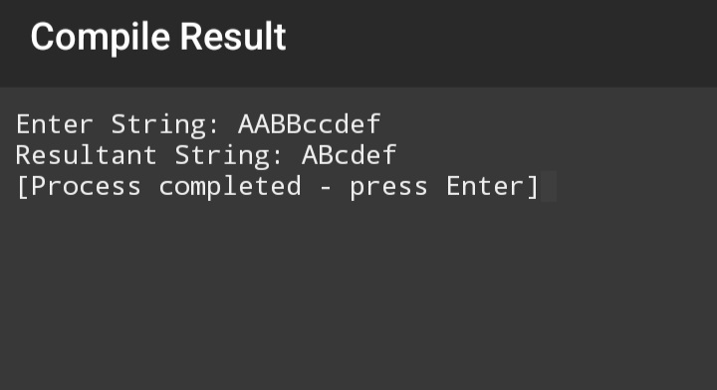

**Question 8:**

Suppose an integer array a[5] = {1,2,3,4,5}. Add more elements to it and

display them in C++.

**Program:**

#include <iostream>

#include<string>

using namespace std;

int main() {

int a[5] = {1, 2, 3, 4, 5};

cout << "Original array: "<<endl;

for (int i = 0; i < 5; i++)

{

cout << a[i] << " "<<endl;

}

cout << endl;

int more_elements[] = {6, 7, 8, 9, 10};

cout << "Array after adding more elements: ";

for (int i = 0; i < 5 + sizeof(more_elements) / sizeof(more_elements[0]); i++)

{

if (i < 5) {

cout << a[i] << " ";

}

else

{

cout <<more_elements[i - 5] << " ";

}

}

cout << endl;

return 0;

}

**Output:**

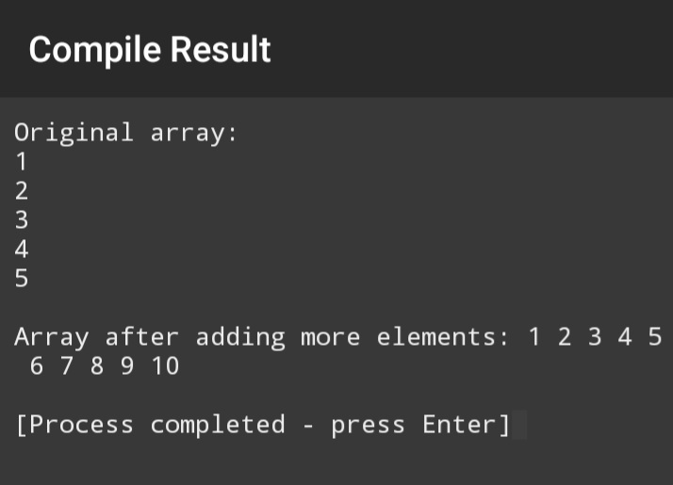

**Question 9:**

Given an integer array and an integer X. Find if there’s a triplet in the array

which sums up to the given integer X

**Program:**

#include<iostream>

using namespace std;

int main()

{

int arr[10]= {1,2,3,4,5,6,7,8,9};

for (int i=0; i<10; i++)

{

for (int j=0; j<10; j++)

{

for (int k=0; k<10; k++)

{

if (arr[i]+arr[j]+arr[k]==10)

{

cout<<arr[i]<<" "<<arr[j]<<" "<<arr[k]<<endl;

}

}

}

}

return 0;

}

**Output:**

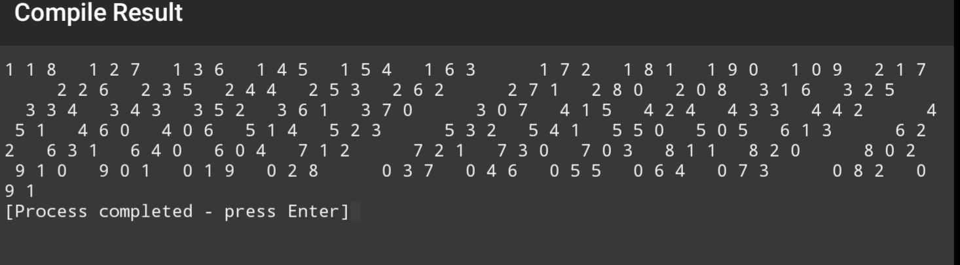

**Question 10:**

#include <iostream>

using namespace std;

// Function to perform Bubble Sort

void bubbleSort(int arr[], int n) {

for (int i = 0; i < n - 1; i++) {

for (int j = 0; j < n - i - 1; j++) {

if (arr[j] > arr[j + 1]) {

int temp = arr[j];

arr[j] = arr[j + 1];

arr[j + 1] = temp;

}

}

}

}

int main() {

int arr[] = {15, 8, 10, 4, 99, 0};

int n = sizeof(arr) / sizeof(arr[0]);

cout << "Original array: ";

for (int i = 0; i < n; i++) {

cout << arr[i] << " ";

}

cout << endl;

bubbleSort(arr, n);

cout << "Sorted array: ";

for (int i = 0; i < n; i++) {

cout << arr[i] << " ";

}

cout << endl;

return 0;

}

**Output:**

