**Program 1**

#include <iostream>

using namespace std;

int main() {

int n;

for (n=1;n<=150;n++)

{

if (n%10==0)

{

continue;

}

cout<<n<<endl;

}

return 0;

}

** Output (part 1 of program 2)**

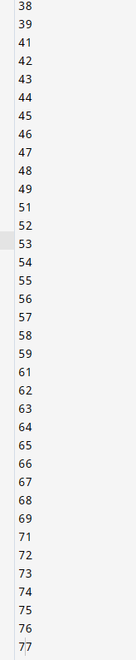

**Output (part 2 of program 2)**

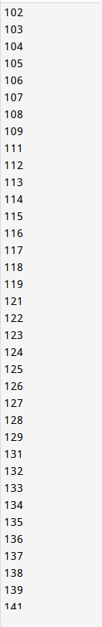

**Output (part 4 of program 1)**

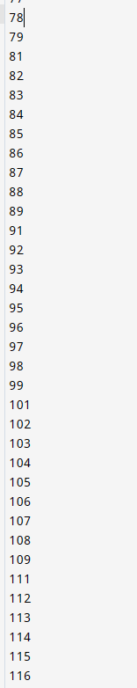

**Output (part 3 of program 1)**

**Program 3**

#include <iostream>

using namespace std;

int main()

{

int n,d;

cout<<"Enter a number to check it,"<<endl;

cin>>n;

for (d=2;d<=n/2;n++)

{

if (n%d==0)

{

cout<<"The number is NOT a prime number."<<endl;

}

else{

cout<<"It is a prime number."<<endl;

}

break;

}

return 0;

}

**Program 3 Output**

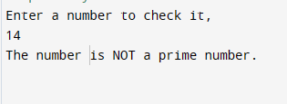

**Program 2**

#include <iostream>

using namespace std;

int main() {

int number,lastDigit,sum;

sum=0;

cout<<"Enter a number."<<endl;

cin>>number;

while (number>0)

{

lastDigit=number%10;

sum=sum+lastDigit;

number=number/10;

}

cout<<"The sum of the digits of the number is "<<sum<<endl;

return 0;

}

**Program 2 Output**

