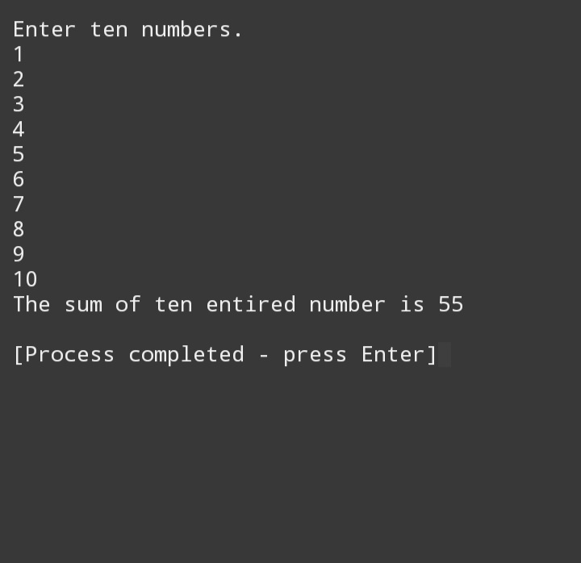

#include<iostream>

Using namespace std;

Int main()

{

Int sum=0,x,y;

Cout<<”Enter ten numbers.”<<endl;

For (x=1;x<=10;x++)

{

Cin>>y;

Sum=sum+y;

}

Cout<<”The sum of ten entired number is “<<sum<<endl;

Return 0;

}

#include<iostream>

Using namespace std;

Int main()

{

Int number,factorial,x; //x is the count

Cout<<”Enter any number for factorial.”<<endl;

Cin>>number;

X=1;

Factorial=1;

While (x<=number)

{

Factorial=factorial\*x;

X++;

}

Cout<<factorial<<endl;

}

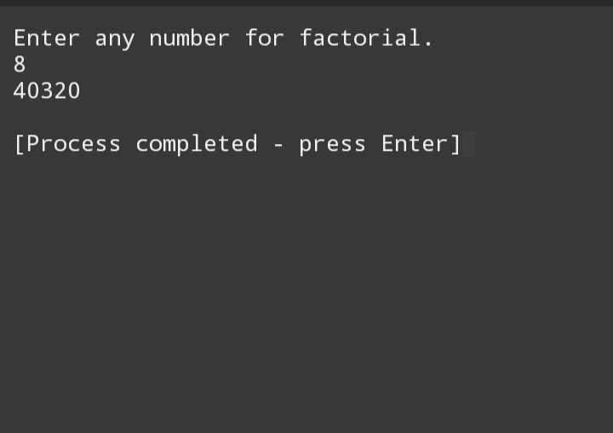

#include<iostream>

using namespace std;

int main()

{

int number,table,multiplyBy;

cout<<"Enter the number to see its table up to ten."<<endl;

cin>>number;

for (multiplyBy=1;multiplyBy<=10;multiplyBy++)

{

table=multiplyBy\*number;

cout<<number<< " \* " << multiplyBy<< " = "<< table<<endl;

}

return 0;

}

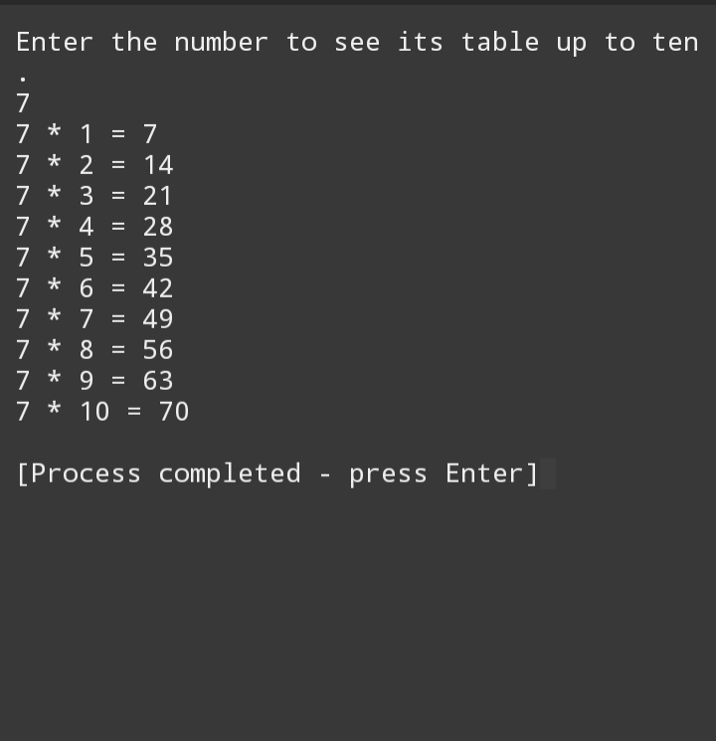

#include <iostream>

using namespace std;

int main()

{

int number1,number2,number3,count=0,sum;

cout<<"Enter first number from where the fibonacci sequence starts : ";

cin>>number1;

cout<<"Enter second number from where the fibonacci sequence starts : ";

cin>>number2;

cout<<"Enter how many times you want the sequence : ";

cin>>number3;

while(count<number3){

sum=number1+number2;

if(number1>number2){

number2=sum;

}

else{

number1=sum;

}

cout<<sum<<"\t";

count++;

}

return 0;

}

