1. Filtering use the following filters Saturate, opacity, invert, sepia, grayscale Download a new font to be used in writing a greeting message for Alvin and the Chipmunks

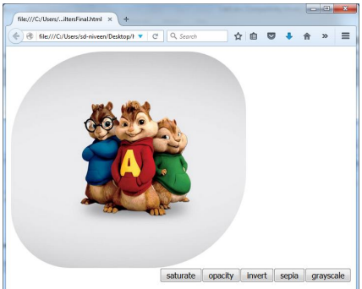

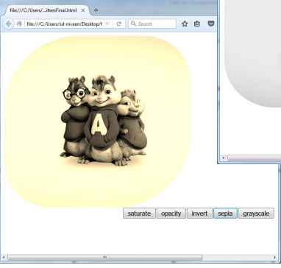

s

https://css-tricks.com/examples/ShapesOfCSS/

