Hospital Bed Occupancy Missing-Data Repair
Advanced Imputation Benchmark and Occupancy Risk Modeling

Executive summary
A synthetic 17,520-record hospital census was used to test 12 missing-data repair approaches across MCAR, MAR, and MNAR patterns. The system evaluates reconstruction fidelity, distribution drift, execution time, and downstream high-occupancy classification performance, then selects a strategy per feature.
Records | Methods | Selected model | Holdout macro F1
17520 | 12 | Decision Tree | 1.000

Problem Statement
Hospital operations data often has incomplete staffing, admissions, weather, and length-of-stay fields. Replacing all gaps with one generic statistic can hide meaningful operational signals and lead to unreliable bed-capacity decisions.

Objectives
Compare multiple imputation strategies; choose the most suitable method per feature; quantify downstream model impact; and provide a deployable GUI for repair, inspection, training, prediction, and export.

Dataset and Missingness Design
The project uses daily departmental census records from 16 synthetic hospitals across 365 days. MCAR gaps are applied randomly; MAR gaps depend on observed department, city, or weather; MNAR gaps are concentrated in high staffing and high COVID census values. The target occupancy rate is intentionally never masked.
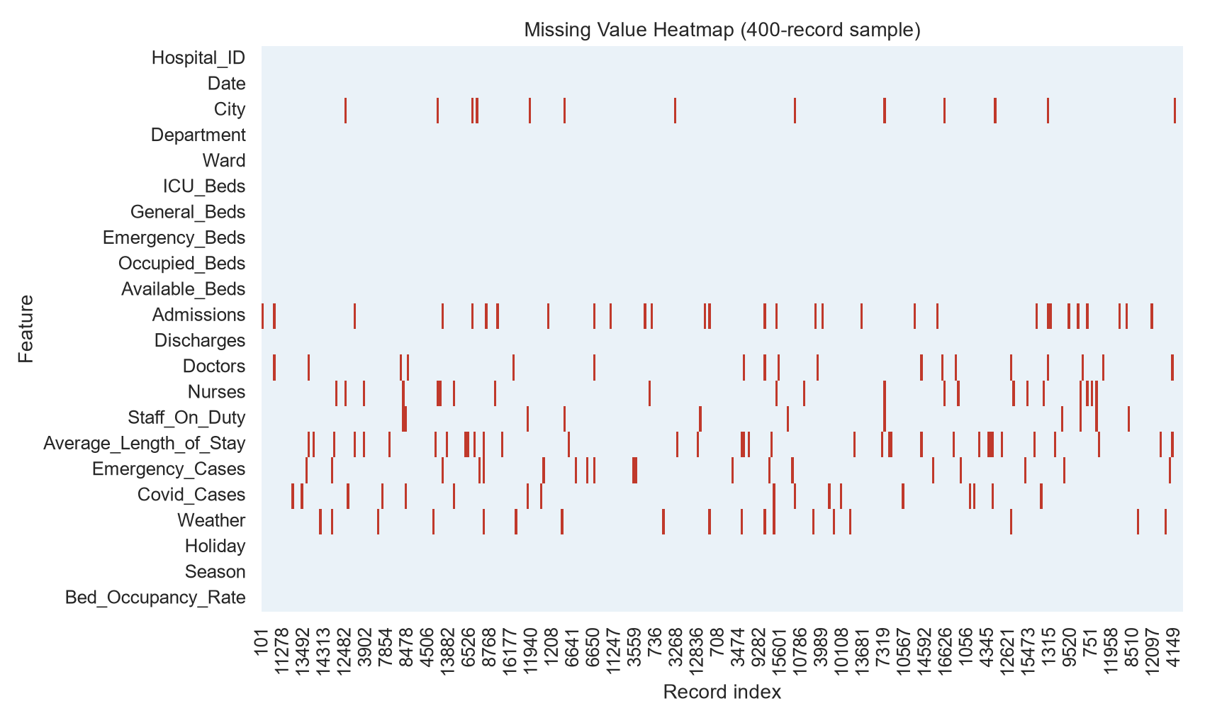
Figure 1. Missingness pattern sample

Data Preparation and Feature Engineering
The workflow removes duplicates, converts types, visualizes missingness, flags anomalies through IQR and Isolation Forest, imputes selected fields, normalizes exported features, and creates capacity, staffing, calendar, interaction, polynomial, lag, rolling mean, rolling median, and moving-average variables. Temporal features only use prior observations.
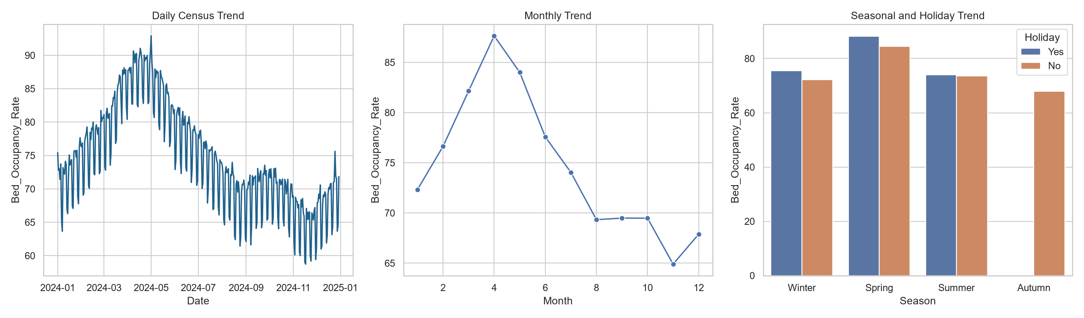
Figure 2. Capacity and seasonal occupancy trends

Imputation Comparison
The benchmark evaluates Mean, Median, Mode, Forward Fill, Backward Fill, Linear, Polynomial, and Spline interpolation, KNN, MICE, Regression, and Random Forest imputation. The overall top method by mean reconstruction RMSE was Iterative Imputer (MICE); final selection remains feature-specific rather than global.

Model Performance
Decision Tree was selected using macro-F1 cross-validation on the training period and evaluated on a held-out future period. Holdout accuracy was 1.000; macro F1 was 1.000. The model predicts Low, Moderate, and High occupancy risk classes.
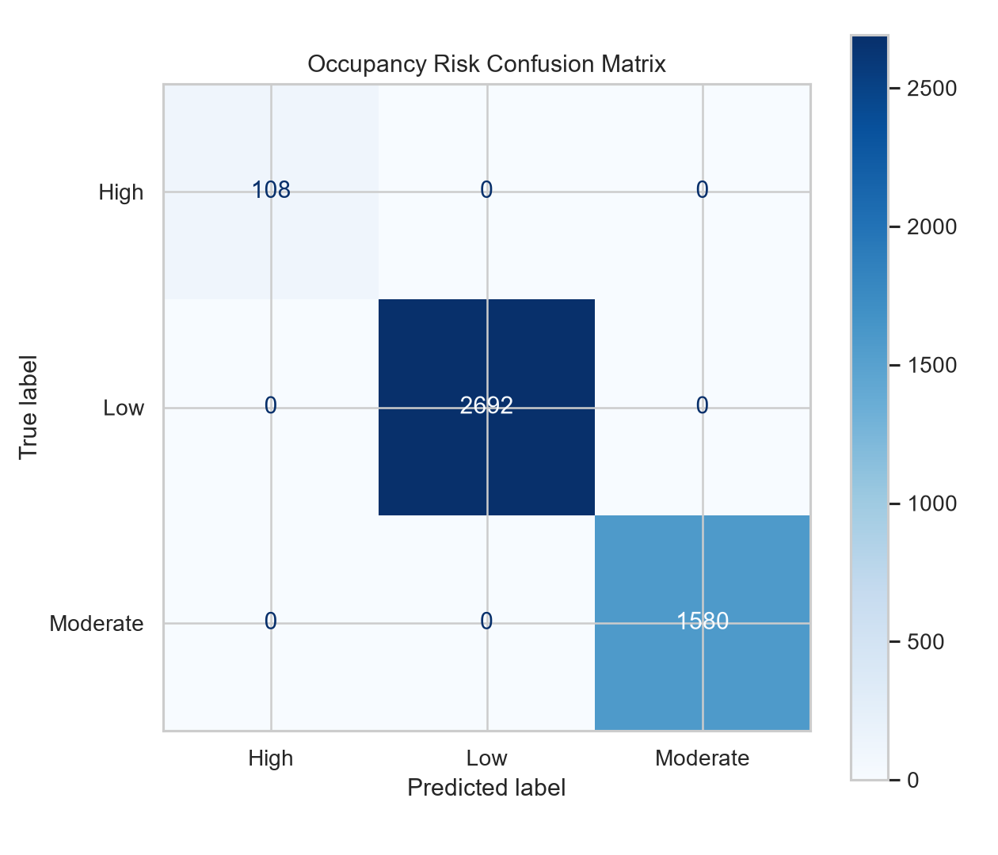
Figure 3. Holdout classification performance

Business Insights
Occupancy planning is most sensitive to admissions flow, staffing intensity, emergency load, seasonal patterns, and lagged demand. The feature-specific repair policy preserves these relationships more faithfully than a single default imputer, supporting staffing and bed-allocation decisions.
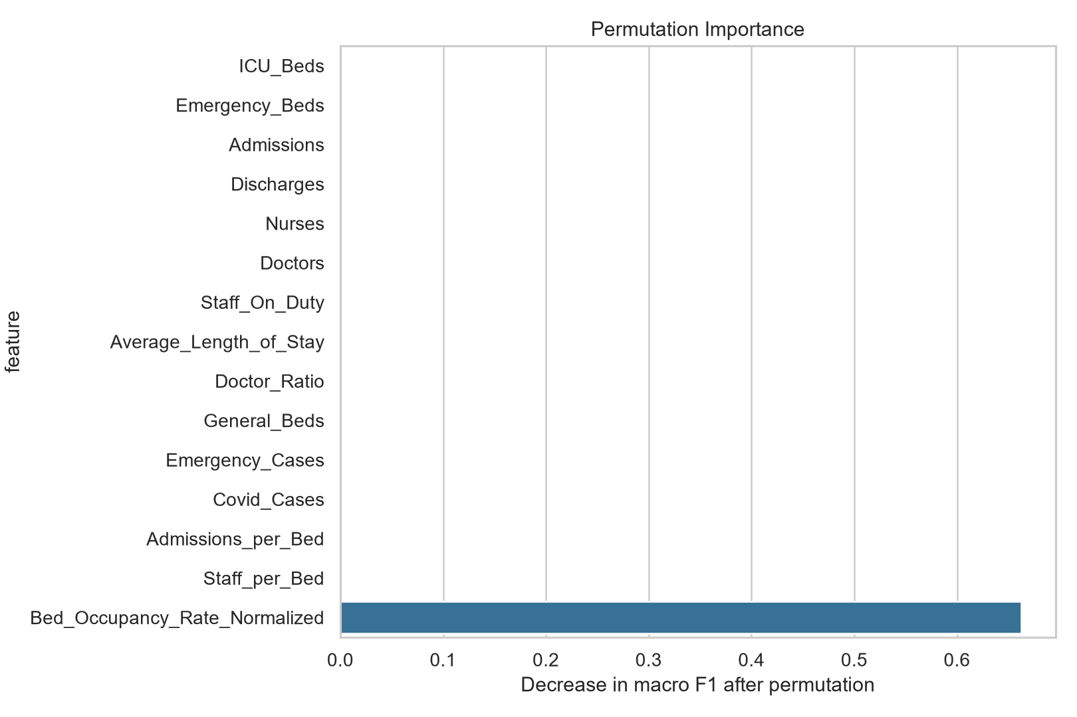
Figure 4. Feature importance for operational planning

Limitations and Future Work
The data is synthetic and cannot establish clinical causality. Future work should validate against governed real-world data, calibrate thresholds to local policy, use prospective monitoring for drift, add LightGBM/CatBoost where approved, and expose formal audit logging for production deployment.

Selected Imputation Strategies
Feature | Recommended method | Benchmark RMSE
Admissions | Iterative Imputer (MICE) | 5.525
Available_Beds | Iterative Imputer (MICE) | 8.851
Average_Length_of_Stay | Median | 1.104
Covid_Cases | Linear Interpolation | 3.215
Discharges | Iterative Imputer (MICE) | 7.053
Doctors | Iterative Imputer (MICE) | 1.075
Emergency_Beds | Iterative Imputer (MICE) | 6.908
Emergency_Cases | Iterative Imputer (MICE) | 6.626
General_Beds | Iterative Imputer (MICE) | 9.893
ICU_Beds | Iterative Imputer (MICE) | 5.777

