CHS – team 15

Cairo University

Faculty of Engineering

Computer Engineering Department

CMPN202

Introduction to Database Systems

Railway Management System

Database Schema Report

Team Number: 15

**Team Members:**

Ahmed Mohamed Ismail Nabeel 1180501

Moaaz Mohamed ElSherbini 1180528

Mostafa Ashraf Ahmed Kamal 1180406

Nader Youhanna Adib Khalil 1180477

**Contact Info:**

Ahmed [ahmedmoh123@hotmail.com](mailto:ahmedmoh123@hotmail.com)

Moaaz [moaz5657@gmail.com](mailto:moaz5657@gmail.com)

Mostafa [moustafa.achraf@hotmail.com](mailto:moustafa.achraf@hotmail.com)

Nader [naderyouhanna@gmail.com](mailto:naderyouhanna@gmail.com)

**ER Diagram:**

1. **Entities and Relationships:**

1. **Attributes of each entity:**

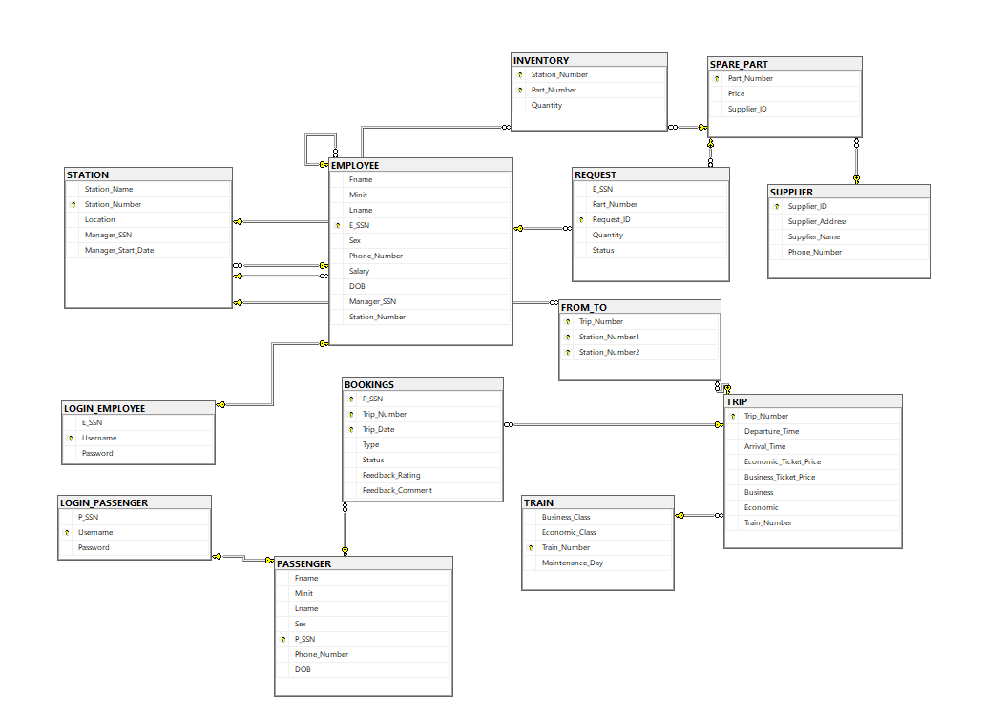**Database Schema:**