

**Credit Hours System**

**Cairo University**

**Faculty of Engineering**

**Image Processing and Computer Vision**

**Project Report**

**Team #7**

**Ahmed Mohamed Ismail Nabeel 1180501**

**Moaaz Mohamed Elsherbini 1180528**

**Mostafa Ashraf Ahmed Kamal 1180406**

**Nader Youhanna Adib Khalil 1180477**

# Used Algorithms:

* Face Detection: Viola Jones algorithm: [Paper](https://www.cs.cmu.edu/~efros/courses/LBMV07/Papers/viola-cvpr-01.pdf)
* Face Recognition: Eigenfaces algorithm: [Paper](Face%20recognition%20using%20eigenfaces%20-%20Computer%20Vision%20and%20Pattern%20Recognition,%201991.%20Proceedings%20CVPR%20'91.,%20IEEE%20Computer%20Society%20Confer%20(ucsb.edu))

# Experiment Results and Analysis

## Face Detection:

* + 98% accuracy on the Olivetti dataset
  + Trained on 837 upfront-face images each of size 24x24 pixels

### Points of Strength:

Very high accuracy and only one run over the dataset is required.

### Points of weaknesses:

Training takes a lot of time. Also, it needs upfront-close face images dataset which is hard to find on the internet.

### Dataset:

We used the Olivetti faces twice and manually added 37 faces to the training dataset for a total of 837 faces. The 37 faces were manually chosen from LFW dataset and manually cropped to match the required input.

### Accuracy:

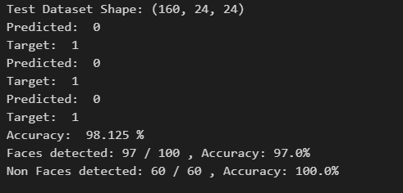

$$Accuracy =\frac{Number of correct predictions}{Total Number of test images}*100$$

### Correct Example:

### 

### 

### Incorrect Example:

### 

## Face Recognition:

* + 97% accuracy on the Olivetti Dataset
  + 400 images of 40 people
  + Each image is $64×64$ pixels
  + 320 images are used for training
  + 80 images are used for testing

Example of two correct recognitions

Example of an incorrect recognition

Accuracy:

Accuracy is calculated as $\frac{number of correct predictions}{Total number of predictions}$ 1000 trials

* Points of strength: The algoritm does not need much time to train because it sees the training data only once (1 epoch)
* Points of weakness: The images must be close ups of faces. The algorithm did not perform well for Datasets where faces were not the main element in the image (15% accuracy for the LFW Dataset).

This is expected of the Eigenfaces algorithm, because it does not try to extract certain features from the images that would make the difference between one face and the other. Rather, it makes the assumption that the faces distribution over the whole image space (which is all possible combinations of pixels $≡$ all possible $width×height$ images) is not random. Based on this assumption, the algorithm aims to calculate the Eigenvectors (called Eigenfaces) that best desribe the distribution of face images over the images space.

# Work Division

|  |  |
| --- | --- |
| Team Member | Task |
| Ahmed Mohamed Ismail | Face Detection |
| Moaz Mohamed Elsherbini |
| Mostafa Ashraf Ahmed | Face Recognition |
| Nader Youhanna Adib |