EASP ��� Final Chapter 1 Revision (University-Compliant)
Table of Contents

Chapter 1 — Project Analysis
Enterprise AI Security Platform (EASP): Data Loss Prevention and Deepfake-Based Social Engineering Defense

1. Project Overview

1.1 Project Title
Enterprise AI Security Platform (EASP): Data Loss Prevention and Deepfake-Based Social Engineering Defense.

1.2 Introduction
Organizations increasingly rely on generative-AI chat services and voice/video communication for daily work. This creates two related risks that legacy security tools were not designed to address together: employees may paste confidential data into public AI tools with no inline inspection, and attackers can use AI-generated (“deepfake”) voices combined with urgency/authority-pressure language to impersonate colleagues or executives in social-engineering attacks. EASP is a cybersecurity engineering platform with integrated AI-assisted detection components — not an AI research project. Machine learning is used strictly as a supporting detection layer inside conventional cybersecurity engineering: authentication, RBAC, encryption, audit logging, and a policy/risk engine.

1.3 Problem Statement
Existing controls address these risks only in isolation. Classic DLP tools rely on static pattern matching and cannot interpret free-form AI conversations; voice-fraud and deepfake-detection tools exist as isolated research prototypes with no connection to identity, policy, or audit systems. Specifically: - Employees may submit source code, credentials, or PII to public AI chat interfaces with no inspection step. - Attackers may use short voice samples to clone a colleague’s or executive’s voice and issue fraudulent instructions over a call. - Prompt-injection payloads may attempt to override an AI assistant’s intended behavior. - No reviewed vendor or academic system unifies AI-prompt DLP with real-time voice-authenticity verification under one explainable, auditable risk score.

1.4 Project Objectives
- Implement a data-loss-prevention pipeline that detects and reversibly redacts sensitive data (PII, credentials, structured secrets) in prompts submitted to generative-AI tools.
- Implement a voice-authenticity classifier that distinguishes genuine from AI-generated (cloned) speech in a controlled demonstration environment.
- Implement a multi-label classifier that detects social-engineering conversational patterns (urgency, authority impersonation, credential/payment requests) in transcribed speech; one utterance may exhibit more than one indicator simultaneously.
- Fuse the above signals into a single, explainable, role-aware risk score enforced by a policy engine with authentication, RBAC, and audit logging.
- Deliver a working, demonstrable prototype within the two-semester timeline, evaluated against explicitly stated (not assumed) targets — with any accuracy/latency figure reported only after real testing.

1.5 Project Scope
The baseline system covers text-based DLP for public generative-AI prompts and voice-based deepfake/social-engineering detection in a controlled demonstration environment, unified under one risk-scoring and policy-enforcement layer with core cybersecurity controls (authentication, RBAC, audit logging). Image/video deepfake detection, production PBX/telephony integration, universal HTTPS interception, an undefined external Threat Intelligence feed, and ML-based semantic source-code leakage detection are explicitly out of baseline scope — see Section 8, Future Work.

2. Background Study

2.1 Literature Review / Existing Systems
Microsoft Purview extends DLP into AI prompts (Copilot/Edge for Business) but offers no voice or deepfake coverage and is tied to the Microsoft ecosystem with premium licensing. Lasso Security provides low-latency, intent-based LLM traffic inspection but is text-only, with no voice-channel coverage. DeepTrust offers real-time voice-deepfake and social-engineering alerts integrated with VoIP platforms (Zoom, Teams, Meet) but does not inspect AI-prompt data leakage. Academic deepfake detectors (RawNet2, AASIST on ASVspoof; FaceForensics++/DeepfakeBench for video) provide strong published baselines but are not engineered as production security controls with RBAC, audit logging, or incident response, and their cross-dataset generalization to real-world content is known to degrade substantially outside benchmark conditions.

2.2 Gap Analysis
No reviewed solution combines (a) semantic AI-prompt DLP, (b) real-time voice-deepfake verification, and (c) a unified, explainable, audit-ready risk score under one identity- and policy-aware security platform. Vendors solve the DLP problem or the deepfake problem, rarely both, and neither integrates a shared, explainable cross-channel risk taxonomy.

3. System Analysis

3.1 Proposed System
EASP is a layered security architecture in which two parallel branches — a Voice/Social-Engineering branch and a Data-Loss-Prevention branch — feed a Unified Risk Fusion Engine. The Risk Fusion Engine’s decision is enforced by a Policy layer tied to Authentication/RBAC and Audit Logging. See Section 4 for the Use Case, Activity, and Architecture diagrams.

3.2 Functional Requirements
Baseline requirements are separated from Future Work (Section 8). Each requirement below has a full traceability entry (component → implementation → API/interface → data → test) in Part 6 of the accompanying Requirement Traceability Matrix.
ID | Requirement | Component | Input | Processing | Output | Priority | Verification
FR-01 | Authenticate user via JWT | Identity Layer | Credentials | JWT issuance/validation | Access token | MUST | Invalid/expired-token test
FR-02 | Enforce role-based access control | Identity Layer | JWT + role claim | RBAC policy check | Allow/deny | MUST | Privilege-escalation test
FR-03 | Submit AI prompt via supported app | Client / Gateway | User text | Capture, route to Gateway | Routed request | MUST | Capture round-trip test
FR-04 | Scan prompt for sensitive data | DLP Branch | Prompt text | Regex + Presidio + spaCy NER | Entity list + sensitivity score | MUST | Labeled PII/credential recall & precision
FR-05 | Reversibly redact sensitive data | DLP Branch | Entities + text | Tokenize, encrypt mapping | Sanitized prompt | MUST | Round-trip integrity test
FR-06 | Restore original values in AI response | DLP Branch | AI response + token map | De-tokenize | Restored response | MUST | Round-trip integrity test
FR-07 | Process controlled audio input | Voice Branch | Audio file/stream | Preprocessing, VAD | Cleaned audio | MUST | Manual playback check
FR-08 | Detect voice deepfake | Voice Branch | Preprocessed audio | Pretrained RawNet2 inference | Authenticity score | MUST | Held-out genuine/spoof set
FR-09 | Transcribe speech | Voice Branch | Preprocessed audio | Faster-Whisper inference | Transcript | MUST | Manual transcript spot-check
FR-10 | Detect social-engineering indicators | NLP Branch | Transcript | mBERT encoder + classification head | Multi-label scores | MUST | Held-out labeled set, per-label F1
FR-11 | Compute unified risk score (Phase 1) | Risk Engine | DLP/voice/NLP scores | Weighted rule fusion | Risk level | MUST | Combined-incident scenario test
FR-12 | Compute unified risk score (Phase 2) | Risk Engine | Risk features | XGBoost classifier | Risk level + probability | SHOULD | Precision/recall vs. Phase-1 baseline
FR-13 | Explain Phase-2 risk decision | Risk Engine | Trained XGBoost model | SHAP value computation | Feature contributions | SHOULD | Manual spot-check on dashboard
FR-14 | Apply security policy decision | Policy Engine | Risk score + role | Policy rule evaluation | Allow/Redact/Block/Escalate | MUST | Policy-rule unit test
FR-15 | Log every decision | Audit/Logging | Decision event | Append-only write | Audit record | MUST | Audit-event generation test
FR-16 | Review alert on dashboard | Analyst UI | Audit record | Query + render | Alert view | MUST | Manual UI verification
FR-17 | Export logs to SIEM | Logging | Audit record | Syslog/CEF formatting | SIEM event | SHOULD | Format validation test
FR-18 | Configure security policy | Admin UI | Admin input | Policy CRUD | Updated policy | MUST | RBAC-gated config test

3.3 Non-Functional Requirements
Category | Requirement
Performance | Target end-to-end latency ≤ 3 seconds, subject to experimental validation; no measured figure exists yet
Security | TLS 1.3 in transit; AES-256 for the redaction token map at rest; salted password hashing; input validation and rate limiting at the gateway
Privacy | Raw audio and prompt text are not persisted beyond the short-lived redaction-map lifetime; only derived findings (scores, labels, entity types) are retained for audit
Reliability | On AI-service timeout, crash, or low-confidence prediction, the system fails safe (routes to manual review), never fails open
Availability | Prototype-level availability sufficient for scripted demonstration scenarios; no formal SLA target is set
Maintainability | Modular microservice boundaries (DLP, Voice, NLP, Risk) so a component can be replaced/retrained independently
Scalability | Stateless API Gateway and AI microservices to allow horizontal scaling; not load-tested at enterprise scale in this project
Usability | Redaction and blocking must not meaningfully disrupt legitimate employee workflows; false-positive rate is tracked as an explicit metric
Auditability | Every Allow/Redact/Block/Escalate decision produces a corresponding, immutable audit-log entry

3.4 Stakeholders / Target Users
Stakeholder | Role | System Interaction | Permissions/Responsibilities
Employee / End User | Submits prompts and participates in voice calls | Uses browser extension / audio capture agent | Subject to DLP scanning and risk scoring; no administrative access
Security Analyst (SOC) | Reviews flagged incidents | Uses dashboard to review alerts, mark true/false positive | Read access to audit logs and risk explanations
Security Administrator | Configures platform policy | Uses admin UI to define DLP/redaction/risk-threshold rules | Full policy-configuration access, RBAC-gated
External AI Service | Receives sanitized prompts, returns responses | Called by the Gateway after policy decision | External, untrusted boundary; no platform credentials
Evaluation Committee (academic) | Assesses the defended prototype against requirements | Reviews documentation, diagrams, and live demo | Academic stakeholder, not a runtime system actor

4. System Modeling

4.1 Use Case Diagram
Figure 1 (below) shows the baseline use-case diagram. Actors are Employee, Security Analyst, Security Administrator, and the external AI Service. Only use cases actually supported by the documented baseline are shown; Future Work items (e.g., image/video deepfake review) are intentionally excluded.
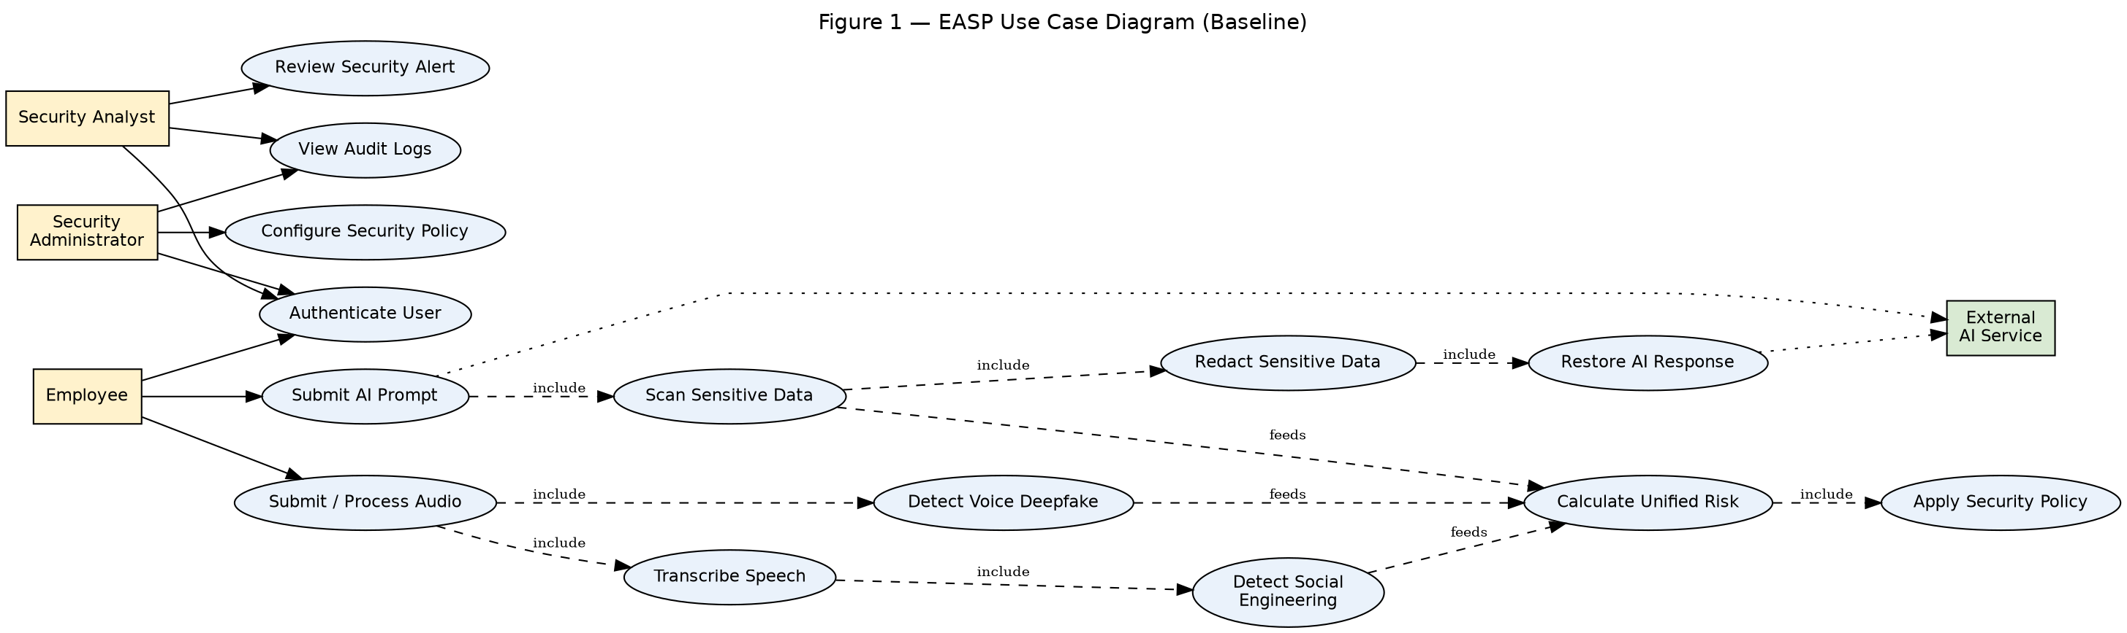
Figure 1 — EASP Use Case Diagram

4.2 Use Case Descriptions
UC-01 Authenticate User - Primary Actor: Employee / Security Analyst / Security Administrator - Goal: Obtain a valid JWT session - Preconditions: User holds valid credentials - Trigger: User submits login request - Main Success Flow: (1) User submits credentials → (2) Identity Layer validates → (3) JWT issued with role claim - Alternative Flow: MFA step if enabled - Exception Flow: Invalid credentials → access denied, attempt logged - Postconditions: Valid session token issued - Related Requirements: FR-01
UC-02 Submit AI Prompt - Primary Actor: Employee; Secondary Actor: External AI Service - Goal: Send a prompt to a supported AI web application safely - Preconditions: User authenticated; browser extension active on a supported site - Trigger: User submits prompt in the web app - Main Success Flow: (1) Extension captures input → (2) Gateway routes to Security Engine → (3) DLP scan (UC-03) → (4) Redaction if required (UC-04) → (5) Forward to AI Service → (6) Response restoration (UC-05) - Alternative Flow: No sensitive data found → forwarded unmodified - Exception Flow: Policy blocks request → user notified, event logged - Postconditions: Sanitized prompt delivered; audit entry created - Related Requirements: FR-03, FR-04, FR-05, FR-06, FR-14, FR-15
UC-03 Detect Sensitive Data (Scan Sensitive Data) - Primary Actor: System (triggered by UC-02); Secondary Actor: DLP Branch - Goal: Identify PII, credentials, and secrets in the prompt - Preconditions: Prompt received by Security Engine - Trigger: DLP scan step of UC-02 - Main Success Flow: (1) Regex pass for structured patterns → (2) Presidio/spaCy NER pass for entities → (3) Sensitivity score computed - Exception Flow: DLP service timeout → fail-safe: escalate to manual review - Postconditions: Entity list and sensitivity score available to Risk Engine - Related Requirements: FR-04
UC-04 Redact Sensitive Data - Primary Actor: System; Secondary Actor: DLP Branch - Goal: Replace detected sensitive values with reversible tokens - Preconditions: Entities detected in UC-03 - Trigger: Policy requires redaction - Main Success Flow: (1) Generate unique token per entity → (2) Store original↔token mapping, encrypted, short-lived → (3) Replace entity with token in prompt - Exception Flow: Token-generation collision → regenerate token - Postconditions: Sanitized prompt ready for forwarding; mapping stored with TTL - Related Requirements: FR-05
UC-05 Restore AI Response - Primary Actor: System; Secondary Actor: External AI Service - Goal: Return the AI response with original values restored for the employee - Preconditions: Valid, non-expired token mapping exists - Trigger: AI Service response received - Main Success Flow: (1) Locate mapping by request ID → (2) De-tokenize response → (3) Return restored response to user → (4) Delete mapping - Exception Flow: Mapping expired/not found → return response with tokens intact and a warning notice - Postconditions: Original response delivered; mapping securely deleted - Related Requirements: FR-06
UC-06 Submit / Process Audio - Primary Actor: Employee - Goal: Provide controlled audio input for the voice-security pipeline demonstration - Preconditions: Controlled audio capture agent configured for the demo scenario - Trigger: Scripted call/audio scenario begins - Main Success Flow: (1) Audio captured → (2) Preprocessing (resampling, VAD) → (3) Parallel dispatch to Voice Deepfake Detection (UC-07) and Speech-to-Text (UC-08) - Postconditions: Preprocessed audio available to both branches - Related Requirements: FR-07
UC-07 Detect Voice Deepfake - Primary Actor: System; Secondary Actor: Voice Branch (RawNet2) - Goal: Classify audio as genuine or synthetic/cloned - Preconditions: Preprocessed audio available (UC-06) - Trigger: Voice-branch dispatch - Main Success Flow: (1) RawNet2 inference on preprocessed audio → (2) Authenticity score returned to Risk Engine - Exception Flow: Service unavailable → fail-safe: mark as inconclusive, escalate - Postconditions: Voice-authenticity score available - Related Requirements: FR-08
UC-08 Transcribe Audio - Primary Actor: System; Secondary Actor: Voice Branch (Faster-Whisper) - Goal: Produce a text transcript of the audio - Preconditions: Preprocessed audio available (UC-06) - Trigger: Voice-branch dispatch - Main Success Flow: (1) Faster-Whisper inference → (2) Transcript passed to UC-09 - Postconditions: Transcript available - Related Requirements: FR-09
UC-09 Detect Social Engineering - Primary Actor: System; Secondary Actor: NLP Branch (mBERT + classification head) - Goal: Classify transcript for urgency/authority/credential/payment-request indicators - Preconditions: Transcript available (UC-08) - Trigger: NLP-branch dispatch - Main Success Flow: (1) Tokenize transcript → (2) mBERT encoding → (3) Classification head produces multi-label scores - Postconditions: Social-engineering label scores available - Related Requirements: FR-10
UC-10 Calculate Risk - Primary Actor: System; Secondary Actor: Risk Fusion Engine - Goal: Produce one unified, explainable risk decision from all branch signals - Preconditions: At least one branch signal available (DLP, voice, and/or NLP) - Trigger: Any branch signal completes - Main Success Flow: (1) Phase 1 rule-based weighted fusion of available scores → (2) [If Phase 2 enabled] XGBoost classification with SHAP explanation → (3) Risk level output to Policy Engine - Exception Flow: Missing signal (e.g., only DLP ran) → fusion proceeds with available signals only, flagged as partial - Postconditions: Risk level and (if Phase 2) explanation available - Related Requirements: FR-11, FR-12, FR-13
UC-11 Apply Security Policy - Primary Actor: System; Secondary Actor: Policy Engine - Goal: Convert a risk level into an enforcement action - Preconditions: Risk level available (UC-10) - Trigger: Risk Engine output received - Main Success Flow: (1) Match risk level + role against policy rules → (2) Emit decision (Allow/Redact/Block/Escalate) - Postconditions: Decision enforced; audit entry created - Related Requirements: FR-14
UC-12 Review Security Alert - Primary Actor: Security Analyst - Goal: Investigate a flagged incident - Preconditions: Analyst authenticated (UC-01); alert exists - Trigger: Analyst opens dashboard alert - Main Success Flow: (1) Analyst views incident details and (if Phase 2) SHAP explanation → (2) Analyst marks true/false positive - Postconditions: Alert status updated; feedback optionally stored for future retraining (Future Work) - Related Requirements: FR-16
UC-13 View Audit Logs - Primary Actor: Security Analyst / Security Administrator - Goal: Inspect the immutable audit trail - Preconditions: Actor authenticated with sufficient role - Trigger: Dashboard query - Main Success Flow: (1) Query audit store → (2) Render filtered results - Postconditions: None (read-only) - Related Requirements: FR-15, FR-16
UC-14 Configure Security Policy - Primary Actor: Security Administrator - Goal: Define or update DLP/redaction/risk-threshold rules - Preconditions: Administrator authenticated with sufficient role - Trigger: Admin submits policy change - Main Success Flow: (1) RBAC check → (2) Validate rule syntax → (3) Persist policy → (4) Log change - Exception Flow: Insufficient privilege → denied, logged - Postconditions: Updated policy active - Related Requirements: FR-02, FR-18

4.3 Activity Diagram / System Flowchart
Figure 2 (below) shows the end-to-end system flowchart, including the DLP path, the parallel voice/NLP path, the risk-fusion decision point, and the fail-safe escalation branch.
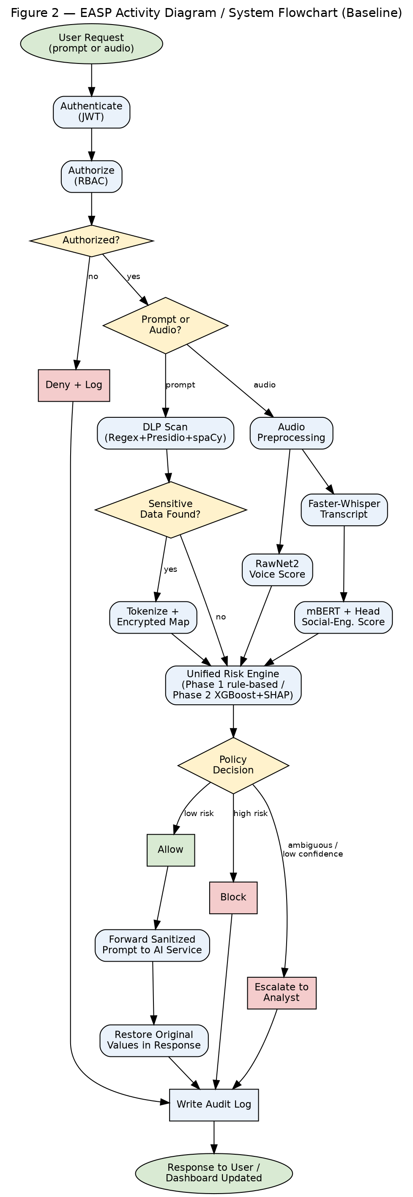
Figure 2 — EASP Activity Diagram / System Flowchart

5. Technical Planning

5.1 Proposed Tools and Technologies
Layer | Technology | Purpose
Frontend | React.js | Security Dashboard and Administrator Panel
Backend | Node.js + Express.js | API Gateway, Policy Engine, business logic
Database | MongoDB | Audit logs, policy configuration
Authentication | JWT + RBAC | Identity and access control
Security controls | TLS/HTTPS, AES-256, salted hashing, input validation, rate limiting | Core application hardening
AI services (Python) | RawNet2, Faster-Whisper, mBERT+head, Presidio, spaCy, regex, XGBoost (Phase 2), SHAP (Phase 2) | Supporting detection microservices
SIEM (should-implement) | Syslog/CEF forwarding | Centralized log correlation
Every technology above has a stated purpose tied to a functional requirement in Section 3.2; no theoretical or unused technology is listed.

5.2 Proposed System Architecture
Figure 3 (below) shows the logical architecture: Client Layer → API Gateway → Authentication & RBAC → Security Processing Layer (DLP / Voice / STT / Social-Engineering) → Risk Fusion Engine → Policy Enforcement → External AI Service / Response Handling → Audit Logging / Dashboard / SIEM.
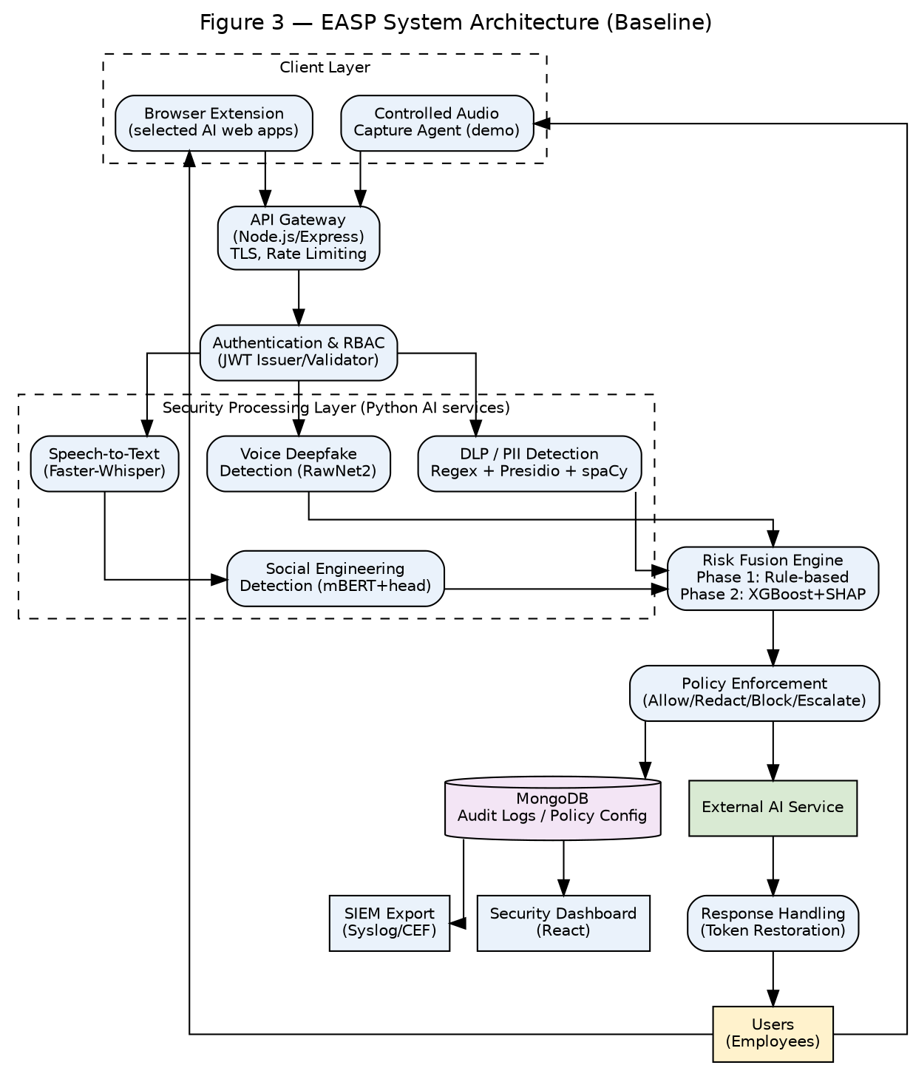
Figure 3 — EASP System Architecture Diagram

5.3 Implementation Methodology
- Requirements and architecture finalization
- Dataset preparation (voice, NLP, PII)
- Baseline AI integration: RawNet2, Faster-Whisper, mBERT + classification head (pretrained-first)
- DLP implementation (regex + Presidio/spaCy) and reversible redaction engine
- Backend/API implementation (Gateway, Identity Layer)
- Core security controls (TLS, rate limiting, input validation, audit logging)
- Risk engine — Phase 1 rule-based (mandatory), Phase 2 XGBoost+SHAP (should-implement, only if labeled data suffices)
- Frontend/dashboard
- Controlled voice/audio integration and, if time permits, browser-extension integration for 2–3 selected AI web apps
- Security testing (auth, RBAC, DLP recall/precision, prompt-injection cases, held-out voice test set)
- AI evaluation (per Section 6.6 metrics)
- System integration testing
- Performance/latency measurement against the ≤3s target
- Final validation and defense rehearsal
XGBoost/SHAP and the browser extension are explicitly marked SHOULD-IMPLEMENT in the timeline and do not block core-prototype completion; this is consistent with the project proposal’s phased Gantt structure (Semester 1: Prototype A/B; Semester 2: risk fusion, dashboard, testing).

5.4 References
[1] Tak, H. et al., “End-to-End anti-spoofing with RawNet2,” ICASSP 2021. [2] Radford, A. et al., “Robust Speech Recognition via Large-Scale Weak Supervision (Whisper),” OpenAI, 2022. [3] SYSTRAN, “Faster-Whisper: Fast inference engine for Whisper models using CTranslate2,” GitHub, 2023. [4] Devlin, J. et al., “BERT: Pre-training of Deep Bidirectional Transformers for Language Understanding,” NAACL 2019. [5] Microsoft, “Presidio: Context-aware, pluggable, and customizable PII de-identification,” GitHub, 2020. [6] Honnibal, M. & Montani, I., “spaCy: Industrial-strength NLP,” Explosion AI, 2017. [7] Lundberg, S. M. & Lee, S.-I., “A Unified Approach to Interpreting Model Predictions (SHAP),” NeurIPS 2017. [8] Chen, T. & Guestrin, C., “XGBoost: A Scalable Tree Boosting System,” KDD 2016. [9] Todisco, M. et al., “ASVspoof 2019: Future Horizons in Spoofed and Fake Audio Detection,” Interspeech 2019. [10] OWASP Foundation, “OWASP Top 10 for LLM Applications,” 2025.

6. Data Science and Artificial Intelligence Components

6.1 Dataset Description and Source
Dataset | Source | Purpose | Type | Labels | Component | Train/Val/Test | Limitations
ASVspoof 2019 (LA/DF) | Public benchmark release | Voice-authenticity evaluation | Audio | Genuine / Spoofed | RawNet2 (Voice Branch) | Standard published splits | Bench-to-real-world generalization gap documented in literature
ASVspoof 2021 / WaveFake | Public benchmark release | Additional voice-spoof coverage | Audio | Genuine / Spoofed | RawNet2 (Voice Branch) | Standard published splits | Size/version to be confirmed during implementation
SMS Spam Collection (UCI) | UCI repository | Urgency/credential-request language patterns | Text | Spam/Ham → remapped to project labels | NLP Branch (mBERT+head) | To be confirmed during implementation | Not spoken-conversation data — domain gap (Section 6.5)
Enron Email Dataset | Public release | Authority-impersonation / business-email patterns | Text | Unlabeled → project-labeled subset | NLP Branch | To be confirmed during implementation | Domain gap; email register differs from speech
Phishing-email corpora | Public release | Social-engineering language patterns | Text | Phishing indicators | NLP Branch | To be confirmed during implementation | Domain gap
Synthetic scripted call dialogues | Team-generated | Bridge the text-to-speech domain gap | Text/Audio (synthetic) | Urgency, Authority Impersonation, Credential Request, Payment Request, Suspicious | NLP Branch | To be confirmed during implementation | Clearly labeled synthetic; not equivalent to real vishing calls
Presidio default recognizers / sample data | Microsoft OSS | PII pattern validation | Text | PII entity types | DLP Branch | Pretrained, no training split needed | —
ai4privacy/pii-masking-200k | Hugging Face | PII/NER validation | Text | PII entity types | DLP Branch | To be confirmed during implementation | License terms to be confirmed
CoNLL-2003 | Public NER benchmark | NER baseline validation | Text | Person/Org/Location | DLP Branch | Standard published splits | English-centric; supplementary use only
Synthetic labeled risk-incident data | Team-generated | Phase-2 risk-engine training | Structured features | Risk level | Risk Engine (Phase 2) | To be confirmed during implementation | No real organizational incident data available; synthetic only

6.2 Data Collection Method
Public datasets are downloaded from their official releases. Synthetic scripted call dialogues and synthetic risk-incident records are authored by the team to represent the target label taxonomy and are clearly marked as synthetic throughout the documentation and dashboard. Training and testing splits are separated at collection time to avoid data leakage.

6.3 Data Preprocessing
- Audio: resampling to a consistent sample rate, voice-activity detection, silence trimming.
- Text: tokenization for the mBERT input pipeline, normalization of mixed Arabic/English text, PII masking removed prior to NER training where dataset licensing requires it.
- Exact preprocessing parameters (sample rate, tokenizer max length, batch size) are to be confirmed during implementation.

6.4 Proposed AI Model / Methodology
Pretrained-first baseline with project-specific adaptation where required: - RawNet2 — pretrained baseline checkpoint used as-is; fine-tuning on ASVspoof/WaveFake is an optional accuracy-improvement step, attempted only if time permits and baseline evaluation shows a need. - Faster-Whisper — pretrained speech-to-text model, used as-is; CTranslate2 reimplementation chosen for inference speed needed to meet the latency target. - mBERT — pretrained language encoder plus a project-specific classification head. The pretrained encoder alone is not a ready-made social-engineering detector; a supervised head trained on the labeled corpus is required regardless of whether the encoder weights are further fine-tuned. This is a multi-label task: Urgency, Authority Impersonation, Credential Request, Payment Request, and Suspicious Social Engineering may co-occur in a single utterance. - Presidio + spaCy — pretrained/ready NLP components with project-specific recognizer configuration and regex rules; no training from scratch. - XGBoost (Phase 2 only) — trained on the team’s synthetic/manually labeled risk-incident dataset, used only if sufficient labeled data is produced; not a dependency for the core prototype.

6.5 Training and Testing Strategy
Held-out test splits are used for every supervised component, with no overlap between training and evaluation data. Voice-authenticity evaluation follows the standard ASVspoof protocol splits. Social-engineering evaluation uses a stratified held-out split across the labeled text corpus. The domain gap between text-based phishing/spam datasets and real spoken social-engineering conversations is explicitly acknowledged: text datasets are used for initial classifier development, and synthetic scripted call dialogues are used for controlled evaluation closer to the deployment domain. The model is not claimed to be validated on real-world Arabic vishing calls, as no such dataset is available to the team.

6.6 Evaluation Metrics
Component | Metrics
Voice Deepfake (RawNet2) | Equal Error Rate (EER); ROC-AUC and FAR/FRR where applicable
Social Engineering (mBERT+head) | Precision, Recall, F1-score per label; confusion matrix; multi-label evaluation (e.g., micro/macro F1)
DLP | Precision, Recall, False Positive Rate; False Negative Rate where measurable
Risk Engine | Precision, Recall, F1, False Positive Rate; alert-prioritization effectiveness (Phase 1 vs. Phase 2 comparison)
System | End-to-end latency, API response time, fail-safe/reliability behavior under simulated failure
No performance value is stated in this document before the corresponding test is actually run; all figures above are metrics to be measured during implementation, not results.

7. Cybersecurity Components

7.1 Security Problem and Threat Model
The core security problem is described in Section 1.3. A STRIDE-based threat model is applied per component:
STRIDE Category | Representative Threat | Affected Component(s)
Spoofing | Voice/identity impersonation; JWT forgery | Voice Branch, Identity Layer
Tampering | Prompt-injection payloads; redaction-map manipulation | NLP input, DLP Branch
Repudiation | Audit-log tampering or deletion | Logging/Audit store
Information Disclosure | Prompt/PII leakage to external AI service | DLP Branch, API Gateway
Denial of Service | API/gateway flooding, AI-microservice overload | API Gateway, all AI services
Elevation of Privilege | RBAC bypass, unauthorized policy configuration | Identity Layer, Admin UI

7.2 Potential Threats and Attack Scenarios
Threat | Attack Vector | Impact | Mitigation | Test Method
PII leakage | Employee pastes customer record into prompt | Privacy/compliance breach | Presidio/spaCy NER detection + redaction | Labeled PII test set — recall/precision
API-key/credential leakage | Employee pastes secret into prompt for debugging | Credential compromise | Regex pattern detection + redaction | Labeled credential test set
Prompt injection | Malicious instruction embedded in input or document | Bypassed intended AI behavior | Semantic screening aligned with OWASP LLM01, policy block | Adversarial prompt corpus test
Voice deepfake impersonation | Cloned voice used in a call | Fraudulent instruction or payment authorization | RawNet2 authenticity score, escalation on low confidence | Held-out genuine/spoofed test set
Social engineering / vishing | Urgency + authority-pressure language in a call | Credential/payment disclosure | mBERT+head classifier, risk escalation | Labeled social-engineering test set
RBAC bypass | Unauthorized role attempts admin endpoint | Policy tampering | RBAC enforcement, audit logging | Privilege-escalation test
JWT misuse | Expired/forged token replay | Unauthorized access | Token validation, short TTL | Expired/invalid-token test
API abuse | Flood of requests against the Gateway | Denial of service | Rate limiting | Load test against configured limit
Audit-log tampering | Attempt to alter or delete logs | Loss of forensic evidence | Append-only store | Tamper-attempt test
AI-service failure | Timeout/crash of a microservice | Silent bypass risk if handled incorrectly | Fail-safe → manual review, never fail-open | Timeout/crash simulation

7.3 Security Requirements
ID | Requirement | Security Mechanism | Component | Verification
SEC-01 | Authentication | JWT-based login | Identity Layer | Invalid-credentials test
SEC-02 | Authorization | Role-checked endpoint access | Identity Layer / Gateway | Unauthorized-endpoint test
SEC-03 | RBAC | Role-scoped policy store | Identity Layer | Privilege-escalation test
SEC-04 | JWT validation | Signature + expiry check on every request | API Gateway | Expired/modified-token test
SEC-05 | TLS/HTTPS | TLS 1.3 for all inter-module traffic | API Gateway, all services | Protocol-downgrade test
SEC-06 | Sensitive-data protection | Regex + Presidio + spaCy detection & redaction | DLP Branch | Labeled PII/credential test
SEC-07 | Rate limiting | Gateway-enforced request caps | API Gateway | Excess-request throttling test
SEC-08 | Input validation | Schema/type validation on all endpoints | API Gateway | Malformed-input test
SEC-09 | Audit logging | Append-only event log | Logging/Audit store | Audit-event generation test
SEC-10 | Secure temporary token mapping | AES-256 encrypted, short-lived, access-controlled mapping | DLP Branch | Restoration + TTL-expiry test
SEC-11 | Fail-safe AI-service handling | Timeout/low-confidence → escalate, not fail-open | Risk Engine / Policy Engine | Timeout/crash simulation
SEC-12 | Data retention / secure deletion | Original values never stored beyond token-map TTL | DLP Branch | Post-TTL deletion verification

7.4 Proposed Security Mechanisms
Authentication (JWT), Authorization/RBAC, TLS/HTTPS in transit, AES-256 encrypted temporary token mapping at rest, input validation, rate limiting, append-only audit logging, least-privilege access to policy configuration, and fail-safe (not fail-open) handling of AI-service errors and low-confidence predictions. The architecture applies Zero-Trust-inspired security principles (every request authenticated/authorized regardless of origin) rather than claiming a complete formal Zero Trust implementation, since components such as continuous device posture assessment are out of scope.

7.5 Security Tools and Testing Environment
Application environment: Linux/Windows development machine; Node.js backend; Python AI microservices; MongoDB; browser-based client / extension; controlled audio input for the voice demonstration.
Security testing tools (proposed, not yet selected as final unless noted): | Tool | Purpose | |—|—| | Postman | API functional and security testing (auth, RBAC, input validation) | | OWASP ZAP | Automated web/API vulnerability scanning against the Gateway | | Burp Suite (proposed) | Manual API security testing, request tampering | | Nmap (proposed) | Service/port discovery in the controlled test environment | | Wireshark (proposed) | Network traffic inspection to confirm TLS usage and absence of plaintext leakage |
Tools marked “proposed” will be confirmed by the team/supervisor before implementation; none is claimed as already in use.

7.6 Security Evaluation and Validation Criteria
Security ID | Threat | Control | Test | Expected Result | Measured Result
SEC-04 | JWT manipulation | Token validation | Submit modified/expired token | Request rejected | To be measured during implementation
SEC-03 | RBAC bypass | Role-scoped access | Call admin endpoint with employee role | Access denied | To be measured during implementation
SEC-07 | API flooding | Rate limiting | Exceed configured request rate | Excess requests throttled/rejected | To be measured during implementation
SEC-06 | PII leakage | DLP detection | Submit prompt with test PII | Entity detected and redacted | To be measured during implementation
SEC-10 | Token restoration | Encrypted mapping | Restore response after valid mapping | Correct original value returned | To be measured during implementation
SEC-10 / SEC-12 | Expired mapping | TTL enforcement | Attempt restoration after TTL | Restoration rejected | To be measured during implementation
SEC-08 | Prompt injection | Semantic screening | Submit adversarial prompt (OWASP LLM01-aligned) | Flagged per implemented policy | To be measured during implementation
SEC-11 | AI-service failure | Fail-safe handling | Simulate service timeout/crash | System escalates to manual review, does not fail open | To be measured during implementation
A control is considered validated only once it has a stated requirement, an implementation, a test case, and an actually measured result — not before.

8. Future Work
The following are explicitly out of baseline scope and must not be presented as implemented anywhere in the documentation, diagrams, or defense:
- Real-time image and video deepfake detection (no model, dataset, or training plan currently defined)
- Federated learning
- Autoencoder-based zero-day / novel-pattern anomaly detection
- Voiceprint enrollment / speaker verification
- Cross-lingual custom XLM-R fine-tuning (retained only as a stretch goal if a bilingual corpus can be assembled)
- Full enterprise PBX / production telephony integration
- Universal HTTPS traffic interception across all enterprise applications
- Advanced ML-based semantic source-code leakage classification (baseline uses rule/signature detection only)
- Threat Intelligence feed integration (no source, ingestion method, format, or test plan currently defined)
- Native Microsoft Teams / Slack / email integrations and SOAR-based automated incident response

CHANGE SUMMARY
1. Already correct and preserved: the core problem statement (AI-prompt DLP + voice deepfake/social-engineering defense as one unified, explainable risk platform); the pretrained-first model selections (RawNet2, Faster-Whisper, mBERT, Presidio/spaCy) and their stated rationale from SRS v2.1 Section B.1; the two-phase risk-engine strategy (rule-based Phase 1, XGBoost+SHAP Phase 2); the reversible-redaction concept; the competitive-gap analysis versus Microsoft Purview and DeepTrust; the two-semester timeline structure.
2. Modified: the architecture diagram and component tables now show only voice deepfake detection (image/video removed); the mBERT description now explicitly states a classification head plus labeled data is required regardless of fine-tuning; the “AES-256 tokenization” phrasing replaced throughout with “reversible encrypted token mapping using AES-256,” with its 11-point lifecycle (format, mapping, encryption, key handling, access control, TTL, restoration, deletion, failure handling, concurrency isolation, no permanent storage) made explicit; latency is now presented strictly as a target, with a separate “measured performance” placeholder; the Browser Extension is now scoped to “supported AI web applications” only, downgraded to SHOULD-IMPLEMENT with an implied alternative (API-based DLP path still functions without it); Threat Intelligence removed from the active architecture and moved to Future Work pending a concrete ingestion definition; source-code leakage detection scoped down to rule/signature-based only.
3. Added: explicit FR-01…FR-18 and SEC-01…SEC-12 identifiers with full traceability (component/implementation/API/data/test) tables; a complete Non-Functional Requirements section (9 categories); a Stakeholders table including the Evaluation Committee as an academic stakeholder; 14 detailed Use Case Descriptions (UC-01…UC-14) with preconditions/triggers/flows/postconditions; three rendered diagrams (Use Case, Activity/Flowchart, Architecture — Figures 1–3, embedded below as images, not text-only descriptions); a Security Evaluation and Validation table with “to be measured during implementation” placeholders instead of invented results; a dedicated Section 8, Future Work, listing all ten explicitly out-of-scope items.
4. Moved to Future Work: image/video deepfake detection; federated learning; autoencoder anomaly detection; voiceprint enrollment; XLM-R fine-tuning (kept only as an optional stretch goal); full PBX/telephony integration; universal HTTPS interception; advanced ML source-code semantic classification; undefined Threat Intelligence integration; native Teams/Slack/email/SOAR integrations.
5. Remains to be confirmed by the team/supervisor: exact dataset versions/sizes for ASVspoof 2021, WaveFake, SMS Spam Collection subset, Enron subset, and ai4privacy (all marked “to be confirmed during implementation”); final selection of Burp Suite/Nmap/Wireshark as testing tools versus alternatives; whether the browser extension is attempted at all given its SHOULD-IMPLEMENT status; exact preprocessing parameters (sample rate, tokenizer max length); whether XLM-R upgrade is attempted depending on corpus availability.
6. Remaining feasibility risks: (a) the social-engineering NLP branch’s core evaluation depends on synthetic scripted call data whose realism cannot be fully validated against genuine vishing calls — this is a known, stated limitation, not a solved problem; (b) Phase 2 (XGBoost+SHAP) depends on the team successfully generating enough labeled synthetic risk incidents, which is a scope risk if under-resourced; (c) the ≤3-second latency target may not be met once all four AI microservices run in sequence/parallel on modest hardware — this must be measured early, not assumed; (d) if the browser extension is dropped, an alternative demonstrable path (e.g., a Postman/API-based prompt-submission demo) must be prepared in advance so the DLP branch is still defensible without it.

FINAL REQUIREMENT COVERAGE MATRIX
University Requirement | Status | Location in Document | Notes
1.1 Project Title | COMPLETE | Section 1.1 | Unchanged from source documents
1.2 Introduction | MODIFIED | Section 1.2 | Reframed to state “not an AI research project” explicitly per Part 2 of this prompt
1.3 Problem Statement | COMPLETE | Section 1.3 | Preserved from Proposal, condensed
1.4 Project Objectives | MODIFIED | Section 1.4 | Objective 3 now states multi-label co-occurrence explicitly
1.5 Project Scope | MODIFIED | Section 1.5 | Now explicitly excludes Future Work items with cross-reference
2.1 Literature Review | COMPLETE | Section 2.1 | Preserved from Proposal Part 2
2.2 Gap Analysis | COMPLETE | Section 2.2 | Preserved from Proposal Part 2
3.1 Proposed System | MODIFIED | Section 3.1 | Now references the three added diagrams
3.2 Functional Requirements | ADDED | Section 3.2 | FR-01…FR-18 with full component/input/output/priority/test table; did not exist in this form previously
3.3 Non-Functional Requirements | ADDED | Section 3.3 | New dedicated section, 9 categories
3.4 Stakeholders / Target Users | ADDED | Section 3.4 | New table including Evaluation Committee
4.1 Use Case Diagram | ADDED | Section 4.1 + Figure 1 | Actual rendered UML-style diagram, not text-only
4.2 Use Case Descriptions | ADDED | Section 4.2 | 14 full descriptions (UC-01…UC-14) with all required fields
4.3 Activity Diagram / Flowchart | ADDED | Section 4.3 + Figure 2 | Actual rendered flowchart with decision points
5.1 Tools and Technologies | COMPLETE | Section 5.1 | Preserved, each entry tied to a requirement
5.2 System Architecture | MODIFIED | Section 5.2 + Figure 3 | Rebuilt as an actual diagram; image/video deepfake and Threat Intelligence removed
5.3 Implementation Methodology | MODIFIED | Section 5.3 | Phase-2/extension items explicitly marked SHOULD-IMPLEMENT in the timeline
5.4 References | COMPLETE | Section 5.4 | Preserved from SRS B.12, trimmed to cited works
6.1 Dataset Description and Source | MODIFIED | Section 6.1 | Sizes/versions replaced with “to be confirmed during implementation” where not already fixed
6.2 Data Collection Method | COMPLETE | Section 6.2 | Preserved
6.3 Data Preprocessing | MODIFIED | Section 6.3 | Exact parameters marked “to be confirmed during implementation”
6.4 Proposed AI Model / Methodology | MODIFIED | Section 6.4 | mBERT clarification added per Part 23 of this prompt
6.5 Training and Testing Strategy | COMPLETE | Section 6.5 | Domain-gap limitation preserved and made explicit
6.6 Evaluation Metrics | COMPLETE | Section 6.6 | No fabricated values; metrics only
7.1 Security Problem and Threat Model | COMPLETE | Section 7.1 | STRIDE table preserved/reorganized
7.2 Potential Threats and Attack Scenarios | MODIFIED | Section 7.2 | Table reformatted to Threat→Vector→Impact→Mitigation→Test
7.3 Security Requirements | ADDED | Section 7.3 | SEC-01…SEC-12 with explicit IDs, mechanism, component, test
7.4 Proposed Security Mechanisms | MODIFIED | Section 7.4 | “Zero-Trust-inspired” wording adopted per Part 27
7.5 Security Tools and Testing Environment | MODIFIED | Section 7.5 | Concrete tool table with stated purpose per tool; unconfirmed tools marked “proposed”
7.6 Security Evaluation and Validation Criteria | ADDED | Section 7.6 | New table, all results marked “to be measured during implementation”
8. Future Work | ADDED | Section 8 | Ten items, none mixed with baseline requirements

FINAL FEASIBILITY STATUS
FEASIBLE WITH CONDITIONS.
The baseline scope — authentication/RBAC, DLP with reversible redaction, voice-deepfake detection via pretrained RawNet2, transcription via Faster-Whisper, social-engineering classification via mBERT plus a trained classification head, a rule-based (and optionally XGBoost-enhanced) risk engine, audit logging, and a defined threat model with mapped tests — is realistically achievable by an undergraduate team in two semesters, because it deliberately reuses strong pretrained models and avoids training anything from scratch as its primary engineering burden. The conditions for maintaining feasibility are: (1) the team must not reintroduce image/video deepfake detection, full PBX integration, universal HTTPS interception, or an undefined Threat Intelligence feed into the baseline at any point during implementation; (2) Phase 2 (XGBoost+SHAP) and the browser extension must remain explicitly optional so their absence does not block a successful defense; (3) all performance figures (latency, EER, F1, precision/recall) must be reported only after actual measurement, never assumed in advance; (4) the acknowledged domain gap between text-based training data and real spoken social-engineering conversations must be kept visible in the final defense rather than glossed over.

