Introduction
Distributed processing is a setup in which multiple individual central processing units (CPU) work on the same programs, functions, or systems to provide more capability for a computer or other device.

Initially, conventional microprocessors involved just one CPU on a chip. As microprocessor engineering evolved, manufacturers discovered that more than one processor could be combined on a single unit to speed up processes. Many modern processors involve a multi-core design, such as a quad-core design pioneered by companies like Intel, where four separate processors offer extremely high speeds for program execution and logic.

Distributed processing can also be used as a rough synonym for parallel processing, in which programs are made to run more quickly with multiple processors. By including more than one processor on a microprocessor chip, hardware users can also string multiple computers together to implement parallel processing with applications known as distributed processing software.

The distributed processing concept is based on Moore’s law, which states that the number of transistors on an individual integrated circuit (IC) doubles every two years. This theory has largely proven correct over the last four decades, and engineering strategies like distributed processing have also increased the speed of logical devices, resulting in amazing advances in computers' ability to perform functional tasks.

hashcat
Cracking passwords has many legitimate uses, besides the obvious criminal and espionage ones. A sysadmin may wish to pre-emptively check the security of user passwords. If Hashcat can crack them, so can an attacker.

Penetration testers on engagement frequently crack stolen password hashes to move laterally inside a network or escalate privileges to an admin user. Since penetration testers work to find security holes on purpose, under contract, so their customers can improve their security, this is also a perfectly legitimate use case.
The real takeaway is that both illegal attackers and legitimate defenders use Hashcat. The best way to prevent an attacker from using Hashcat against you is to test your defenses first to ensure any such attack can’t succeed.

How does Hashcat work?
- At its most basic level, Hashcat guesses a password, hashes it, and then compares the resulting hash to the one it’s trying to crack. If the hashes match, we know the password. If not, keep guessing. Numerous attacks are short of a full brute-force attempt, including dictionary, combinator, mask, and rule-based attacks. Hashcat can also harness the power of your GPU to brute force if you have the computing rig for it — and time to spare.
- Hashcat mask attack Many users tend to use passwords in a certain format. For example, one uppercase letter followed by six letters plus a digit on the end is common for older passwords — “Bananas1”. Instead of trying to brute-force every possible password, you can use Hashcat to search for all passwords in that format, which drastically reduces the number of possible guesses necessary — if, indeed, the password in question is in that format
- Hashcat rule-based attack If other, easier options fail and you have a specific sense of how your target constructs a password, hashcat offers a programming language-like syntax for a rule-based attack, in which you can specify what kind of passwords to try.
“The rule-based attack is one of the most complicated of all the attack modes,” the hashcat website says. “The rule-based attack is like a programming language designed for password candidate generation. It has functions to modify, cut or extend words and has conditional operators to skip some, etc. That makes it the most flexible, accurate and efficient attack.”
- Hashcat brute-force attack If all else fails, throw a hail Mary and hope Hashcat’s brute-force attack succeeds before our sun goes nova and engulfs the Earth. You never know, you might get lucky.

Study case
Before you begin, we have a company named Alexandria, which has three branches in the USA, Italy, and Germany. All these branches use the same website and the same cloud database. Employees in this company use the username and password to log into the database to share information and paperwork for each branch or business documents, which are essential to a company's operations and can be physical or digital. They can include legal documents, financial documents, contracts, and more. Company documents can inform investors, shareholders, lenders, government agencies, and the public, and outline a company's legal status.

USA

Italy
Germany
Target

Adman for this company needs to be sure all login in website and database with Distributed processing is secure. The admin should check and Analyze passwords by Using a more secure and computationally intensive Hashcat hashing algorithm for a password. Advertising professionals will check:

Using CPU instances with a combination of uppercase, lowercase, special characters, and digits, a password length of 8 using an MD5 hash takes 246 days to decrypt, while using GPU, it takes only 3 days.

B—Similarly, the same password length using the more secure SHA-256 hashing algorithm takes 863 days for our CPU machine to crack, whereas, with our GPU, it takes only 10 days.

C- Using a more secured and computationally intensive Hashcat hashing algorithm, a password length of 4 characters only with a combination of characters like uppercase, lowercase, special characters, and digits, it takes our CPU instances 84 days to crack, whereas with our GPU only 12 days

D - GPU instancing took only 5 min to crack SHA-256 password length of 8 with special characters only, whereas it took almost 3 hours to crack a password length of 4 with Hashcat algorithm Breaches of complex passwords are on the rise as hackers use Hashcat to crack passwords using known hashes. This is next-level hacking that goes beyond simply stuffing credentials into username/password fields on web applications.

Organizations often conduct security to assess the
strength of passwords used by their employees by
using Hashcat, security professionals can test the
effectiveness of the organization's password policies.
By cracking passwords, they can identify weak
passwords that are susceptible to brute-force attacks,
helping the organization enforce them. stronger
password policies

In a digital investigation, Hashcat can be utilized to recover passwords from encrypted files or compromised systems. For example, suppose an investigator encounters an encrypted document and suspects that the password is weak. In that case, Hashcat can be employed to crack the password and gain access to the document’s contents.

Steps and Procedures

A hash is a fixed-length string representation created from the password using a hash function.
Simply put, a hash function takes input data and returns a fixed-length string through mathematical computations. Once the data has been hashed, there is no way to reverse the process and retrieve the original data from the hash.

Install Hashcat
sudo apt-get install hashcat
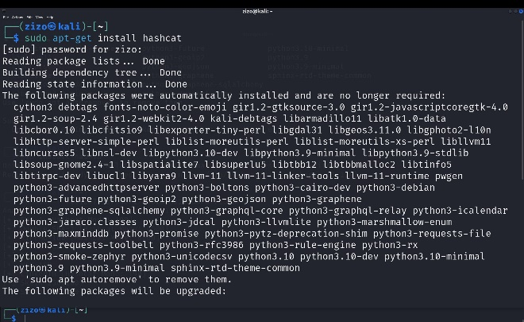
Figure 1 - Password Recovery

Advanced CPU-based password recovery utility
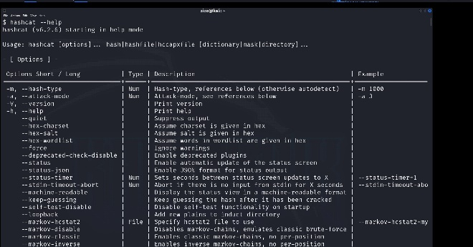
Figure 2 Hashcat Options

All options in Hashcat
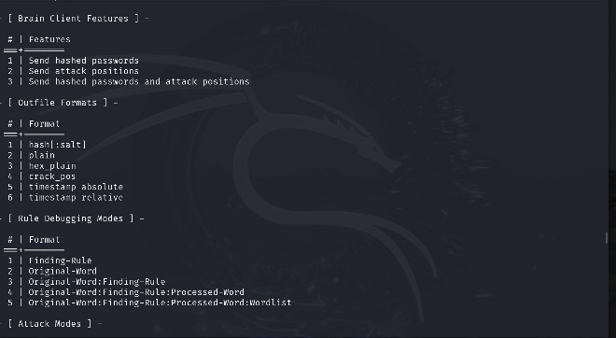
Figure 3 Stored Password

Hashcat-data
Hashcat is an advanced CPU/GPU-based password recovery utility supporting seven unique modes of attack for over 100 optimized hashing algorithms.
This package contains the data files for hashcat, including charsets, rules, salts, tables and Python tools.
Installed size: 28.25 MB
How to install:
sudo apt install hashcat-data

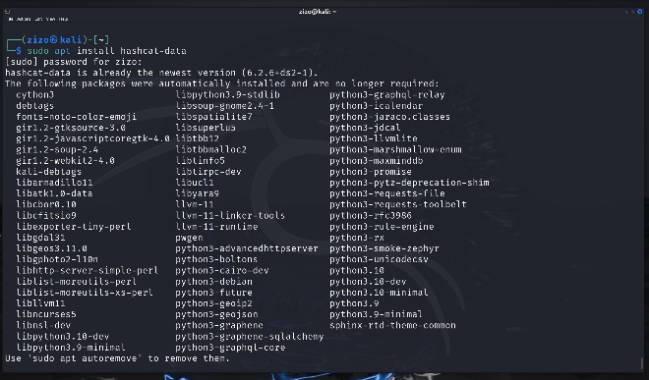
Figure 4 Hashcat install

Password Lists In Kali
Kali comes pre-packaged with wordlists that can be used for cracking passwords. The wordlist files are in the /usr/share/wordlists directory.
The one that is used the most, especially when doing a CTF (capture the flag), is the rockyou.txt file. This file is massive, It contains over fourteen million user passwords.
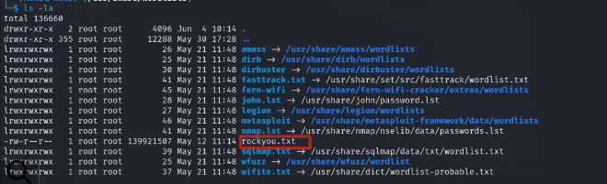
Figure 5 Password list
The rockyou.txt file comes from the over 32 million user credentials exposed due to a data breach in 2009 on the social media platform RockYou. These passwords were kept in plain text, not hashed or otherwise obfuscated.

A nother great resource for passwords is SecLists on GitHub. This list contains many password lists, including “500-worst-passwords.txt” and “darkweb2017-top10000.txt.” The password lists are collections of commonly used, default, or leaked passwords.

Th e right wordlist for Hashcat can significantly boost the effectiveness of password cracking by being tailored to the organization or demographic being tested.
It should be comprehensive yet specific and consider common weak passwords, organization-specific terms, language and localization, and common password mutations.
Pros:

Environment Isolation: Running Hashcat in a VM keeps your main OS separate from your Host OS
Ease of Setup: Hashcat is already installed on Kali, making it easier to get up and running without installation or configuration.
Testing and Experimentation: Using Hashcat in a VM allows you to test and experiment without affecting your host OS.
Cons:
P erformance Overhead: Running Hashcat in a VM is slower than running it on native hardware, especially due to its GPU-intensive tasks, because of the additional layer of abstraction provided by the VM.
Hardware Access: While most VM solutions support passing through USB devices to the guest operating system, GPU passthrough (beneficial for a tool like Hashcat) can be complex and may only be supported on some systems or with some VM software.
Resource Allocation: VMs require a portion of your system's resources. Running intensive applications in a VM could impact the performance of the host system.

Hashcat on Host Machine
The decision to run Hashcat directly on the host OS versus in a VM depends on your specific needs and resources. Running Hashcat natively on the host operating system like Windows has its own set of pros and cons.

Pros:
performance: Running Hashcat on the host OS performs better than running it inside a VM. This is because there are no additional layers of abstraction between the application and the hardware.
Simplicity: It might be simpler to install and run for users who are more comfortable working in a Windows environment than a Linux one or for those unfamiliar with setting up VMs.

Cons:
Resource Consumption: Hashcat is designed to use as much of your system's resources as possible to perform its tasks quickly. While running, your computer might be slow to respond to other tasks.
System Compatibility: While Hashcat is built to be compatible with a wide range of systems and hardware, there can always be unforeseen compatibility issues or bugs that could impact
There are some hash types you may see as penetration testers or ethical hackers.

SHA-256 (Secure Hash Algorithm 256-bit): This is part of the SHA-2 family and is widely used in cryptographic applications and protocols, including TLS and SSL, PGP, SSH, and Bitcoin, among others.
Here is an example of an SHA-256 hash:
f2881bb653e5a11780fad1b3a7ef2d4fd10f1cced3d71c76443d7670aa0257d8

AS-REP (Authentication Service Response): This hash is part of the Kerberos protocol used for network authentication, including in Windows Active Directory domains and some Unix environments. This hash is acquired through AS-REP roasting, which extracts users' password hashes with the activated "Do not require Kerberos preauthentication" setting Identify Hashes

If you come across a hash and aren’t sure what hashing algorithm is being used, some tools can help you identify them, such as Hash-Identifer or hashID.
hashID replaces Hash-Identifier, although it can still be used and is installed by default on Kali.
hashID can be installed from the command line using the following.

pip install hashid
Once installed, you simply type hashid -m and the hash you need to be identified, as seen below. This will show the corresponding Hashcat mode alongside the potential hash. Let’s take the following hash and put it into hashID
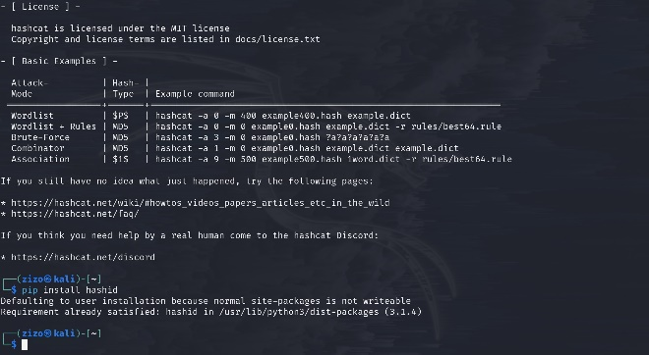
Figure 6 Analyzing

Analyze step
7b126739275d3717e981a78311dbdf6f71b7a74

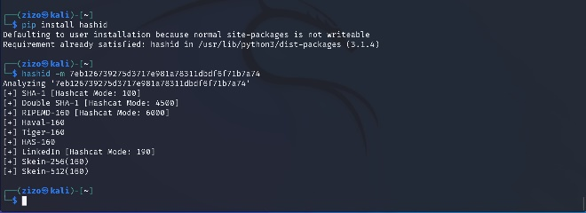
Figure 7 Hash identification
The hash is identified as being a SHA-1 hash.
These tools do their best at guessing the correct hash but may not be able to accurately identify all hashes you input. Understanding the technology you are working with, will go a long way in knowing which hash is being used.

The NTLM hash, our second hash type, is quite frequent if you're pursuing a career as a penetration tester or interested in learning to attack Active Directory. The NTLM hash is still frequently used today in Windows operating systems.

The syntax you need to use is:
hashcat.exe -m 1000 ntlmhash.txt -a 0 rockyou.txt

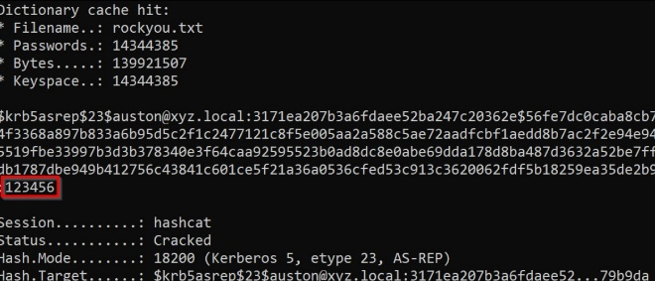
Figure 8 Syntax used

V-Conclusion

Hashcat is a powerful open-source password-cracking tool used extensively in the field of cybersecurity and InfoSec. With its ability to crack a diverse range of hashed passwords, from SHA-256 to NTLM and Kerberos. Hashcat can swiftly crack many passwords by harnessing your GPU's power using a dictionary attack through various attack modes, support for numerous hash types, and GPU acceleration, Hashcat has become an indispensable tool for professionals in the industry.

Whether it's for password recovery, security audits, forensics, or research purposes, Hashcat offers a versatile and efficient solution. By mastering Hashcat, professionals can enhance their careers in areas such as penetration testing, forensics, and incident response, contributing to the overall security of organizations and systems.
Hashcat's relevance in the industry is expected to continue growing as new cryptographic algorithms and hash functions emerge, requiring continuous evaluation and testing for potentially embracing best practices and ethical guidelines, and professionals can leverage Hashcat's capabilities while maintaining a responsible and secure approach to password cracking.

References
- https://link.springer.com/article/10.1007/s11277-023-10497-y
- Clusters and security: distributed security for distributed systems | IEEE Conference Publication | IEEE Xplore
- Cyber-security of centralized, decentralized, and distributed control-detector architectures for nonlinear processes - ScienceDirect
- Distributed password cracking with BOINC and hashcat | Digital Investigation: The International Journal of Digital Forensics & Incident Response (acm.org)
- A Study on the Security of Password Hashing Based on GPU Based, Password Cracking using High-Performance Cloud Computing (stcloudstate.edu)
- Cyber-security of centralized, decentralized, and distributed control-detector architectures for nonlinear processes - ScienceDirect

