|  |  |  |
| --- | --- | --- |
| Module | ID | Name |
| Text Recognition | 9210859 | Kirollos Baghdad |
| Field Detection | 9220501 | Ali Afifi |
| Image Acquisition & Preprocessing | 9220111 | Ahmed Mostafa Ali Bakr |
| Excel Sheet Generation & Data Parsing | 9220019 | Ahmed El Sayed Mohsen |

**Image Processing Project**

***Project Idea***

**Grades auto-filler**

This project is an assistant to TAs and Professors in our department. It should provide an easy way to fill the grades electronically, and it should be able to correct MCQ bubble sheet exams automatically.

**It consists of 2 modules:**

1. **Grades sheet**
2. **Bubble sheet correction**

**Grades Sheet**

**Input:** TAs or professors will fill this sheet with the corresponding grades for each column for each student. Then, a picture taken by a mobile camera will be the input to the system.

**Output:** Output should be an excel sheet that contains a sheet similar to the one.

**The following data should be converted to text:**

1. Printed Student ID
2. The following written symbols:
   1. **✓** (output should be 5)
   2. □ ( output should be 0)
   3. **-** ( output should be 0)
   4. **Empty cell** ( output should be empty cell)
   5. **Stacked Vertical lines** **|||** in the cell [ output should be i where i is the number of lines ]
   6. **Stacked Horizontal lines** - in the cell [output should be (5 - i) where i is the number of lines].
   7. **?** ( output should be an empty cell with a red background color).
3. Numeric written values

**Bubble Sheet Correction**

**Input:** The input of this module is a bubble sheet like the following:

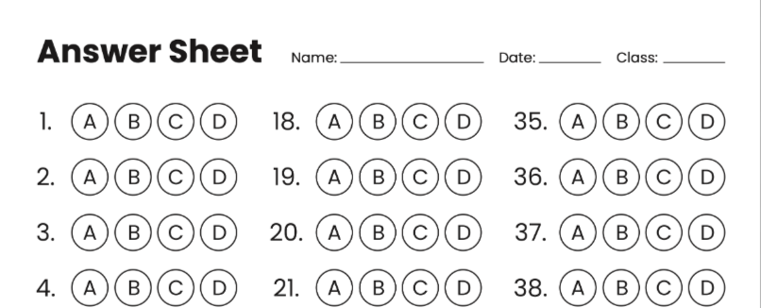

**Output:** The output will be a spreadsheet with the following:

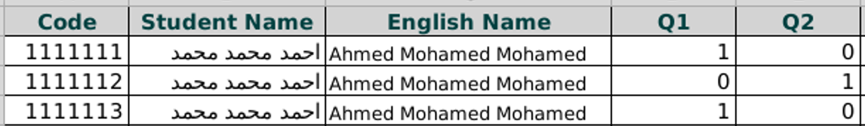

For each correct answer, you give 1, and for each wrong answer, you show 0.

***Project Need***

**Efficiency and Accuracy**: Manual data entry is time-consuming and prone to errors. By automating the process using image processing, we can significantly reduce the time and effort required, while also minimizing human errors.

**Versatility for different Formats:** This system works for multiple input formats. It works for Grades sheet which uses multiple symbols and numbers. Also It works for bubble sheet to determine the correctness of the answers given a model answer.

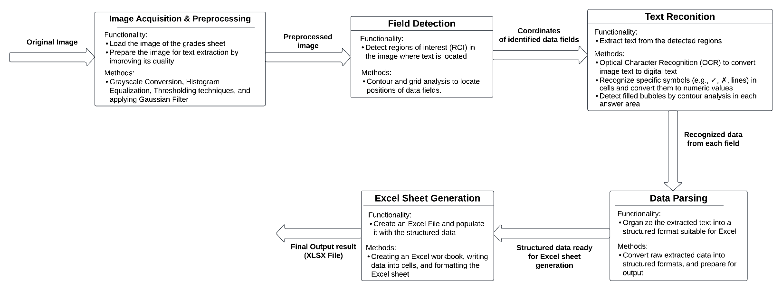***Project Block Diagram***

***Non-Primitive functions***

**Image Acquisition & Preprocessing:**

Use OpenCV for reading the image.

**Field Detection:**

Use OpenCV's contour detection to locate and define the boundaries of each data field.

**Text Reconition:**

Use Tesseract or a similar OCR library for printed IDs and numbers.

**Data Parsing:**

Use dictionary or DataFrame structure with specific cell mapping logic.

**Excel Sheet Generation:**

Using openpyxl or pandas for reading/writing excel files and generation.

(to_excel) function takes required input and produces the excel file in a suitable format by organizing the input data.

***Scientific Papers:***

[(PDF) Optical Character Recognition from Text Image](https://www.researchgate.net/publication/272709776_Optical_Character_Recognition_from_Text_Image)  
[[PDF] Image Processing Based Scene-Text Detection and Recognition with Tesseract | Semantic Scholar](https://www.semanticscholar.org/reader/3fd22074cfaba168bd86d4ee82989cb8dbc5d574)