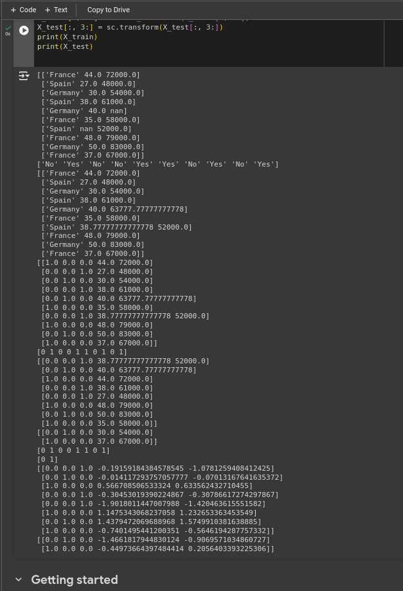
1. Dataset1 – countries NNM22IS083

2.Dataset2 – mobile games

