**Riphah International University, Lahore Campus, Pakistan**

Riphah School of Computing & Innovation

**Artificial Intelligence – Fall 2022**

**Lab Assignment**

**Name: Ahmed Mujtaba Sap id: 26617 section: 6A**

**Repository link.**

[**https://github.com/ahmedmujtaba99/AI_Lab_Linear_Regrassion**](https://github.com/ahmedmujtaba99/AI_Lab_Linear_Regrassion)

**Problem:**

For the Halloween carnival in your neighborhood, your task is to predict the selling price of products based on given features. With 50 stalls offering various products in different categories, your predictions will help estimate the prices for a successful event. Get ready to analyze the features and make accurate price predictions for a memorable Halloween carnival.

**Errors:**

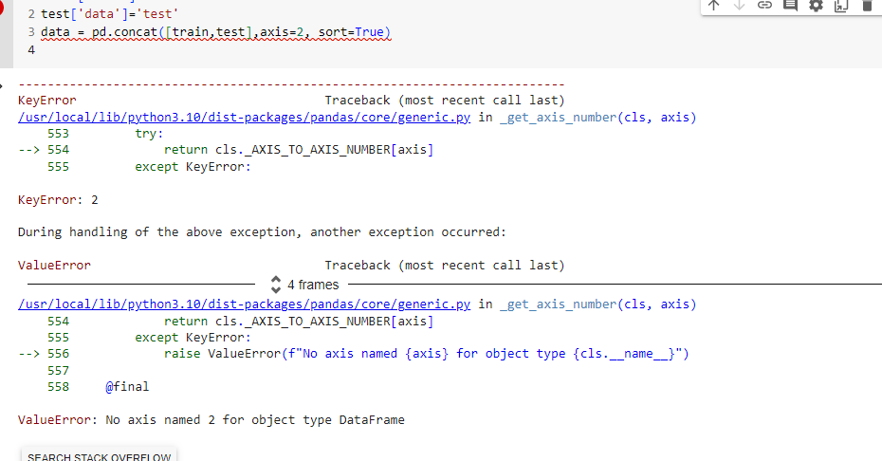

|  |
| --- |
| Error in setting the axis. |

|  |
| --- |
|  |

|  |
| --- |
| return pd.crosstab(index=data[column],  Having Error in this Line  freq_tab = frequency_table(Train, "Market_Part")  train file not fetch data from .cse file dua to change the variable name. |

**I have Question here ??**

|  |
| --- |
| def frequency_table(data, column):  return pd.crosstab(index=data[column],  columns="count").sort_values(by="count",  ascending=False)  freq_tab = frequency_table(train, "Market_Part")  freq_tab  print(freq_tab)   * If we make the ascending True it shah the market Part from lower side. |

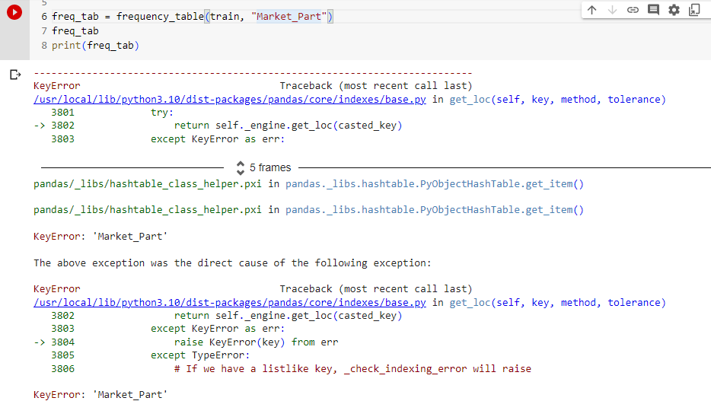

|  |
| --- |
| Key Error  For not mating features in the tarin.scv file. Not Code problem DataSet have some problem (.csv) |

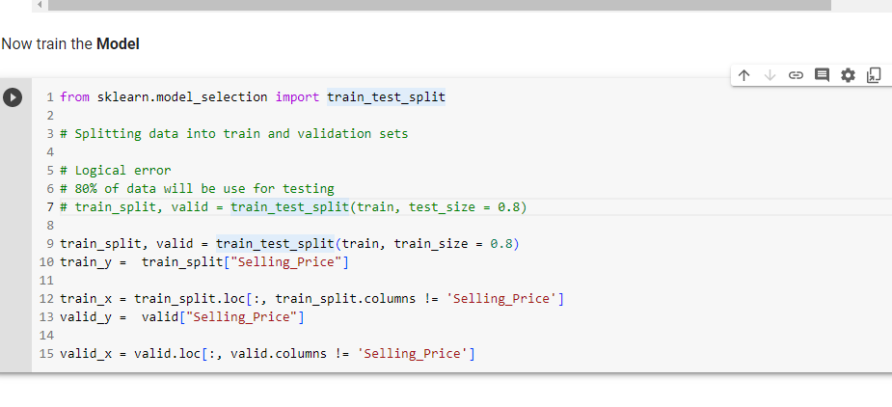

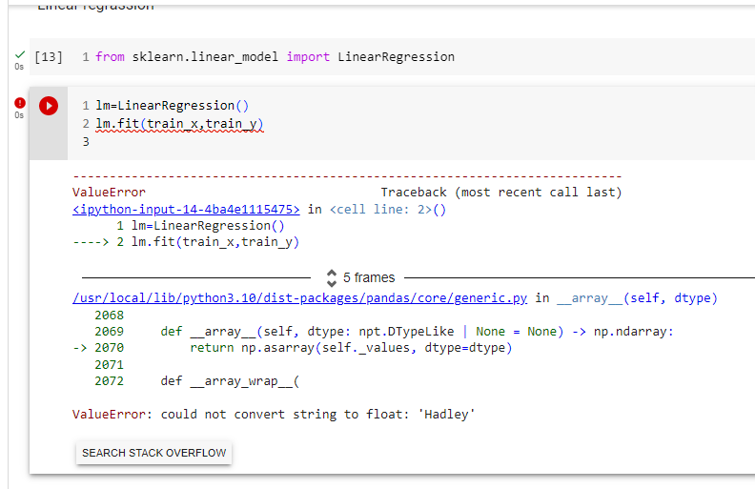

|  |
| --- |
| For this error, I have to convert string values columns into numerical values |

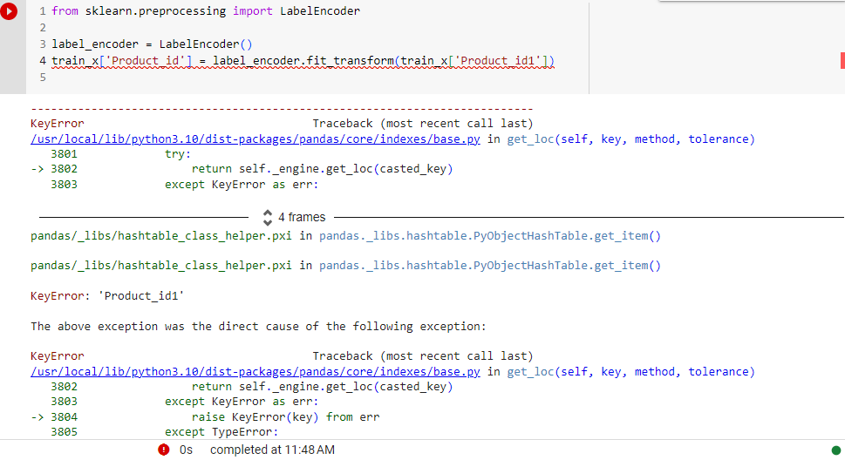

|  |
| --- |
| Converting String value to numerical values |

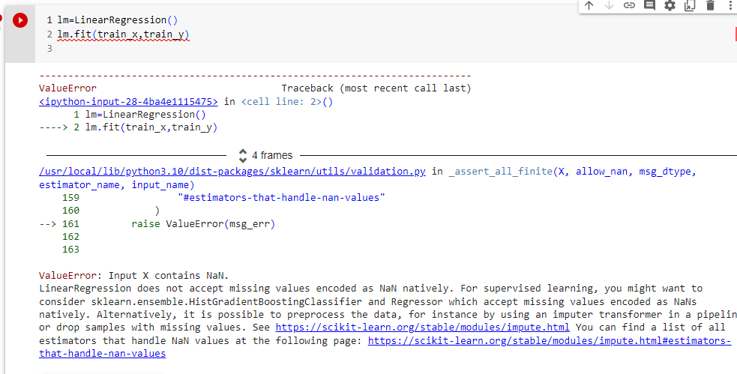

|  |
| --- |
| This error is due to null values in the train.csv  train_x = train_x.dropna()  train_y = train_y.drop(train_y.index[train_y.isnull()])  I drop the null values in train.csv |

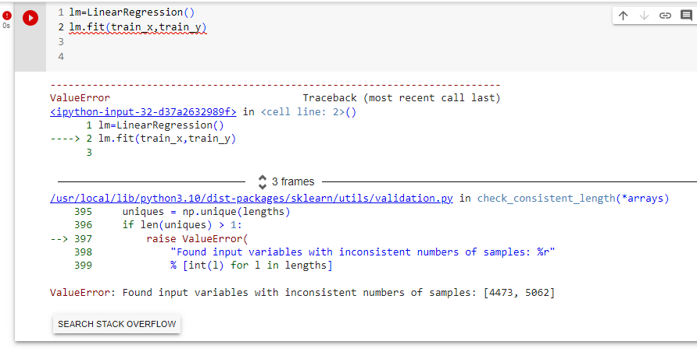

|  |
| --- |
| Error in string values length or flout values length |

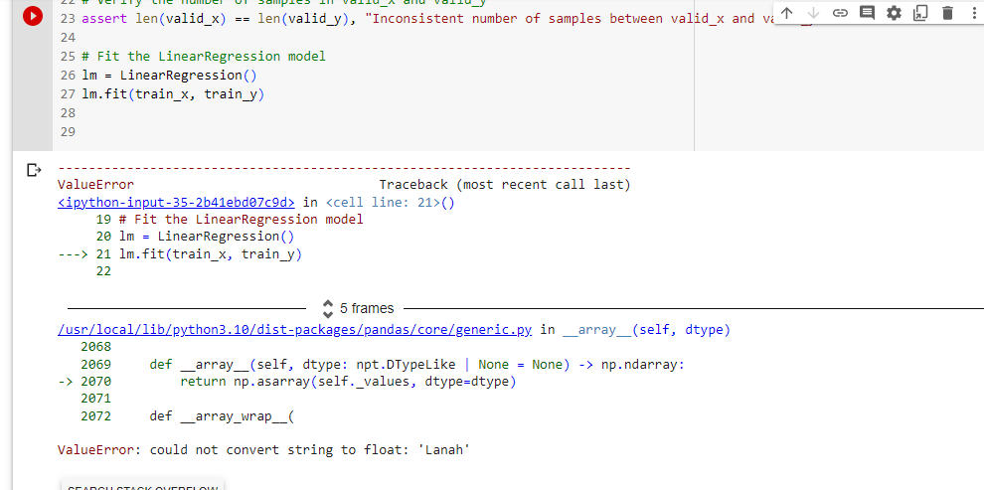

|  |
| --- |
| label_encoder = LabelEncoder() #trainsform value of Selling_price  train_x['Selling_Price'] = label_encoder.fit_transform(train_x['Selling_Price']) |

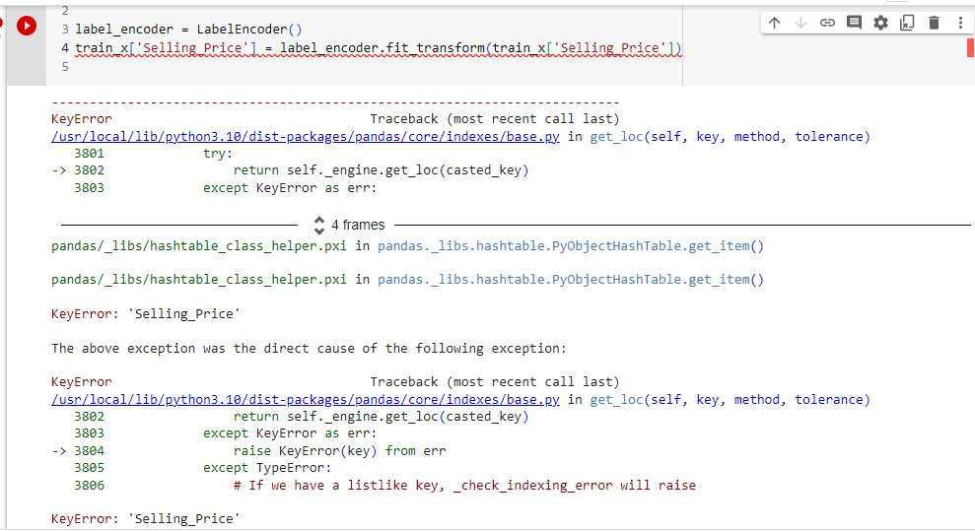

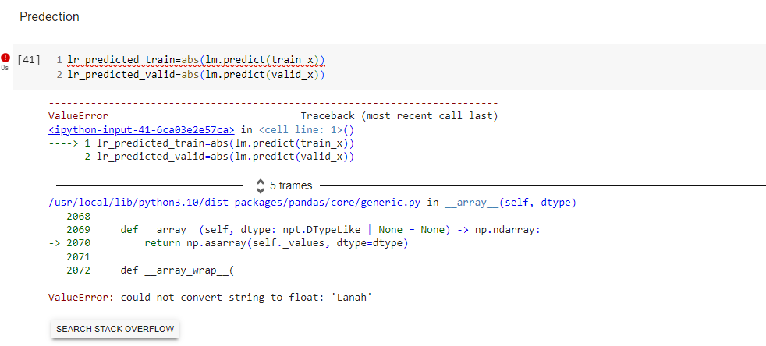

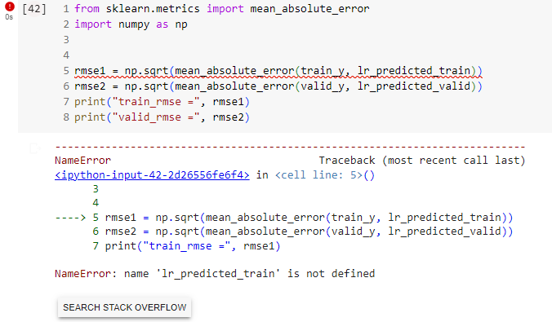

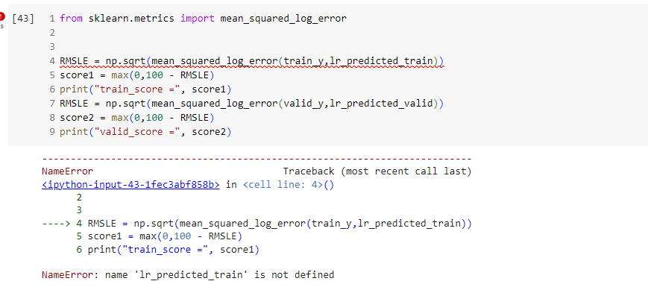

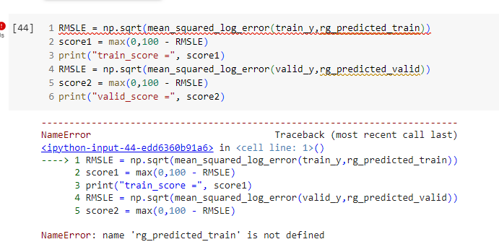

|  |
| --- |
| Due to some error in given dataset  some parts contain string value, some contain flout value, and some contain a numeric value. |