* 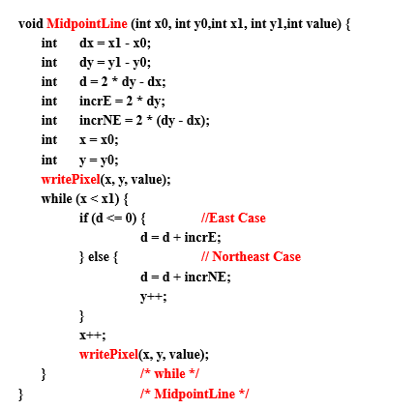**Assignment 3 (Midpoint Line Algorithm)**
* Trace the code

Using the Midpoint algorithm, given that:

P = (1,1.2), (x0, y0) = (1,1), (x1, y1) = (4,4)

* x0 = 1

y0 = 1

x1 = 4

y1 = 4

* dx = 4 – 1 = 3

dy = 4 – 1 = 3

d = (2 * 3) – 3 = 3

incrE = 2 * 3 = 6

incrNE = 2 * (3 – 3) = 2 * 0 = 0

x = 1

y = 1

* WritePixel (1, 1, value)
* iteration from x = 1 until x = 3
  + 1. iteration 1: x = 1, y = 1, d = 3

d > 0, it will take the north-east

d = 3 + 0 = 3

y++, y = 2

x++, x = 2

WritePixel (2, 2, value)

* + 1. iteration 2: x = 2, y = 2, d = 3

d > 0, it will take the north-east

d = 3 + 0 = 3

y++, y = 3

x++, x = 3

WritePixel (3, 3, value)

* + 1. iteration 3: x = 3, y = 3, d = 3

d > 0, it will take the north-east

d = 3 + 0 = 3

y++, y = 4

x++, x = 4

WritePixel (4, 4, value)

* 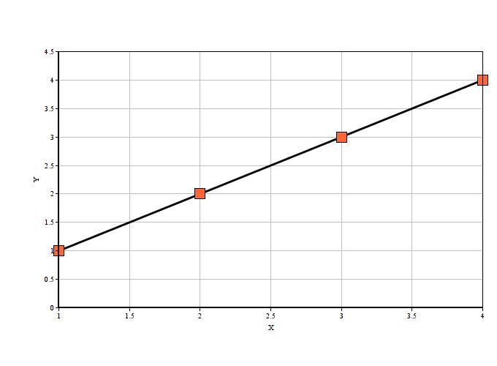Table form & graph:

|  |  |
| --- | --- |
| x | y |
| 1 | 1 |
| 2 | 2 |
| 3 | 3 |
| 4 | 4 |

* 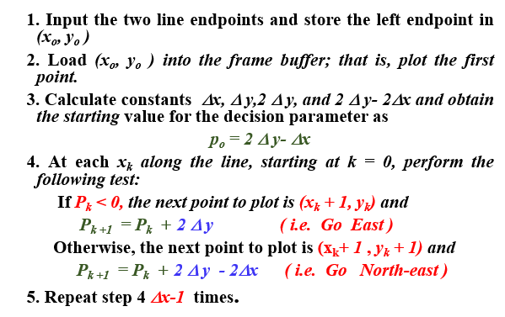**Assignment 4 (Bresenham** **Line Algorithm)**
* Trace the code

Use Bresenham Algorithm to draw line starting at (20,10) and ending at (30,18).

* x0 = 20

y0 = 10

x1 = 30

y1 = 18

* WritePixel (20, 10)
* ∆x = x1 - x0 = 30 – 20 = 10

∆y = y1 - y0 = 18 – 10 = 8

2∆y = 2*8 = 16

2∆y - 2∆x = 16 – (2*10) = -4

P0 = 2∆y - ∆x = 16 – 10 = 6

* Iteration will be repeated until ∆x – 1 = 9 times

1. iteration 1: x = 20, y = 10, Pk = P0 = 6

Pk > 0, it will take the north-east

next pixel = (Xk+1, Yk +1)

y++, y = 11

x++, x = 21

Pk +1 = Pk + 2∆y - 2∆x = 6 + (-4) = 2

WritePixel (21,11)

1. iteration 2: x = 21, y = 11, Pk = P1 = 2

Pk > 0, it will take the north-east

next pixel = (Xk+1, Yk +1)

y++, y = 12

x++, x = 22

Pk +1 = Pk + 2∆y - 2∆x = 2 + (-4) = -2

WritePixel (22,12)

1. iteration 3: x = 22, y = 12, Pk = P2 = -2

Pk < 0, it will take the east

next pixel = (Xk+1, Yk)

y = 12

x++, x = 23

Pk +1 = Pk + 2∆y = -2 + 16 = 14

WritePixel (23,12)

1. iteration 4: x = 23, y = 12, Pk = P3 = 14

Pk > 0, it will take the north-east

next pixel = (Xk+1, Yk +1)

y++, y = 13

x++, x = 24

Pk +1 = Pk + 2∆y - 2∆x = 14 + (-4) = 10

WritePixel (24,13)

1. iteration 5: x = 24, y = 13, Pk = P4 = 10

Pk > 0, it will take the north-east

next pixel = (Xk+1, Yk +1)

y++, y = 14

x++, x = 25

Pk +1 = Pk + 2∆y - 2∆x = 10 + (-4) = 6

WritePixel (25,14)

1. iteration 6: x = 25, y = 14, Pk = P5 = 6

Pk > 0, it will take the north-east

next pixel = (Xk+1, Yk +1)

y++, y = 15

x++, x = 26

Pk +1 = Pk + 2∆y - 2∆x = 6 + (-4) = 2

WritePixel (26,15)

1. iteration 7: x = 26, y = 15, Pk = P6 = 2

Pk > 0, it will take the north-east

next pixel = (Xk+1, Yk +1)

y++, y = 16

x++, x = 27

Pk +1 = Pk + 2∆y - 2∆x = 2 + (-4) = -2

WritePixel (27,16)

1. iteration 8: x = 27, y = 16, Pk = P7 = -2

Pk < 0, it will take the east

next pixel = (Xk+1, Yk)

y = 16

x++, x = 28

Pk +1 = Pk + 2∆y = -2 + 16 = 14

WritePixel (28,16)

1. iteration 9: x = 28, y = 16, Pk = P8 = 14

Pk > 0, it will take the north-east

next pixel = (Xk+1, Yk +1)

y++, y = 17

x++, x = 29

Pk +1 = Pk + 2∆y - 2∆x = 14 + (-4) = 10

WritePixel (29,17)

………………………………

* Table form & graph:

|  |  |  |  |  |
| --- | --- | --- | --- | --- |
| Iteration (∆x – 1) | k | Pk | x | y |
| 1 | 0 | 6 | 21 | 11 |
| 2 | 1 | 2 | 22 | 12 |
| 3 | 2 | -2 | 23 | 12 |
| 4 | 3 | 14 | 24 | 13 |
| 5 | 4 | 10 | 25 | 14 |
| 6 | 5 | 6 | 26 | 15 |
| 7 | 6 | 2 | 27 | 16 |
| 8 | 7 | -2 | 28 | 16 |
| 9 | 8 | 14 | 29 | 17 |
| - | 9 | 10 | 30 | 18 |

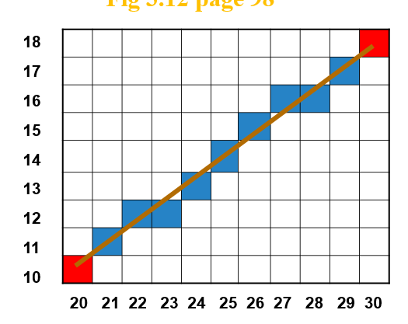

* **Assignment 5 (Bresenham Line Algorithm)**

a. Rotate point A = (2,3) around point B = (1,2) at angle  = 30 degree.

b. Show your computations

c. Draw a sketch for this operation

d. Rotate point A= (1,2) around point B = (2,3) at angle  = 30 degree.

e. Show your computations.

f. Draw a sketch for that operation

g. Comment on (c) and (f)

Solution



M1 =

M2 =

M3 =

1. Q = (M3 M2 M1) * (Rotating point A) =

( * * ) * ( ) =

( * * ) * ( ) =

( * ) * ( ) =

( * =

Aˉ = (1.36, 3.36)

1. 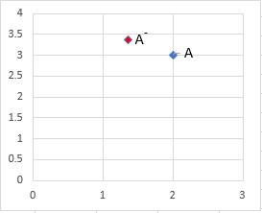

M1 =

M2 =

M3 =

1. Q = (M3 M2 M1) * (Rotating point A) =

( $\begin{matrix}1 & 0 & 2 \\ 0 & 1 & 3 \\ 0 & 0 & 1\end{matrix}$ $\begin{matrix}\cos{30} & -\sin{30} & 0 \\ \sin{30} & \cos{30} & 0 \\ 0 & 0 & 1\end{matrix}$ $\begin{matrix}1 & 0 & -2 \\ 0 & 1 & -3 \\ 0 & 0 & 1\end{matrix}$* * ) * ( $\begin{matrix}1 \\ 2 \\ 1\end{matrix}$) =

( $\begin{matrix}1 & 0 & 2 \\ 0 & 1 & 3 \\ 0 & 0 & 1\end{matrix}$ $\begin{matrix}0.866 & -0.5 & 0 \\ 0.5 & 0.866 & 0 \\ 0 & 0 & 1\end{matrix}$ $\begin{matrix}1 & 0 & -2 \\ 0 & 1 & -3 \\ 0 & 0 & 1\end{matrix}$* * ) * ( $\begin{matrix}1 \\ 2 \\ 1\end{matrix}$) =

( $\begin{matrix}0.866 & -0.5 & 2 \\ 0.5 & 0.866 & 3 \\ 0 & 0 & 1\end{matrix}$ $\begin{matrix}1 & 0 & -2 \\ 0 & 1 & -3 \\ 0 & 0 & 1\end{matrix}$* ) * ( $\begin{matrix}1 \\ 2 \\ 1\end{matrix}$) =

( $\begin{matrix}0.866 & -0.5 & 1.768 \\ 0.5 & 0.866 & -0.597 \\ 0 & 0 & 1\end{matrix}$ $\begin{matrix}1 \\ 2 \\ 1\end{matrix}$* = $\begin{matrix}1.63 \\ 1.63 \\ 1\end{matrix}$

Aˉ = (1.63, 1.63)

1. 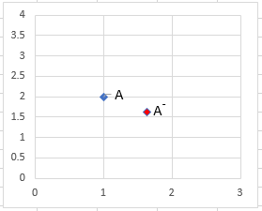
2. The rotation is not reflexive transformation,

as when rotate the point A = (2,3) around point B = (1,2) at angle θ = 30 degree, it gives us the point Aˉ = (1.36, 3.36) and,

when rotate the point A = (1,2) around point B = (2,3) at angle θ = 30 degree, it gives us another point Aˉ = (1.63, 1.63).