**Q1**

#include<iostream>

using namespace std;

int main()

{

unsigned int y[200];

unsigned char a[200], b[200] ,c[200];

for (int i=0; i<200; i++)

{

cin>>y[i];

}

for (int i=0; i<200; i++)

{

a[i]=y[i];

y[i]=y[i]>>8;

b[i]=b[i]|y[i];

y[i]=y[i]>>8;

c[i]=c[i]|y[i];

y[i]=y[i]>>8;

}

cout<<hex;

for(int i=0;i<200;i++)

{

cout<<(int)a[i]<<endl;

cout<<(int)b[i]<<endl;

cout<<(int)c[i]<<endl;

}

return 0;

}

**Q2**

#include<iostream>

#include<string>

using namespace std;

struct student

{

int ID;

char Name[20];

char Address[60];

float Weight;

float Height;

char Gender[7];

};

string GoodShape(student s)

{

if(s.Weight+10<s.Height-65)

return ("Overweight");

if(s.Weight>s.Height-90)

return ("Underweight");

if(s.Weight-5<=s.Height-80)

return ("Ideal Weight");

}

int main()

{

student x;

cin>>x.Weight;

cin>>x.Height;

cout<<GoodShape(x)<<endl;

return 0;

}

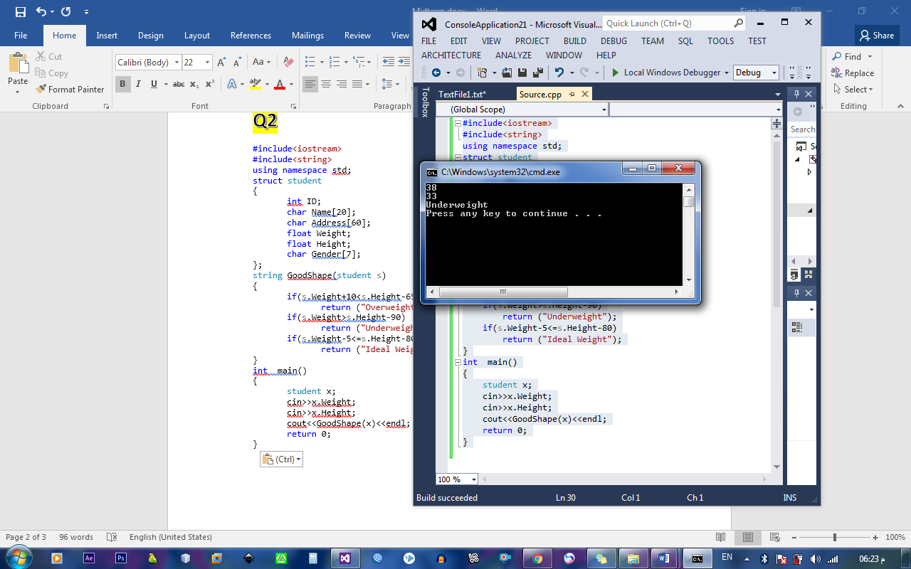

**Q3**

#include<iostream>

using namespace std;

const int x=100;

struct stack

{

char c[x];

int top;

};

void reset( stack &x)

{

x.top=-1;

}

void push (char c,stack &x)

{

x.top++;

x.c[x.top]=c;

}

char pop(stack &x)

{

return x.c[x.top--];

}

bool empty(stack &x)

{

return x.top==-1;

}

bool full(stack &z)

{

return z.top==x-1;

}

stack remove_Char_a (stack & k)

{

stack s2;

reset(s2);

while(!empty(k))

{

if(k.c[k.top]=='a')

k.top--;

else

push(pop(k),s2);

}

return s2;

}

int main()

{

stack s1;

char str [40]={"my name is ahmed"};

int i=0;

cout<<str<<endl;

reset(s1);

while(str[i])

if(!full(s1))

push(str[i++],s1);

s1=remove_Char_a(s1);

while(!empty(s1))

{

cout<<pop(s1);

}

cout<<endl; return 0; }

