**Bakery System (SDD)**

**Team Members:**

Kariem Abdelmoniem Ahmed

Abdelrahman Mohamed

Bassem Barket-allah **presented to :**

Ahmed Mohamed Nabil Dr. Mohamed Ramdan

**TABLE OF CONTENTS 1. INTRODUCTION**

1.1 Purpose

1.2 Overview

**2. SYSTEM ARCHITECTURE**

2.1 Architectural Design 3.2 Decomposition Description 3.3 Design Rationale

**3. DATA DESIGN**

**4. HUMAN INTERFACE DESIGN**

4.1 Overview of User Interface 4.2 Screen Images

**5. REQUIREMENTS MATRIX 8.**

**1. INTRODUCTION**

**1.1 Purpose**

Develop a comprehensive set of RESTful APIs for managing online shops

Functionalities like product management, order processing, and customer

interaction into their e-commerce platforms

Improve efficiency and scalability of online shop operations through automation

and seamless integration (APIs can automate tasks such as product updates and

order processing, which can save time and resources.)

**1.2 Overview**

Our project is an online shopping platform facilitating user registration and login for customers, administrators, and delivery personnel. It offers comprehensive product management, seamless shopping cart functionality, and efficient order processing, ensuring a user-friendly experience and effective feedback collection for continuous improvement.

**2. SYSTEM ARCHITECTURE**

**2.1 Architectural Design** 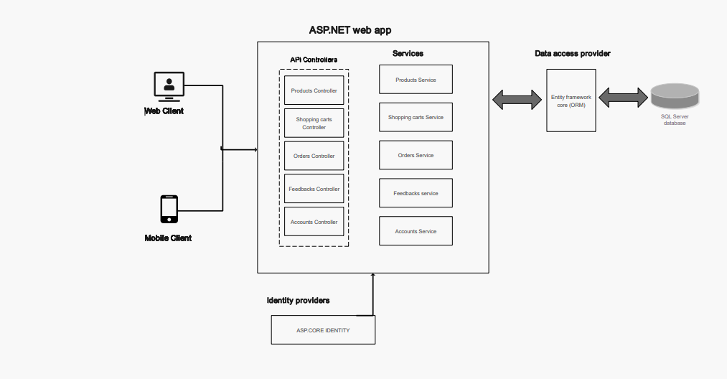

**2.2 Decomposition Description**

**Class Diagram:-**

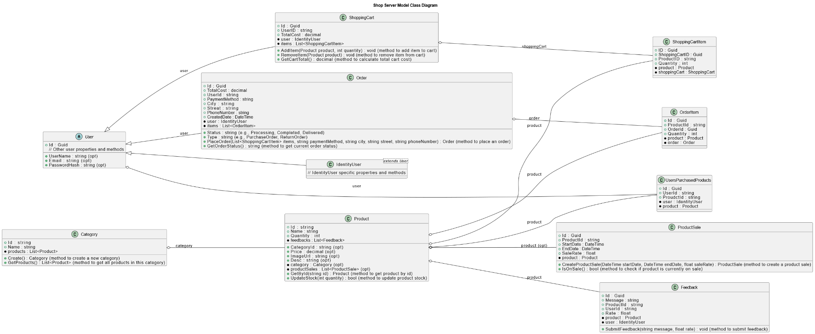

**3. DATA DESIGN**

**3.1 Entity Relationship diagram**

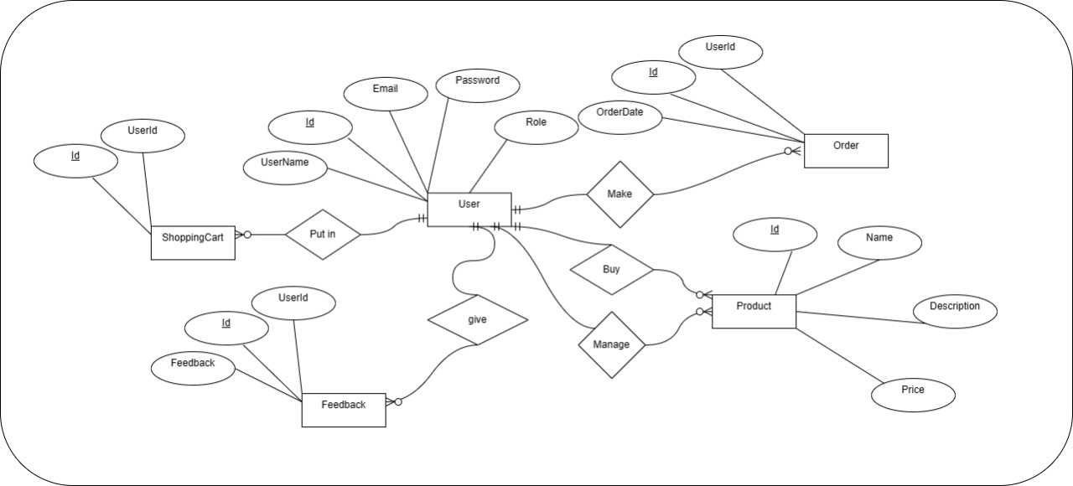

**3.2 Database schema diagram**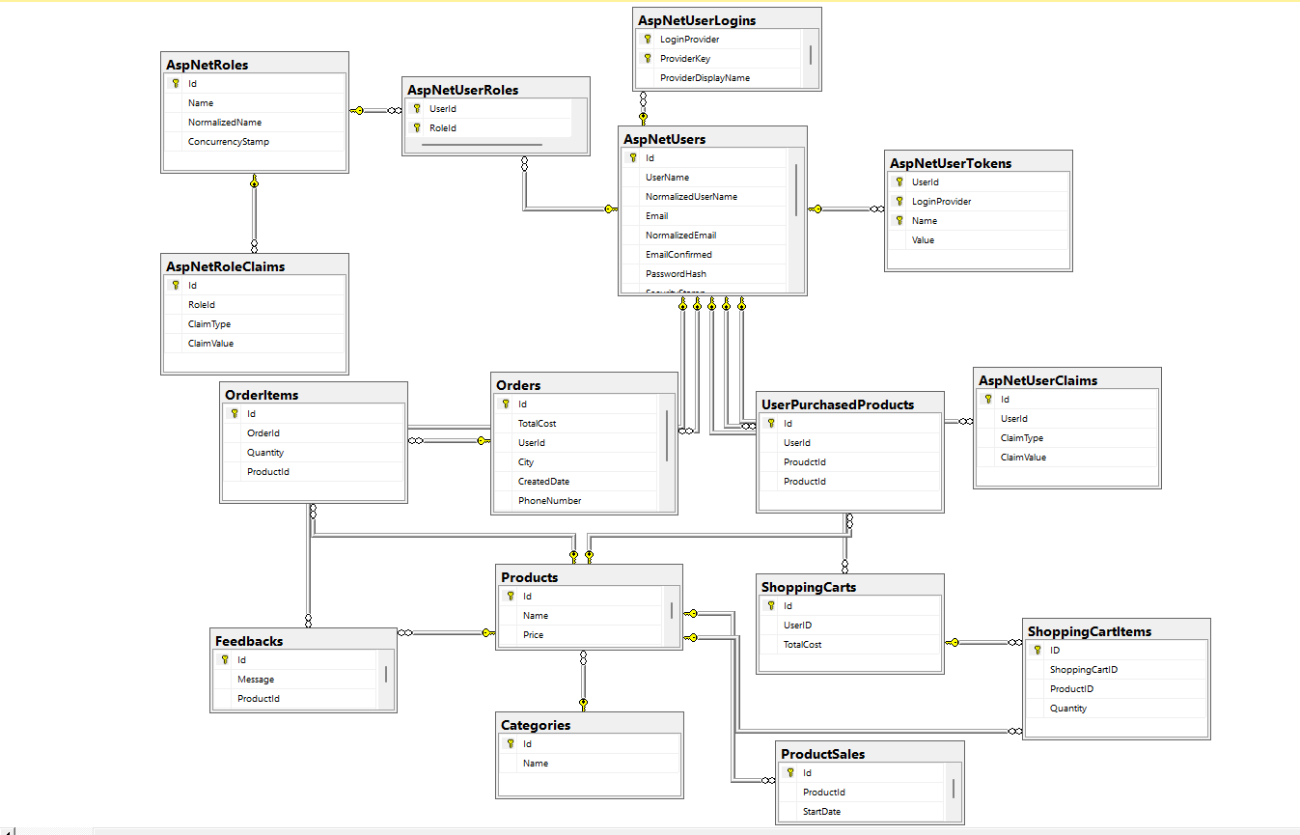

**4. HUMAN INTERFACE DESIGN**

**4.1 Overview of User Interface**

Home Page: when a user lands on the homepage of the bakery shop website, they are greeted with a visually appealing layout.

Navigation: The website typically has a navigation menu at the top, allowing users to easily browse different sections such as "Home," "Shop," "Blog" , "Contact ".

Products Page: Clicking on the "Shop" section takes the user to a page displaying all the bakery items available for purchase. Each product is usually accompanied by an image and name of the product. They can also make filter options (like size, category).

Product Details: Clicking on a specific product takes the user to its detailed page, where they can find more information such as description, price, and rate by customers. They can also choose the quantity before adding it to their cart.

Shopping Cart: Users can view and manage items in their shopping cart. They can update quantities, remove items, or proceed to checkout.

Account Management: Users can create an account on the website, by signing up with (user name, email, password).

Contact and Support: The website typically provides contact information (such as email) for users to reach out for assistance or inquiries.

Browsing Products:

* User Action: Users can navigate to the "Shop" section from the homepage to browse available bakery items.
* Feedback Information: As users hover over or click on product images, they receive feedback in the form of tooltips or product descriptions displaying key information like name, price, and possibly customer ratings.

Viewing Product Details:

* User Action: Clicking on a specific product leads users to its detailed page.
* Feedback Information: Users see detailed product descriptions, ingredients, nutritional information, and any customer reviews or ratings.

Adding Items to Cart:

* User Action: Users select the quantity and any customization options before clicking the "Add to Cart" button.
* Feedback Information: A confirmation message pops up, indicating that the item has been successfully added to the cart. Additionally, the cart icon may display the updated number of items in the user's cart.

Managing Shopping Cart:

* User Action: Users can view their cart, update quantities, remove items, or proceed to checkout.
* Feedback Information: Changes made to the cart are reflected instantly, with the subtotal and total cost recalculated accordingly. Feedback messages confirm actions such as item removal or quantity update.

Account Management:

* User Action: Users can create an account, log in.
* Feedback Information: Feedback includes confirmation messages for successful account creation, login.

**Contact and Support:**

* **User Action:** Users can reach out for assistance or inquiries using provided contact information or a contact form.
* **Feedback Information:** Users receive confirmation messages upon successful submission of their queries. Response times and communication channels for support requests may also be displayed to manage user expectations.

**4.2 Screen Images**

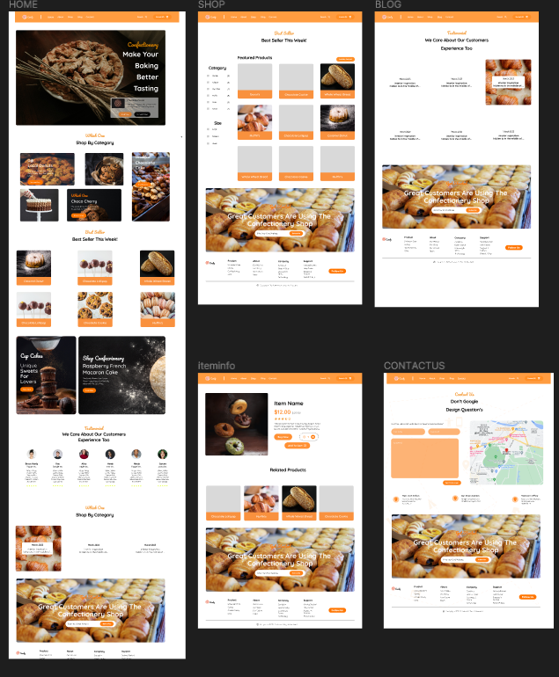

**5. REQUIREMENTS MATRIX**

| **Requirement ID** | **Description** | **Design Document** | **Implementation** |
| --- | --- | --- | --- |
| REQ-001 | The system shall allow users to create an account. | DD-001 | Implemented |
| REQ-002 | Users shall be able to browse bakery products. | DD-002 | Implemented |
| REQ-003 | The system must support online payments. | DD-003 | NOT Implemented |
| REQ-004 | Customers should receive email notifications for order confirmations. | DD-004 | Not Implemented |
| REQ-005 | Admins should be able to manage inventory. | DD-005 | Implemented |
| REQ-006 | The system should generate sales reports. | DD-006 | Not Implemented |