Software Requirements Specification

for

Travel Advisor Website
Version 1.1
Prepared by Ahmed Zahran – Abdelrhman Khaled
07/04/2026
Table of Contents
1 Introduction 2
1.1 Purpose 2
1.2 Intended Audience and Reading Suggestions 2
1.3 Product Scope 2
1.4 References 2
2 Overall Description 3
2.1 Product Perspective 3
2.2 Product Functions 3
2.3 User Classes and Characteristics 4
2.4 Operating Environment 4
2.5 Design and Implementation Constraints 4
2.6 Assumptions and Dependencies 5
3 External Interface Requirements 6
3.1 User Interfaces 6
3.2 Hardware Interfaces 14
3.3 Software Interfaces 14
3.4 Communications Interfaces 14
4 System Features 14
4.1 Login 14
4.2 User Registration 15
4.3 Home Page 17
4.4 Destination Details 18
4.5 Flight Search 18
4.6 Flight Result 19
4.7 Passenger Details 20
4.8 Payment Feature 21
4.9 User Management (Admin Feature) 22
4.10 Booking History (Admin Feature) 23

Revision History
Name | Date | Reason For Changes | Version
Alaa Abdelmoneam | 07/04/2026 | Vague and non-testable requirements. | 1.0

1 Introduction

1.1 Purpose
This Software Requirements Specification defines the requirements for the Travel Advisor Website.
The purpose of this document is to describe the functional and non-functional requirements of the web-based system that enables users to search for available flights, compare ticket prices, book flight tickets, make online payments, and see top flight destinations.

1.2 Intended Audience and Reading Suggestions
The primary audience includes project managers, system analysts, software developers, UI/UX designers, and testers. It may also be useful for stakeholders such as clients and business analysts who need a clear understanding of the system requirements and expected behavior.

For effective reading, all readers are encouraged to start with the overview sections first, including Purpose, Scope, and Product Perspective, and then continue to the detailed requirements based on their responsibilities.

1.3 Product Scope
The Travel Advisor Website is a web-based system that helps users book flight tickets online. The website allows users to search for available flights, compare prices, choose suitable tickets, make payments, manage their bookings, and see top flight destinations.

The main goal of this system is to make the flight booking process easier, faster, and more convenient for users. It also helps the business by attracting more customers, improving service quality, and increasing online booking opportunities.

Our Project will divide into:
- Dashboard for admin who can see and manage what is happening in the whole system.
- Website for users who're interested in booking flight tickets.

1.4 References
The following documents were used as references for preparing this Software Requirements Specification:

- Customer Requirements Specifications (CRS) for Travel Advisor Website.

- IEEE Recommended Practice for Software Requirements Specifications, IEEE, Version 1998, source: IEEE standards documentation.

2 Overall Description

2.1 Product Perspective
The Travel Advisor Website is a self-contained web-based system developed to help users search for flights, compare ticket prices, book tickets, and manage their reservations online.

This system works as a standalone website, but it also connects with some external services to complete its functions. For example, it may connect with airline or flight data sources to display available flights and with an online payment gateway to process payments securely. The website mainly includes modules such as user registration and login, flight search, booking management, and payment processing.

2.2 Product Functions
- Allow users to create an account, and log in.

- Display list of top flights destination with details such as destination name, description, images, and top places

- Display List of users reviews about their experience with booking flights using the website.

- Allow users to search for available flights by entering details such as departure location, destination, travel date, and number of passengers.

- Display a list of available flights with details such as airline name, departure time, arrival time, ticket price, and flight duration.

- Allow users to compare flight options and choose the most suitable one.

- Allow users to book flight tickets by entering passenger information.

- Allow users to make secure online payments using the available payment methods.

- Send notifications by email and confirmation messages to users through the website.

- Allow the admin to manage bookings, and user information.

2.3 User Classes and Characteristics
The main users of the Travel Advisor Website:

- Admin: The administrator manages the website and has a higher access level than normal users. The admin can monitor bookings and manage user accounts.

- User: is the main user of the system. This user can search for flights, book tickets, and make payments.

2.4 Operating Environment
- The website should work on common operating systems such as Windows, Android, and iOS

- The system should support web browsers such as Google Chrome, Mozilla Firefox, Microsoft Edge, and Safari.

- On the server side, the system will run on a web server connected to a database server that stores all data.

- External services such as a payment gateway for online payments and an email service for sending notifications.

2.5 Design and Implementation Constraints
- The system should be developed as a web-based application, so users can access it through a browser without installing special software.

- The system should use a database to store all users’ data

- The website should interface with external services such as a payment gateway and possibly a flight data source or API.

- The system should follow common web development standards and design conventions to make maintenance easier.

- The system shall include basic security considerations, especially for user login, personal data, and online payment processing.

- The project may be limited by available time, budget, and development tools.

- The website should be compatible with common browsers and normal internet-based communication.

2.6 Assumptions and Dependencies
This project assumes that users have internet access, a working web browser, and basic knowledge of using websites and online payment systems.
It also assumes that the external services used by the system, such as the flight information source, payment gateway, and email notification service, will be available and working correctly.
The website depends on the database server, hosting environment, and third-party services to function properly, so any failure or change in these components may affect the performance of the system.

3 External Interface Requirements

3.1 User Interfaces
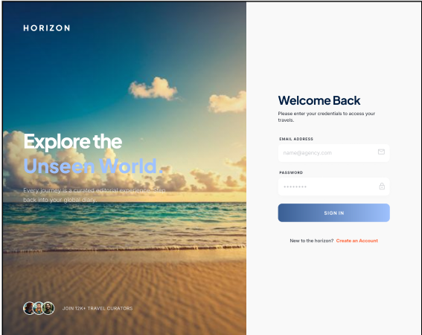


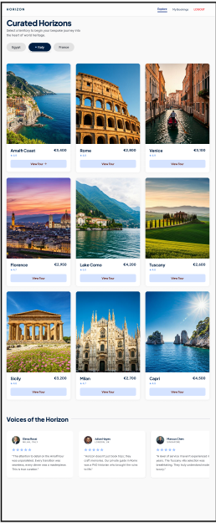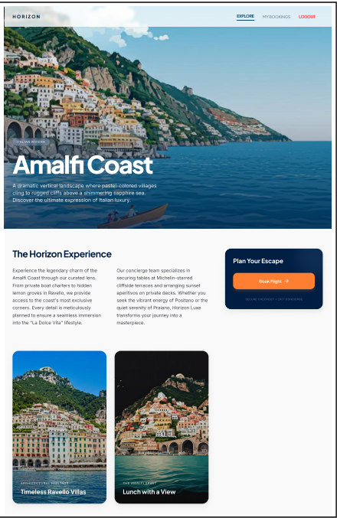
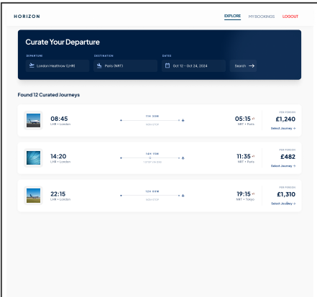
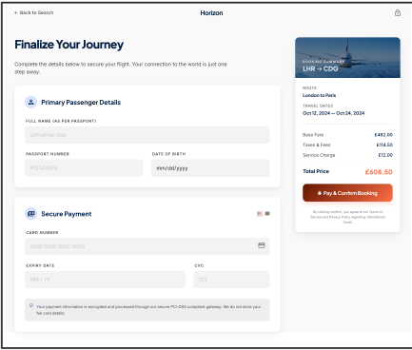

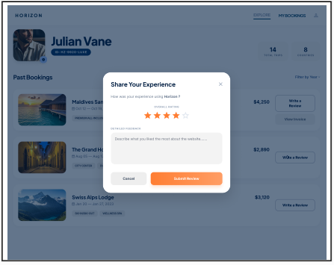
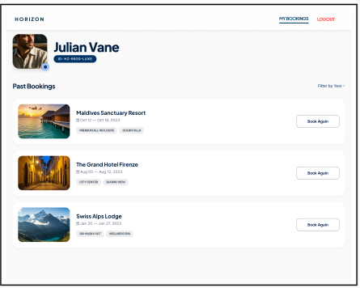
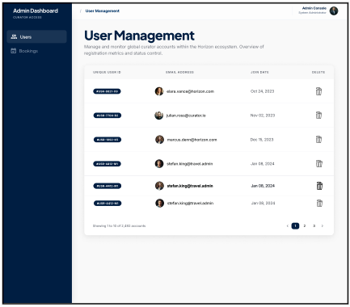
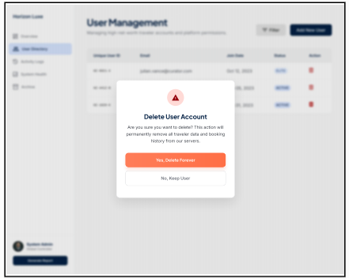
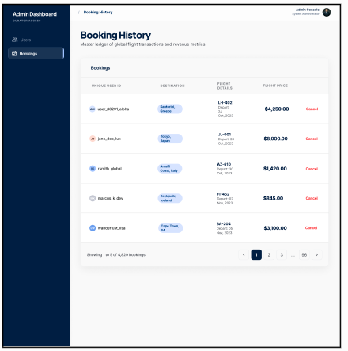
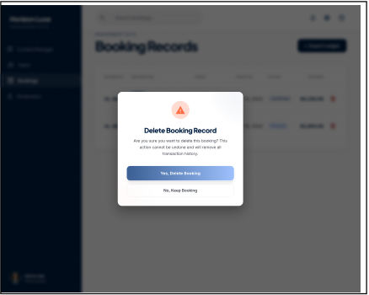

3.2 Hardware Interfaces
The Travel Advisor Website is a web-based system, so it does not need any special hardware devices to operate. Users can access the website using common devices such as desktop computers, laptops, tablets, and smartphones.

The main hardware components connected to the system are the user’s device, the web server, the database server, and the network equipment used for internet communication.
Users interact with the system through normal input and output devices such as a keyboard, mouse, touchscreen, and monitor.

3.3 Software Interfaces
- The website should run on a web server that receives user requests, processes system logic, and sends responses back to the browser.
- The system should connect to a database management system to store and retrieve all users’ data.

3.4 Communications Interfaces
- The Travel Advisor Website is a web-based system, so it uses internet communication to connect users, servers, and external services. The main communication takes place between the user’s web browser and the web server that hosts the website.
- The system should use HTTPS for communication between the client and the server.
- Data exchanged between systems should follow standard web message formats such as form data, JSON, or other API response formats supported by the connected service.

4 System Features
This section provides the Features, requirements and validations for user and admin flows.

4.1 Login

4.1.1 Description and Priority
This feature allows a registered user or authorized admin to log in to the system using email and password credentials. The system shall validate the entered data and grant access upon successful login.
Priority: High

4.1.2 Stimulus/Response Sequences
1. The user/admin enters email and password and clicks Login.
2. The system validates the entered input.
3. If the input or credentials are invalid, the system displays the relevant error message.
4. If the credentials are valid, the system logs the user in and redirects the user/admin to the next page.

4.1.3 Functional Requirements
UL-01: Error message should appear under each field when user logs in with empty fields “This field is required”
UL-02: Error message should appear for invalid email formats “Invalid email format” under email field
UL-03: System should not allow invalid credentials with error message “invalid email or password”
UL-04: User should be redirected to registration page upon clicking on Create account button
UL-05: Admin should be redirected to User management page when login is successful
UL-06: Upon successful login, user is redirected to Explore/home page

4.2 User Registration

4.2.1 Description and Priority
This feature allows a new user to create an account by entering first name, last name, email, password, and confirm password. The system validates the entered data, prevents duplicate registration, and creates the account when all required conditions are met.
Priority: High

4.2.2 Stimulus/Response Sequences
1. The user enters the required registration data and clicks Register.
2. The system validates the entered input.
3. If any input is invalid, the system displays the relevant validation message.
4. If all entered data is valid, the system creates the user account.
5. The system confirms successful registration or redirects the user to the login page.

4.2.3 Functional Requirements
UR-01: Error message appears under each field when user logs in with empty fields “This field is required”
UR-02: Error message appears under First name or last name fields when maximum length is violated “Name should be between 2 and 50 characters”
UR-03: Error message appears under password field when password length rule is violated “password cannot be less than 8 characters”
UR-04: Error message appears under password field when complexity rule is violated “password should have one small letter,one capital letter,one number and one special character”
UR-05: Error message appears when passwords don’t match in password and confirm password fields “ password doesn’t match”
UR-06: Error message should appear for invalid email format (such as missing @,missing domain,etc..) “Invalid email format” under email field
UR-07: Error message appears for first and last name fields when user enters special characters or numbers “Only alphabetic characters are allowed”
UR-08: Error message appears “Email already has an account” when user enters registers with an email that is already registered
UR-09: Upon successful registration, user should be redirected to Explore/home page
UR-10: User should be redirected to login page upon clicking on Login link

4.3 Home Page

4.3.1 Description and Priority
This feature allows the user to view the main landing page of the website, including the navigation bar, website banner, top travel destinations, destination cards, top reviews, and access to additional destinations.
Priority: High

4.3.2 Stimulus/Response Sequences
1. The user opens the Home page.
2. The system displays the page header, navigation bar, and website banner.
3. The user browses the displayed content and chooses the preferred country
4. The system displays destination cards for the selected countries.
5. The system displays the top reviews of the website
6. The user clicks "view tour" to view destination details.

4.3.3 Functional Requirements
HP-01: The system shall redirect the user to the “Find Flights” Page when the user clicks on “Find Flights” in the navigation bar.
HP-02: The system shall redirect the user to the “My Bookings” Page when the user clicks on “My Bookings” in the navigation bar to show previous bookings.
HP-03: The system shall stay on the same page when the user clicks on “Explore” in the navigation bar.
HP-04: The system shall redirect the user to the “Login” Page when the user clicks on “LOGOUT” in the navigation bar to login again.
HP-05: The system shall show 9 tour cards of Italy when clicking “Italy”, showing tour rating, cost, and “View Tour” button to show tour details.
HP-06: The system shall show 9 tour cards of France when clicking “France”, showing tour rating, cost, and “View Tour” button to show tour details.
HP-07: The system shall show 9 tour cards of Egypt when clicking “Egypt”, showing tour rating, cost, and “View Tour” button to show tour details.
HP-08: The system shall redirect the user to the corresponding Destination Details Page when the user clicks on “View Tour” in any tour card.

4.4 Destination Details

4.4.1 Description and Priority
This feature allows the user to view detailed information about a selected destination, including destination images, place name, description, top places, and a booking action.
Priority: High

4.4.2 Stimulus/Response Sequences
1. The user opens a destination details page.
2. The system displays the destination image, place name, and description.
3. The user clicks the Book Now button to proceed with booking.

4.4.3 Functional Requirements
DD-01: The system shall allow the user to proceed to the booking flow by clicking the “Book Flight” button.

4.5 Flight Search

4.5.1 Description and Priority
This feature allows the user to search for available flights by selecting trip type, departure location, destination, travel date.
Priority: High

4.5.2 Stimulus/Response Sequences

4.5.2.1 The user enters the departure, destination, and date fields and clicks Search.
2. The system validates the entered and selected values.
3. If all values are valid, the system processes the flight search request and returns matching results.
4. If one value or more is invalid, the system prevents search and displays
an error message under field if any field is invalid or empty.

4.5.3 Functional Requirements
FS-01: All the three fields shall be mandatory.
FS-02: The user shall be able to search using country name, city name.
FS-03: The From destination (Departure) shall not be the same as the To destination.
FS-04: The system shall allow users to select desired year, month and day from the date picker field.
FS-05: The system shall disable all dates prior to the current day in the calendar.
FS-06: The Depart date shall be equal to or later than today’s date.
FS-07: The system shall validate the entered search criteria before processing the search request (only valid data allow proceeding to Flight Results page)
FS-08: The system shall allow the search button to be clickable only when all required fields are filled.

4.6 Flight Result

4.6.1 Description and Priority
This feature allows the user to view available flight results based on previously entered search criteria.
Priority: High

4.6.2 Stimulus/Response Sequences
1. The user will be able to gain the Flight Results after submitting valid flight search criteria.
2. The system displays the available flight results.
3. The system allows selecting a specific flight to proceed with the “Select Journey” button.

4.6.3 Functional Requirements
FSR-01: The system should redirect the users to the personal details and the payment page if the “Select Journey” button has been pressed.

4.7 Passenger Details

4.7.1 Description and Priority
This feature allows the user to enter passenger details during the booking process.
Priority: High

4.7.2 Stimulus / Response Sequences
1. The user enters passenger details (Full Name, passport number, date of birth) in the form fields.
2. The system continuously validates the input.
3. If any field is empty, the system displays an error message under the corresponding field.
4. If all fields are filled, the system considers the data valid and stores it temporarily.

4.7.3 Functional Requirements
PD-01: The system shall provide input fields for Full Name, passport number, and date of birth.
PD-02: The full name field shall not be empty.
PD-03: The passport number field shall not be empty.
PD-04: The date of birth field shall not be empty.
PD-05: The system shall display an error message “This field is required” under any empty field in real time or on input completion.
PD-06: The system shall temporarily store valid passenger details for use in the booking process.
PD-07: The system shall accept only alphabetic characters (A–Z) in the full name field.
PD-08: The system shall not allow numbers or special characters in the Full Name field.
PD-09 : The system shall enforce a minimum length of 3 characters and a maximum length of 30 characters for the Full Name field.
PD-10: The system shall accept only alphanumeric characters in the passport number field.
PD-11: The system shall not allow spaces in the passport number field.
PD-12: The system shall ensure that the date of birth is in the past.

4.8 Payment Feature

4.8.1 Description and Priority
This feature allows the u ser to enter card payment details to complete the booking process.
Priority: High

4.8.2 Stimulus / Response Sequences
1. The user enters payment details (card number, cardholder name, expiry date, CVV).
2. The user clicks the “Pay & Confirm” button.
3. The system validates that all required fields are filled.
4. If any field is empty, the system displays an error message under field.
5. If all fields are filled, the system processes the payment
6. After successful payment, the system redirects the user to the “Share Your Experience” page

4.8.3 Functional Requirements
PAY-01: The system shall provide input fields for card number, cardholder name, expiry date, and CVV.
PAY-02: The card number field shall not be empty.
PAY-03: The cardholder name field shall not be empty.
PAY-04: The expiry date field shall not be empty.
PAY-05: The CVV field shall not be empty.
PAY-06: The system shall initiate payment processing when the user clicks the “Pay & Confirm” button.
PAY-07: The system shall display an error message under field “This field is required” if any required field is left empty.
PAY-08: The system shall redirect the user to the “Share Your Experience” page with popup to share comments after successful payment
PAY-09: The system shall redirect the user to the “My booking” page if user clicks on cancel button in “Share Your Experience” page
PAY-010: The system shall redirect the user to the “My booking” page if user clicks on submit button in “Share Your Experience” page

4.9 My Bookings

4.9.1 Description and Priority
This feature allows users to view previously booked destinations and to rebook a selected destination.
Priority: High

4.9.2 Stimulus / Response Sequences
1. The user clicks on Book Again button
2. User is redirected to Find Flights page to search for new flights

4.9.3 Functional Requirements
MB-01: User should be redirected to Find Flights page upon clicking on Book Again button for any destination and Destination field should be prefilled with selected destination

4.10 User Management (Admin Feature)

4.10.1 Description and Priority
This feature allows the admin to manage registered users in the system, including viewing users, navigating through pages, and deleting user accounts with confirmation.
Priority: High

4.10.2 Stimulus / Response Sequences
1. The admin opens the User Management page.
2. The system displays a list of all registered users.
3. The admin navigates through users using pagination.
4. The admin selects a user to delete.
5. The system displays a confirmation prompt.
6. If the admin confirms, the system deletes the user.
7. If the admin cancels, the system keeps the user unchanged
8. The system updates the user list after any deletion.

4.10.3 Functional Requirements
UM-01: The system shall provide a User Management page for the admin.
UM-02: The system shall display a list of all registered users.
UM-03: The system shall allow the admin to browse users using pagination.
UM-04: The system shall allow the admin to delete a selected user.
UM-05: The system shall display a confirmation prompt before deleting a user.
UM-06: The system shall delete the user only if the admin confirms the action.
UM-07: The system shall retain the user if the admin cancels the deletion.
UM-08: The system shall update the user list after any deletion.

4.11 Booking History (Admin Feature)

4.11.1 Description and Priority
This feature allows the admin to manage customer bookings by viewing all booked flights, navigating through them by pagination, and canceling bookings when necessary.
Priority: High

4.11.2 Stimulus / Response Sequences
1. The admin opens the Booking History page.
2. The system displays all booked flights made by users.
3. The admin browses bookings using pagination.
4. The admin selects a specific booking.
5. The admin requests to cancel the booking.
6. The system displays a confirmation prompt.
7. If the admin confirms, the system cancels the booking.
8. If the admin cancels, the booking remains unchanged.
9. The system updates the booking list after any cancellation.

4.11.3 Functional Requirements
BH-01: The system shall provide a Booking History page for the admin.
BH-02: The system shall display all booked flights made by users.
BH-03: The system shall allow the admin to browse bookings using pagination.
BH-04: The system shall allow the admin to cancel a selected booking.
BH-05: The system shall display a confirmation prompt before canceling a booking.
BH-06: The system shall cancel the booking only if the admin confirms the action.
BH-07: The system shall retain the booking if the admin cancels the action.
BH-08: The system shall update the booking list after cancellation.

