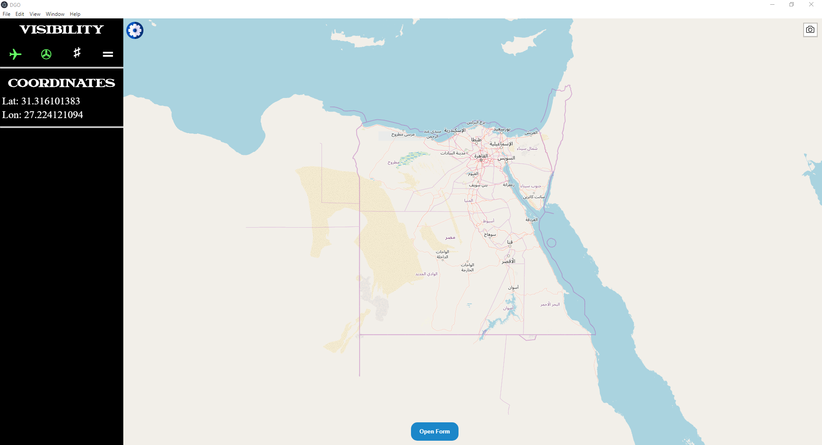

It consists of 5 main parts:

1. Map.
2. Display options panel.
3. Screenshot button.
4. Open form button.
5. Selection Form

Each part highlighted in the following image and explained individually.

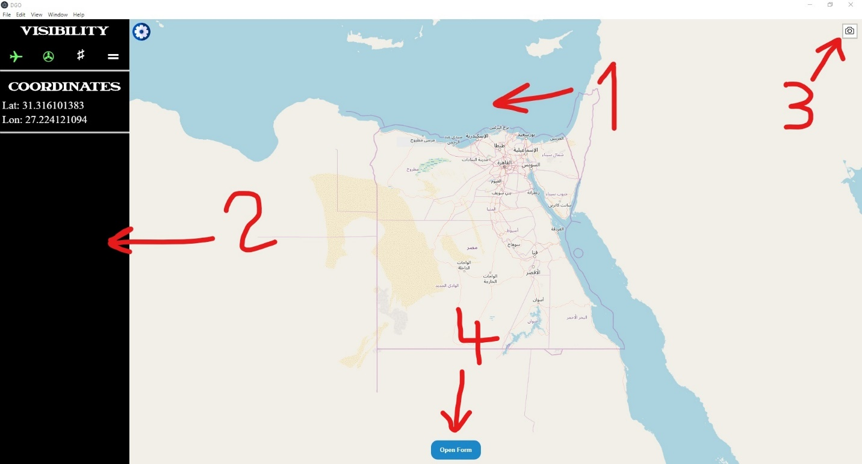

## Map

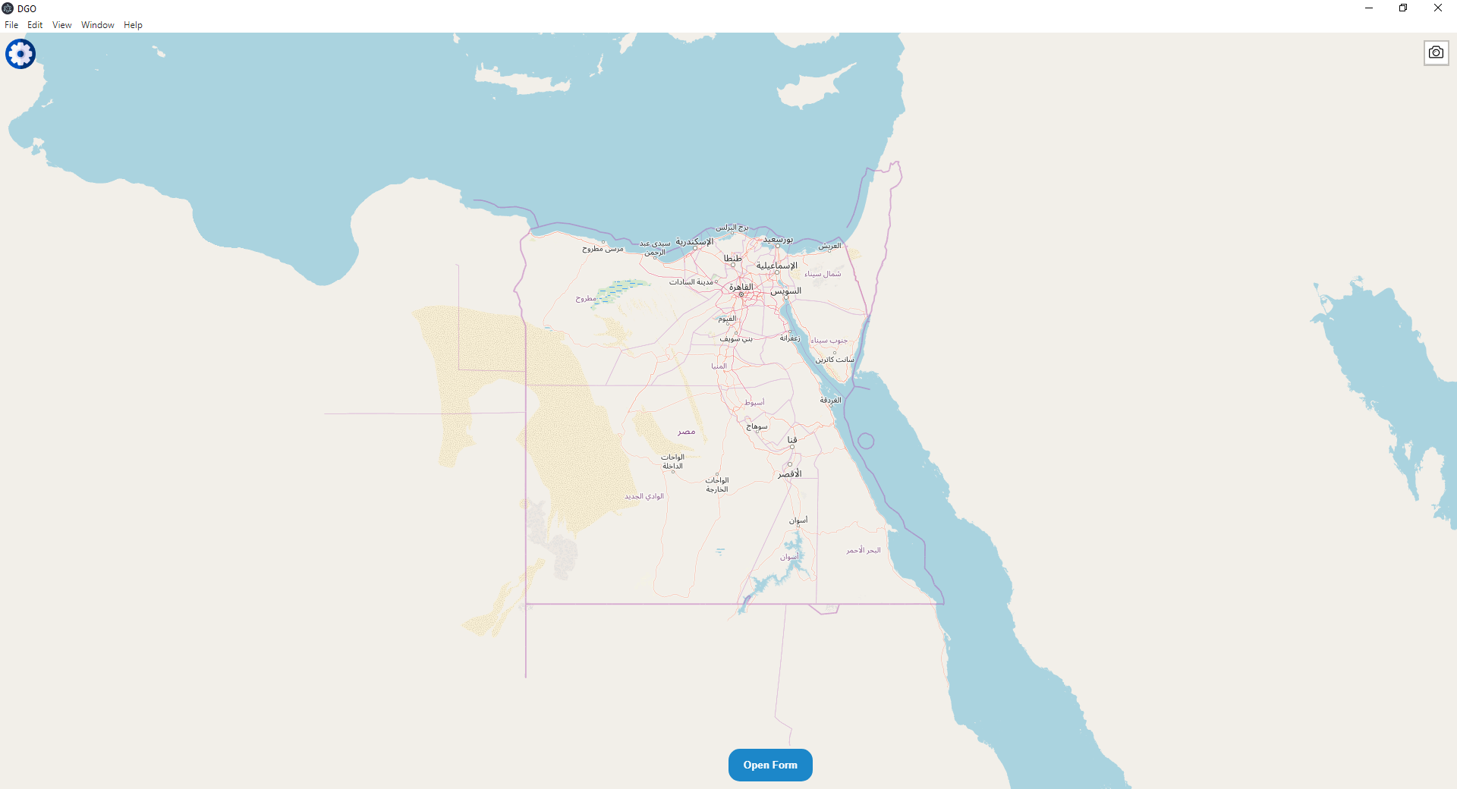

The map uses the open source Javascript library [**Leaflet**](https://leafletjs.com/). It provides the needed functionality to render the map tiles on screen, handling user interactions and showing objects on the screen.

The map consists of layers shown on top of each other containing each of the map elements (Basemap, roads, names). Each tile is a png of the map elements within it. Whenever you zoom in/out the map requests new tiles from the server to be shown on the screen for the scale the map is set to currently view.

## Display options Side Panel

The side panel is used to show and hide objects added to the map from the database.

Note: You can use the F1 Key to show/hide the side panel.

## Screenshot button

Takes a snapshot of the current view on the map and saves it as a png image. The library used to provide this funcionality is [**leaflet-simple-map-screenshoter**](https://github.com/grinat/leaflet-simple-map-screenshoter)

## Open Form button

Used to show the form on top of the map. The form contains all the customization tools needed for showing the recorded track data on the map.

Note: Use the F2 key to show the form.

## Selection Form

