Lab 2
Threads

Code Organization:
The code is divided into several modules :
a) header files for functions definitions.
b) header files for structures definitions.
Structure Modules :
1) Matrix.h : definition for matrix structure which contains information about matrix : rows count, columns count, 2D array of values.
2) Thread_Data.h : definition for a structure that contains information passed to the thread function. Information includes matrix A, matrix B, row and column to be used in calculations, result matrix.
Function Modules :
1) file_processing.h : contains functions for reading and writing matrices from and to files.
2) matrix_multiplication.h : contains functions for multiplying matrices using two multi-threaded methods.

Main Functions:
- write_matrix : writes a matrix to file in formated style.
- read_matrix : reads a matrix from a file and load into Matrix structure.
- multiply_matrix_N_threads : multiplies two matrices using N threads.
- multiply_matrix_NM_threads :multiplies two matrices using N*M threads.
- multiply_matrices : multiplies two matrices using the two methods mentioned and saves both results in a file.

Code Compilation Instructions:
Type the following instructions in terminal :
cmake CmakeLists.txt
make
./matMultp [input_matrix_1_file_name input_matrix_2_file_name output_matrix_file_name]

Sample Runs:
Test 1)
Matrix A :
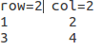

Matrix B :
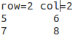

Running :
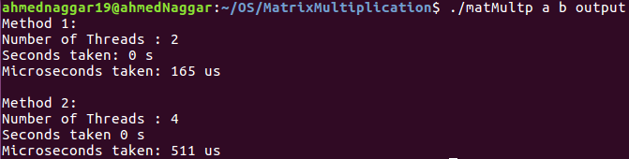
Output 1 & 2:
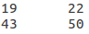

Test 2 )
Matrix A :
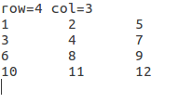

Matrix B :

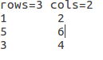

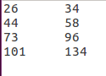
Running : Output 1 & 2 :
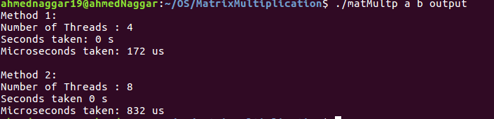

Comparison:
Method 1:
Method 1 uses N threads where N denotes the number of rows
of matrix A. Each thread calculates a specific row in the result
matrix.
Method 2:
Method 2 uses N * M threads, where N denotes the number of rows of matrix A and M denotes the number of columns of matrix B. Each thread calculates one element in the result matrix.

These are successive runs for Test 1 listed above :

Method 1 (in us) | Method 2 (in us)
4789 | 2002
5308 | 16072
5359 | 3816
2726 | 8732
8566 | 2244

Logically, Method 2 should take considerably less time than Method 1 since in Method 2 we divide work load over N * M instead of just N threads in Method 1.

