How to create an Accommodation Booking in DOTW?
To create a New Accommodation Booking, the NEW BOOKING link in the Operations section would need to be clicked. This will pull down a drop-down list, showing the available services to book. A user would need to click on ACCOMMODATION BOOKING.

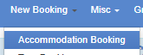

This will load the next page, where the customer’s profile would need to be input. To do this, the client’s name needs to be encoded in the COMPANY NAME field and the correct customer profile needs to be chosen from the list of the customers that would pop up. Once the correct profile is found, the FILTER CUSTOMERS button can be clicked.

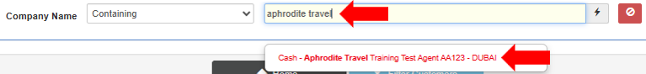
Filtering the customers profile would allow one to see all the DOTWConnect user profiles the client has with us. Clients would usually have multiple user profiles under their accounts.

If the client has a specific preference under which account the booking is to be placed, the specific user account mentioned should be the one chosen. On the other hand, if the client did not specify which user account to use, the profile tagged as MAIN USER can be chosen.

Once the client’s profile has been chosen, the next page will allow one to input the search filters for the accommodation booking requested. The first row will allow for the DESTINATION for the booking to be input.

INPUTTING THE DESTINATION

The DESTINATION filter will allow for the search via a Specific Destination, Hotel Name, Location or Landmark.

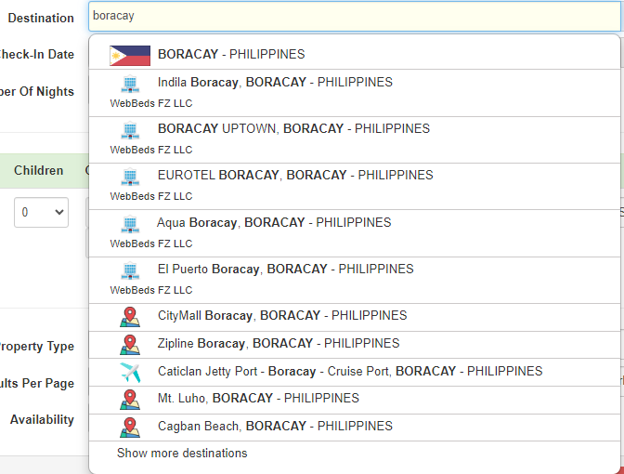
Subsequently, if a specific destination is input, the DOTWConnect platform will present recommendations, such as:

a. Similar named cities,
b. Recommended hotels, and
c. Recommended landmarks in the destination.

One may choose from the recommendation given by the system or search for a specific destination.

INPUTTING THE TRAVEL DATES

The row below Destination would allow to input the CHECK-IN and CHECK-OUT dates for the booking searched. The check-out date can be changed automatically, by adjusting the Number of Nights from the drop-down list.

INPUTTING THE OCCUPANCY

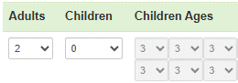
The next information that can be adjusted would be the OCCUPANCY of a booking. By default, a DOTWConnect new booking search would initially be for double occupancy but can be changed accordingly to the actual occupancy that needs to be booked.

If there are children included in the booking, the exact ages of the children, at the time of the stay, will be required to be input. DOTWConnect will automatically give the appropriate rates, based on the children’s age as well as the hotel’s contract with us.

INPUTTING THE MEAL PLAN

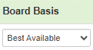
The next information that can be filtered would be the BOARD BASIS or Meal Plan requested for the booking.

By default, a DOTWConnect new booking search initially would place the Board Basis under Best Available (or all available meal plans). This, however, can be changed accordingly to the actual meal plan requested by the client.

INPUTTING THE NATIONALITY & COUNTRY OF RESIDENCE

The next information that can be filtered would be the PASSENGER’S COUNTRY OF RESIDENCE & NATIONALITY. This needs to be accurately requested from the client, to ensure the accurate market-specific rates are given during booking.

ADDING MULTIPLE ROOMS IN THE BOOKING

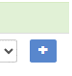
Clicking on this BLUE BUTTON would allow for the searching of multiple rooms within the same destination.

The DOTWConnect platform would add an additional row in the filter, allowing the input of the occupancy, board basis and guest nationality & residence for the additional rooms.

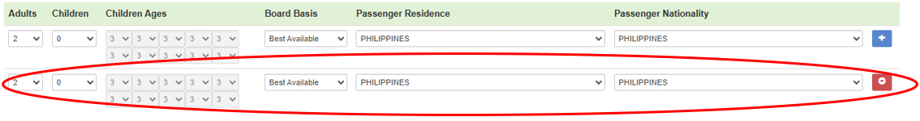

A limitation of this type of multiple room search is that both rooms would need to be made in the same hotel and for the same travel dates. In the event a client would like to book multiple hotel rooms but in different hotels or dates, multiple individual bookings in an itinerary would need to be created.

ADDITIONAL FILTERS

Above the Search button gives a user option to filter booking results based on:
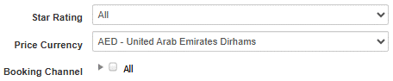
A. STAR RATING
B. PRICE CURRENCY
C. BOOKING CHANNEL (Supplier Type)

By default, the PRICE CURRENCY would be the main currency that the client has chosen to pay for their WebBeds bookings. However, if the client would like to pay for the booking using a different currency, the drop-down box for Price Currency can be clicked to see what the available currencies are to change to.

It is only feasible to change the currency for the Selling Price at the time of the booking. Once it has been booked, the selling price can no longer be changed.

Availabilities from ALL kinds of booking channels/suppliers are shown in DOTWConnect, by default, when searching for a new booking. It is possible to search for specific availabilities only when making a new booking.

Options to filter the BOOKING CHANNEL/Suppliers are:

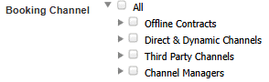
A. Offline Contracts: DC and DMC
B. Direct & Dynamic: Dynamic (Hotel Chain)
C. Third Party: Third Party Suppliers and Intercompany
D. Channel Managers

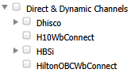
Further, clicking on the arrows beside the Booking Channel will expand the list, allowing the ability to filter down to the specific Supplier Name during Booking Search.

This functionality is most useful when searching for availabilities for other hotels during relocation tickets.

Once all appropriate booking search filters have been adjusted and input, the Search button may be clicked. The DOTWConnect system will display, in the lower part of the page, the results based on the information filtered.

DOTWConnect will, by default, chronologically sort the results first based any hotels in preferred status, followed by the hotels with lowest nightly selling price, as of real-time. If needed, the results can further be sorted via:

- Star Rating: sorts the results by the star rating of the hotels
- Accommodation Name: sorts the results by the name of the hotels
- Preferred: sorts the results by showing the preferred hotels first
- Suites: sorts the results by showing the hotels that offer suites as availability
- Price: sorts the results via the nightly rate of the hotels, whether from lowest or highest nightly rate
- Luxury: sorts the results based on the luxury of the hotels

Accommodation search results would present a summary of the hotel and its availability. The information given would include the:

- Accommodation Info, which shows information and pictures of the hotel
- Hotel Name
- Hotel’s Star Rating
- Lowest Nightly Selling Price for the specific hotel
- See Room Types button, which allows the available room types and total selling prices to be seen

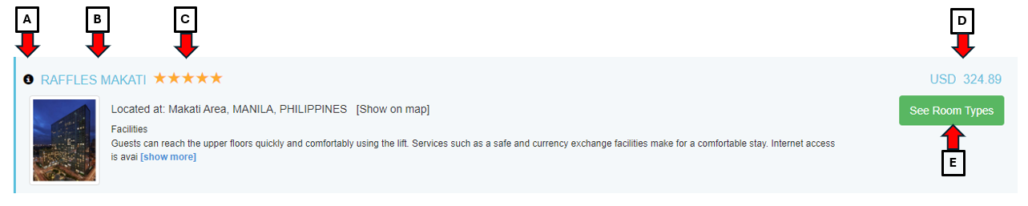

When a WebBeds user is quoting a client, it is very important that our team member does not give the lowest nightly selling price as this is not indicative of the number of nights and chosen room type of the client. The team member would need to click on the SEE ROOM TYPES button first, search for the requested room type and it will show the total selling price for the whole stay.

Clicking on the See Room Types button will allow DOTWConnect to show the available rooms for the hotel, their cancellation deadlines, and the total selling price. A team member will have access to this information, when looking at the room availability:

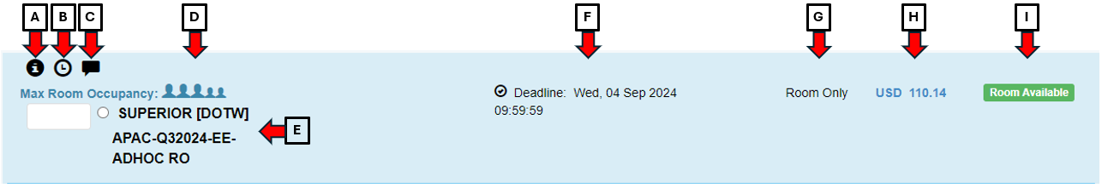

- Room Information: gives access to the room information given by the hotel/supplier. The information is mostly basic information only. Thus, it’s best to check in the hotel’s website or with the supplier on the specific hotel room’s specification. This section will also show the maximum adults, children, and occupants in the room.

- Cancellation & Amendment Policies: gives access to the cancellation/amendment deadline and penalties that apply for the booking. Dates and times in the policy are in the client’s time zone.

- Rate Notes: gives access to the hotel’s rate or tariff notes.

- Max Room Occupancy: gives information regarding the maximum room occupancy of a room. This may or may not show in this section, depending on which supplier the rate and availability was taken from.

- Room Name and Type: gives information about the room name and the supplier the booking was booked from

- Cancellation Deadline: gives information regarding the cancellation deadline for a booking. For prepaid-cash clients, this would also be the payment deadline for the booking.

- Board Basis: gives information regarding the board basis/meal plan included in the booking.

- Total Selling Price: gives information regarding the total selling price for the booking, inclusive of all nights, taxes, and fees.

- Room Availability: gives information if the ROOM is AVAILABLE or if the ROOM is ON REQUEST.

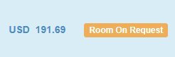
If a room is showing as ROOM ON REQUEST, it is important to check first with the hotel if they can accommodate the booking. If the client insists to make the booking, the client needs to be clearly informed that the room is on- request, and the hotel may or may not accept the booking.

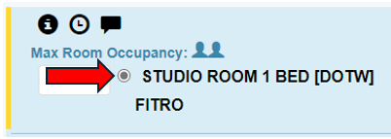
Once a user has found the room that would like to be booked, the tick circle beside the room name would need to be clicked. Afterwards, the PROCEED TO BOOKING button, at the end of the availability, would need to be clicked.

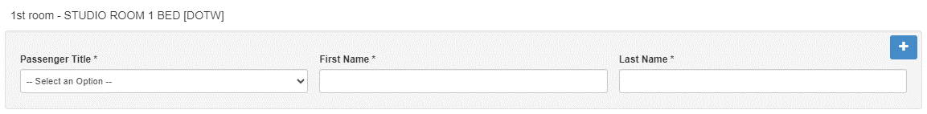
A pop-up box will show, wherein the names of the guests, their bedding preference, and special requests (if any) would need to be input. The number of guest names that will need to be input depends on the kind of supplier. Some suppliers require only the lead guest’s name, while others require all guests’ names.

A user will need to ensure that only English characters are used. There should be no special characters used and that there should be no spaces at the beginning or end of the names.

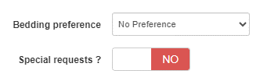
Any special requests noted at the time of the booking will be forwarded to the hotel via the LPO. However, as with any special request, these are subject to availability, at the time of the check-in.

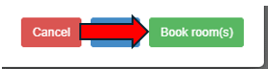
Once all the guest names and preferences are correctly input, and the terms and conditions are read, the green BOOK ROOMS button can now be clicked.

It will lead DOTWConnect to make the booking itself. Once the booking is created, it will bring the user to the full booking summary.

