INTRODUCTION

This entity relationship diagram represents the model of bus ticket booking system entity. The entity relationship diagram of bus ticket booking system shows all the visual instrument was f database tables and the relations between booking, bus route, bus, seat etc. Here the bus ticket booking system and their attribute are given bellow.

1. **Passenger**

**2. Bus_Info**

3. **Ticket**

4. **Route**

In this ER diagram we will show the relationship between these entities and the relationship between attribute and entity.

Case Study

In a bus ticketing system a passenger may buy at most one ticket. One ticket may be bought by exactly one passenger.

A passenger is identified by a passenger id. The system also stores name, gender, age, contact, address and card.

A ticket is identified by a ticket number. Ticket price and final price is also stored. A passenger may board on exactly one bus. A bus may board many passengers.

A bus is identified by bus number. The system also stores departure location, total seat, available seat, seat number, arrival time, destination, source, and departure date and departure time. A bus may travel through exactly one route.

A route may be travelled through by much bus. A route is identified by route id. The system also stores pick up point and route point.

ER-Diagram

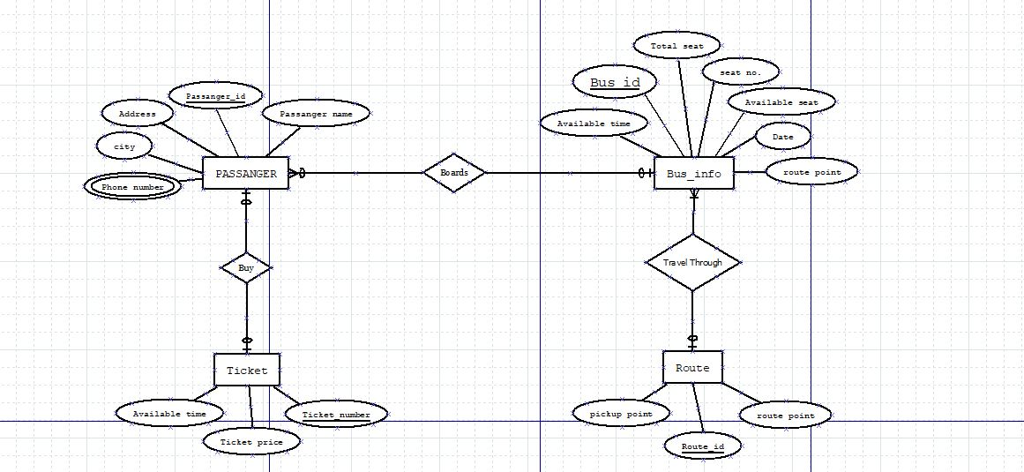

Normalization

**Buy:** (passenger-id, address, city, phone number, passenger name, ticket number, ticket price, available time)

**1NF:** Phone multivalued attributed.

**2NF:** passenger-id, address, city, phone number, passenger name

Ticket number, ticket price, available time, passenger-id

**3NF:** passenger-id, aid, phone number, passenger name

Ticket number, ticket price, available time, passenger-id

Aid, address, city.

**Table:**

1. passenger-id, aid, phone number, passenger name
2. Ticket number, ticket price, available time, passenger-id
3. Aid, address, city.

**Boards:** (passenger-id, address, city, phone number, passenger name, bus-id, available time, seat no., available seat, total seat, date, route point)

**1NF:** Phone number multivalued attribute

**2NF:** passenger-id, address, city, phone number, passenger name

bus-id, available time, seat no., available seat, total seat, date, route point,

passenger-id, address, city, phone number, passenger name

**3NF:** passenger-id, aid, phone number, passenger name

bus-id, available time, seat no., available seat, total seat, date, route point,

passenger-id.

aid, address ,city.

**Table:**

1. passenger-id, aid, phone number, passenger name
2. bus-id, available time, seat no., available seat, total seat, date, route point, passenger-id.
3. aid, address, city.

**Travel through:** (route_id, pickup_point, route_point, bus-id, available time, seat no., available seat, total seat, date)

**1NF:** no multivalued attribute

**2NF:** route_id, pickup_point, route_point.

bus-id, available time, seat no., available seat, total seat, date,

route_id, pickup_point, route_point.

**3NF:** route_id, pickup_point,route_point.

bus-id, available time, seat no., atid, date.

Atid, available seat, total seat.

**Table:**

1. route_id, pickup_point, route_point.
2. bus-id, available time, seat no., atid, date.
3. Atid, available seat, total seat.

**Total table:**

1. passenger-id, aid, phone number, passenger name
2. Ticket number, ticket price, available time, passenger-id
3. Aid, address, city.
4. ~~passenger-id, aid, phone number, passenger name~~
5. bus-id, ,available time, seat no., available seat, total seat, date, route point, passenger-id.
6. ~~aid, address, city.~~
7. route_id, pickup_point, route_point.
8. bus-id, ,available time, seat no., atid, date.
9. Atid, available seat, total seat.

**Final table:**

1. passenger-id, aid, phone number, passenger name
2. Ticket number, ticket price, available time, passenger-id
3. Aid, address, city.
4. bus-id, available time, seat no., available seat, total seat, date, route point, passenger-id.
5. route_id, pickup_point, route_point.
6. bus-id, available time, seat no., atid, date.
7. Atid, available seat, total seat.

Table creation

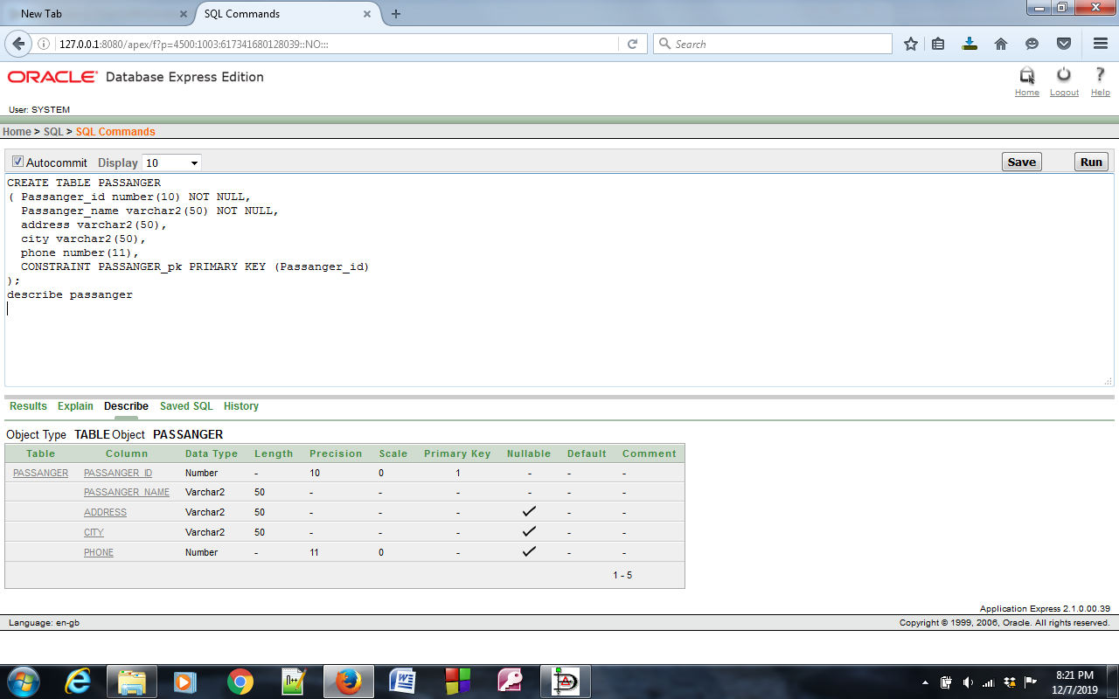

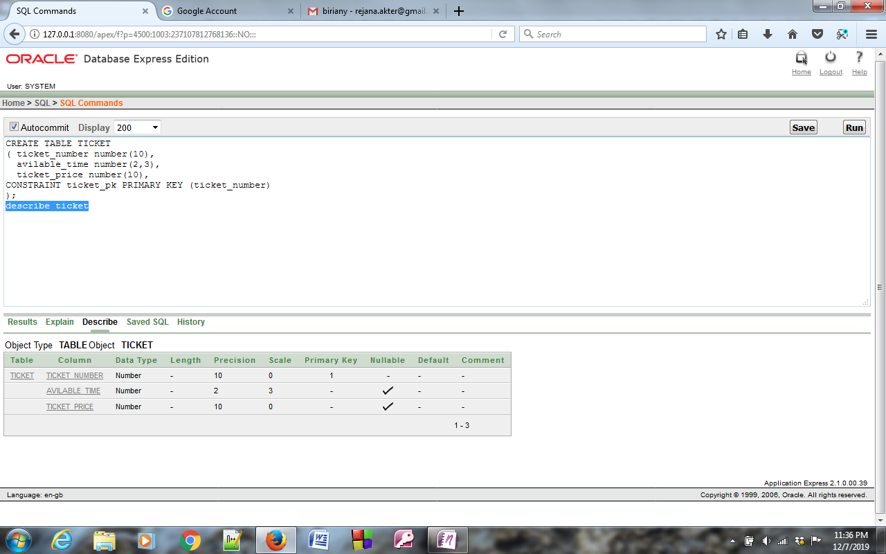 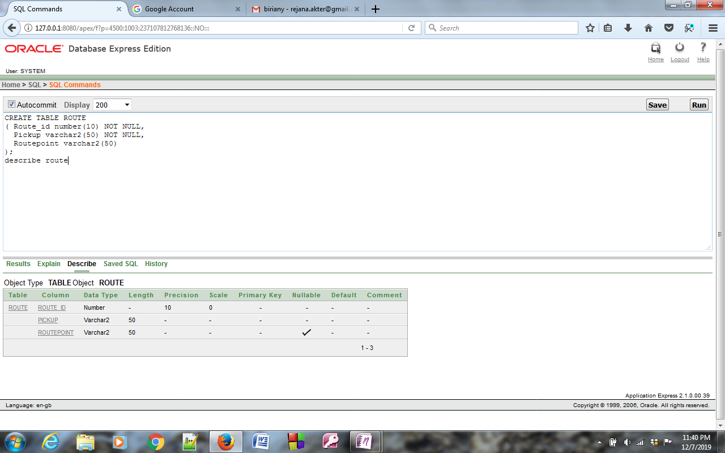

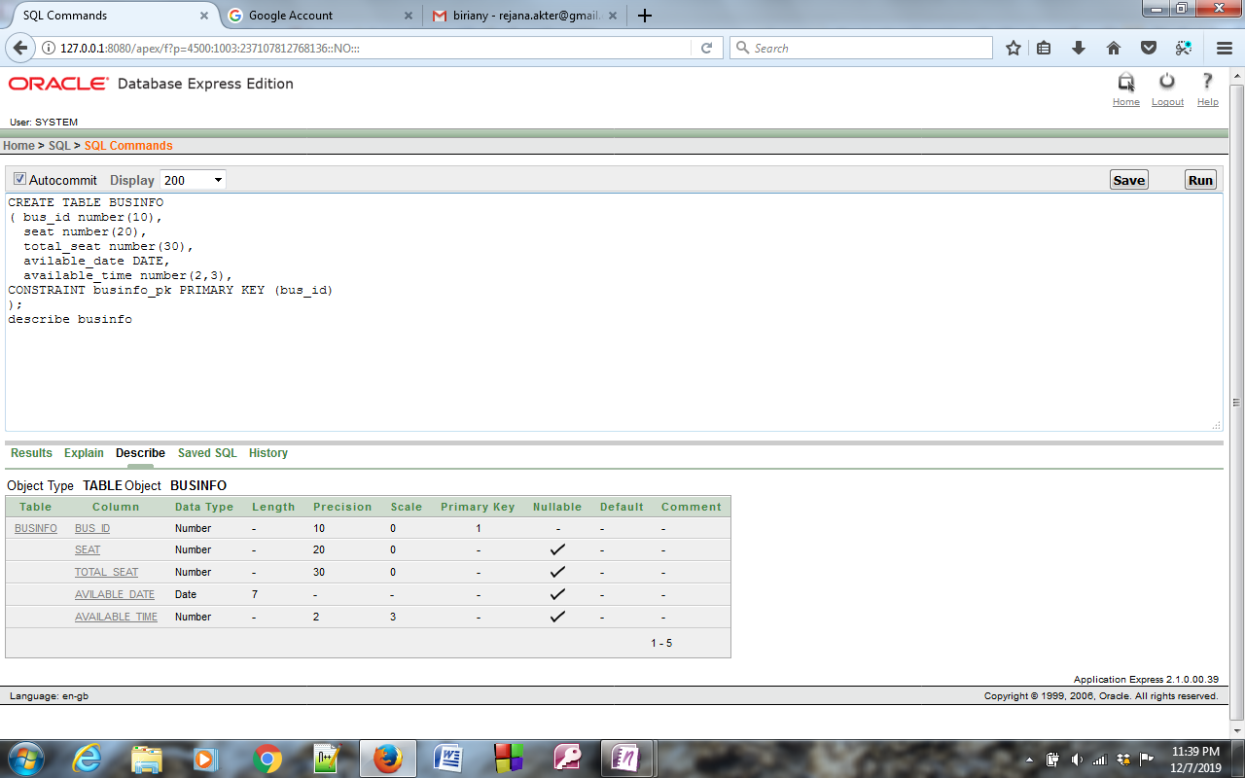

Data Insertion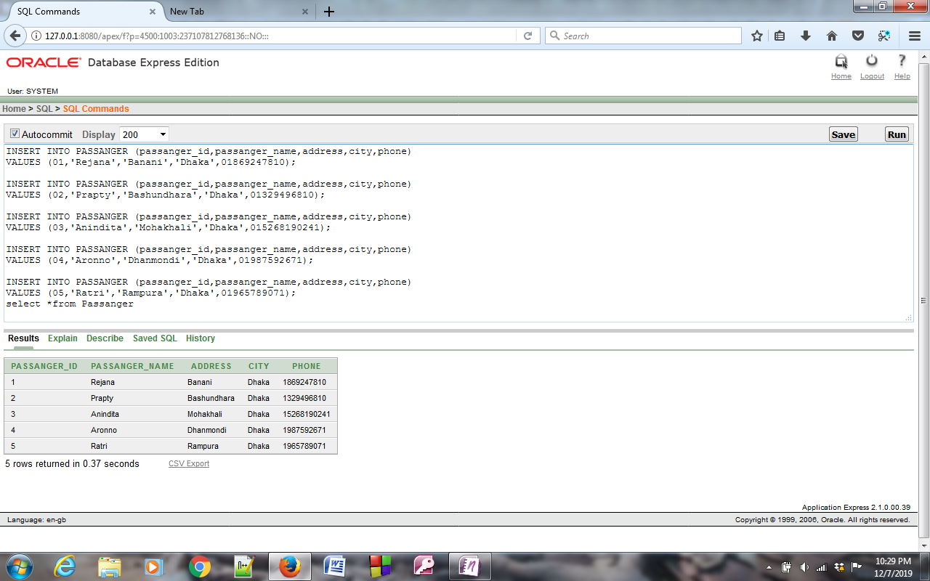

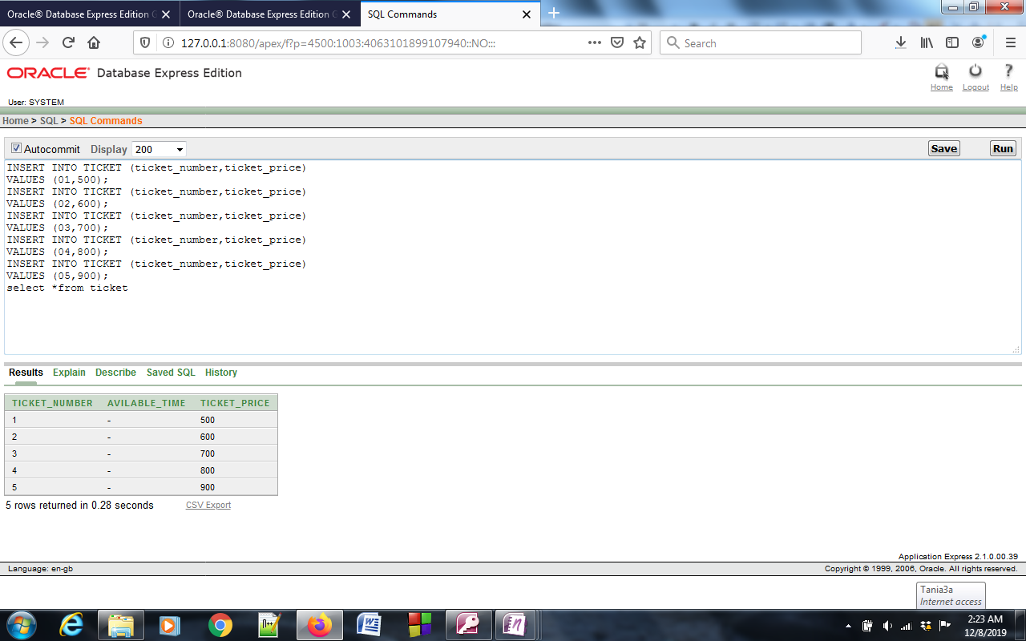 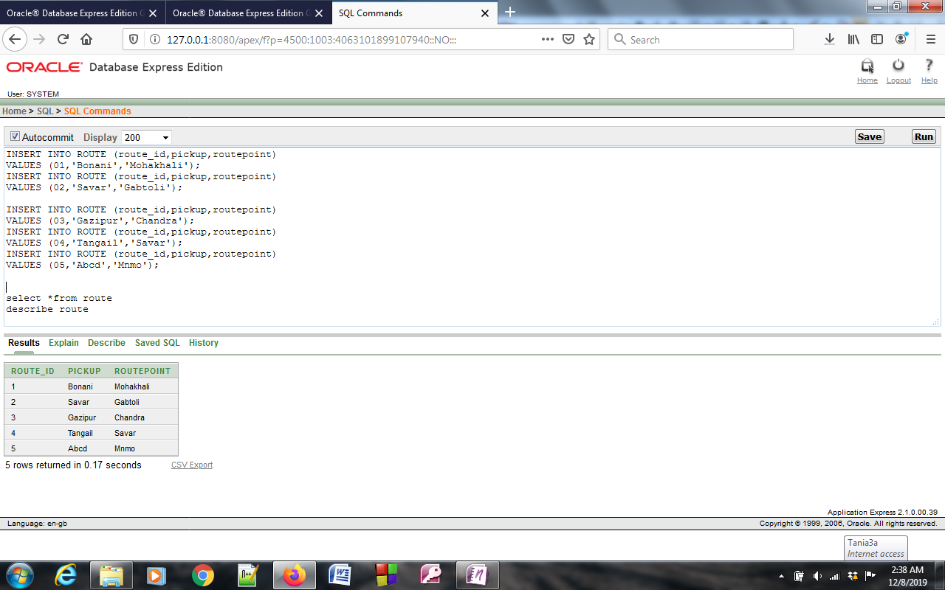

SUB QUARY

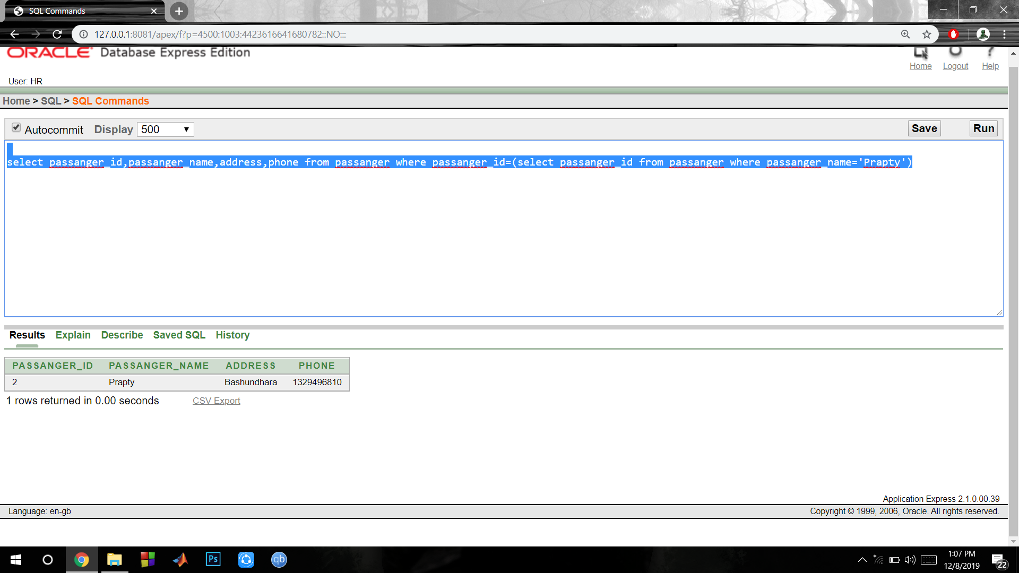

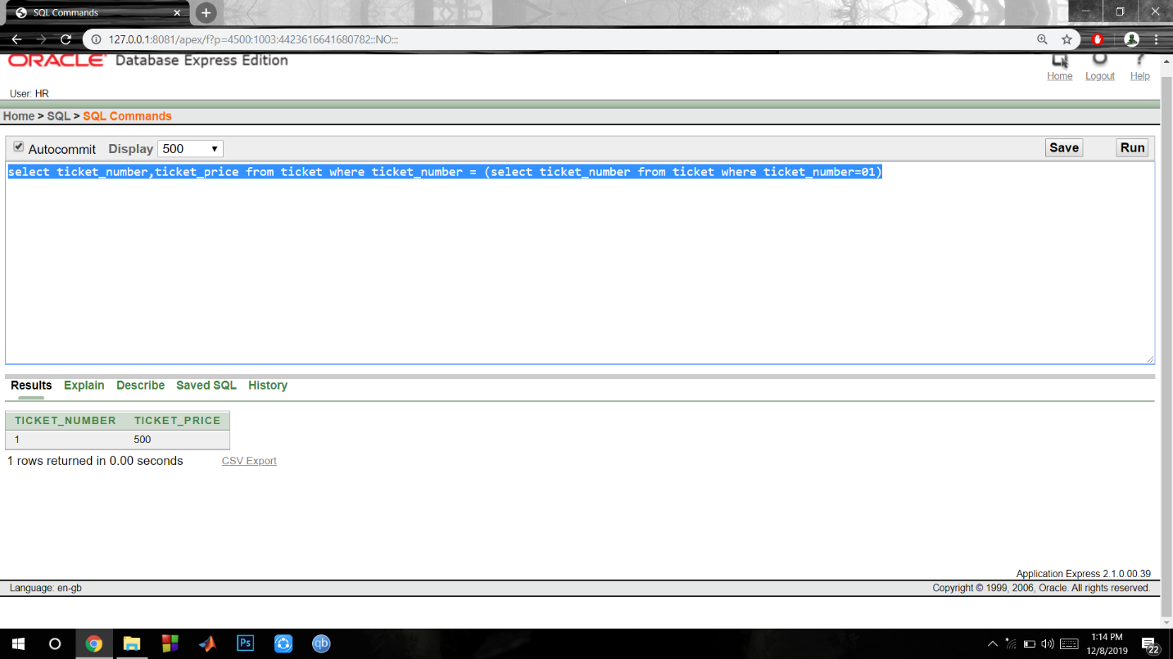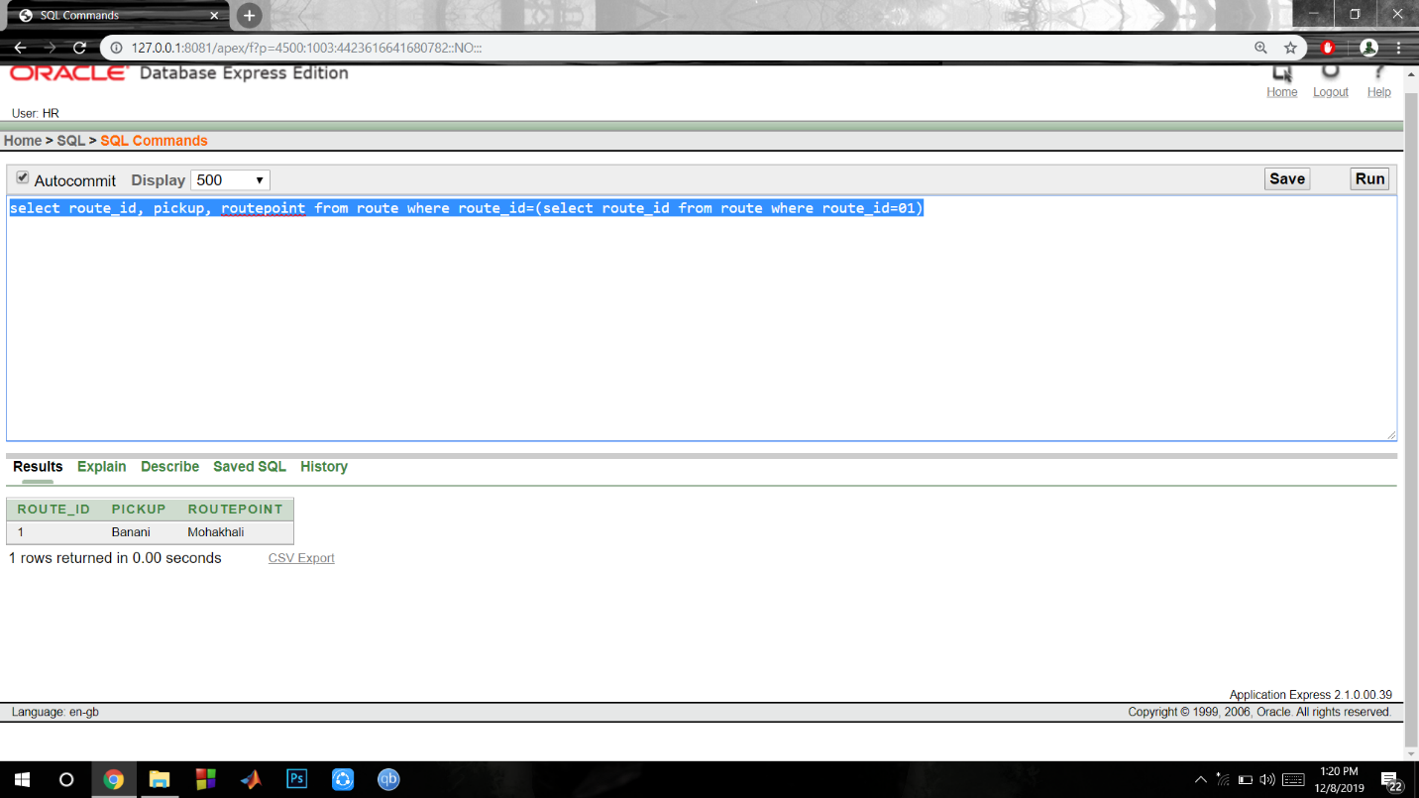

**Conclusion**

Our project on bus ticketing system provides an easy way for looking the bus ticket. Our project has succeed in managing the data and providing the best service to the user so that they can easily choose their bus according to their requirement.